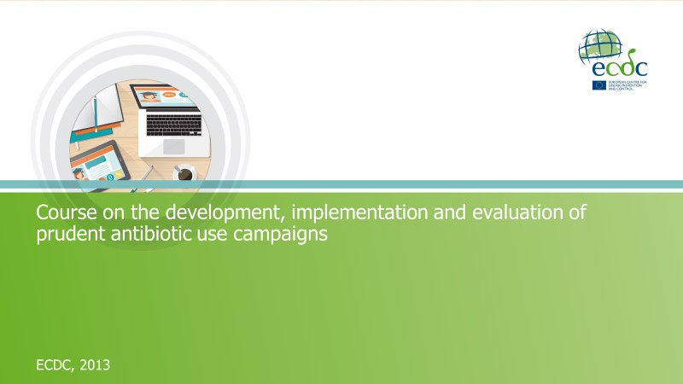
Participant Workbook
Revised version April 2018
Course on the development, implementation and evaluation of prudent antibiotic use campaigns
Participant workbook
Course on the development, implementation and evaluation of prudent antibiotic use campaigns
This document belongs to the training toolkit for the course on the “Development, implementation and evaluation of prudent antibiotic use campaigns”, commissioned by the European Centre for Disease Prevention and Control (ECDC) in 2013, under service contract no. ECDC/2011/029 with Karolinska Institutet, Sweden.

Authors: Senia Rosales Klintz, PhD, MSc (Microbiology); Erika Anne-Marie Saliba, MMSc (Global Health), RN, BSc (Nursing); Charlotta Zacharias, Lic. Med. Sci., MSc (International Health), MD; and Cecilia Stålsby Lundborg, Prof, PhD, MScPharm – Dept. of Public Health Sciences (Global Health/IHCAR), Karolinska Institutet.

Suggested citation: Rosales Klintz S, Saliba EA, Zacharias C, Stålsby Lundborg C. Course on the development, implementation and evaluation of prudent antibiotic use campaigns: facilitator manual. Stockholm: European Centre for Disease Prevention and Control; 2013.

You are free to:
- Share – copy, distribute and transmit the work
- Remix – adapt the work

Under the following conditions:
- Attribution – you must attribute the work in the manner specified by the author or licensor (but not in any way that suggests that they endorse you or your use of the work)
- Non-commercial – you may not use this work for commercial purposes
- Share Alike – if you alter, transform, or build upon this work, you may distribute the resulting work only under the same or similar license to this one

With the understanding that:
- Waiver – any of the above conditions can be waived if you get permission from the copyright holder
- Public Domain – where the work or any of its elements is in the public domain under applicable law, that status is in no way affected by the license
- Other Rights – in no way are any of the following rights affected by the license:
  - Your fair dealing or fair use rights, or other applicable copyright exceptions and limitations
  - The author's moral rights
  - Rights other persons may have either in the work itself or in how the work is used, such as publicity or privacy rights
- Notice – for any reuse or distribution, you must make clear to others the license terms of this work

Original: Stockholm, October 2013. Revision: April 2018.

Acknowledgments
We would like to express our gratitude to the following persons for their valuable comments during the revision of this course package.

- Giovanni Mancarella, Sarah Earnshaw, Dominique Monnet, Barbara Albiger, Sonsoles Guerra, Irina Dinca, Andrea Mendez, Nabil Safrany and Ülla-Karin Nurm – ECDC
- Ashish Pathak, Meena Daivadanam, Hana Taha, Maria Polyzoi, Myroslava Protsiv and Ioana Vlad – Dept. of Public Health Sciences (Global Health/IHCAR), Karolinska Institutet
- Taina Mäntyranta and Mairi Juriska – Dept. of Learning, Informatics, Management and Ethics (LIME), Karolinska Institutet
- Liselotte Schäfer Elinder – Dept. of Public Health Sciences (Social Medicine), Karolinska Institutet
- Anna Nyberg – Stockholm School of Economics, Sweden
- Vera Vlahović-Palčevski – University of Rijeka Medical Faculty, Croatia
- Christiana Salvi – WHO/Europe
- Courtney Dowd – Public Health Agency of Canada
- Mats Erntell – Swedish Strategic Programme against Antibiotic Resistance (Strama)

Course on the development, implementation and evaluation of prudent antibiotic use campaigns
Participant workbook

Table of contents

Abbreviations iv
Introduction 1
1.1 Background: EAAD campaign development 3
1.2 The inception of this course 3
1.3 Description of the course content 4
1.4 Course schedule 6
Group work 11
Case studies 21
3.1 Introduction 23
3.2 Intended learning outcomes 23
3.3 Instructions 23
Indicators list 153
Glossary 169
Bibliography 179

Abbreviations
ATC | Anatomical therapeutic chemical classification system
BCC | Behaviour change communication
BCI | Behaviour change intervention
DDD | Defined daily doses
DID | Defined daily doses per 1,000 inhabitants per day
EAAD | European Antibiotic Awareness Day
ECDC | European Centre for Disease Prevention and Control
EMRSA | Endemic strain of MRSA
EU | European Union
GP | General practitioner
HCP | Healthcare professional
I | Introduction
ICPC-2-R | International classification of primary care, revised second edition
ICU | Intensive care unit
IEC | Information, education and communication
MHS | Maccabi Healthcare Services
MRSA | Methicillin-resistant Staphylococcus aureus
NGO | Non-governmental organisation
NHI | National health insurance
Q & A | Question and answer
RTAS | Rapid tests to diagnose group A streptococci
RTI | Respiratory tract infection
S | Session
SWOT | Strengths, weaknesses, opportunities, threats
URI | Upper respiratory infections
VISA | Vancomycin-intermediate resistant Staphylococcus aureus
VRI | Viral respiratory infections
VRSA | Vancomycin-resistant Staphylococcus aureus
WHO | World Health Organization

Course on the development, implementation and evaluation of prudent antibiotic use campaigns

Introduction

1.1 Background: EAAD campaign development
The European Antibiotic Awareness Day (EAAD) is a European public health initiative led by the European Centre for Disease Prevention and Control (ECDC). Since 2008, EAAD, held during the week of November 18th, has been used as a platform to raise awareness about the threat of antibiotic resistance to public health and to communicate about prudent antibiotic use. EAAD builds on the successful awareness campaigns on appropriate antibiotic use at national level by Member States.
The goal of EAAD is to provide an evidence-based focus for national campaigns, as well as key messages, campaign materials, technical and political support. In addition, EAAD has been able to secure political support at European Union (EU)-level and across the Member States through engagement with the rotating Eu Presidency, as well as members of the European Parliament, national health ministers and chief medical officers.
In the initial stages of EAAD (2008-2010), the campaign worked towards developing key messages and campaign materials targeting the general public, primary care and hospital prescribers. ECDC together with the European Commission, World Health Organization (WHO) Regional Office for Europe, national antimicrobial resistance focal points, professional societies and other experts in the field, developed communication toolkits. These toolkits included templates for campaign materials which could be adapted at national level, as well as guidelines for campaign implementation. An EAAD website is available in all official EU languages (http://antibiotic.ecdc.europa.eu).
In 2011-2012, the focus of EAAD shifted towards consolidation, with activities to support the development, implementation and evaluation of national prudent antibiotic use campaigns. In this context, ECDC intends to support the consolidation and further development of effective prudent antibiotic use campaigns at national level.

1.2 The inception of this course
With the realisation that Member States have a need for better understanding on campaign planning and evaluation, ECDC initiated the development of this reference curriculum. The main aim of this training module on the development, implementation and evaluation of prudent antibiotic use campaigns is to have a reference curriculum and toolkit that can be used as a basis to organise training courses at national level that will strengthen participants’ knowledge and skills on prudent antibiotic use campaigns.

1.3 Description of the course content
1.3.1 Overview of the course curriculum
1.3.1.1 Aim and general intended learning outcomes
The aim of this course is to provide planners and implementers of prudent antibiotic use campaigns with the basic knowledge and skills required to plan, conduct and evaluate such campaigns.
By the end of the course, participants should be able to:
- understand and explain the rationale, key elements and steps required to develop behaviour change communication campaigns on prudent antibiotic use,
- understand and apply basic social marketing concepts in the development, implementation and evaluation of behaviour change communication campaigns on prudent antibiotic use,
- design and implement behaviour change communication campaigns on prudent antibiotic use,
- identify and select appropriate indicators, methods and tools for evaluation of behaviour change communication campaigns on prudent antibiotic use, and
- design and implement an evaluation work plan for behaviour change communication campaigns on prudent antibiotic use.

1.3.1.2 Learning opportunities
The course will provide appropriate learning opportunities for participants to acquire:
- knowledge on:
  - basic concepts regarding behaviour change communication campaigns, including theoretical underpinnings and planning frameworks,
  - key elements of a social marketing plan for development of behaviour change communication campaigns on prudent antibiotic use,
  - strategies to overcome implementation barriers related to resource limitations (budget, time and staff constraints), and
  - basic concepts on evaluation methods and tools.
- skills related to:
  - stepwise design and implementation of a social marketing plan for a behaviour change communication campaign on prudent antibiotic use, including but not limited to, market research (formative evaluation and segmentation) and marketing mix formulation (product, price, place, promotion), and
  - stepwise planning for evaluation of a behaviour change communication campaign on prudent antibiotic use.

1.3.1.3 Course structure
The course consists of three components:
- A pre-course package to assist participants in their preparation for the face-to-face course.
- A 2.5-day face-to-face course divided into three modules:
  - Module 1: Introduction to the development of campaigns on prudent antibiotic use
  - Module 2: Implementation of prudent antibiotic use campaigns
  - Module 3: Introduction to evaluation of prudent antibiotic use campaigns
- A post-course package to evaluate course outcomes and to follow-up participant’s application of the knowledge and skills acquired during the training.

1.3.1.4 Training methods
This course uses participants’ experiences as a point of departure and builds up from there, inserting core content blended with experience as the course progresses. The training methods include lectures and interactive presentations to introduce relevant concepts related to the course topics. In addition, the course uses group discussions and group work to make use of participants’ experiences and promote their active involvement in their learning process and group interaction. Case studies are used to support the integration and application of knowledge acquired throughout the course. All teaching activities aim at enhancing the participant’s ability to apply key concepts and theory/theoretical frameworks, in an analytical and reflective practice of their own.
1.3.2 Training materials
Participants are provided with a participant workbook which provides all that one will need throughout the duration of the course. The workbook consists of six chapters:
- Introduction: provides general information about the course and workbook
- Group work: contains all the necessary worksheets needed during group work activities
- Case studies: includes a selection of case studies and related questions
- Indicators: provides a selection of indicators which may be of use during the course as well as afterwards
- Glossary: a list of key words and their definitions
- Bibliography

1.4 Course schedule
Day 1
Module 1: Introduction to the development of prudent antibiotic use campaigns

Time | Session (S)
8:45 | Arrival to the venue
9:00 | I1: Introduction to day 1
10:30 | ~ Coffee break ~
11:00 | Feedback from the coffee break activity
11:10 | S1: Problem description
12:30 | ~ LUNCH ~
13:30 | S2: Stepwise planning
14:00 | S3: Formative evaluation
15:00 | ~ Coffee break ~
15:20 | Group work: initial development of a campaign strategy
17:20 | Feedback session on the group work progress
17:40 | Wrap-up & assignments for next day
18:00 | End of day 1

Day 2
Module 1: Introduction to the development of prudent antibiotic use campaigns

Time | Session (S)
9:00 | I2: Introduction to day 2
9:30 | S4: Strategy development
10:30 | ~ Coffee break ~
11:00 | Feedback from the coffee break activity
11:20 | S5: Prototyping and pre-testing
12:30 | ~ LUNCH ~
Module 2: Implementation of prudent antibiotic campaigns

13:00 | S6: Implementation
14:30 | ~ Coffee break ~
Module 3: Introduction to the evaluation of prudent antibiotic use campaigns

14:45 | S7: Evaluation
15:45 | Group work: development of a campaign strategy
17:45 | Wrap-up
18:00 | End of day 2

Day 3
Module 3: Introduction to the evaluation of prudent antibiotic use campaigns

Time | Session (S)
9:00 | I3: Introduction to day 3
9:30 | Group presentations (including: coffee break)
12:00 | Wrap-up
12:30 | End of day 3

Course on the development, implementation and evaluation of prudent antibiotic use campaigns

Group work

Social marketing plan

In this section you will find instructions and tools which will guide you when developing your social marketing plan during group work sessions. You can work at your own pace during the two sessions allocated for group work.
On day three of the course, you will be expected to present your work to the rest of the group for discussion; therefore you should select one person in the group to be a moderator and another to be note-taker during the group work sessions.

Group number: __________
Target audience: _______________________________
Group members (name, nationality and profession):
- _____________________________________________________________________
- _____________________________________________________________________
- _____________________________________________________________________
- _____________________________________________________________________
- _____________________________________________________________________

I. General description
Setting | Preferably represented by someone in the group
Country/  region | If applicable
Broad target audience | Define the broad audience you wish to target
Problem definition | Identify and define a specific problem related to antibiotic use and/or resistance affecting your target audience, problem, including the behavioural component
II. Practical considerations
Composition of the strategy/  campaign team | Define the team (i.e. the general professional profile or expertise required)
Potential partners | List potential partners you could consider for this particular campaign
III. Formative evaluation
Research questions | What do you need to know about your audience?
Methods | Enumerate probable methods for conducting the formative evaluation
Behavioural determinants | Describe the potential behavioural determinants influencing your target audience segment
Competitive analysis | Fill in table on next page
Define your target audience segments | Identify and segment your target audience

Competitive analysis
 |  | Current behaviour  (competing behaviour) |  | Desired behaviour
Please describe: |  | The current problematic behaviour |  | The behaviour you expect from the audience or that you wish for them to adopt
Benefits
(identify potential benefits linked to the behaviour)
Barriers
(identify potential barriers linked to the behaviour)

IV. Objectives
List your objectives here. What action/s are you trying to influence?
V. Marketing mix
The 4Ps of marketing | Product | What is the product being offered and what are its benefits?
The 4Ps of marketing | Price | What is the cost of the product?
The 4Ps of marketing | Place | Where and through what channels are you promoting your product (access)?
The 4Ps of marketing | Promotion | How will you promote the campaign?
Key benefits |  | What will the audience get from the campaign that they want?
VI. Pre-testing
Probable methods for pre-testing

VII. Evaluation plan
Instructions:
According to the type of evaluation, please define the:
- Evaluation questions
  - What do you want to know though your evaluation?
  - Examples: How many materials have been distributed [process indicator]? Has there been any behavioural change [outcome indicator]? Has the behaviour resulted in the intended effect [impact indicator]?
- Methods that may be used for evaluation
- Tools that may be used to gather the data required
- Potential indicators which may be used to measure progress towards the goals, objectives and evaluation questions which you defined (you can refer to your list of indicators in a separate section for ideas)

VII. Evaluation plan
Type of evaluation | Evaluation questions | Data collection methods | Data collection tools | Indicators
Process

Outcome

Impact
(if applicable)

Presentation evaluation using a score matrix
The evaluation score matrix should be used when assessing presentations given by other groups during the course. Below you will find an explanation on how to use it.

Instructions:
- The table below is to be used for evaluating the presentations of your peers’ group work, excluding that of your own group.
- Each principle must be marked from a scale of 1-10, with 10 representing “a strong application, describing, or addressing that principle” and 1 corresponding to “weak applying, addressing, or describing of the principle”.
- The exceptions to the above scale are ‘audience’ and behaviour’. These should be marked with an ‘X’ if mentioned/described or left blank if they are never indicated in the presentation.

Example table:
Audience | Behaviour | Product | Price  (benefits/barriers) | Place | Promotion | Competition | Evaluation
 |  |  | Price  (benefits/barriers) |  |  |  | Formative  research | Process  evaluation | Impact/  outcome  evaluation
X |  | 8 | 3 | 10 | 10 | 1 | 7 | 6 | 4

Source: Turning point. Social marketing and public health: lessons from the field. USA: Turning Point National Program Office at the University of Washington; 2003.
Group number: __________ Target audience: _________________________________
Audience | Behaviour | Product | Price  (benefits/barriers) | Place | Promotion | Competition | Evaluation
 |  |  | Price  (benefits/barriers) |  |  |  | Formative  research | Process  evaluation | Impact/  outcome  evaluation

Group number: __________ Target audience: _________________________________
Audience | Behaviour | Product | Price  (benefits/barriers) | Place | Promotion | Competition | Evaluation
 |  |  | Price  (benefits/barriers) |  |  |  | Formative  research | Process  evaluation | Impact/  outcome  evaluation

Group number: __________ Target audience: _________________________________
Audience | Behaviour | Product | Price  (benefits/barriers) | Place | Promotion | Competition | Evaluation
 |  |  | Price  (benefits/barriers) |  |  |  | Formative  research | Process  evaluation | Impact/  outcome  evaluation

Group number: __________ Target audience: _________________________________
Audience | Behaviour | Product | Price  (benefits/barriers) | Place | Promotion | Competition | Evaluation
 |  |  | Price  (benefits/barriers) |  |  |  | Formative  research | Process  evaluation | Impact/  outcome  evaluation

Group number: __________ Target audience: _________________________________
Audience | Behaviour | Product | Price  (benefits/barriers) | Place | Promotion | Competition | Evaluation
 |  |  | Price  (benefits/barriers) |  |  |  | Formative  research | Process  evaluation | Impact/  outcome  evaluation

Course on the development, implementation and evaluation of prudent antibiotic use campaigns

Case studies

3.1 Introduction
This section includes a choice of case studies which may be used throughout the duration of the course. The case studies are sorted according to the topic they cover, and are indicated by a number and title. Each case study begins with a brief description of the campaign or intervention, followed by a set of questions which participants should discuss and answer. The purpose of the case studies is educational, with the aim of the engaging participants in the thinking process as a marketer rather than to discuss or scrutinise the details of a given scenario.

3.2 Intended learning outcomes
Following completion of this exercise, you should be able to:
- understand and apply the social marketing process of campaign development,
- understand and apply the monitoring and evaluation process of campaign development, and
- critically appraise campaigns on prudent antibiotic use in different settings.

3.3 Instructions
- Read the relevant case study carefully and answer the subsequent questions.
- If you are working in teams, discuss the case study and its questions briefly with your group.
- Each group should preferably elect a moderator to guide the discussion and ensure:
  - that all questions are discussed,
  - that time is kept vigilantly,
  - a balanced group discussion, ensuring that all group members participate, and
  - the summing-up of the discussion in key points.

Case study one
“Just a taster”
Description
In 2000, antibiotic use and bacterial resistance in France was among the highest in Europe. In 2002, France initiated a long-term national campaign entitled, “Keep antibiotics working”, and was designed to reduce the irrational use of antibiotics and to improve quality of care both in the community and in hospitals. The overall goal of the community campaign was to reduce antibiotic use in children aged 0-6 years and for the treatment of upper and lower respiratory tract infections. The campaign was mainly driven by the National Health Insurance System, with the main message being, “Les antibiotiques, c’est pas automatique” (“Antibiotics are not automatic”). The general public was targeted using written materials and television ads. General practitioners were targeted using academic detailing, peer-to-peer visits and promotion of streptococcal rapid diagnostic tests for sore throats. In hospitals, the campaign favoured stricter antibiotic policies implemented by Antibiotic Policy Committees, surveys of antibiotic use, identification of anti-infective specialists, and promotion of a multidisciplinary approach involving clinicians, microbiologists and pharmacists.
The campaign was presented in 2001 by the publication of a National plan to preserve antibiotic efficacy, which was reinforced by a consensus Conference statement on antibiotic policies in hospitals by the French Society of Infectious Diseases in 2002.
Initial results comparing the period between October-March showed a 13% decrease in total antibiotic use between 2001-2002 and 2004-2005. A 19% decrease was observed in children under 15 years. Over the years, the greatest antibiotic reduction rates were seen in penicillins, macrolides and cephalosporins. Moreover, successive public opinion polls showed shifts in knowledge about antibiotics and their role in general medical practice.
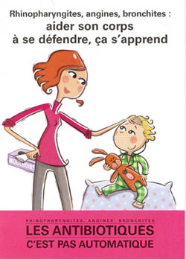
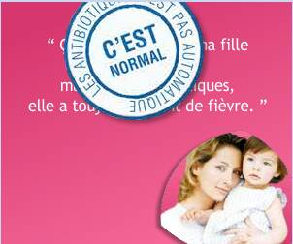

Figure 1: Use of mass media in France.

Adapted from: Goossens H, Guillemot D, Ferech M, Schlemmer B, Costers M, van Breda M, Baker LJ, Cars O, Davey PG. National campaigns to improve antibiotic use. Eur J Clin Pharmacol. 2006 May;62(5):373-379.
Q & As
  - What was the behavioural objective/s in this campaign?

  - Who was the target audience in this campaign?

  - Is there any evidence, in your view, that the principles of the marketing mix were used in the planning of this campaign? Use the table below for your answers.
Target audience/s | Product | Price | Place | Promotion
Target audience/s | Product | Price | Place | Promotion
  - Through what channels was the audience reached?

Case study two
“A hospital intervention”
Description
A 600-bed tertiary referral centre used an antimicrobial working team consisting of representatives from pharmacy, microbiology and infectious disease departments to develop, implement and evaluate guidelines for appropriate use of antimicrobials. They carried out several activities to do so, including, the development and promotion of a restricted antimicrobial policy, and specific guidelines for the management of pneumonia, surgical prophylaxis and wound infection. The guidelines were made available on the hospital’s intranet, on hard copies in all wards, and on laminated cards attached to hospital identification tags. Active promotion of the guidelines was carried out at orientation and via a two-week intensive period four times a year (corresponding to the registrar rotation), weekly meetings and follow-up of non-compliance courses directly with the attending medical officer. Education and feedback to specific groups was provided as required. Other projects included a campaign to encourage oral antibiotics where indicated. To promote this change, posters and postcards were distributed to individual doctors and bright orange stickers were placed in the medical records of patients on intravenous antibiotics. Regular drug utilisation evaluations were undertaken to measure outcomes, along with other indicators of antibiotic use such as the prevalence of antimicrobial resistance. Moreover, regular reviewing and updating of antibiotic guidelines was carried out to ensure their relevance.
Since the start of the intervention to promote adequate use of antimicrobials in this hospital, the prevalence of certain organisms associated with healthcare-acquired infections dropped. As a matter of fact, between 1997 and 2000, healthcare-acquired Clostridium difficile infection rate fell from 9.8 cases per 105 patient days to 4.0 cases per 105 patient days.
Adapted from: Tiley SM, MacDonald JJ, Doherty PL, Ferguson JK, Fergusson JE. Active promotion of antibiotic guidelines: an intensive programme. Commun Dis Intell Q Rep. 2003;27(Suppl):S13-18.

Q & As
- What was the behavioural objective/s in this intervention?

- Who was the target audience in this campaign?

- Is there any evidence, in your view, that the principles of the marketing mix were used in the planning of this campaign? Please use the table below for your answers.
Target audience/s | Product | Price | Place | Promotion
- Through what channels was the audience reached?

Case study three
“Maximising media coverage”
Description
Penicillin-non-susceptible pneumococci in Iceland were first detected in 1988, spreading rapidly in a five year period to reach an incidence of 20% by 1993. This rise was not expected due to the high restrictions in antimicrobial use since they could only be obtained on prescription. Additionally, this rise was observed during a time when penicillin-non-susceptible pneumococci were low in northern European settings.
In order to stop the development of pneumococcal resistance, Icelandic authorities realised the need of identifying the risk factors contributing to this problem. However, these were not completely understood, showing the need for research in the area. Consequently, the most important risk factors for antimicrobial resistance in Iceland were reported to be: (i) young age, (ii) antimicrobial use, and (iii) day care centre attendance.
Intervention measures to reduce the overuse of antimicrobials were initiated in 1991 and continued till 1997. They were not introduced in an orderly fashion, nor were they overseen by an official body; they were mainly carried out by key opinion leaders, especially in clinical microbiology, infectious diseases, general practice and paediatrics. Interventions focused on the overuse of antimicrobials in children. Since almost everyone in Iceland had access to a TV and/or radio and newspapers were bought by most households at the time, messages were conveyed via television, radio and newspaper interviews, as well as through articles in the Icelandic Medical Journal, and at medical meetings and conferences. Moreover, doctors were urged to attend medical meetings, not to prescribe antibiotics for viral infections, and to give antibiotics less frequently for otitis media, sinusitis and bronchitis in children. New prescribing guidelines were formulated for general practitioners, and the issue of prudent antibiotic use was discussed in numerous meetings and in the Icelandic Medical Association.
The rapid rise in the incidence of resistant pneumococci and an increase in the number of hospital admissions in young children needing parenteral antibiotics for otitis media attracted the media’s attention. This was used to notify the public that antibiotics are not always helpful and may sometimes be harmful. Infection control interventions were mainly applied to infected patients in hospitals, especially in wards treating patients with chronic lung diseases. Infected patients were moved to single or isolation rooms.
The general impression of Icelandic doctors was that the media propaganda changed parents’ attitudes towards antibiotics. Instead of demanding antibiotics when their children had an upper respiratory tract infection, they began questioning doctors who decided to prescribe antibiotics. Moreover, a telephone survey of 524 parents of young children showed that 98.9% agreed that overuse of antibiotics can lead to reduced efficacy of the drugs. Antimicrobial use has been declining in Iceland since 1991.
Adapted from: Kristinsson KG. Modification of prescribers’ behavior: the Icelandic approach. Clin Microbiol Infect. 1999 Aug;5 (Suppl 4):S43-47.
Q & As
- What was the behavioural objective/s in this intervention?

- Who was the target audience in this intervention?

- Is there any evidence, in your view, that the principles of the marketing mix were used in the planning of this campaign? Please use the table below for your answers.
Target audience/s | Product | Price | Place | Promotion

- Through what channels was the audience reached?

- Finally, carry out a SWOT analysis of the intervention. Use the table below for your answers.

 | Strengths |  | Weaknesses
Opportunities
Threats

Case study four
“Political support and commitment”
Description
In 2011, a local campaign was launched in Asturias, Spain, which ran in parallel to the national campaign. In a press conference, the President of the Asturian Pharmacists Professional Association presented the campaign, ”Antibioticos? Solo los necesarios” (”Antibiotics? Only the necessary”), with the participation of 500 Asturian pharmacies that wished to promote the rational use of prescribed antibiotics.
This initiative was started simultaneously with the European Antibiotics Awareness Day celebrated on November 18th, which is supported by all pharmacists as public health providers and takes the opportunity of direct contact with users to guarantee informed treatment. This is not the first time this campaign took place. According to data from the Eurobarometer, in the previous five years, the request of antibiotics without prescription decreased from 30% to 3%.
The Asturian Pharmacists Professional Association prepared 500 posters and 20,000 diptychs with the basic indications for the rational use of antibiotics. They explained that antibiotics are only efficacious against bacterial infections and are therefore not useful against colds, flu and sore throats. It was also emphasised that only a doctor or a dentist can prescribe antibiotics and that self-medication is not recommended. It was also said that it is fundamental to complete the treatment, otherwise it can promote relapses and increase antibiotic resistance.
The President of the Asturian Pharmacists Professional Association indicated the importance of pharmacists’ participation in health promotion activities, disease prevention and early detection of specific conditions, such as HIV. This was supported by the General Director of the Asturian Public Health Office, who also guaranteed political support in the campaign.

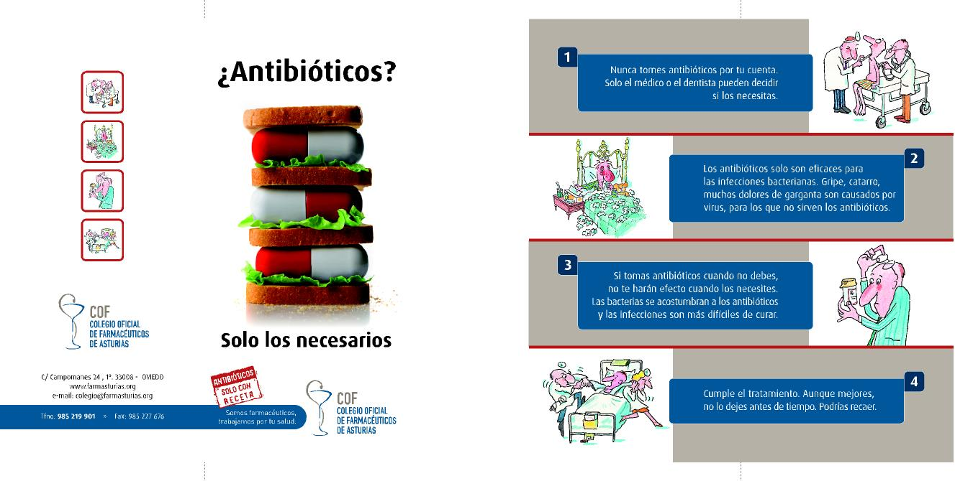

Figure 1: Tools used in the local campaign.

Adapted from:
- Europa press. Europa press. [internet] 2012 [cited 2012 Oct 8]. Available from: http://www.europapress.es/
- Colegio Oficial de Farmacéuticos de Asturias. Consejos de Salud. [internet]. 2012 [cited 2012 Oct 8]. Available from: http://www.farmasturias.org/GESCOF/cms/contenidos/contenido.asp?id=173&IdMenu=119
Q & As
- Discuss the involvement of stakeholders in this campaign. Were they relevant/important? Do you think that there could have been any conflicts of interest?

- Discuss the importance of political commitment in antibiotic campaigns.

Case study five
“An alternate strategy”
Description
In the early 1990s, increasing antibiotic use and the detection of resistant pneumococcal clones among young children, alarmed medics and medical authorities in Sweden. This prompted a coordinated effort to prevent further spread. As a result, in 1994, a national organisation called Strama (Swedish Strategic Programme for the Rational Use of Antimicrobial Agents and Surveillance of Resistance) was founded, coming into action in 1995, to provide surveillance of antibiotic use and resistance, and to implement the rational use of antibiotics and development of novel knowledge. The overall aim of Strama is to maintain the effectiveness of antimicrobial agents and although Strama initially targeted pneumococcal resistance in the community, the programme has since expanded and today includes activities within many fields including, primary and hospital care, nursing homes and day care centres. Since 2000, Strama has been receiving financial support from the Swedish government.
Strama is structured into national and regional groups. The national group’s main objectives are to organise activities, including trend analysis in antibiotic resistance and consumption, identification of knowledge gaps and studies to fill these gaps, and priority setting for interventions to inhibit antibiotic resistance at national level. A committee meets monthly (approximately) with the role of working out yearly action plans, coordinating activities, and supporting regional Strama groups. Since 1998, a public website has been made available which is regularly updated on regional and national data on antibiotic use and resistance, treatment guidelines, and results from Strama-funded projects and local activities of the local regional groups. Moreover, an annual national meeting together with all regional Strama group and other interested parties is held, where updates on antibiotic resistance, annual statistics on antibiotic use and resistance, and results and analysis of studies, interventions, and educational programmes are discussed.
The regional groups are often led by the county medical officer for communicable disease control, and they monitor regional antibiotic use and resistance, and distribute knowledge and locally-adapted guidelines on the prevention and treatment of infections to healthcare professionals. They also work in close collaboration with the regional drug and therapeutics committees.
Below are the results of interventions led by Strama and their outcomes:
Antibiotics use and their indications for use
Between 1995 and 2004, antibiotic use for outpatients in Sweden decreased from 15.7 to 12.6 defined daily doses (DDD) per 1,000 inhabitants per day and from 536 to 410 prescriptions per 1,000 inhabitants per year. The reduction was most noticeable in children aged 5-14 years (52%) and for macrolides (65%). During this period, the number of hospital admissions for acute mastoiditis, rhinosinusitis, and quinsy (peritonsillar abscess) was stable or declining. Even though the epidemic spread in southern Sweden of penicillin-resistant Streptococcus pneumoniae was restrained, the national frequency increased from 4-6%. However, during this period, resistance in most other bacterial species remained low.
Although, the distribution of antibiotic sales data (especially geographical variation) has drawn a lot of attention and interest, such data excludes indications on antibiotic use and thus cannot be used to assess the quality of antibiotic prescribing. As a result, Strama began numerous large-scale surveys on the indications of antibiotic prescriptions.
Antibiotic resistance
Since 1994, laboratories around Sweden have collected quantitative antibiotic susceptibility data (zone diameters) for specific antibiotics in a minimum of 100 consecutive clinical isolates of 6 bacterial species annually. The data are entered into an internet-based software programme which allows annual monitoring at national level of resistance among clinical isolates of S. pneumoniae, S. aureus, P. aeruginosa, H. influenzae, S. pyogenes, and E. coli.
In 1999, a national programme was initiated in intensive care units (ICUs) in order to raise awareness of antibiotic resistance and infection control problems among ICU doctors (ICU-Strama). This surveillance programme has shown low prevalence of antibiotic-resistant S. aureus (MRSA), E. coli, and Klebsiella spp., despite high antibiotic consumption. However, experience from other countries and ICUs shows that the situation can quickly change, therefore continuous surveillance is necessary to design interventions in antibiotic policy or hygiene procedures when needed.
Infection control
Since the 1970s, the use of alcohol hand rub rather than soap has been recommended for hand disinfection between patient visits. Sweden has been one of few countries with less than 1% resistance to methicillin among invasive isolates of S. aureus. However, recent spread of MRSA in a few Swedish hospitals has highlighted the need for increasing activities in the infection control arena. Between 1997 and 2000, there was the largest Swedish outbreak of an endemic strain of MRSA (EMRSA-16) at a hospital in Gothenburg. The outbreak was successfully terminated by use of aggressive infection-control measures and a large high-cost sampling programme. What was learnt from this outbreak was that the measures taken were cost-effective and that the previously recommended barrier precautions, which were implemented when identifying new carriers of MRSA, were often introduced too late to be able to inhibit an outbreak. In an effort to be one step ahead of MRSA spread, uniform use of basic hygiene precautions was introduced during the outbreak, which applied to all patients and staff and included banning the use of private clothes and wearing rings, bracelets and watches at work. A dress code was also introduced which enforced that all healthcare workers wear short sleeves. Also, use of alcohol hand rub before and after every patient contact and the use of gowns with every close patient contact, were recommended. In addition, Strama initiated the formation of a national expert group on hygiene and infection control to record relevant areas for future actions and interventions.
In 2000, the National Board of Health and Welfare, in close cooperation with Strama, prepared a national action plan to contain antibiotic resistance in Sweden and the objectives of this plan are being used when developing annual work plans for Strama activities. Also in 2000, new national guidelines were established for the treatment of acute otitis media, acute pharyngotonsillitis and impetigo in 2002, and for acute sinusitis in 2005. The guidelines for the treatment of urinary tract infections were updated in 2006, and new guidelines for lower respiratory tract infections were issued in 2008.
The Strama project was designed to be an on-going coordinated national effort to decrease antibiotic use and spread of resistance, not to be scientifically evaluated. Although no coordinated public campaign has been launched in Sweden, as in other European countries, regular collaboration with news media, both national and regional, has been one of Strama’s priorities; this multidisciplinary, coordinated programme has shown to have contributed to the reduction of antibiotic use without measurable negative consequences. Indeed, discussion in the public media probably led to a substantial contribution to the decrease in antibiotic use in the year prior to Strama’s formal launch.
Adapted from: Mölstad S, Erntell M, Hanberger H, Melander E, Norman C, Skoog G, Lundborg CS, Söderström A, Torell E, Cars O. Sustained reduction of antibiotic use and low bacterial resistance: 10-year follow-up of the Swedish Strama programme. Lancet Infect Dis. 2008 Feb;8(2):125-132.

Q & As
- Describe the role of networks and partnerships in this intervention. How does one engage partners and organise networks? How does one gain political support?

- How was the sustainability of this large-scale intervention maintained throughout the years?

- What evaluation methods did they use?

- What is your opinion on the strategy employed by Swedish authorities and the Strama group?

Case study six
“Don’t do it yourself!”
Description
Part 1
In a survey carried out in 2002 in Spain, it was shown that, two out of three citizens consume antibiotics every day. Consequentially, in 2002, Spain conducted its second national campaign entitled, “Con los antibióticos no se juega” (“Don’t play with antibiotics”). It was a joint activity between the Ministries of Health, the pharmaceutical industry and the Professional Associations of Physicians and Pharmacists of Spain. The main objective for this campaign was to stop the irrational use of antibiotics through information and education, focusing mainly on self-medication and non-compliance.
In order to better comprehend the true situation of antibiotic consumption in Spain, the campaign organisers conducted a national survey on antibiotic consumption, exploring users’ attitudes, behaviour and beliefs. The survey demonstrated that self-medication was practiced by 10.9% of the population and that 10% did not comply with treatment. Previous studies reported a self-medication prevalence of 32% whereas non-compliance was between 42-61%. According to experts, this decrease in the figures was attributed to the impact of informative campaigns.
Adapted from: Ripoll Lozano MÁ. Con los antibióticos no se juega. Medicina General. 2002;42:167-168.

Q & As
- Who were the stakeholders involved in this campaign?

- How does one engage stakeholders and develop partnerships for campaign development? Please give suggestions.

Part 2
Among the cases of self-medication, 40% acquired antibiotics from their medicine cabinet at home whilst 59% acquired them from pharmacies. The main reasons for this practice were, knowledge of treatment based on previous prescriptions (50%), inability to go for a consultation (22%) and familiarity with the product (16%). On the other hand, causes for non-compliance were improvement of symptoms (75%) and side effects (8%). Most participants (58%), especially young citizens, affirmed that they used antibiotics for colds and flu. Thirteen percent considered that antibiotic prescription is only needed in severe cases and 25% thought that prescriptions are not needed at all for antibiotic dispensation.
Adapted from: Ripoll Lozano MÁ. Con los antibióticos no se juega. Medicina General. 2002;42:167-168.

Q & As
- What do you think were the competing behaviours in this population group?

- Can you suggest how one could conduct a competitive analysis to change these behaviours?

- How would you address these challenging behaviours if you were the head of the committee organising the intervention?

Part 3
The campaign lasted three months (February to April), during which several dissemination and informative activities took place. For example, information counters were placed in healthcare centres to inform the general population. Pamphlets with information explaining the consequences of non-compliance and self-medication, promoting the use of prescribed antibiotics, encouraging the public to consult a healthcare provider when in doubt of treatment, and explaining the differences between bacteria and viruses, were distributed.
Some of the messages targeted towards the general public were: If you take antibiotics when you do not need them: (i) they will not have any effect when you need them, (ii) the bacteria will get used to the antibiotic and will become resistant, and (iii) the antibiotics’ efficacy decreases and the infections are more difficult to treat.
Another leaflet was also made, aimed towards healthcare professionals (doctors and pharmacists), focusing on the problem of antibiotic resistance. It motivated them to actively promote the rational use of antibiotics by: (i) convincing the patient when visiting the clinic to complete treatment and follow the indications in order to avoid the consequences of irrational use, (ii) informing the patient when visiting the pharmacy about the importance of completing treatment and reminding them of the correct doses/instructions for treatment, and (iii) using empiric treatment only when strictly needed and requesting cultures and antibiograms while in hospital.
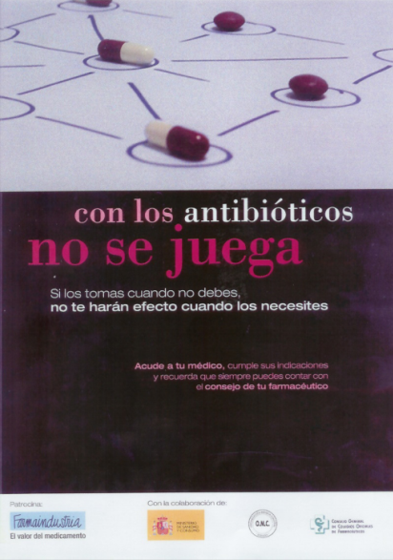

Figure 1: The poster used in the campaign.

Adapted from: Ripoll Lozano MÁ. Con los antibióticos no se juega. Medicina General. 2002;42:167-168.

Q & As
- Suggest how the campaign messages and materials could have been pilot tested.

Case study seven
“Going big”
Description
Part 1
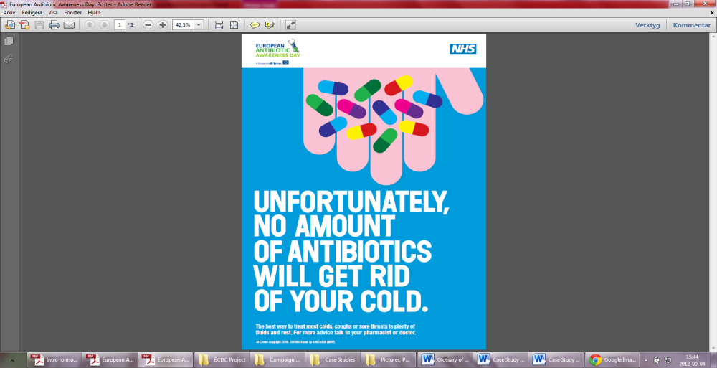
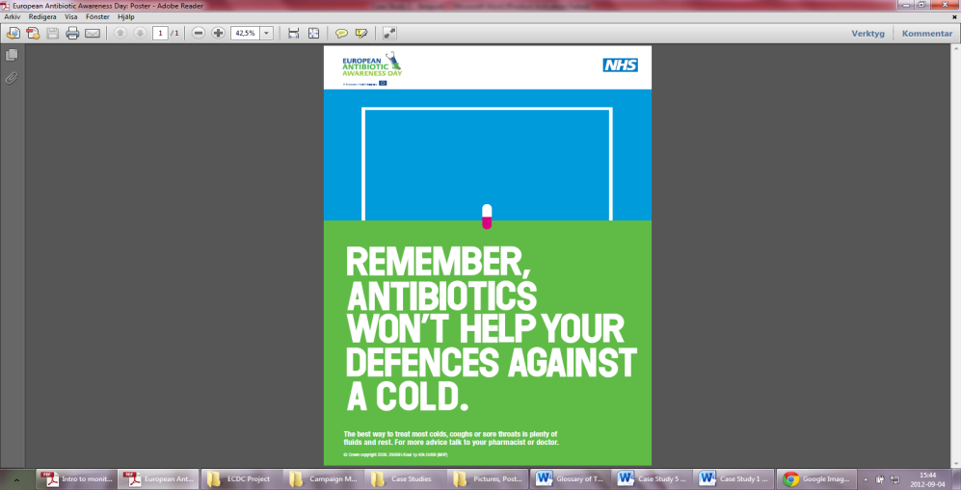
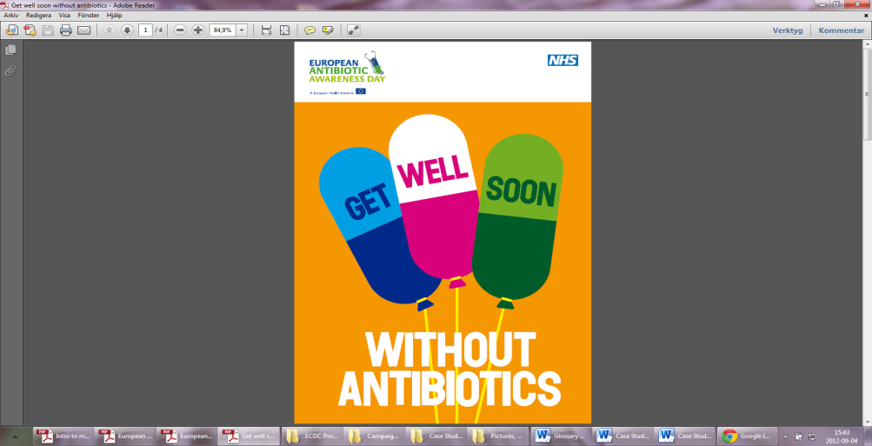
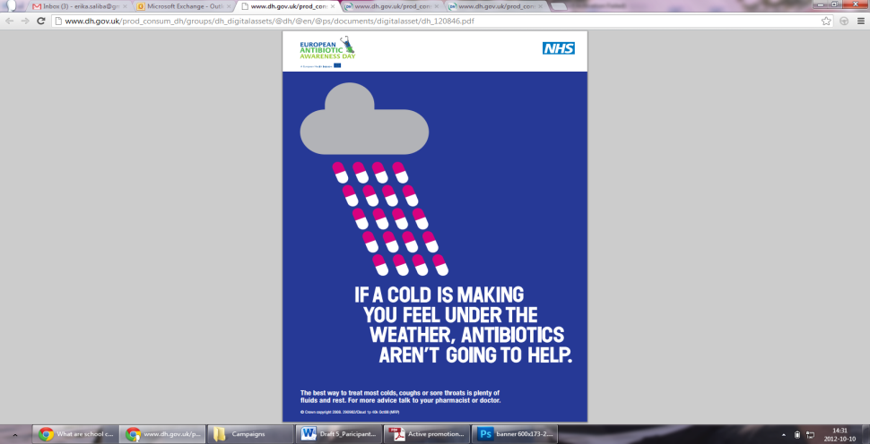
In 2008, it was highlighted by the European Health Council that antimicrobial resistance was still an augmenting health problem leading to increased morbidity and mortality, in addition to higher healthcare costs. Consequently, England, similar to other European countries, has conducted campaigns to encourage the general public to demand fewer antibiotics. In February of 2008, England launched a nation-wide campaign targeting antibiotic resistance, featuring three posters displayed in magazines and newspapers. The key message was, “The best way to treat most colds, coughs or sore throats is plenty of fluids and rest. For advice talk to your pharmacist or doctor”. A copy of the posters and some copies of an A5 patient advice leaflet (given to patients instead of antibiotic prescriptions) were sent, by post, to English (not Scottish) general practice surgeries and independent pharmacies. An accompanying letter from the Inspector of Microbiology and the Chief Pharmaceutical Officer indicated that extra copies could be ordered free of charge via phone, fax or from the order line website. A copy of this letter was also sent electronically to acute hospital trusts and health promotion units. When in November 2008, the European Union launched its first annual European Antibiotic Awareness Day (EAAD), England and Scotland participated and the English Department of Health repeated the February 2008 campaign in exactly the same way the following November, simply adding the EAAD logo to all materials.

Figure 1: The leaflet (first picture on the left) and three posters used in the UK campaign.
In July 2008, the National Institute for Health and Clinical Excellence published guidelines on the primary care management of common, acute, self-limiting, respiratory tract infections (RTIs). It was recommended that general practitioners should agree to a ‘no antibiotic prescribing strategy’ or a ‘delayed antibiotic prescribing strategy’ for patients with RTIs, and that they should advise patients about the natural course of the illness, the lack of importance of antibiotics and their side effects, and how to manage symptoms using other medications.
Adapted from: McNulty CAM, Nichols T, Boyle P, Woodhead M, Davey P. The English antibiotic awareness campaigns: did they change the public’s knowledge of and attitudes to antibiotic use. J Antimicrob Chemother. 2010;65(7):1526-1533.
Q & As
- What was the behavioural objective/s in this campaign?

- Who was the target audience in this campaign?

- Is there any evidence, in your view, that the principles of the marketing mix were used in the planning of this campaign? Please use the table below for your answers.
Target audience/s | Product | Price | Place | Promotion
- Through what channels was the audience reached?

Part 2
A large before and after household survey done through telephone interviews, was carried out in both England and Scotland just before the start of the first antibiotic campaign in February of 2008 and then again the following year. The aim was to determine the effects of the 2008 public antibiotic campaigns on the public’s knowledge, attitudes and behaviour with respect to antibiotic use and to determine whether there were any differences between patient groups in the English and the Scottish settings. The first sample in January 2008 consisted of 1888 adults (1706 in England and 182 in Scotland) and 1830 adults the subsequent year (1707 in England and 123 in Scotland).
The results showed little evidence that the 2008 campaign had a positive effect. No improvement was detected in either England or Scotland, or any difference between England and Scotland in the public understanding of the lack of benefit of antibiotics for coughs and colds. They did not detect any improvement in the reported use of antibiotics in both England and Scotland either. There was a small but significant increase in public recall of the campaign posters (mostly the ‘hand’ poster) in England, but the increase was only 2.3% greater than the increase in Scotland. Moreover, an increase in the retention of leftover antibiotics was seen from 2008-2009. Also, English respondents were significantly more likely to disagree with the statement, “Resistance to antibiotics is a problem in British hospitals” in 2009 than in 2008. However, it was noted that patient-based interventions were in fact being used in general practice; 0.20% of all participants recalled discussing antibiotics with their general practitioner or nurse in the period from 2008 to 2009. Advice for delayed antibiotic prescription in 2009 was reported significantly more often by English than by Scottish participants and English participants received more advice from healthcare providers regarding appropriate treatment of colds and flu in 2009 than in 2008.
Adapted from: McNulty CAM, Nichols T, Boyle P, Woodhead M, Davey P. The English antibiotic awareness campaigns: did they change the public’s knowledge of and attitudes to antibiotic use. J Antimicrob Chemother. 2010;65(7):1526-1533.
Q & As
- In your opinion, what were the main specific barriers and benefits to reach the final intended audience of the campaign?
Target audience | Barriers | Benefits
- How (design, method/s and outcome variable/s) was the success/failure of the intervention measured? Would you have evaluated it differently? If so, how?

- Identify and/or develop key indicators as well as data collection methods and tools that could be used to evaluate the given campaign.

Key activities | Specific objectives | Key indicators |  | Data collection methods/tools
 |  | Process | Outcome

- In your view, what were the strengths of this campaign?

- What do you think were the weaknesses of this campaign? What do you think could have been improved and how? Keeping the social marketing principles in mind, what would you have done differently in order to improve the campaign in your given scenario? Please discuss and write down your own suggestions.

- What were the desired/intended outcomes of the campaign and were they reached? Were there any unintended outcomes?

Case study eight
“Involving actors for change”
Description
In 1998, Belgium had the second highest rate of antibiotic consumption in the community in Europe. Consequently, in November 2000, the Belgian Antibiotic Policy Co-ordination Committee launched nation-wide campaigns promoting rational use of antibiotics in the community with a budget of €400,000. Their goals were to: (i) provide the general public with a better understanding of the natural course of infections such as the common cold, acute bronchitis and influenza, (ii) explain when antibiotics are needed, (iii) underline the consequences of the emergence of resistance to antibiotics, and (iv) facilitate patient-doctor and patient-pharmacist discussion on the appropriate use of antibiotics. The three successive, three-month long annual campaigns targeted both the public and prescribers during winter (November to February). The three main messages were: “Use antibiotics less frequently but better”, “Save antibiotics, they may save your life”, and “Talk to you doctor, talk to your pharmacist”. The public was targeted via television, radio, posters, brochures and information folders. General practitioners (GPs), paediatricians, pneumonologists, ear nose and throat specialists and community pharmacists received personal letters together with campaign materials for patients.
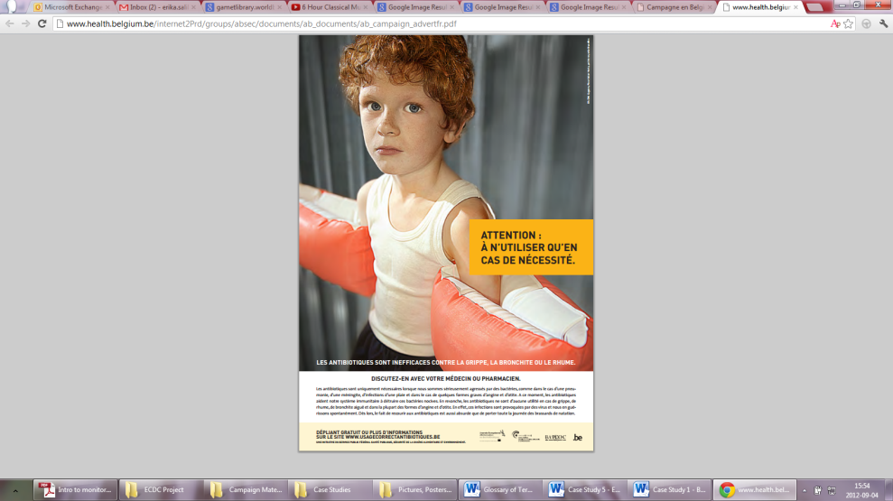
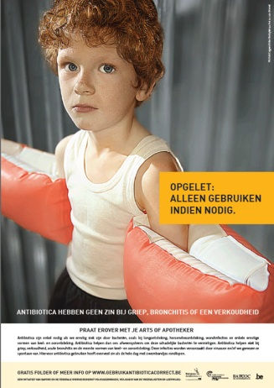

Figure 1: In the nation-wide campaign, posters were distributed both in Flemish and in French.

The impact of the first two campaigns was evaluated through: (i) pre- and post- campaign face-to-face interviews with the general public, with good representation of the national population in terms of age, socioeconomic status, region and geographical area, and (ii) post-campaign surveys with GPs.
The post-campaign survey, which was carried out 1-2.5 months after the end of the first campaign, showed that, 46% of the public recalled the campaign (79% through television, 17% through newspapers and 14% through radio). The first campaign also had high visibility for GPs (100%), was given positive feedback and shifted opinion in favour of using antibiotics more carefully (75% public; 63% GPs). Expectations for antibiotics also decreased significantly (p<0.05) for acute bronchitis, flu, sore-throat, common cold and diarrhoea. To assess the campaign’s effectiveness, a statistical time-series analysis, controlled for the influence of seasonal variation of influenza-like illness in 2000-2001 and 2001-2002, as compared to previous years, was carried out in a separate study. Antibiotic reimbursement data between 1997 and 2003 expressed in defined daily doses, and antibiotic packages, shows a decline in antibiotic use in the community since 2000.
Adapted from:
- Goossens H, Coenen S, Costers M, De Corte S, De Sutter A, Gordts B, Laurier L, Struelens M. Achievements of the Belgian Antibiotic Policy Coordination Committee (BAPCOC). Euro Surveill. 2008 Nov 13;13(46):pii 19036.
- Goossens H, Guillemot D, Ferech M, Schlemmer B, Costers M, van Breda M, Baker LJ, Cars O, Davey PG. National campaigns to improve antibiotic use. Eur J Clin Pharmacol. 2006 May;62(5):373-379.

Q & As
- What was the behavioural objective/s in this campaign?

- Who was the target audience in this campaign?

- Is there any evidence, in your view, that the principles of the marketing mix were used in the planning of this campaign? Use the marketing mix score matrix* below to assess to which degree you think the social marketing principles were applied, described or addressed.
Product | Price  (benefits/barriers) | Place | Promotion
……………………………………………………………………………………………………………
* Each principle must be marked from a scale of 1-10, with 10 representing “a strong application, description or addressing of the principle” and 1 corresponding to “weak application, description or addressing of the principle”.

- Through what channels was the audience reached?

- What/Who do you think were the main competitors in this campaign?

- In your opinion, what were the main specific barriers and benefits to reach the final intended audience of the campaign?
Target audience | Barriers | Benefits
Target audience | Barriers | Benefits
- How (design, method/s and outcome variable/s) was the success/failure of the intervention measured? Would you have evaluated it differently? If so, how?

- Identify and/or develop key indicators as well as appropriate data collection methods and tools that could be used to evaluate the given campaign.
Key activities | Specific objectives | Key indicators |  | Data collection methods/tools
 |  | Process | Outcome

Key activities | Specific objectives | Key indicators |  | Data collection methods/tools
 |  | Process | Outcome

- In your view, what were the strengths of this campaign?

- What do you think were the weaknesses of this campaign? What do you think could have been improved and how? Keeping the social marketing principles in mind, what would you have done differently in order to improve the campaign in your given scenario? Please discuss and write down your own suggestions.

- What were the desired/intended outcomes of the campaign and were they reached? Were there any unintended outcomes?

Case study nine
“Knowing your audience”
Description
Part 1
With the realisation of excess antibiotic use in ambulatory care and the rapid rise in antibiotic resistance in community-acquired bacterial pathogens, a controlled trial of the impact of a mass media campaign to reduce community-level antibiotic use was conducted. The mass media campaign was delivered in Denver, Colorado, a large city of around 2.2 million inhabitants, and targeted young children and primary care doctors. The results of the campaign were then compared to Colorado Springs, a city located 100kms away with a population of around 550,000 people with similar demographic distribution to the intervention city, but with entirely separate TV, radio and newspaper organisations. The campaign was launched in November 2002 and media events were planned for each month up until February, 2003.
The strategy for the campaign included: out-of-home advertising, mass media events and the initiation of community advocacy. Some of the mass media included: billboards (n=5), posters on the outside of buses (n=40), bus stop posters (n=20), signs in interior of buses (n=150), and radio spots (n=60). In addition, airing (n=112) was also done in Spanish (the second main language spoken in the area) free of cost by a local Spanish network. The cost of the purchased advertising space and public relations services in 2002 was approximately $88,500 for the four-month intervention.
The campaign messages and dissemination strategy were developed following focus groups, interviews and surveys, held both in English and Spanish, and conducted by the investigators in collaboration with advertising/marketing and public relations companies and through consultation with social marketing experts. In the early design phase of the mass media campaign, two focus groups (N=16) were held addressing the message concept options for the mass media materials. Later, two groups were held in with English speakers (N=26) and four groups with Spanish-speaking Latinos (N=27) to place their input on logo options and specific message and phrases for the campaign.
Ultimately, the underlying key messages for the English speakers were determined to be: (i) Our antibiotics are becoming less effective and it’s a serious public health issue, (ii) Taking antibiotics today when you don’t need them means they may not work in the future when you really do need them, and (iii) You don’t need antibiotics every time you get sick. Ask your healthcare provider to be sure. The key slogan for the English language campaign was “Get smart: use antibiotics wisely”. Simple translation of the campaign’s slogan to Spanish was determined to be misleading and would rather be interpreted as an approval of self-medication. Consequently, the slogan was altered slightly to read, “Use antibióticos solo si un doctor se lo receta” (“Use antibiotics only if a doctor prescribes them”) instead.
Monthly earned media events for the “Get smart Colorado” campaign included: designation of “Antibiotic Awareness Week” by the city council, Winter Health Fairs (n=2), and “Antibiotics Amnesty Month”, an initiative which encouraged people to return leftover antibiotics to their local pharmacies. An opinion article was also published in a prominent local newspaper during this period. Doctor advocacy activities enhanced the paid advertising campaign by utilising the same logos, messages and materials in doctors’ offices. Primary care doctors (n=1167) were sent a postcard asking for their support (by signing and returning the postcard) in the campaign. Office materials posted to requesting doctors included: waiting and examination room posters on appropriate antibiotic use for pharyngitis and bronchitis, patient brochures relating to appropriate antibiotic use and antibiotic resistance, and stethoscope clips with the campaign’s logo. The estimated cost of materials and staff support for the earned media activities in 2002 was about $30,000.
Adapted from: Gonzales R, Corbett KK, Wong S, Glazner JE, Deas A, Leeman-Castillo B, Maselli JH, Sebert-Kuhlmann A, Wigton RS, Flores E, Kafadar K. Get smart Colorado: impact of a mass media campaign to improve community antibiotic use. Med Care. 2008 Jun;46(6):597-605.

Q & As
- What was the behavioural objective/s in this campaign?

- Who was the target audience in this campaign?

- Is there any evidence, in your view, that the principles of the marketing mix were used in the planning of this campaign? Use the marketing mix score matrix* below to assess to which degree you think the social marketing principles were applied, described or addressed.
Product | Price  (benefits/barriers) | Place | Promotion
……………………………………………………………………………………………………………
* Each principle must be marked from a scale of 1-10, with 10 representing “a strong application, description or addressing of the principle” and 1 corresponding to “weak application, description or addressing of the principle”.
- Through what channels was the audience reached?

- What/Who do you think were the main competitors in this campaign?

- Describe how the tools for this campaign were pre-tested.

- Discuss the importance of formative evaluation before implementing campaigns.

- In your opinion, what were the main specific barriers and benefits to reach the final intended audience of the campaign?
Target audience | Barriers | Benefits
Part 2
In order to determine whether residents of the intervention community were exposed to appropriate antibiotic use messages to a greater extent than the control community, cross-sectional, random-digit-dialled telephone surveys of adults residing in the intervention and control communities were conducted in both languages. Telephone surveys were conducted during a pre-baseline winter period (October-November, 2001), the baseline winter period (January-March, 2002) and the intervention winter period (February 7 to March 10, 2003). Community-level antibiotic dispensing data from retail pharmacies (about 89% of all pharmacies in the area) for 2002 and 2003 was also collected. Ambulatory doctor office visits, emergency department visits, and antibiotic prescription rates were based on administrative claims. Since the mass media campaign materials’ emphasis was on the appropriate use of antibiotics for acute respiratory tract infections, these ambulatory visits were separated from non-acute respiratory tract infection visits.
During the campaign, survey respondents residing in the intervention community reported seeing or hearing ads or news on the campaign more than the control community (51% vs. 39%). Similarly, among respondents visiting a doctor’s office during the campaign, 43% of those living in the intervention community reported seeing materials related to the consequences of antibiotic overuse, versus 24% in the control community. The frequency of seeing or hearing ads or news about antibiotic resistance during the intervention phase did not vary between the groups.
In 2002, retail pharmacies dispensed 1.08 million antibiotic prescriptions in the intervention community versus 0.28 million in the control group. Following the campaign, the rate of antibiotic prescribing declined in both groups. The net difference in monthly antibiotic prescription rates between the intervention and control groups decreased sharply and incrementally within the five months following the launch of the mass media campaign. Most of the change in antibiotic prescription rates for the mass media versus the comparison communities occurred among paediatric patients (<18 years). After the mass media campaign, office visit rates, primarily for acute respiratory tract infection among pediatric patients residing in the intervention community declined in relation to visit rates among those residing in control group. No major change was seen in adult visit rates after the campaign.
Adapted from: Gonzales R, Corbett KK, Wong S, Glazner JE, Deas A, Leeman-Castillo B, Maselli JH, Sebert-Kuhlmann A, Wigton RS, Flores E, Kafadar K. Get smart Colorado: impact of a mass media campaign to improve community antibiotic use. Med Care. 2008 Jun;46(6):597-605.

Q & As
- How (design, method/s and outcome variable/s) was the success/failure of the intervention measured? Would you have evaluated it differently? If so, how?

- Identify and/or develop key indicators as well as data collection methods and tools that could be used to evaluate the given campaign.

Key activities | Specific objectives | Key indicators |  | Data collection methods/tools
 |  | Process | Outcome

- In your view, what were the strengths of the campaign?

- What do you think were the weaknesses of the campaign? What do you think could have been improved and how? Keeping the social marketing principles in mind, what would you have done differently in order to improve the campaign in your given scenario? Please discuss and write down your own suggestions.

Case study ten
“Maximising a small budget”
Description
In a survey carried out by Eurobarometer before and after the 2009 European Antibiotic Awareness Day (EAAD) campaign indicated that, 55% of the Maltese population had taken antibiotics in the previous year (the second highest antibiotic consumption in Europe); 26% of respondents saying they took antibiotics for the flu and 31% for a sore throat. Furthermore, in 2002, it was shown that over-the-counter acquisition of antibiotics was up at 19%.
For almost a decade, the Maltese Health Department (and then the National Antibiotic Committee since its establishment in 2008) held several initiatives, mainly addressing non-prescribed use and over-the-counter dispensing of antibiotics. These were complemented by increased regulatory pressure on pharmacists to adhere to national legislation prohibiting the sale of antibiotics without a medical prescription. Due to lack of a financial budget, formal campaigns like those held in France and Belgium could not be achieved. Initiatives therefore relied heavily on maximising free media opportunities through participation in radio and television chat shows (primarily in the winter) as well as newspaper interviews and articles. With the launch of EAAD, some funds were put towards the campaign enabling the production of a small amount of promotional materials such as leaflets, posters and billboards. The billboards were erected in two heavily used roads in the country; the posters and leaflets were distributed to health centres, private doctors’ clinics as well as local councils. In total, two non-commercial posters with the slogan: “Saħħtek ibża’ għaliha, tabbużax mill-antibijotiċi” (“Take good care of your health, do not abuse of antibiotics”), were used throughout the month of November and one television spot was aired on the EAAD before the evening news report on the national television station. This used the ECDC hedgehog clip translated into Maltese. The main messages, in addition to the primary slogan, were, “Isalvaw il-ħajja imma jekk tabbuża minnhom, jistgħu jagħmlu ħsara lilek u lil ta’ madwarek” (“They save lives but if abused they can cause harm both to you and to those around you”) and “Tissikkax lit-tabib jew spiżjar biex jagħtik l-antibijotiċi” (“Do not put pressure on your doctor or pharmacist to give you antibiotics”). A press conference was also held on 17th November by the Parliamentary Secretary. The budget for the 2009 campaign was €3000, €4000 less than the previous year. The campaign was primarily targeted at the general population.
Formal evaluation of the impact of the campaign was not possible due to lack of resources. However, following the campaign, a Eurobarometer survey showed that dispensing of antibiotics over-the-counter had fallen to 4%. Nonetheless, knowledge on antibiotic function and use was low; only 10% of respondents got 4 out of 4 answers correct. Despite this, 94% of respondents knew that unnecessary use of antibiotics make them ineffective. With regards to retrieval of information, respondents believed that doctors are the most trustworthy source of information (95%). However, only 16% reported being told by a doctor about not taking antibiotics unnecessarily.
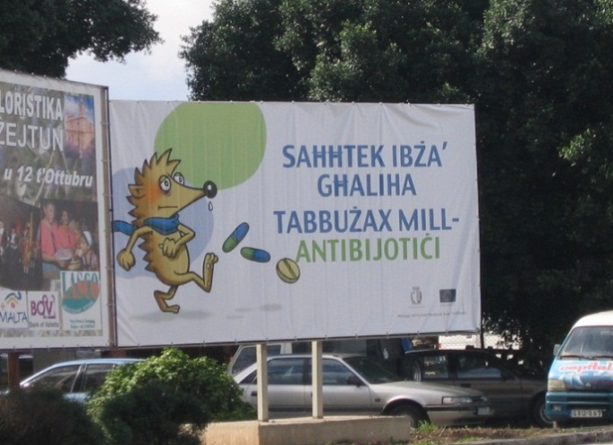
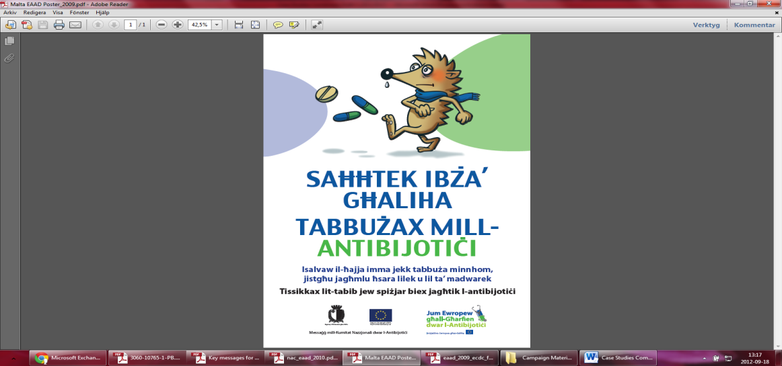

Figure 1: Posters and billboards distributed in the campaign.

Regarding the direct impact of campaign material, Eurobarometer showed that 34% of participants remembered receiving information about not taking antibiotics. The most effective means of delivery of information in the Maltese context appeared to be the media, with 30% remembering the television advertisement. However, overall it was shown that only 47% said that the information they received changed their views on antibiotics, although 88% stated that they will in future consult a doctor when they think that they need an antibiotic.
Adapted from:
- Borg MA, Scicluna EA. Over-the-counter acquisition of antibiotics in the Maltese general population. Int J Antimicrob Agents. 2002 Oct;20(4):253-257.
- Health, the Elderly and Community Care. National antibiotic committee. [internet]. 2012 [cited 2012 Oct 13]. Available from: https://ehealth.gov.mt/HealthPortal/others/regulatory_councils/national_antibiotic_committee/download_material.aspx
- National Antibiotic Committee. Annual report. [internet]. 2009 [cited 2012 Oct 15]. Available from: https://ehealth.gov.mt/HealthPortal/others/regulatory_councils/national_antibiotic_committee/download_material.aspx
- Special Eurobarometer 338. Antimicrobial resistance: report. Brussels: TNS Opinion & Social; 2010.

Q & As
- What was the behavioural objective/s in this campaign?

- Who was the target audience in this campaign?

- Is there any evidence, in your view, that the principles of the marketing mix were used in the planning of this campaign? Use the marketing mix score matrix* below to assess to which degree you think the social marketing principles were applied, described or addressed.
Product | Price  (benefits/barriers) | Place | Promotion
……………………………………………………………………………………………………………
* Each principle must be marked from a scale of 1-10, with 10 representing “a strong application, description or addressing of the principle” and 1 corresponding to “weak application, description or addressing of the principle”.
- Through what channels was the audience reached?

- In your opinion, what were the main barriers and benefits to reach the final intended audience of the campaign?
Target audience | Barriers | Benefits
Target audience | Barriers | Benefits
- Given the low budget (€3,000), a thorough evaluation of the campaign was not deemed feasible. Give suggestions on how a campaign with a tight budget can be effectively evaluated.

- Identify and/or develop key indicators as well as data collection methods and tools that could have been used to evaluate the given campaign.
Key activities | Specific objectives | Key indicators |  | Data collection methods/tools
 |  | Process | Outcome

- Given the low budget of €3,000, brainstorm and suggest alternative strategies for all phases of campaign development (planning, implementation and evaluation), that could be used when developing an antibiotic campaign on a small budget.

- In your view, what were the strengths of this campaign?

- What do you think were the weaknesses of this campaign? What do you think could have been improved and how? Keeping the social marketing principles in mind, what would you have done differently in order to improve the campaign in your given scenario? Please discuss and write down your own suggestions.

- Finally, carry out a SWOT analysis of the campaign. Use the table below for your answers.

 | Strengths |  | Weaknesses
Opportunities
Threats

Case study eleven
“A poster intervention”
Description
Research shows that 10-22% of children below the age of 18 years received antibiotics from their healthcare providers for common colds or upper respiratory tract infections. Given the extent of the problem, researchers attempted to test the efficacy of educational posters on antibiotic use as a single intervention in three private paediatric group practices belonging to a network of office practices, in Westchester County, New York. Seven doctors working at these clinics accepted to participate and share medical records with the research team.
The aim of study was to evaluate whether an educational poster placed in the reception area of a clinic would lead to a decrease in the frequency of antibiotic prescriptions for children with symptoms of respiratory illness. The study duration was one month and historical controls were also carried out. Children between 6 months and 10 years at time of visit were enrolled. Posters measuring 40cm x 56cm, were placed in the reception area of each clinic on December 1st, 2001 and provided short answers to the following questions: ‘What causes a runny nose during a cold?’, ‘How is a viral respiratory infection treated?’, ‘What are antibiotics and when are they needed?’ and ‘Why not take antibiotics now?’.
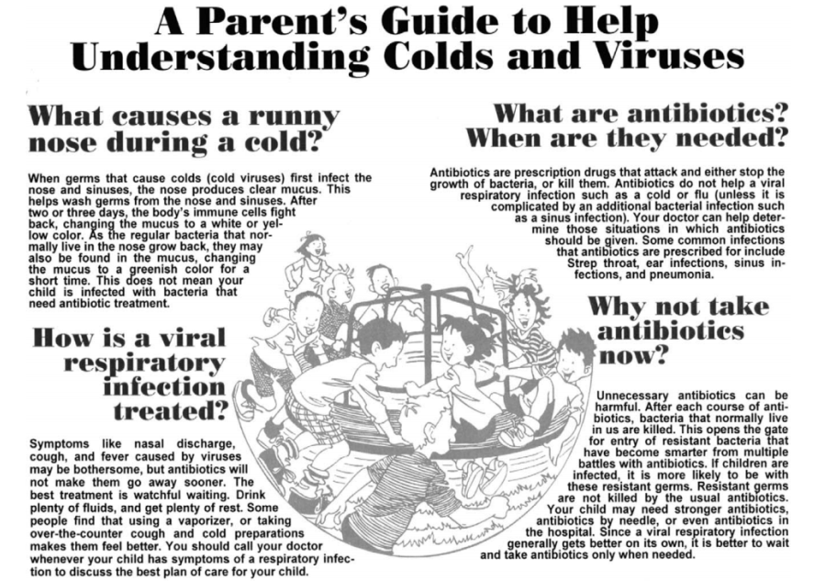

Figure 1: Poster placed in clinic reception areas.

Antibiotic prescription for children with respiratory illnesses during the study period were compared to those given during the three, one-month historical control periods (November 2000, December 2000 and November 2001), using the proportion of visits that resulted in an antibiotic prescription as the outcome measure. Out of the 720 participants (51.3% boys and 28.8% girls), mean age of 4.2 years, 45.2% were treated with an antibiotic. Multiple logistic regression showed no statistically significant difference in the proportion of visits resulting in an antibiotic prescription among the four study months (p=.79), suggesting that public education through a poster did not have a great impact on antibiotic use or a decrease in antibiotic prescriptions.
Adapted from: Ashe D, Patrick PA, Stempel MM, Shi Q, Brand DA. Educational posters to reduce antibiotic use. J Pediatr Health Care. 2006 May-June;20(3):192-197.

Q & As
- What was the behavioural objective/s in this campaign?

- Who was the target audience in this campaign?

- Is there any evidence, in your view, that the principles of the marketing mix were used in the planning of this campaign? Use the marketing mix score matrix* below to assess to which degree you think the social marketing principles were applied, described or addressed.
Product | Price  (benefits/barriers) | Place | Promotion
……………………………………………………………………………………………………………
* Each principle must be marked from a scale of 1-10, with 10 representing “a strong application, description or addressing of the principle” and 1 corresponding to “weak application, description or addressing of the principle”.
- Through what channels was the audience reached?

- How (design, method/s and outcome variable/s) was the success/failure of the intervention evaluated? Would you have evaluated it differently? If so, how?

- Identify and/or develop key indicators as well as data collection methods and tools that could be used to evaluate the given intervention.
Key activities | Specific objectives | Key indicators |  | Data collection methods/tools
 |  | Process | Outcome

- In your view, what were the strengths of this campaign?

- What do you think were the weaknesses of this campaign? What do you think could have been improved and how? Keeping the social marketing principles in mind, what would you have done differently in order to improve the campaign in your given scenario? Please discuss and write down your own suggestions.

- Take a look at the poster used in the intervention in Figure 1. Give your own comments and opinion about the layout, structure and messages of the tool shown. Below are a few hints which may help you.
- What strikes you about it?
- How do you think it conveys the intended message?
- Do you think it has the potential to reach the intended audience? Explain.
- Would you change the poster in any way? If so, how?

Case study twelve
“Campaign progression over the years”
Description
Part 1
The use of antibiotics in Italy is continuously on the rise. In fact, at the time of the first campaign, Italy is one of the European countries with the highest consumption of antibiotics, preceded only by France and Cyprus. In 2008, 44% of the population received at least one prescription for antibiotics, and this was mostly observed in paediatric and geriatric patients.
In light of this problem, following the ECDC initiative of European Antibiotic Awareness Day in 2008, the Italian Medicines Agency, the Italian Institute of the National Health Service, and the Ministry of Labour, Health and Social Politics, implemented an antibiotics awareness campaign with the message, “Antibiotici si, ma con cautela” (“Antibiotics yes, but with caution”), the underlying messages being: (i) appropriate use of antibiotics depending on pathology of illness; antibiotics work against bacteria but not against viral flus, (ii) the necessary prescription of antibiotics by a doctor, (iii) the importance of completing antibiotic therapy, (iv) the incorrect use of antibiotics augments bacterial resistance, making available antibiotics less effective against bacterial infection, and (v) the responsible use of antibiotics takes care of everyone’s health, not just your own.
The main objective was to inform the general public of the importance of not using antibiotics to treat cold and flu, to take antibiotics only when absolutely necessary and with a medical prescription, and not to stop antibiotic therapy before the indicated time unless otherwise specified by a doctor. The campaign was launched during a press conference where antibiotic use in Italy and in Europe, as well as, the phenomenon of antibiotic resistance and resistance data, was conveyed to the media.
In order to reach the whole population, the campaign utilised several methods of communication, including adverts in: national and local newspapers, women’s magazines, 30 second television and radio spots both at national and local level, websites, and at cinemas. Messages were also spread via posters in train stations, communal spaces, publicity on buses, and on a special website designed for the campaign: www.antibioticoresponsabile.it. Finally, the public was also able to call the Italian Medicines Agency for free to ask questions on the correct use of antibiotics.
Adapted from:
- Agenzia Italiana del Framaco. “Antibiotici. Difendi la tua difesa. Usali con cautela”. [internet]. 2012 [cited 2012 Oct 5]. Available from: http://www.agenziafarmaco.gov.it/it/content/antibiotici-difendi-la-tua-difesa-usali-con-cautela-0
- Istituto Superiore di Sanità. Antibiotici, usali con cautela: campagna di communicazione per un uso corretto degli antibiotic. [internet]. 2012 [cited 2012 Oct 3]. Available from: http://www.iss.it/binary/pres/cont/antibio09.pdf

Pantosti A, Del Grosso M, editors. Giornata europea degli antibiotici: uso responsabile per il controllo dell’antibiotico-resistenza. Rome: Istituto Superiore di Sanità; 2009.

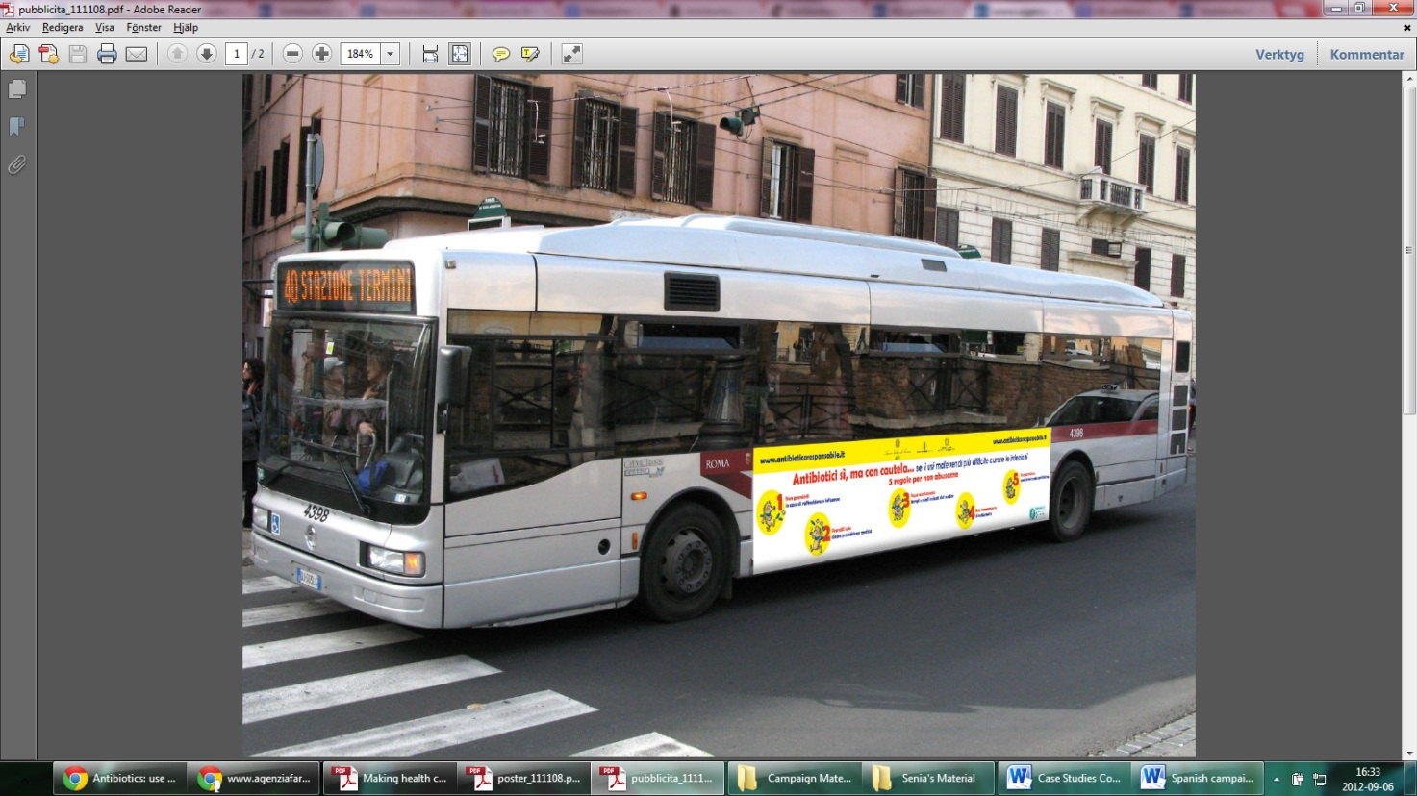
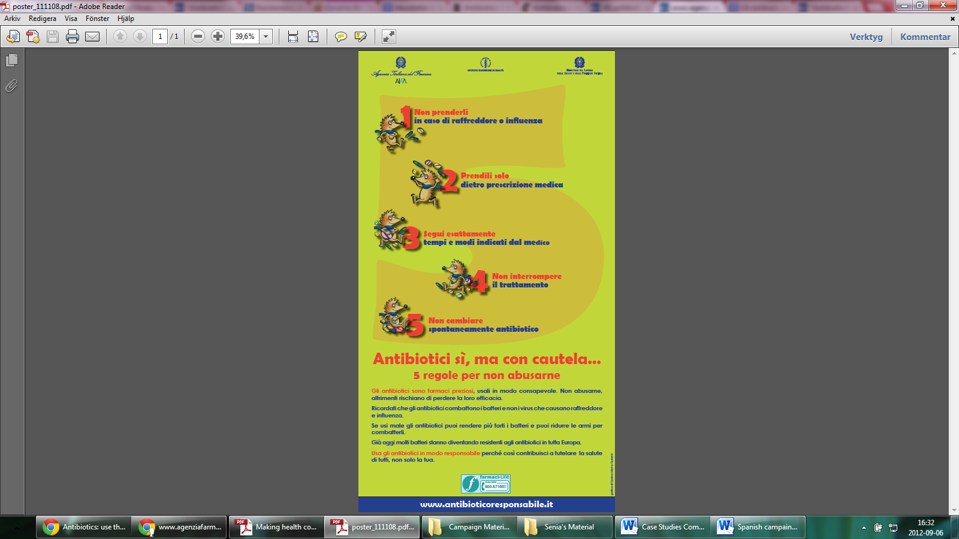
Figure 1: Some of the mass media used in the 2008 campaign.

Q & As
- What was the behavioural objective/s in this campaign?

- Who was the target audience in this campaign?

- Is there any evidence, in your view, that the principles of the marketing mix were used in the planning of this campaign?
    - What was the product?
    - What was the price/cost of the campaign?
    - Where did the campaign take place?
    - What were the key activities implemented?

- Through what channels was the audience reached?

Part 2
An evaluation requested by the Italian Medicines Agency showed that, albeit the limited time (28 days), budget constraints and no appeal to re-convey messages on television spots, the communication methods gave superior results that were not shown by previous institutional campaigns of longer duration and more comprehensive communication methods. Post-campaign, it was found that, the overall antibiotic consumption in January 2009 as compared to January 2008 decreased by 8% and there was a decrease in expenditure by 16.4% corresponding to approximately 18.5 million euros. Moreover, 66.5% of people interviewed found the messages conveyed useful to induce them to change their behaviour, 72.2% also claimed that the campaign made them reflect, and 88% remembered the campaign’s messages clearly.
Adapted from:
- Agenzia Italiana del Framaco. “Antibiotici. Difendi la tua difesa. Usali con cautela”. [internet]. 2012 [cited 2012 Oct 5]. Available from: http://www.agenziafarmaco.gov.it/it/content/antibiotici-difendi-la-tua-difesa-usali-con-cautela-0
- Istituto Superiore di Sanità. Antibiotici, usali con cautela: campagna di communicazione per un uso corretto degli antibiotic. [internet]. 2012 [cited 2012 Oct 3]. Available from: http://www.iss.it/binary/pres/cont/antibio09.pdf

Pantosti A, Del Grosso M, editors. Giornata europea degli antibiotici: uso responsabile per il controllo dell’antibiotico-resistenza. Rome: Istituto Superiore di Sanità; 2009.

Q & As
- How (design, method/s, outcome variable/s) was the success/failure of the intervention measured?

- Identify and/or develop key indicators as well as data collection methods and tools that could be used to evaluate the given campaign.

Key activities | Specific objectives | Key indicators |  | Data collection methods/tools
 |  | Process | Outcome

Key activities | Specific objectives | Key indicators |  | Data collection methods/tools
 |  | Process | Outcome

Key activities | Specific objectives | Key indicators |  | Data collection methods/tools
 |  | Process | Outcome

- In your view, what were the strengths of the campaign?

- What do you think were the weaknesses of this campaign? What do you think could have been improved and how? Keeping the social marketing principles in mind, what would you have done differently in order to improve the campaign in your given scenario? Please discuss and write down your own suggestions.

- What were the desired/intended outcomes of the campaign and were they reached? Were there any unintended outcomes?

- Finally, carry out a SWOT analysis of the campaign. Use the table below for your answers.

 | Strengths |  | Weaknesses
Opportunities
Threats

Part 3
In 2009, the campaign was re-launched, this time the overall message being, “Antibiotici, usali con cautela” (“Antibiotics, use with caution”), with the following underlying messages: (i) do not use antibiotics for cold and flu, (ii) take antibiotics only with a prescription, and (iii) take correct dosage and duration of therapy. The objective was to promote the appropriate use of antibiotics and to reduce the development of antibiotic resistance, targeting the general population. This was again done through a press conference, 30 second spots on television, cinema and radio, publicity on buses, bill boards, magazines, posters at check-in lounges at airports, train stations and communal spaces, freephone for questions from the public, and websites.

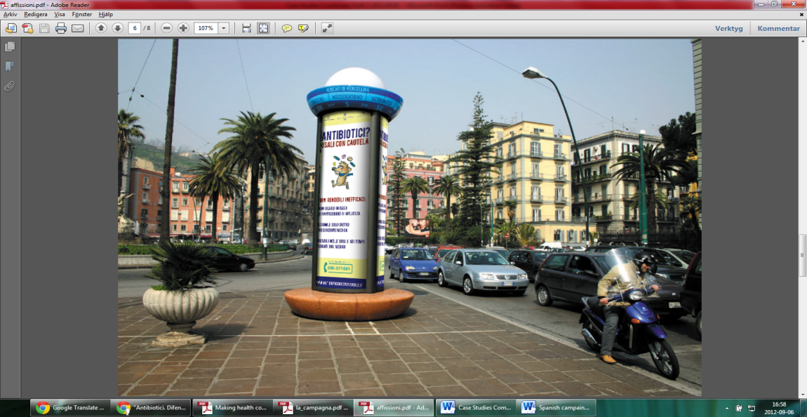
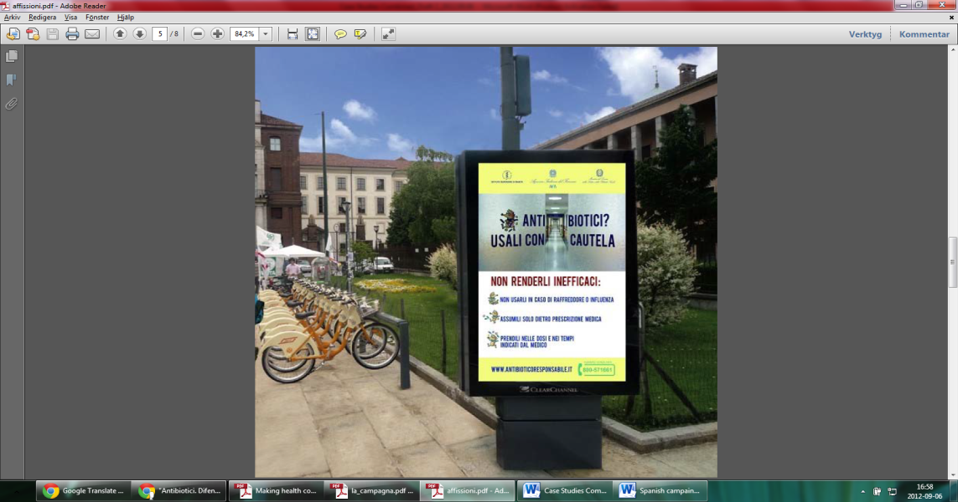
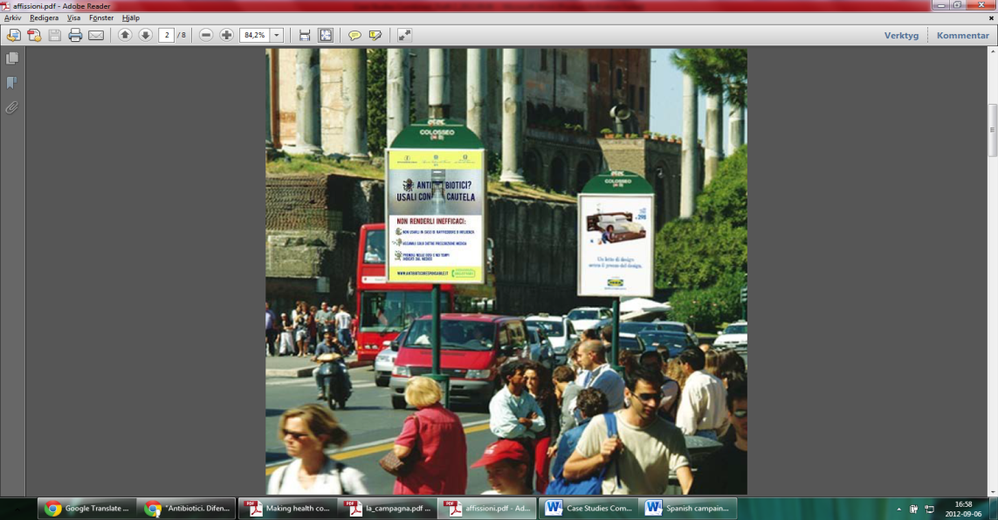
Figure 2: Posters in communal and public areas during the 2009 campaign.

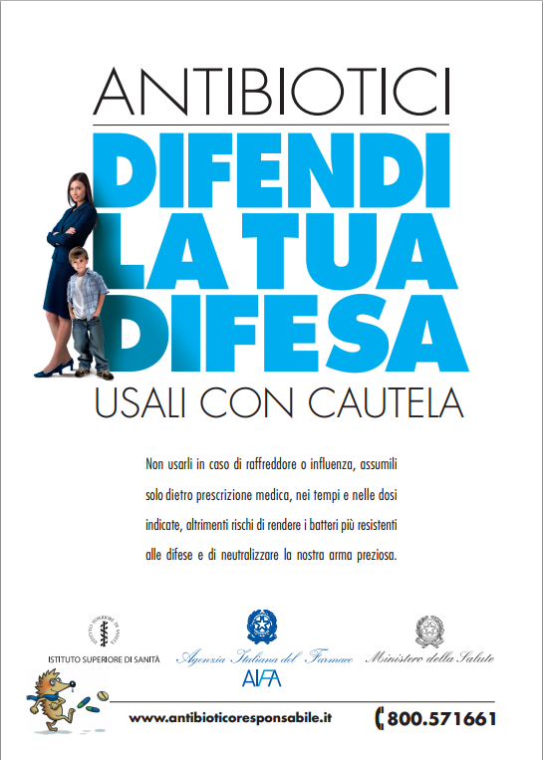
In 2010, the campaign was launched again, with the overall message being, “Antibiotici. Difendi la tua difesa. Usali con cautela.” (“Antibiotics. Defend your defence. Use with caution”). The target population remained the general public and the underlying messages were the same as well as the means of communication, however this time the campaign was centred on the prudent use of antibiotics in hospitals and also targeted healthcare providers. This was initiated as the importance of antibiotic resistance within hospitals was realised as a growing problem which needed to be tackled. The objective of this year’s campaign was to: (i) promote the appropriate use of antibiotics, (ii) reduce the development of antibiotic resistance, (iii) limit the excessive use of resources and direct them towards innovation, and (iv) reduce adverse effects.

Figure 3: The poster used in the 2010 campaign.
Adapted from:
- Agenzia Italiana del Framaco. “Antibiotici. Difendi la tua difesa. Usali con cautela”. [internet]. 2012 [cited 2012 Oct 5]. Available from: http://www.agenziafarmaco.gov.it/it/content/antibiotici-difendi-la-tua-difesa-usali-con-cautela-0
- Istituto Superiore di Sanità. Antibiotici, usali con cautela: campagna di communicazione per un uso corretto degli antibiotic. [internet]. 2012 [cited 2012 Oct 3]. Available from: http://www.iss.it/binary/pres/cont/antibio09.pdf

Pantosti A, Del Grosso M, editors. Giornata europea degli antibiotici: uso responsabile per il controllo dell’antibiotico-resistenza. Rome: Istituto Superiore di Sanità; 2009.

Q & As
- What were the changes made to the campaign as compared to previous years?
  - How did the behavioural objective evolve over the years?
  - How did the target audience/s evolve over the years?
  - How did the messages evolve during these two years?
  - Did they make use of new channels? If so, which?

- How was the sustainability of the campaign maintained?

- Referring back to Part 1, compare the layout, structure and messages of the mass media tools shown in Figures 1, 2 and 3, and give your own comments and opinion about them. Below are a few hints which may help you.
  - What strikes you about them?
  - Do you think they convey the intended message well? If so, how?
  - Do you think they have the potential to reach the intended audience? If so, how?
  - Would you change anything?

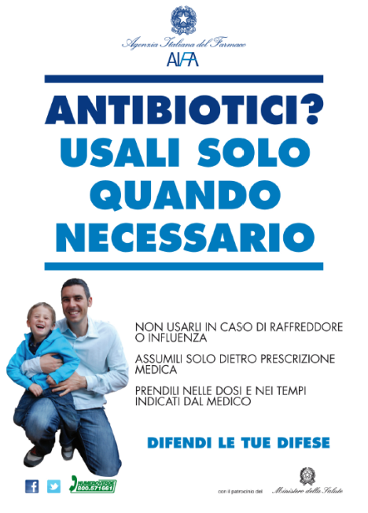
Part 4
The upcoming 2012 campaign the message, “Antibiotici? Usali solo quando necessaro” (“Antibiotics? Use only when necessary”) was employed, and they concentrated on the use of websites and social media such as Facebook and Twitter to deliver their messages, amongst other means, in order to target the overall population on the importance of: (i) consuming antibiotics only when necessary and when prescribed appropriately by a doctor, (ii) not interrupting antibiotic therapy earlier than prescribed unless specifically indicated by a doctor or following doctor’s advice, and (iii) not consuming antibiotics to cure viral infections.

Figure 4: The poster used in the 2012 campaign.
Adapted from:
- Agenzia Italiana del Framaco. “Antibiotici. Difendi la tua difesa. Usali con cautela”. [internet]. 2012 [cited 2012 Oct 5]. Available from: http://www.agenziafarmaco.gov.it/it/content/antibiotici-difendi-la-tua-difesa-usali-con-cautela-0
- Istituto Superiore di Sanità. Antibiotici, usali con cautela: campagna di communicazione per un uso corretto degli antibiotic. [internet]. 2012 [cited 2012 Oct 3]. Available from: http://www.iss.it/binary/pres/cont/antibio09.pdf

Pantosti A, Del Grosso M, editors. Giornata europea degli antibiotici: uso responsabile per il controllo dell’antibiotico-resistenza. Rome: Istituto Superiore di Sanità; 2009.
Q & As
- What were the new channels introduced in the 2012 campaign?

- What, in your opinion, were the advantages and disadvantages of introducing these new channels to the campaign?

Case study thirteen
“A multi-targeted intervention”
Description
Part 1
In 2006-2007, Spain conducted a national antibiotic campaign with the overall message being, “Uso responsable de antibióticos. Usándolos bien hoy, mañana nos protegerán” (“Responsible use of antibiotics. Using them correctly today, they will protect us tomorrow”). The main objectives of this campaign were to: (i) achieve an attitude change in the population in relation to the indiscriminate use of antibiotics in situations where they are not required, (ii) inform and sensitise society about the usefulness of antibiotics when prescribed by a doctor to treat bacterial infections. Sometimes antibiotics might represent a risk; their inadequate use accelerates the appearance of resistant bacteria thus making antibiotics no longer efficacious to treat infections caused by these types of bacteria, and (iii) avoid risks associated with the abuse of unnecessary antibiotic consumption.
Adapted from: Goberno de España. Sin tu ayuda, los antibióticos pueden perder su eficacia. 2012 [cited 2012 Oct 8]. Available from: www.antibioticos.msc.es

Q & As
- Given the above scenario, how would you formulate your campaign objective?

Part 2
The campaign was directed towards the general population, parents of children and healthcare professionals (doctors and pharmacists). It ran for two months and was allocated a budget of 6.4 million euros.
Several messages were constructed, according to the audience. Below are a few of them.
- General population:
  - Without your help antibiotics can stop working.
  - Antibiotic treatment should be indicated by your doctor.
  - If we continue abusing antibiotics, we might have serious difficulties to combat severe infections, since we will not have any antibiotics left to treat bacteria
  - In cases where the doctor gives you antibiotic treatment, it is essential to abide by and obey given instructions regarding the duration of treatment and the required dose.
- Parents of young children:
  - Colds and flus are caused by viruses. They can present with fever but will not improve nor avoid their spread with antibiotics
  - Providing unnecessary antibiotics to your child may be harmful to his/her health and it may be more difficult for your child to be cured if s/he has an infection with resistant bacteria
- Healthcare professionals:
  - Without your help, antibiotics might lose their efficacy.
Adapted from: Goberno de España. Sin tu ayuda, los antibióticos pueden perder su eficacia. 2012 [cited 2012 Oct 8]. Available from: www.antibioticos.msc.es

Q & As
- How relevant were the campaign messages for the target populations they wished to target? Would you have altered/changed their messages in any way? If yes, why and how?

Part 3
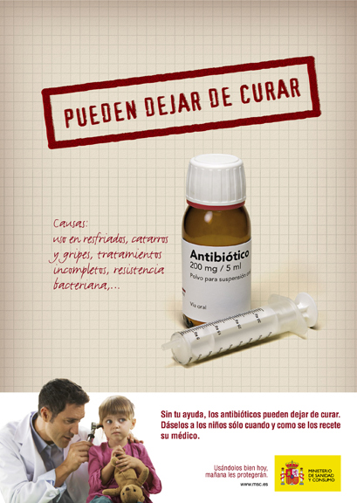
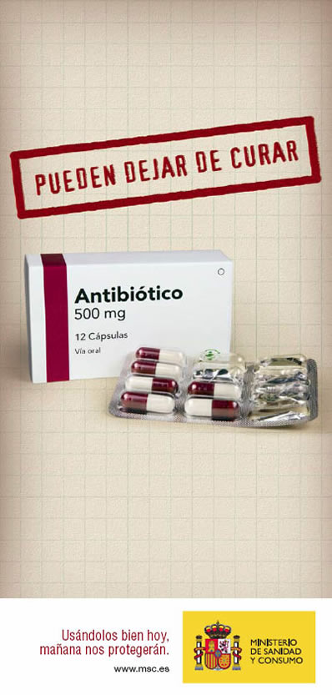
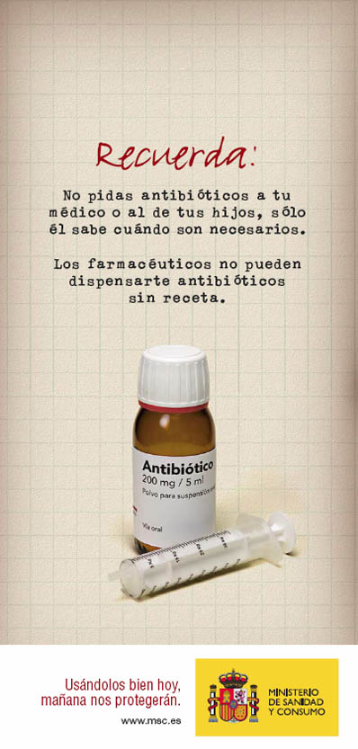
The outreach for the general population and parents was done through 3,000 television commercials (10 and 25 seconds), 600 radio spots, printed material, the internet, leaflets and posters. Healthcare professionals were reached by preparing and distributing a scientific report, of which 100,000 copies were sent to general practitioners and 21,000 copies were sent to pharmacists and other professional associations. A website was also constructed for this purpose.
Figure 1: Some of the materials used in the campaign
Adapted from: Goberno de España. Sin tu ayuda, los antibióticos pueden perder su eficacia. 2012 [cited 2012 Oct 8]. Available from: www.antibioticos.msc.es

Q & As
- Give suggestions on how the success/failure of the intervention can be evaluated.

- Identify and/or develop key indicators as well as data collection methods and tools that could be used to evaluate the given campaign.
Key activities | Specific objectives | Key indicators |  | Data collection methods/tools
 |  | Process | Outcome

- In your view, what were the strengths of this campaign?

- What do you think were the weaknesses of this campaign? What do you think could have been improved and how? Keeping the social marketing principles in mind, what would you have done differently in order to improve the campaign in your given scenario? Please discuss and write down your own suggestions.

Case study fourteen
“Comprehensive mass media campaign”
Description
Antibiotic over-prescription is a problem in the Israeli healthcare system, particularly those antibiotics used to treat viral upper respiratory infections (URI) and influenza. It is estimated that up to 10% of the Israeli population suffers from influenza annually, creating a considerable burden on healthcare services. During the winter of 2005-2006 Maccabi Healthcare Services (MHS), Israel’s second largest health maintenance organisation, initiated a nationwide media campaign with the aim of increasing awareness on the misuse of antibiotics among the general public. The main emphasis of the campaign was placed on the inappropriate use of antibiotics in the treatment of influenza and URI.
In January 2006, MHS initiated a comprehensive mass media campaign consisting of radio and television advertisements, together with a concurrent four-part television series, targeted towards parents of children. The ads delivered a general message that antibiotics are not the appropriate treatment for colds and other viral URI, whilst the television series presented the serious repercussions of antibiotic misuse. The media campaign ran for a two-week period in January in order to target the annual peak of antibiotic use in January and February.
A population-based study was later conducted to evaluate the impact of the campaign on parental knowledge and awareness of appropriate antibiotic use for the treatment of acute viral conditions, as well as on patterns of actual antibiotic use. The effectiveness of the campaign was evaluated in two ways. Firstly, to determine whether the campaign affected actual antibiotic use, an analysis of medical and administrative information drawn from the MHS central computer database was conducted. The impact of the campaign on antibiotic use was assessed by comparing monthly antibiotic purchasing rates during the pre-intervention (November to December, 2005) and post-intervention (January to February, 2006) phases of the study with the corresponding periods of the baseline winter (November 2004 until February 2005). Secondly, a random sample of parents whose children were diagnosed with URI were surveyed by phone to assess attitude changes towards antibiotic use. The survey was intended to assess exposure to the campaign and to be able to compare attitudes towards antibiotic use among respondents exposed and unexposed to the campaign. The telephone survey, which consisted of 860 randomly selected parents who were also MHS members, started several days after the campaign officially came to an end and was conducted over two weeks.
A reduction in antibiotic purchases for URI, pharyngitis and otitis media during the post-intervention phase as compared to the parallel period in the baseline winter was noted. With regards to exposure to the campaign, more than half of the survey respondents (54%) stated that they were exposed to the media campaign. Moreover, exposure to the media campaign was positively associated with appropriate attitudes toward antibiotic use; parents of children with URI exposed to the media campaign were more likely to express agreement with standards of appropriate antibiotic use than those parents not exposed.
Adapted from: Hemo B, Shamir-Shtein NH, Silverman BG, Tsamir J, Heymann AD, Tsehori S, Friedman NL. Can a nationwide media campaign affect antibiotic use? Am J Manag Care. 2009 Aug;15(8):529-534.

Q & As
- What was the behavioural objective/s in this campaign?

- Who was the target audience in this campaign?

- Is there any evidence, in your view, that the principles of the marketing mix were used in the planning of this campaign? Use the marketing mix score matrix* below to assess to which degree you think the social marketing principles were applied, described or addressed.
Product | Price  (benefits/barriers) | Place | Promotion
……………………………………………………………………………………………………………
* Each principle must be marked from a scale of 1-10, with 10 representing “a strong application, description or addressing of the principle” and 1 corresponding to “weak application, description or addressing of the principle”.
- Through what channels was the audience reached?

- How (design, method/s and outcome variable/s) was the success/failure of the intervention measured? Would you have evaluated it differently? If so, how?

- Identify and/or develop key indicators as well as data collection methods and tools that could be used t evaluate the given campaign.
Key activities | Specific objectives | Key indicators |  | Data collection methods/tools
 |  | Process | Outcome

- In your view, what were the strengths of this campaign?

- What do you think were the weaknesses of this campaign? What do you think could have been improved and how? Keeping the social marketing principles in mind, what would you have done differently in order to improve the campaign in your given scenario? Please discuss and write down your own suggestions.

- What were the desired/intended outcomes of the campaign and were they reached? Were there any unintended outcomes?

- Discuss the methods used for evaluation of the campaign and their importance in interventions such as this.

Case study fifteen
“A multi-faceted strategy”
Description
Part 1
In the early 2000s, antibiotic consumption in France was shown to be among the highest in Europe, with one of the highest antibiotic users worldwide. Thus, the French government launched a long-term, nation-wide campaign to reduce antibiotic overuse and to control the spread of bacterial resistance in the community. In 2001, the national programme entitled, “Keep antibiotics working” was launched, targeting the general public and healthcare professionals (HCPs) with the aim of promoting antibiotic surveillance and more specific antibiotic use.
Since 2002, the French National Health Insurance (NHI) has launched nationwide campaigns in the community, focusing mainly on the unnecessary use of antibiotics in viral respiratory infections (VRI) in young children. The aim from its initiation was to decrease the total use of antibiotics in the community by 25%. The central theme of the campaign was, “Les antibiotiques c’est pas automatique” (“Antibiotics are not automatic”). The campaign was launched each winter (October-March), and aimed at altering behaviour for antibiotic treatment of VRI.
The public campaign mainly targeted children and their parents, emphasising that: (i) antibiotic efficacy is endangered by bacterial resistance and it is essential to preserve their efficacy; (ii) higher consumption rates are linked to higher resistance levels; (iii) antibiotics do not cure VRI; (iv) majority of upper respiratory infection are of viral origin; (v) antibiotics do not lower fever, lessen pain, or shorten duration of illness; and (vi) it is vital to abide by treatment duration and dosage prescribed. The general public campaign appeared in national media outlets, including, prime-time television and radio, newspapers and websites, and in doctor’s offices, including booklets, handouts and posters in doctor’s waiting rooms. A travelling educational exhibition about microbes was also created.

Figure 1: Example of a poster used in the campaign.

An educational campaign was also initiated for HCPs, with face-to-face education and guideline dissemination. In addition to providing information on appropriate antibiotic use, the campaign promoted the use of rapid tests to diagnose group A streptococci (RTAS) tonsillitis. Physicians were invited to county-level training on how to use RTAS and optimise antibiotic use. They were also visited by NHI doctors for face-to-face peer education sessions. Free tests were provided to doctors who attended training. Antibiotic guidelines were sent to targeted practitioners and distributed during trainings and visits.
Of ~2,400,000 children aged <3 years, one quarter attend day care. Day care workers were therefore trained to not systematically require antibiotic treatment as a condition for day care attendance of children with VRI and to relay the message of optimal antibiotic use to parents.
Adapted from:
- Huttner B, Harbarth S. “Antibiotics are not automatic anymore”: the French national campaign to cut antibiotic overuse. PLoS Med. 2009 Jun 2;6(6):e1000080.
- Sabuncu E, David J, Bernède-Bauduin C, Pépin S, Leroy M, Boëlle PY, Watier L, Guillemot D. Significant reduction of antibiotic use in the community after a nationwide campaign in France, 2002-2007. PLoS Med. 2009 Jun 2;6(6):e1000084.

Q & As
- What was the behavioural objective/s in this campaign?

- Who was the target audience in this campaign?

- Is there any evidence, in your view, that the principles of the marketing mix were used in the planning of this campaign?
    - What was the product?
    - What was the price/cost of the campaign?
    - Where did the campaign take place?
    - What were the key activities implemented?

- Through what channels was the audience reached?

Part 2
An analysis of the campaign data estimated that 8 million RTAS were distributed to doctors and paediatricians between 2002-2007. Furthermore, 45,000 general practitioners had at least one peer visit with an NHI doctor between 2003-2005. From 2002-2008, the cost of the campaign was estimated to be €500,000,000, i.e. ~€1.40/inhabitant/year. Between 2002-2007, direct savings related to decreased antibiotic use was estimated to be €850,000,000, i.e. ~€2.80/inhabitant/year.
The French NHI also carried out a follow-up survey of doctors and general public knowledge and attitudes. It was found that parents expected an antibiotic prescription in 37% of VRI consultations in 2002 and in 23% of VRI consultations in 2007. Thirty per cent of people knew that antibiotics are only effective against bacteria in 2002, but this figure rose to 40% in 2007. Eight out of ten physicians were more confident in their decisions not to prescribe unnecessary antibiotics in 2007.
Adapted from:
- Huttner B, Harbarth S. “Antibiotics are not automatic anymore”: the French national campaign to cut antibiotic overuse. PLoS Med. 2009 Jun 2;6(6):e1000080.
- Sabuncu E, David J, Bernède-Bauduin C, Pépin S, Leroy M, Boëlle PY, Watier L, Guillemot D. Significant reduction of antibiotic use in the community after a nationwide campaign in France, 2002-2007. PLoS Med. 2009 Jun 2;6(6):e1000084.

Q & As
- How (design, method/s and outcome variable/s) was the success/failure of the intervention measured? Would you have evaluated it differently? If so, how?

- Identify and/or develop key indicators as well as appropriate data collection methods and tools that could be used to evaluate the given campaign.
Key activities | Specific objectives | Key indicators |  | Data collection methods/tools
 |  | Process | Outcome

- In your view, what were the strengths of this campaign?

- What do you think were the weaknesses of this campaign? What do you think could have been improved and how? Keeping the social marketing principles in mind, what would you have done differently in order to improve the campaign in your given scenario? Please discuss and write down your own suggestions.

- What were the desired/intended outcomes of the campaign and were they reached? Were there any unintended outcomes?

Case study sixteen
“Getting creative”
Description
Part 1
Antibiotic consumption in Croatia, similar to other countries, is high. As part of an initiative to reduce this high rate of consumption, a campaign was launched in February/March 2009, and again in February/March 2010, supported by the Croatian Government, by the City of Rijeka Government at a regional level, and the Primorje-Gorski kotar County. The regional campaigns lasted for one month and cost approximately €50,000 (excludes staff salaries). A voluntary, multidisciplinary team was involved in the campaign, consisting of; specialists in clinical pharmacology, paediatrics and public health; general practitioners; a psychologist; pharmacists; and medical students. Similar to other campaigns, the campaign concentrated on respiratory tract infections, and targeted general care, public care and primary care doctors.
The campaign delivered multi-faceted interventions with its key messages being: (i) respiratory tract infections are caused by viruses and cannot be treated with antibiotics, (ii) misuse of antibiotics promotes bacterial resistance, and (iii) physician advice on how and when to take antibiotics should be followed. Permission was obtained from ECDC’s campaign communication materials for EAAD to obtain visual identity. Interventions targeting the public included: press conferences, media ads and interviews, ads on public transport, leaflets, freephone helplines, a weekend stand in a main pedestrian zone with merchandise carrying the message “cold or flu – no antibiotics”, and doctor’s advice on how to consume antibiotics responsibly.
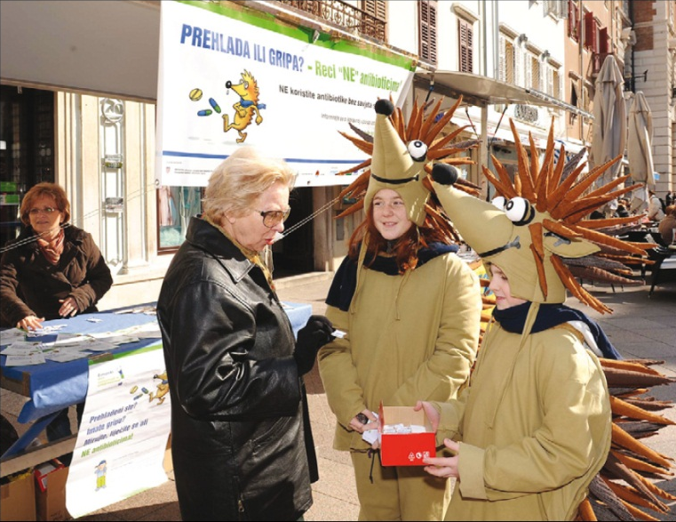

Figure 1: Stand in a main pedestrian street during the 2010 campaign in Rijeka, Croatia.

In addition, lectures were delivered to high school students, parents of children attending primary schools and to teachers in day care centres. Healthcare professionals were targeted through primarily informing doctors about the public campaign and inviting them to actively engage in it, and anonymous questionnaires were distributed to all primary care doctors around the county. A symposium was held on the EAAD (November 18th), 2009, with sessions focusing on the treatment of most common infections. Guidelines for the use of antibiotics in primary care were distributed in the form of a comprehensive booklet covering various infections. The 2010 campaign included the same activities as in 2009.
Adapted from: Vlahović-Palčevski V. Reducing antibiotic use in Croatia. Lancet Infect Dis. 2010 Oct;10(10):670-671.

Q & As
- What was the behavioural objective/s in this campaign?

- Who was the target audience in this campaign?

- Is there any evidence, in your view, that the principles of the marketing mix were used in the planning of this campaign? Please use the table below for your answers.
Target audience/s | Product | Price | Place | Promotion
Target audience/s | Product | Price | Place | Promotion
- Through what channels was the audience reached?

- Who were the stakeholders involved in this campaign?

- How does one engage stakeholders and develop partnerships for campaign development? Please give suggestions.

Part 2
Only short-term outcomes of the campaigns, such as patient’s knowledge and attitudes towards antibiotics, were possible to assess. Findings of an anonymous questionnaire administered to the general population, noted that 35% of patients prior to the first campaign, and 25% after it, thought that antibiotics are drugs that treat influenza. Mid-term outcomes could be measured by the amount of antibiotics used. Although a decline in antibiotic use after the first campaign was not expected, the use of prescribed co-amoxiclav fell by 4%. Long-term outcomes and changes in resistance patterns cannot be seen as of yet.
Adapted from: Vlahović-Palčevski V. Reducing antibiotic use in Croatia. Lancet Infect Dis. 2010 Oct;10(10):670-671.

Q & As
- How (design, method/s and outcome variable/s) was the success/failure of the intervention measured? Would you have evaluated it differently? If so, how?

- Identify and/or develop key indicators as well as data collection methods and tools that could be used to evaluate the given campaign.
Key activities | Specific objectives | Key indicators |  | Data collection methods/tools
 |  | Process | Outcome

- In your view, what were the strengths of the campaign?

- What do you think were the weaknesses of this campaign? What do you think could have been improved and how? Keeping the social marketing principles in mind, what would you have done differently in order to improve the campaign in your given scenario? Please discuss and write down your own suggestions.

- What were the desired/intended outcomes of the campaign and were they reached? Were there any unintended outcomes?

Case study seventeen
Embracing EAAD”
Description
In 2006, the prevalence of MRSA in Luxembourg ranged between 10-25%, and Luxembourg was also the 6th country in Europe with highest total antibiotic use. As a result, in 2008, Luxembourg joined with the European campaign on the prudent use of antibiotics to prevent the emergence of antibiotic-resistant bacteria. Their message was, “Les antibiotiques sont inefficaces contre les virus: Utilisons-les à bon escient” (“Antibiotics are ineffective against viruses: Use them wisely”).
With the launch of the European Antibiotic Awareness Day, Luxembourg held a press conference which informed the media, both in writing and orally, about the subject. Posters and leaflets were distributed to doctors, pharmacists, hospitals and clinics, communal administration departments, schools, day-care centres, halfway houses, some ministries, and public places, e.g. trains, and the Union of sickness funds. Radio, TV and cinematic spots were also produced both in Luxembourgish and Portuguese which explained to the public about the phenomenon of antibiotic resistance, unnecessary prescription and inadequate consumption, through a conversation between two antibiotic capsules when faced by a virus.
They also had an interactive online quiz with a set of questions and responses which complemented the campaign and allowed people to test their knowledge on the subject. The budget for the campaign was €50,000.
Adapted from: Christmann S. Communique de presse: journée européenne consacrée à la résistance aux antibiotiques (European Antibiotic Awareness Day). Luxembourg: Le Gouvernement du Grand-Duché de Luxembourg; 2008.

Q & As
- What was the behavioural objective/s in this campaign?

- Who was the target audience in this campaign?

- Is there any evidence, in your view, that the principles of the marketing mix were used in the planning of this campaign? Use the marketing mix score matrix* below to assess to which degree you think the social marketing principles were applied, described or addressed.
Product | Price  (benefits/barriers) | Place | Promotion
……………………………………………………………………………………………………………
* Each principle must be marked from a scale of 1-10, with 10 representing “a strong application, description or addressing of the principle” and 1 corresponding to “weak application, description or addressing of the principle”.
- Through what channels was the audience reached?

- With the given budget (€50,000), suggest alternative ways by which the above campaign could have been unrolled.

- Give suggestions on how the campaign can be evaluated and re-implemented.

- Identify and/or develop key indicators as well as data collection methods and tools that could be used to evaluate the given campaign.
Key activities | Specific objectives | Key indicators |  | Data collection methods/tools
 |  | Process | Outcome

Case study eighteen
“Addressing minority groups”
Description
Part 1
In the past decade, two key observations have become a target for several interventions: antibiotic resistance among community-acquired bacterial pathogens and the recent use of antibiotics as one of the strongest risk factors for carriage or infection with resistant bacteria. In the current scenario, acute respiratory tract infections account for the vast majority of antibiotic prescriptions in ambulatory care.
In 2001, an intervention was designed in Colorado to assess the impact of including household-based and doctor’s office-based patient education in an existing doctor-centered intervention aimed at reducing antibiotic prescribing for children with pharyngitis and adults with acute bronchitis. The major hypothesis was that a joint patient and doctor intervention would be more effective in reducing excess antibiotic use in private office practices than a doctor-centred intervention alone.
Since 1999 (two years prior to the intervention), primary care doctors had been receiving individual prescribing profiles showing: the proportion of adult bronchitis patients receiving antibiotic treatment (target ≤10%), the proportion of these antibiotics belonging to a first-line group (target ≥70%), and the proportion of these antibiotics ineffective against diagnosed bacterial cases of uncomplicated acute bronchitis (target 0%). Likewise, doctors providing care to children with pharyngitis were also mailed profiles showing: the proportion of all pharyngitis patients having a group A streptococcus identification test performed, the proportion of pharyngitis patients not receiving a group A streptococcal identification test who were treated with antibiotics (target 0%), and the proportion of antibiotics belonging to a first-line group (target ≥70%).
Adapted from: Gonzales R, Corbett KK, Leeman-Castillo BA, Glazner J, Erbacher K, Darr CA, Wong S, Maselli JH, Sauaia A, Kafadar K. The minimizing antibiotic resistance in Colorado project: impact of patient education in improving antibiotic use in private office practices. Health Serv Res. 2005 Feb;40(1):101-116.

Q & As
- Discuss the importance of formative evaluation before implementing campaigns.

- Highlight the key areas identified in the text that required improvement.

Part 2
Household-based and doctor’s office-based educational material were adapted from a previous intervention that had successfully reduced antibiotic treatment of adults with acute bronchitis. Focus group discussions were conducted with parents to obtain feedback and develop paediatric materials prior to their distribution. Campaign packets were posted to households (n=37,375) identified through participating doctor’s offices in the first week of November, 2001.
Adapted from: Gonzales R, Corbett KK, Leeman-Castillo BA, Glazner J, Erbacher K, Darr CA, Wong S, Maselli JH, Sauaia A, Kafadar K. The minimizing antibiotic resistance in Colorado project: impact of patient education in improving antibiotic use in private office practices. Health Serv Res. 2005 Feb;40(1):101-116.

Q & As
- Discuss the need for adaptation and the importance of pre-testing materials.

Part 3
Each household packet consisted of a bilingual introductory letter (English and Spanish, the second main language in the area) explaining the campaign, brochures on antibiotic resistance, a fridge magnet and a reference card providing easy-to-read facts about symptoms and treatment for acute respiratory tract infections. All materials were provided in both languages except for the magnet which was only provided in English. Materials for doctor’s offices (produced in both languages) included waiting room posters and patient reference cards, and examination room posters which contained discussion points for doctors to use when talking about appropriate antibiotic use for pharyngitis with paediatric patients and bronchitis in adults. All educational materials were available online on the project’s website.
Adapted from: Gonzales R, Corbett KK, Leeman-Castillo BA, Glazner J, Erbacher K, Darr CA, Wong S, Maselli JH, Sauaia A, Kafadar K. The minimizing antibiotic resistance in Colorado project: impact of patient education in improving antibiotic use in private office practices. Health Serv Res. 2005 Feb;40(1):101-116.

Q & As
- Use the marketing mix score matrix* below to assess to which degree you think the social marketing principles were applied, described or addressed.
- Product | Price  (benefits/barriers) | Place | Promotion
……………………………………………………………………………………………………………
* Each principle must be marked from a scale of 1-10, with 10 representing “a strong application, description or addressing of the principle” and 1 corresponding to “weak application, description or addressing of the principle”.
- Suggest other channels through which the intervention could have been delivered.

Part 4
Office practices located in a pre-selected geographical area in Denver, Colorado, the intervention city, were invited to participate as intervention practices. Eligibility criteria for the doctor’s offices included having 20 or more patient visits for acute respiratory tract infections during the baseline observation period (November 2000 to February 2001). They also had to provide a mailing and telephone list of regular patients (any adult having at least two office visits during the prior 24 months or any child having at least two office visits during the prior 12 months), and to review and approve the ultimate educational material for the intervention. Ten private doctor clinics were identified as potential participates however five agreed to participate.
In addition, two city practices in Denver, outside the pre-selected geographical area, were selectively enrolled in order to ensure adequate sample size for a separate analysis. Office practices in the surrounding urban area of Denver served as ‘‘local control’’ practices. In addition, practices located in a geographically distinct urban area, Colorado Springs, 100kms south of the intervention city served as ‘‘distant control’’ practices. Eligibility criteria for local and distant control practices were the same as for the intervention practices.
For paediatric pharyngitis, the adjusted antibiotic prescription rates during baseline and intervention periods increased from 38% to 39% at the distant control practices, decreased from 39% to 37% at the local control practices and decreased from 34% to 30% at the intervention practices. For acute bronchitis in adults, the adjusted antibiotic prescription rates during baseline and intervention periods decreased from 51% to 44% at the distant control practices, decreased from 55% to 45% at the local control practices and decreased from 60% to 36% at the intervention practices.
The total cost of the household intervention in 2001 was around $1.64/household for 37,375 households and for the office materials in 2001 it was approximately $350/practice.
Adapted from: Gonzales R, Corbett KK, Leeman-Castillo BA, Glazner J, Erbacher K, Darr CA, Wong S, Maselli JH, Sauaia A, Kafadar K. The minimizing antibiotic resistance in Colorado project: impact of patient education in improving antibiotic use in private office practices. Health Serv Res. 2005 Feb;40(1):101-116.

Q & As
- How (design, method/s and outcome variable/s) was the success/failure of the intervention measured? Would you have evaluated it differently? If so, how?

- Identify and/or develop key indicators as well as data collection methods and tools that could be used to evaluate the given campaign.
Key activities | Specific objectives | Key indicators |  | Data collection methods/tools
 |  | Process | Outcome

- Does it appear that the intervention was successful? Discuss.

Course on the development, implementation and evaluation of prudent antibiotic use campaigns

Indicators list

Illustrative indicators list
Below is an extensive list of potential process and outcome indicators which may be used during evaluation of an antibiotic use campaign. This list contains only a sample of indicators and should be used and adapted accordingly, depending on the context, the type of interventions carried out, the approach by which the campaign is unfolded and the target audience, among others.
For ease of use, the list is divided into two parts beginning with process indicators and ending with outcome indicators. Process indicators are then further sub-divided into three sections: (i) process indicators which can be used during the pre-intervention phase (NB. refers to activities conducted in preparation to roll-out the campaign), (ii) process indicators which can be used whilst carrying out the intervention and (iii) process indicators for the post-intervention phase. The three sub-sections are split again for convenience into valid sub-divisions for each phase of the intervention.
Similarly, the list of outcome indicators, which are to be used at the end of the intervention as a means of evaluation, is also sub-divided, albeit slightly differently to the process indicators list. The outcome indicators are sub-divided as such: (i) knowledge and attitudes on antibiotics, (ii) antibiotic prescribing/dispensing, (iii) antibiotic consumption, and (iv) antibiotic resistance. You will again find further sub-sections in certain divisions according to the diagnoses or bacterial isolates.
You will note that under the heading ‘unit’ the following symbols/abbreviations are used: #, mins, % and DID. These symbols represent: # – numerical figure, mins – number of minutes, % – figure in percentage, and DID – defined daily doses per 1,000 inhabitants per day.

 | Attention
 | Not all outcome indicators can directly attribute certain outcomes as direct effects of the intervention. Some indicators, such as those on antibiotic resistance, may be used as proxy indicators but are not necessarily a direct result of the intervention. They may however give an overview of the situation post-intervention and aid in setting targeted goals for future interventions.

Examples of process indicators
 | Indicator | Unit
Pre-intervention | Capacity building
 | - Total number of materials/guidelines developed to build capacity | #
 | - Total number of capacity-building training sessions conducted (train-the-trainers) | #
 | - Total number of workshops conducted (for training purposes; train-the-trainers) | #
 | - Total number of behaviour change communication (BCC) workshops conducted (for training purposes; train-the-trainers) | #
 | - Total number of advocacy activities (by focus) implemented (train-the-trainers) | #
 | - Total number of group education activities (by focus) | #
 | - Total number of training participants | #
 | - Total number of workshop participants by focus of workshop (train-the-trainers) | #
 | - Total number of people trained | #
 | - Total number of healthcare professionals/press officers/public health officials, etc. trained in information, education and communication (IEC), behaviour change intervention (BCI) and BCC | #
 | - Total number of individuals trained in IEC/BCI/BCC | #
 | - Total number of supervisors | #
 | - Total number of formative studies/assessments conducted | #
 | - Total number of projects/programmes/interventions designed | #
 | - Total number of monitoring and evaluation systems established | #
 | Resource development
 | - Total number of grants awarded | #
 | - Total budget allocated to the intervention
 | - Total number of behaviour change communication materials and guidelines developed and produced | #
 | - Total number of IEC materials (flyers, posters, etc.) developed | #
Pre-intervention | - Total number of YouTube videos created | #
 | - Total number of advertisements created | #
 | Policy development
 | - Number of IEC materials developed (for policy) | #
 | - Number of tools developed (for policy) | #
 | Partnerships
 | - Total number of networks, NGOs and coalitions formed | #
 | - Total number of new organisations, businesses and media outlets participating in the programme | #
During intervention | Channels
 | - Total number of press conferences | #
 | - Total number of television stations involved | #
 | - Total number of radio stations involved | #
 | - Total number of hotlines available | #
 | - Total number of websites used in the intervention | #
 | - Total number of YouTube videos used in the intervention | #
 | - Total number of cinema spots/advertisements | #
 | - Total number of workshops conducted | #
 | - Total number, type and frequency of activity/channel (print, radio, TV, video, hotline, newspapers, lectures, etc.)
 | - Total number of educator services provided | #
 | - Total number of educator services provided per targeted group | #
 | Activity dissemination
 | - Total number of IEC events conducted | #
 | - Total number of conferences coordinated | #
 | - Total number of IEC materials (flyers, posters, etc.) disseminated | #
 | - Total number of IEC materials (flyers, posters, etc.) disseminated (for policy) | #
 | - Total number of IEC campaigns conducted | #
During intervention | - Total number of IEC campaigns conducted (for policy) | #
 | - Total number of television spots/advertisements aired | #
 | - Total television air time | #
 | - Total number of radio spots/advertisements aired | #
 | - Total television radio time | #
 | - Total number of media articles written about the campaign/intervention | #
 | - Total number of social media tools on Twitter | #
 | - Total number of social media tools on Facebook | #
 | - Total number and type of EAAD campaign materials used | #
 | - Total number of tools disseminated (for policy) | #
 | - Total number of articles published in scientific journals | #
 | - Total number of workshops conducted | #
 | - Total number of advocacy activities (by focus) implemented | #
 | - Total number of group education activities (by focus) | #
 | - Total number of rapid diagnostic tests distributed | #
 | - Total number of supervisors | #
 | Uptake of activity dissemination
 | - Total number of hotline calls (by reason for call, age, sex of caller) | #
 | - Total number of visitors to websites (by interest subject) | #
 | - Average time spent on websites by visitors | mins
 | - Total number of YouTube views | #
 | - Total number of YouTube comments | #
 | - Total number of video likes and dislikes | #
 | - Estimated number of viewers of television spots/advertisements aired | #
 | - Estimated number of listeners of radio spots/advertisements aired | #
 | - Estimated number of viewers of cinema spots/advertisements | #
 | - Total number of workshop participants by focus of workshop | #
 | - Total number of doctors reached through group activity by peers | #
 | - Total number of doctors reached one-to-one by peers | #
 | - Total number of tweets and re-tweets on Twitter | #
 | - Total number of likes on Facebook posts | #
During intervention | - Total number of posts and comments on Facebook | #
 | - Total number of times posts, videos or links were shared | #
 | Partnerships
 | - Total number of collaborative events | #
 | - Total number of agencies involved in collaborative events | #
 | - Total number of volunteers who took part in the intervention | #
Post-intervention | Coverage
 | - Coverage of the campaign (national, regional and/or local levels) | %
 | - Total number of activities organised (national, regional and/or local levels) | #
 | - Type of activities organised (national, regional and/or local levels)
 | Exposure
 | - Proportion of the targeted population reached | %
 | - Total number of targeted target population reached | #
 | - Proportion of targeted population reached through IEC events | %
 | - Total number of targeted population reached through IEC events | #
 | - Proportion of targeted population reached through educational programmes | %
 | - Total number of targeted population reached through educational programmes | #
 | - Total print coverage and estimated readership | %
 | - Total exposure of social media interventions | %
 | Stakeholders and partnerships
 | - Total number of networks, NGOs and coalitions formed | #
 | - Total number of people working on the campaign/intervention (at national, regional and/or local levels) | #
 | - Total number and type of governmental institutions contributing to the development of the campaign/intervention | #
 | - Total number and type of non-governmental stakeholders supporting the campaign/intervention | #
Post-intervention | - Total number and type of non-governmental stakeholders sponsoring the campaign/intervention | #
 | - Total number and type of stakeholders criticising the campaign/intervention
 | Policy development
 | - Total number of antibiotic use plan/guidelines developed | #
 | - Total number of global guidelines/standards developed | #
 | - Total number of indicators developed/refined | #
 | - Total number of tools developed | #
 | - Total number of tools disseminated | #
 | - Total number of strategies/guidelines developed | #

Examples of outcome indicators
 | Indicator | Unit
Knowledge and attitudes on antibiotics | - Prevalence of target population with correct knowledge about antibiotics and their appropriate use | %
 | - Prevalence of target population with incorrect knowledge about antibiotics and their appropriate use | %
 | - Prevalence of population self-medicating with antibiotics | %
 | - Prevalence of population consuming non-prescribed antibiotics | %
 | - Prevalence of population not following correct dosage instructions | %
 | - Prevalence of population discontinuing antibiotics earlier than prescribed | %
 | - Prevalence of population keeping leftover antibiotics | %
Antibiotic prescribing/ | - Prevalence of doctors who feel pressured by patients to prescribe antibiotics | %
dispensing | - Prevalence of patients who put pressure on doctors to prescribe antibiotics | %
 | - Total antibiotic sales | DID
 | - Number of antibiotic packages dispensed per 1,000 inhabitants per day | #
 | - Number of antibiotic packages dispensed over-the-counter without a prescription per total antibiotic dispensation | %
 | - Prevalence of patients with age and/or gender limitation prescribed an antibiotic | %
 | - Prevalence of patients with age and/or gender limitation prescribed an antibiotic, and receiving the guideline-recommended antibiotic | %
Antibiotic prescribing/ dispensing | - Prevalence of patients with age and/or gender limitation prescribed an antibiotic, and receiving quinolones | %
 | Acute bronchitis/bronchiolitis
 | - Prevalence of patients aged between 18 and 75 years with acute bronchitis/bronchiolitis (ICPC-2-R: R78) prescribed antibacterials for systemic use (ATC: J01) | %
 | - Prevalence of patients aged between 18 and 75 years with acute bronchitis/bronchiolitis (ICPC-2-R*: R78) receiving the recommended antibacterials (ATC†: J01CA or J01AA) | %
 | - Prevalence of patients aged between 18 and 75 years with acute bronchitis/bronchiolitis (ICPC-2-R*: R78) receiving quinolones (ATC†: J01M) | %
 | Acute upper respiratory infection
 | - Prevalence of patients older than 1 year with acute upper respiratory infection (ICPC-2-R*: R74) prescribed antibacterials for systemic use (ATC†: J01) | %
 | - Prevalence of patients older than 1 year with acute upper respiratory infection (ICPC-2-R*: R74) receiving the recommended antibacterials (ATC†: J01CA or J01AA) | %
 | - Prevalence of patients older than 1 year with acute upper respiratory infection (ICPC-2-R*: R74) receiving quinolones (ATC†: J01M) | %
 | Cystitis/other urinary infection
 | - Prevalence of female patients older than 18 years with cystitis/other urinary infection (ICPC-2-R*: U71) prescribed antibacterials for systemic use (ATC†: J01) | %
 | - Prevalence of female patients older than 18 years with cystitis/other urinary infection (ICPC-2-R*: U71) receiving the recommended antibacterials (ATC†: J01CA or J01AA) | %
 | - Prevalence of female patients older than 18 years with cystitis/other urinary infection (ICPC-2-R*: U71) receiving quinolones (ATC†: J01M) | %
Antibiotic prescribing/ | Acute tonsillitis
dispensing | - Prevalence of patients older than 1 year with acute tonsillitis (ICPC-2-R: R76) prescribed antibacterials for systemic use (ATC: J01) | %
 | - Prevalence of patients older than 1 year with acute tonsillitis (ICPC-2-R*: R76) receiving the recommended antibacterials (ATC†: J01CA or J01AA) | %
 | - Prevalence of patients older than 1 year with acute tonsillitis (ICPC-2-R*: R76) receiving quinolones (ATC†: J01M) | %
 | Acute/chronic sinusitis
 | - Prevalence of patients older than 18 years with acute/chronic sinusitis (ICPC-2-R*: R75) prescribed antibacterials for systemic use (ATC†: J01) | %
 | - Prevalence of patients older than 18 years with acute/chronic sinusitis (ICPC-2-R*: R75) receiving the recommended antibacterials (ATC†: J01CA or J01AA) | %
 | - Prevalence of patients older than 18 years with acute/chronic sinusitis (ICPC-2-R*: R75) receiving quinolones (ATC†: J01M) | %
 | Acute otitis media/myringitis
 | - Prevalence of patients older than 2 years with acute otitis media/myringitis (ICPC-2-R*: H71) prescribed antibacterials for systemic use (ATC†: J01) | %
 | - Prevalence of patients older than 2 years with acute otitis media/myringitis (ICPC-2-R*: H71) receiving the recommended antibacterials (ATC†: J01CA or J01AA) | %
 | - Prevalence of patients older than 2 years with acute otitis media/myringitis (ICPC-2-R*: H71) receiving quinolones (ATC†: J01M) | %
 | Pneumonia
 | - Prevalence of patients aged between 18 and 65 years with pneumonia (ICPC-2-R*: R81) prescribed antibacterials for systemic use (ATC†: J01) | %
Antibiotic prescribing/dispensing | - Prevalence of patients aged between 18 and 65 years with pneumonia (ICPC-2-R*: R81) receiving the recommended antibacterials (ATC†: J01CA or J01AA) | %
 | - Prevalence of patients aged between 18 and 65 years with pneumonia (ICPC-2-R: R81) receiving quinolones (ATC: J01M) | %
Antibiotic consumption | - Total antibiotic consumption | #
 | - Prevalence of antibiotic use in primary care with age and/or gender limitation | %
 | - Prevalence of antibiotic use in outpatients with age and/or gender limitation | %
 | - Prevalence of antibiotic use in tertiary care with age and/or gender limitation | %
 | - Prevalence of antibiotic use among residents in nursing homes | %
 | - Total antibiotic use in primary care with age and/or gender limitation | DID
 | - Total antibiotic use in outpatients with age and/or gender limitation | DID‡
 | - Total antibiotic use in tertiary care with age and/or gender limitation | DID‡
 | - Total antibiotic use among residents in nursing homes | DID‡
 | - Prevalence of population self-medicating with antibiotics | %
 | - Prevalence of population consuming non-prescribed antibiotics | %
 | - Prevalence of population not following correct dosage instructions | %
 | - Prevalence of population discontinuing antibiotics earlier than prescribed | %
 | - Prevalence of population keeping leftover antibiotics | %
 | - Consumption of antibacterials for systemic use (ATC†: J01) | DID‡
Antibiotic consumption | - Consumption of tetracyclines (ATC: J01A) | DID
 | - Consumption of penicillins (ATC*: J01C) | DID†
 | - Consumption of cephalosporins and other beta-lactams (ATC*: J01D) | DID†
 | - Consumption of sulfonamides and trimethoprim (ATC*: J01E) | DID†
 | - Consumption of macrolides, lincosamides and streptogramins (ATC*: J01F) | DID†
 | - Consumption of quinolones (ATC*: J01M) | DID†
 | - Consumption of other ATC*: J01 classes | DID†
 | - Consumption of tetracyclines (ATC*: J01A) | %
 | - Consumption of penicillins (ATC*: J01C) | %‡
 | - Consumption of cephalosporins (ATC*: J01D) | %‡
 | - Consumption of sulfonamides and trimethoprim (ATC*: J01E) | %‡
 | - Consumption of macrolides, lincosamides and streptogramins (ATC*: J01F) | %‡
 | - Consumption of quinolones (ATC*: J01M) | %‡
 | - Consumption of β-lactamase sensitive penicillins (ATC*: J01CE) | %‡
 | - Consumption of combination of penicillins, including β-lactamase inhibitor (ATC*: J01CR) | %‡
 | - Consumption of third and fourth generation of cephalosporins (ATC*: J01(DD+DE)) | %‡
 | - Consumption of fluoroquinolones (ATC*: J01MA) | %‡
 | - Ratio of the consumption of broad (ATC*: J01(CR+DC+DD+(F-FA01))) to the consumption of narrow spectrum penicillins, cephalosporins and macrolides (ATC*: J01(CE+DB+FA01))
Antibiotic consumption | - Seasonal variation of the total antibiotic consumption (ATC: J01) | %
 | - Seasonal variation* of quinolone consumption (ATC†: J01M) | %
 | - Seasonal variation* of quinolone consumption (ATC†: J01M) multiplied by their use in DID | %
 | - Index of longitudinal trends of antibiotic consumption
Antibiotic resistance | Staphylococcus aureus
 | - Number of MRSA bacteraemias per 100,000 patient days | #
 | - Prevalence of S. aureus resistant to methicillin (MRSA) | %
 | - Prevalence of S. aureus resistant to beta-lactams | %
 | - Prevalence of S. aureus resistant to vancomycin (VRSA) | %
 | - Prevalence of vancomycin-intermediate resistant S. aureus (VISA) | %
 | Escherichia coli
 | - Prevalence of E. coli resistant to broad-spectrum penicillins | %
 | - Prevalence of E. coli resistant to broad-spectrum aminopenicillins | %
 | - Prevalence of E. coli resistant to fluoroquinolones | %
 | - Prevalence of E. coli resistant to aminoglycosides | %
 | - Prevalence of E. coli resistant to third generation cephalosporins | %
 | - Prevalence of multi-drug resistant E. coli (resistance to ≥2 classes of antimicrobials) | %
 | Enterococci
 | - Prevalence of enterococci isolates | %
 | - Prevalence of enterococci resistant to vancomycin | %
 | - Prevalence of enterococci resistant to aminoglycosides | %
Antibiotic resistance | Streptococcus pneumoniae
 | - Prevalence of S. pneumoniae serotypes | %
 | - Prevalence of S. pneumoniae isolates | %
 | - Prevalence of S. pneumoniae isolates non-susceptible to penicillin | %
 | - Prevalence of S. pneumoniae isolates non-susceptible to erythromycin | %
 | - Prevalence S. pneumoniae isolates non-susceptible to both penicillin and erythromycin | %
 | Klebsiella pneumoniae
 | - Prevalence of K. pneumoniae isolates | %
 | - Prevalence of K. pneumoniae resistant to fluoroquinolones | %
 | - Prevalence of K. pneumoniae resistant to aminoglycosides | %
 | - Prevalence of K. pneumoniae resistant to third generation cephalosporins | %
 | - Prevalence of K. pneumoniae resistant to carbapenems | %
 | - Prevalence of multi-drug resistant K. pneumoniae (resistance to ≥2 classes of antimicrobials) | %
 | Pseudomonas aeruginosa
 | - Prevalence of P. aeruginosa resistant to piperacillin and piperacillin/tazobactam | %
 | - Prevalence of P. aeruginosa resistant to aminoglycosides | %
 | - Prevalence of P. aeruginosa resistant to fluoroquinolones | %
 | - Prevalence of P. aeruginosa resistant to carbapenems | %
 | - Prevalence of P. aeruginosa resistant to Ceftazidime (cephalosporins) | %
 | - Prevalence of multi-drug resistant P. aeruginosa (resistance to ≥2 classes of antimicrobials) | %

Sources:
- Adriaenssens N, Coenen S, Tonkin-Crine S, Verheij TJM, Little P, Goossens H, on behalf of the ESAC Project Group. European surveillance of antimicrobial consumption (ESAC): disease-specific quality indicators for outpatient antibiotic prescribing. BMJ Qual Saf. 2011 Mar 21;Epub ahead of print.

- Coenen S, Ferech M, Haaijer-Ruskamp FM, Butler CC, Vander Stichele RH, Verheij TJ, Monnet DL, Little P; Goossens H,ESAC Project Group. European surveillance of antimicrobial consumption (ESAC): quality indicators for outpatient antibiotic use in Europe. Qual Saf Health Care. 2007 Dec;16(6):440-445.

- Earnshaw S, Monnet DL, Duncan B, O’Toole J, Ekdahl K, Goossens H, European Antibiotic Awareness Day Technical Advisory Committee, European Antibiotic Awareness Day Collaborative Group. European antibiotic awareness day, 2008 - the first Europe-wide public information campaign on prudent antibiotic use: methods and survey of activities in participant countries. Euro Surveill. 2009 Jul 30;14(30):19280.

- European Antimicrobial Resistance Surveillance System. EARSS annual report 2008: on-going surveillance of S. pneumoniae, S. aureus, E. coli, E. faecium, E. faecalis, K. pneumoniae, P. aeruginosa. Bilthoven, The Netherlands: EARSS Management Team, members of the Advisory Board, and national representatives of EARSS; 2009.

- European Surveillance of Antimicrobial Consumption. ESAC yearbook 2009. Antwerp, Belgium: ESAC Management Team, the ESAC Scientific Advisory Board and the ESAC National Networks; 2010.

- Family Health International. Core module 1: introduction to monitoring and evaluation. Monitoring HIV/AIDS programs: a facilitator’s training guide. USA: A USAID Resource for Prevention, Care and Treatment; 2004.

- Family Health International. Module 6: monitoring and evaluating behavior change communication programs. Monitoring HIV/AIDS programs: a facilitator’s training guide. USA: A USAID Resource for Prevention, Care and Treatment; 2004.

- Goossens H. Expert-proposed European strategies to monitor and control infection, antibiotic use, and resistance in health-care facilities. Lancet Infect Dis. 2011 Apr 7;11(5):338-340.

- Mitsi G, Jelastopulu E, Basiaris H, Skoutelis A, Gogos C. Patterns of antibiotic use among adults and parents in the community: a questionnaire-based survey in a Greek urban population. Int J Antimicrob Agents. 2005 May;25(5):439-443.

- Neiger BL, Thackeray R, Van Wagenen SA, Hanson CL, West JH, Barnes MD, Fagen MC. Use of social media in health promotion: purposes, key performance indicators, and evaluation metrics. Health Promot Pract 2012 Mar;13(2):159-164.

Course on the development, implementation and evaluation of prudent antibiotic use campaigns

Glossary

Barriers |  | Factors which keep the target audience from adopting the targeted behaviour/s. Interventions use tactics which seek to remove or minimise these barriers.
Behaviour |  | Refer to ‘Health behaviour’
Behaviour change |  | An intervention which aims to alter a behaviour/s and has explicit measurable behavioural objectives.
Behaviour change communication |  | A method of any intervention involving individuals, communities and/or societies, to develop communication strategies to promote positive behaviours, which in turn provides a supportive environment to enable persons to initiate and sustain positive and desirable behaviour change
Benefits |  | The advantage of adopting a behaviour as perceived by the target audience. It need not be a monetary benefit.
Competition |  | Competing forces to the proposed behaviour change. Interventions use approaches which seek to remove or minimise this competition.
Consumer orientation |  | Interventions are based on an understanding of consumer experiences, values and needs, identified through formative evaluation. Intervention elements are then pre-tested with the target group.
Evaluation
 | Formative | Interventions are generally based on a clear understanding of the target audience’s experiences, values and needs. Formative evaluation is carried it prior to an intervention in order to identify these, after which the intervention elements are pre-tested among the target audience.
 | Process | Process evaluation focuses on programme activities and is used to assess whether a programme is being implemented as intended.
 | Outcome | Outcome evaluation is used to assess the degree to which programme activities are making progress on the sequence of outcomes or effects that the programme aims to address – in this case, appropriate antibiotic use and antibiotic resistance. Outcomes can be differentiated into short-term, intermediate, and long-term outcomes.  Short-term outcomes for appropriate antibiotic use programmes might include:  - Increased public knowledge and awareness of appropriate antibiotic use messages  - Increased knowledge and awareness among providers of appropriate antibiotic use  - Increased skills among providers to communicate appropriate antibiotic use messages to patients  - Adoption of appropriate prescribing guidelines by provider practice or organisation  - Changes in childcare or workplace policies regarding return to school or work after an illness  Intermediate outcomes for appropriate antibiotic use programmes might include:  - Changes in norms among providers to favour appropriate antibiotic prescribing  - Increased adherence to appropriate antibiotic use prescribing guidelines among providers  - Decreased patient demand for antibiotics  - Increased adherence to prescribed antibiotics among consumers  Long-term outcomes for appropriate antibiotic use programmes might include:  - Decreased inappropriate antibiotic prescribing  - Decreased inappropriate antibiotic use  - Decrease in the rate of rise of antibiotic resistance
 | Impact | Impact evaluation looks at the effect of an intervention on final development outcomes, rather than just campaign outputs, or a process evaluation which focuses on implementation. It is concerned with determining the difference the campaign made. Impact evaluation is also considered as evaluation carried out after some time, e.g. 5-10 years after the campaign has ended, in order to examine the long-term effects.
Exchange |  | Interventions consider motivators that will engage people to participate in the intervention voluntarily, and offers them something beneficial in return. The benefit/s offered may be intangible (e.g. personal satisfaction) or tangible (e.g. rewards for participating in the programme and making the desired behavioural changes).
Health behaviour |  | An action taken by an individual or a group of people to alter or sustain their health status, or prevent illness or injury.
Health indicator |  | Health indicators measure the health of people in a given context. They are powerful tools for evaluation and communicating critical information on the status reached at a particular level or outcome, output or activity, how much things are changing, as well as quantifying whether a goal/s has been achieved. They can be sub-divided into process, output and outcome indicators. Process indicators measure ways in which campaign services and materials are being provided, and their quantities. Outcome indicators measure the broader results achieved through the provision campaign materials and/or services.  Indicators are also used to:  - support planning (set priorities, develop and target resources, identify benchmarks),  - engage partners into civic and collaborative action (create an awareness of the problems and trends),  - inform policy and policy makers, and  - promote accountability among governmental and non-governmental agencies.
Indicator |  | Refer to ‘Health indicator’
Marketing mix |  | Consists of the four Ps: product, price, place and promotion. Other Ps might include policy change or people (e.g. training is provided to intervention delivery agents). Interventions which only use promotion are social advertising, not social marketing. Below are the definitions of each of the four components of the marketing mix.
 | Product | The ultimate goal of the intervention, e.g. adoption of an idea, belief or attitude, or adoption of a one-off or sustained behaviour.
 | Price | The costs that the audience have to accept and barriers they have to overcome to adopt the targeted behaviour/s. Costs/barriers are not only financial but can also be, psychological, emotional, cultural, practical, physical etc.
 | Place | The channels through which behaviour change is promoted and the places where the change is supported and encouraged.
 | Promotion | The means by which behaviour change is promoted to the target audience and may include, but is not restricted to, advertising.
Pre-testing |  | The consumer is always placed at the centre of the social marketing process in any campaign, therefore one must test intervention materials thoroughly with the target audience. During this pre-testing period, several intervention strategies are tested in order to determine which ones are most effective and best received by the target audience. Through the feedback received one will be able to fine-tune the campaign. It may take several refinements before the campaign can be re-launched.
Prototype |  | An early sample of one’s campaign materials or services, developed to test the final product before it is released.
Segmentation and targeting |  | A process of taking an audience and seeking to identify clear, manageable sub-groups (segments) that may have comparable needs, attitudes or behaviours. Different segmentation criteria are considered when selecting the intervention target audience. The intervention strategy is then tailored towards the selected segment/s.
Social marketing |  | There are numerous definitions for social marketing. The following is one of several: an increasingly popular behavioural approach to achieve positive and sustainable effects on the lives of individuals and/or groups. In essence it involves the application of commercial marketing techniques to the analysis, planning, execution and evaluation of programmes created to influence the voluntary behaviour of target audiences in order to improve their personal welfare and that of society.
Socio-ecological framework |  | This approach to health promotion recognises the contributions of both individual influences (e.g. knowledge, attitudes and skills) and social environmental influences (e.g. social norms, and organisational policies and practices) on health behaviour. It assimilates person-focused efforts to modify people’s health behaviour with environment-focused interventions to enhance their physical and social surroundings. Using an ecological framework, as presented by McLeroy et al., can be useful to focus one’s attention on both individual and social environmental factors as campaign targets when promoting appropriate antibiotic use. Using this framework, the outcome of interest, i.e. appropriate antibiotic use, is seen as being determined by:  - Individual or intrapersonal factors, e.g. knowledge, attitudes, behaviours, and skills.  - Groups or social networks, e.g. family, work, and friendship networks.  - Organisational factors, e.g. social institutions and their organisational characteristics.  - Community factors, e.g. relationships among organisations and institutions within defined boundaries.  - Public policy: laws and policies.
Stages of change model |  | Also known as the transtheoretical model, it is one of the most frequently discussed behavioural theories. It categorises key stages which individuals can (in specific contexts) experience when trying to adopt different behaviours. This theory sees behaviour as a process rather than as a one-time event; it also recognises that individuals have different motivational and readiness-to-change levels. It also suggests that individuals do not always progress through the stages at the same rate; some may remain at a particular stage for a long time. Therefore, it could be beneficial to look into what keeps some individuals from moving forward and others to do so.  Below is a diagram depicting the stage of change model. Note that it is not a linear, one-way process but rather individuals may go back and forth, and up or down the stages along the way.
 |  | 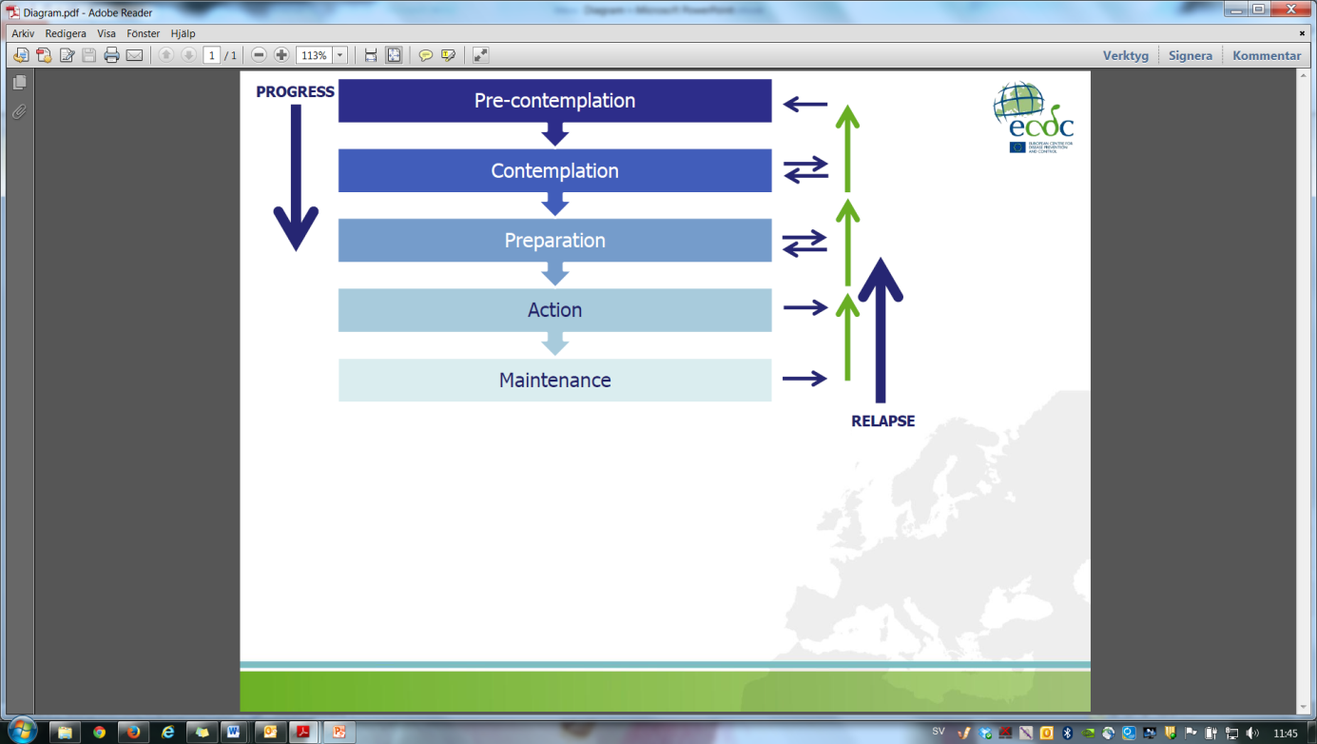
 | Pre-contemplation | Individual is unaware, and has no consideration or intention to adopt a particular behaviour.
 | Contemplation | Individual is aware and starting to comprehend and consider adopting a behaviour, and may be ready to seek more information about it.
 | Preparation | Individual is actively thinking about adopting a certain behaviour and is starting to make a commitment towards it.
 | Action | Individual performs or starts to perform a given behaviour.
 | Maintenance | Individual maintains the behaviour and combines it with his/her regular routine. Possibility of ‘relapse’ or return to one’s previous behaviour exists.
Stakeholder/s |  | Persons or organisations who are invested in the campaign, are interested in the evaluation results, and/or play a role in what will results from the evaluation. Representing their needs and interests throughout the process is fundamental to good campaign evaluation.  Key stakeholders in public health campaigns fall into three major groups:  Those involved in campaign operations:  - Programme managers and staff  - Local, state and regional coalitions interested in reducing inappropriate antibiotic use  - State and local health departments  - Funding agencies, such as national and state governments  Those served or affected by the campaign:  - Doctors, nurse practitioners, pharmacists and other healthcare providers  - Healthcare systems and the medical community  - Healthcare delivery organisations  - Healthcare insurers and insurer organisations  - Schools and educational groups  - Universities and educational institutions  - Childcare providers and organisations of childcare providers  - Community organisations  - Consumer advocacy groups  - Patients and the general public  The intended users of the evaluation results will vary with each specific evaluation and often the users comprise a subset of the individuals and groups listed in the prior two categories.
SWOT |  | A useful, structured way of depicting internal factors (strengths and weaknesses) and external factors (opportunities and threats) of a campaign in order for one to develop a clear action plan. The aim of this analysis is to use one’s strengths to: (i) take advantage of the available opportunities, (ii) counterbalance or improve the identified weaknesses, and (iii) lower the risk of potential threats, whilst also considering: (i) potential competition as well as existing opportunities and services that one may be able to make use of, and (ii) internal or external factors which may hinder or promote your campaign (e.g. funding). In summary:
 | Strengths |  | Weaknesses
Opportunities | How do we use the strengths to take advantage of these opportunities? |  | How do we overcome the weaknesses that prevent us taking advantage of these opportunities?
Threats | How do we use our strengths to reduce the likelihood and impact of these threats? |  | How do we overcome the weaknesses that will make these threats a reality?

Target audience |  | In order to develop a campaign strategy one must understand which groups of people need to change their behaviour. Once identified, this is what is called the target audience. A target audience may then be sub-divided into primary and secondary. The primary target audience is the main audience one wishes to target and the secondary audience is a group of individuals who influence the primary target audience in one way or other. They are not individuals who may be secondarily exposed to part of the campaign activities. Refer to ‘Segmentation and targeting’ for more information.

Sources:
- Andreasen A. Marketing and social change: changing behaviours to promote health, social development and the environment. San Francisco: Jossey-Bass; 1995.

- Andreasen AR. Marketing social marketing in the social change marketplace. J Public Policy Mark. 2002 Spring;21(1):3-13.

- Blair-Stevens C, Reynolds L, Christopoulos A. Behavioural theory: understanding the key influences on human behaviour. In: French J, Blair-Stevens C, McVey D, Merritt R, editors. Social marketing and public health: theory and practice. Oxford: Oxford University Press; 2010.

- Centers for Disease Control and Prevention. Introduction to program evaluation for public health programs: evaluating appropriate antibiotic use programs. Atlanta: CDC; 2006.

- Centers for Disease Control and Prevention. Social marketing: nutrition and physical activity [Internet]. [cited 2013 Oct 2]. Available from: www.cdc.gov/nccdphp/dnpa/socialmarketing/training

- Centers for Disease Control and Prevention. Workplace health promotion: glossary [Internet]. 2013 [updated 2011 Apr 25; cited 2013 Oct 2]. Available from: http://www.cdc.gov/workplacehealthpromotion/glossary/index.html#H

- Chen PF. Planning BCC interventions: a practical handbook. Thailand: UNFPA CST Bangkok; 2006.

- French J, Blair-Stevens C, McVey D, Merritt R, editors. Social marketing and public health: theory and practice. Oxford: Oxford University Press; 2010.

- Hastings G, Angus K, Bryant C, editors. The SAGE handbook of social marketing. London: SAGE Publications Ltd.; 2011.

- Independent Evaluation Group of the World Bank, in collaboration with the DAC Secretariat. Impact evaluation: an overview and some issues for discussion. 4th meeting, 30-31 March 2006. DAC network on development evaluation; 2006.

- Macdonald L, Cairns G, Angus K, Stead M. Evidence review: social marketing for the prevention and control of communicable disease. Stockholm: ECDC; 2012.

- McLeroy KR, Bibeau D, Steckler A, Glanz K. An ecological perspective on health promotion programs. Health Educ Q. 1988 Winter;15(4):351-377.

- Merritt R. Development. In: French J, Blair-Stevens C, McVey D, Merritt R, editors. Social marketing and public health: theory and practice. Oxford: Oxford University Press; 2010.

- National Cancer Institute. Theory at a glance: a guide for health promotion practice. 2nd ed. USA: U.S. Department of Health and Human Services, National Institutes of Health; 2005.

- Reynolds L, Merritt R. Scoping. In: French J, Blair-Stevens C, McVey D, Merritt R, editors. Social marketing and public health: theory and practice. Oxford: Oxford University Press; 2010.

- Stokols D. Translating social ecological theory into guidelines for community health promotion. Am J Health Promot. 1996 Mar-Apr;10(4):282-298.

- Titan Fitness Challenge. Readiness assessment: transtheoretical model of change [Internet]. 2013 [cited 2013 Oct 2]. Available from http://asi.fullerton.edu/tfc/applyNow.asp

- Weissman J, Besser RE. Promoting appropriate antibiotic use for pediatric patients: a social ecological framework. Semin Pediatr Infect Dis. 2004 Jan;15(1):41-51.

- Wold C. Module 1: overview of health indicators (part 1) [Internet]. [cited 2013 Oct 2]. Available from: www.nlm.nih.gov/

Course on the development, implementation and evaluation of prudent antibiotic use campaigns

Bibliography

Adriaenssens N, Coenen S, Tonkin-Crine S, Verheij TJM, Little P, Goossens H, on behalf of the ESAC Project Group. European surveillance of antimicrobial consumption (ESAC): disease-specific quality indicators for outpatient antibiotic prescribing. BMJ Qual Saf. 2011 Mar 21;Epub ahead of print.
Agenzia Italiana del Framaco. “Antibiotici. Difendi la tua difesa. Usali con cautela”. [internet]. 2012 [cited 2012 Oct 5]. Available from: http://www.agenziafarmaco.gov.it/it/content/antibiotici-difendi-la-tua-difesa-usali-con-cautela-0
Andreasen A. Marketing and social change: changing behaviours to promote health, social development and the environment. San Francisco: Jossey-Bass; 1995.
Andreasen AR. Marketing social marketing in the social change marketplace. J Public Policy Mark. 2002 Spring;21(1):3-13.
Ashe D, Patrick PA, Stempel MM, Shi Q, Brand DA. Educational posters to reduce antibiotic use. J Pediatr Health Care. 2006 May-June;20(3):192-197.
Biggs J. Teaching for quality learning at university. 2nd ed. Buckingham: The Society for Research into Higher Education and Open University Press; 2003.
Blair-Stevens C, Reynolds L, Christopoulos A. Behavioural theory: understanding the key influences on human behaviour. In: French J, Blair-Stevens C, McVey D, Merritt R, editors. Social marketing and public health: theory and practice. Oxford: Oxford University Press; 2010.
Borg M. National cultural dimensions as drivers of inappropriate ambulatory care consumption of antibiotics in Europe and their relevance to awareness campaigns. J Antimicrob Chemother. 2012 Mar;67(3):763-767.
Borg MA, Scicluna EA. Over-the-counter acquisition of antibiotics in the Maltese general population. Int J Antimicrob Agents. 2002 Oct;20(4):253-257.
Budge M, Deahl C, Dewhurst M, Donajgrodzki S, Wood F. Communications and behaviour change. UK: COI Publications; 2009.
Centers for Disease Control and Prevention. How to plan a successful Get Smart about antibiotics week. November 14th-20th, 2011 [internet]. Atlanta, GA: CDC; 2011. Available at: http://www.cdc.gov/getsmart/campaign-materials/week/gsw-doc/gsw-entire.pdf
Centers for Disease Control and Prevention. Introduction to program evaluation for public health programs: evaluating appropriate antibiotic use programs. Atlanta: CDC; 2006.
Centers for Disease Control and Prevention. Social marketing: nutrition and physical activity [Internet]. [cited 2013 Oct 2]. Available from: www.cdc.gov/nccdphp/dnpa/socialmarketing/training
Centers for Disease Control and Prevention. Workplace health promotion: glossary [Internet]. 2013 [updated 2011 Apr 25; cited 2013 Oct 2]. Available from: http://www.cdc.gov/workplacehealthpromotion/glossary/index.html#H
Charani E, Edwards R, Sevdalis N, Alexandrou B, Sibley E, Mullett D, Franklin BD, Holmes A. Behavior change strategies to influence antimicrobial prescribing in acute care: a systematic review. Clin Infect Dis. 2011 Oct;53(7):651-662.
Chen PF. Planning BCC interventions: a practical handbook. Thailand: UNFPA CST Bangkok; 2006.
Christmann S. Communique de presse: journée européenne consacrée à la résistance aux antibiotiques (European Antibiotic Awareness Day). Luxembourg: Le Gouvernement du Grand-Duché de Luxembourg; 2008.
Coenen S, Ferech M, Haaijer-Ruskamp FM, Butler CC, Vander Stichele RH, Verheij TJ, Monnet DL, Little P; Goossens H,ESAC Project Group. European surveillance of antimicrobial consumption (ESAC): quality indicators for outpatient antibiotic use in Europe. Qual Saf Health Care. 2007 Dec;16(6):440-445.
Coffman J. Public communication campaign evaluation: an environmental scan of challenges, criticisms, practice, and opportunities. Cambridge, MA: Harvard Family Research Project; 2002.
Colegio Oficial de Farmacéuticos de Asturias. Consejos de Salud. [internet]. 2012 [cited 2012 Oct 8]. Available from: http://www.farmasturias.org/GESCOF/cms/contenidos/contenido.asp?id=173&IdMenu=119
Core Group Social and Behavioral Change Working Group. Designing for behavior change curriculum. Washington: CORE Group; 2008.
Deschepper R, Grigoryan L, Stålsby Lundborg C, Hofstede G, Cohen J, Van Der Kelen G, Deliens L, Haaijer-Ruskamp FM. Are cultural dimensions relevant for explaining cross-national differences in antibiotic use in Europe? BMC Health Serv Res. 2008;8:123.
Donovan RJ. The role for marketing in public health change programs. Aust Rev Pub Aff. 2011 Jul;10(1):23-40.
Earnshaw S, Monnet DL, Duncan B, O’Toole J, Ekdahl K, Goossens H, European Antibiotic Awareness Day Technical Advisory Committee, European Antibiotic Awareness Day Collaborative Group. European antibiotic awareness day, 2008 - the first Europe-wide public information campaign on prudent antibiotic use: methods and survey of activities in participant countries. Euro Surveill. 2009 Jul 30;14(30):19280.
Europa press. Europa press. [internet] 2012 [cited 2012 Oct 8]. Available from: http://www.europapress.es/
Emmer CL, Besser RE. Combating antimicrobial resistance: intervention programs to promote appropriate antibiotic use. Infect Med. 2002;19(4):160-173.
European Antimicrobial Resistance Surveillance System. EARSS annual report 2008: on-going surveillance of S. pneumoniae, S. aureus, E. coli, E. faecium, E. faecalis, K. pneumoniae, P. aeruginosa. Bilthoven, The Netherlands: EARSS Management Team, members of the Advisory Board, and national representatives of EARSS; 2009.
European Centre for Disease Prevention and Control. Evaluation of the European Antibiotic Awareness Day (EAAD) 2011 [internal document]. Stockholm: ECDC, 2012.
European Centre for Disease Prevention and Control Public Health Training Section. Epidemiological methods applied to vaccine preventable diseases: train the trainers; 2012 Feb 21-23; Florence, Italy. Stockholm: ECDC; 2012.
European Surveillance of Antimicrobial Consumption. ESAC yearbook 2009. Antwerp, Belgium: ESAC Management Team, the ESAC Scientific Advisory Board and the ESAC National Networks; 2010.
Family Health International. Core module 1: introduction to monitoring and evaluation. Monitoring HIV/AIDS programs: a facilitator’s training guide. USA: A USAID Resource for Prevention, Care and Treatment; 2004.
Family Health International. Module 6: monitoring and evaluating behavior change communication programs. Monitoring HIV/AIDS programs: a facilitator’s training guide. USA: A USAID Resource for Prevention, Care and Treatment; 2004.
French J. Social marketing on a shoestring budget. In: French J, Blair-Stevens C, McVey D, Merritt R, editors. Social marketing and public health: theory and practice. Oxford: Oxford University Press; 2010.
French J, Blair-Stevens C, McVey D, Merritt R, editors. Social marketing and public health: theory and practice. Oxford: Oxford University Press; 2010.
Goberno de España. Sin tu ayuda, los antibióticos pueden perder su eficacia. 2012 [cited 2012 Oct 8]. Available from: www.antibioticos.msc.es
Gonzales R, Corbett KK, Leeman-Castillo BA, Glazner J, Erbacher K, Darr CA, Wong S, Maselli JH, Sauaia A, Kafadar K. The minimizing antibiotic resistance in Colorado project: impact of patient education in improving antibiotic use in private office practices. Health Serv Res. 2005 Feb;40(1):101-116.
Gonzales R, Corbett KK, Wong S, Glazner JE, Deas A, Leeman-Castillo B, Maselli JH, Sebert-Kuhlmann A, Wigton RS, Flores E, Kafadar K. Get smart Colorado: impact of a mass media campaign to improve community antibiotic use. Med Care. 2008 Jun;46(6):597-605.
Goossens H. Expert-proposed European strategies to monitor and control infection, antibiotic use, and resistance in health-care facilities. Lancet Infect Dis. 2011 Apr 7;11(5):338-340.
Goossens H, Coenen S, Costers M, De Corte S, De Sutter A, Gordts B, Laurier L, Struelens M. Achievements of the Belgian Antibiotic Policy Coordination Committee (BAPCOC). Euro Surveill. 2008 Nov 13;13(46):pii 19036.
Goossens H, Guillemot D, Ferech M, Schlemmer B, Costers M, van Breda M, Baker LJ, Cars O, Davey PG. National campaigns to improve antibiotic use. Eur J Clin Pharmacol. 2006 May;62(5):373-379.
Grier S, Bryant CA. Social marketing in public health. Ann Rev Public Health. 2005;26:319-339.
Hastings G, Angus K, Bryant C, editors. The SAGE handbook of social marketing. London: SAGE Publications Ltd.; 2011.
Health, the Elderly and Community Care. National antibiotic committee. [internet]. 2012 [cited 2012 Oct 13]. Available from: https://ehealth.gov.mt/HealthPortal/others/regulatory_councils/national_antibiotic_committee/download_material.aspx
Hemo B, Shamir-Shtein NH, Silverman BG, Tsamir J, Heymann AD, Tsehori S, Friedman NL. Can a nationwide media campaign affect antibiotic use? Am J Manag Care. 2009 Aug;15(8):529-534.
Huttner B, Goossens H, Verheij T, Harbarth S, CHAMP consortium. Characteristics and outcomes of public campaigns aimed at improving the use of antibiotics in outpatients in high-income countries. Lancet Infect Dis. 2010 Jan;10(1):17-31.
Huttner B, Harbarth S. “Antibiotics are not automatic anymore”: the French national campaign to cut antibiotic overuse. PLoS Med. 2009 Jun 2;6(6):e1000080.
Independent Evaluation Group of the World Bank, in collaboration with the DAC Secretariat. Impact evaluation: an overview and some issues for discussion. 4th meeting, 30-31 March 2006. DAC network on development evaluation; 2006.
International HIV/AIDS Alliance. 100 ways to energise groups: games to use in workshops, meetings and the community. Brighton: The International HIV/AIDS Alliance; 2002.
International Training and Education Center for Health. Ice breaker activities for training sessions [Internet]. 2004 August [cited 2012 Nov 16]. Available from: www.go2itech.org/HTML/TT06/.../IceBreakerActivTrngSess.doc
International Training and Education Center for Health. Training evaluation framework and tools (TEFT). 2011 [cited 2013 Jan 9]. Available from: http://www.go2itech.org/resources/TEFT
International Training and Education Center for Health. Training toolkit [Internet]. 2006 [cited 2013 Oct 2]. Available from: http://www.go2itech.org/HTML/TT06/toolkit/about/about.html
Istituto Superiore di Sanità. Antibiotici, usali con cautela: campagna di communicazione per un uso corretto degli antibiotic. [internet]. 2012 [cited 2012 Oct 3]. Available from: http://www.iss.it/binary/pres/cont/antibio09.pdf
Kaufman DM. ABC of learning and teaching in medicine: applying educational theory in practice. BMJ. 2003 Jan 25;326:213-216.
Knowles MS. Andragogy in action: applying modern principles of adult learning. San Francisco: Jossey-Bass; 1984.
Kolb D. Experiential learning: experience as the source of learning and development. Englewood Cliffs, New Jersey: Prentice-Hall; 1984.
Kotler P, Zaltman G. Social marketing: an approach to planned social change. J Mark. 1971 Jul;35(3):3-12.
Kristinsson KG. Modification of prescribers’ behavior: the Icelandic approach. Clin Microbiol Infect. 1999 Aug;5 (Suppl 4):S43-47.
Macdonald L, Cairns G, Angus K, Stead M. Evidence review: social marketing for the prevention and control of communicable disease. Stockholm: ECDC; 2012.
McLeroy KR, Bibeau D, Steckler A, Glanz K. An ecological perspective on health promotion programs. Health Educ Q. 1988 Winter;15(4):351-377.
McNulty CAM, Nichols T, Boyle P, Woodhead M, Davey P. The English antibiotic awareness campaigns: did they change the public’s knowledge of and attitudes to antibiotic use. J Antimicrob Chemother. 2010;65(7):1526-1533.
McVey D, Crossier A, Christopoulos A. Evaluation. In: French J, Blair-Stevens C, McVey D, Merritt R, editors. Social marketing and public health: theory and practice. Oxford: Oxford University Press; 2010.
Merritt R. Development. In: French J, Blair-Stevens C, McVey D, Merritt R, editors. Social marketing and public health: theory and practice. Oxford: Oxford University Press; 2010.
Mitsi G, Jelastopulu E, Basiaris H, Skoutelis A, Gogos C. Patterns of antibiotic use among adults and parents in the community: a questionnaire-based survey in a Greek urban population. Int J Antimicrob Agents. 2005 May;25(5):439-443.
Mosby’s Medical Dictionary. 9th edition. Missouri: Elsevier; 2013. Managed care; p.1087-1088.
Mölstad S, Erntell M, Hanberger H, Melander E, Norman C, Skoog G, Lundborg CS, Söderström A, Torell E, Cars O. Sustained reduction of antibiotic use and low bacterial resistance: 10-year follow-up of the Swedish Strama programme. Lancet Infect Dis. 2008 Feb;8(2):125-132.
National Antibiotic Committee. Annual report. [internet]. 2009 [cited 2012 Oct 15]. Available from: https://ehealth.gov.mt/HealthPortal/others/regulatory_councils/national_antibiotic_committee/download_material.aspx
National Cancer Institute. Making health communications programs work: a planner’s guide. USA: U.S. Department of Health and Human Services, National Institutes of Health; 2008.
National Cancer Institute. Theory at a glance: a guide for health promotion practice. 2nd ed. USA: U.S. Department of Health and Human Services, National Institutes of Health; 2005.
Neiger BL, Thackeray R, Van Wagenen SA, Hanson CL, West JH, Barnes MD, Fagen MC. Use of social media in health promotion: purposes, key performance indicators, and evaluation metrics. Health Promot Pract 2012 Mar;13(2):159-164.
Pantosti A, Del Grosso M, editors. Giornata europea degli antibiotici: uso responsabile per il controllo dell’antibiotico-resistenza. Rome: Istituto Superiore di Sanità; 2009.
Public Health England. Campaign resource centre: your one-stop shop for all PHE campaigns. FRANK [Internet] 2012 Jan 6 [cited 2013 Oct 4]. Available from: http://campaigns.dh.gov.uk/category/frank/
Reynolds L, Merritt R. Scoping. In: French J, Blair-Stevens C, McVey D, Merritt R, editors. Social marketing and public health: theory and practice. Oxford: Oxford University Press; 2010.
Ripoll Lozano MÁ. Con los antibióticos no se juega. Medicina General. 2002;42:167-168.
Sabuncu E, David J, Bernède-Bauduin C, Pépin S, Leroy M, Boëlle PY, Watier L, Guillemot D. Significant reduction of antibiotic use in the community after a nationwide campaign in France, 2002-2007. PLoS Med. 2009 Jun 2;6(6):e1000084.
Saunders RP, Evans MH, Joshi P. Developing a process evaluation plan for assessing health promotion program implementation: a how-to guide. Health Promot Pract. 2005 Apr;6(2):134-147.
Schön DA. Educating the reflective practitioner: toward a new design for teaching and learning in the professions. San Francisco: Jossey-Bass; 1990.
Schön DA. The reflective practitioner: how professionals think in action. Aldershot, England: Arena; 1995.
Smith WA, Strand J. Social marketing behavior: a practical resource for social change professionals. Washington: Academy for Educational Development; 2008.
Special Eurobarometer 338. Antimicrobial resistance: report. Brussels: TNS Opinion & Social; 2010.
Stokols D. Translating social ecological theory into guidelines for community health promotion. Am J Health Promot. 1996 Mar-Apr;10(4):282-298.
Tiley SM, MacDonald JJ, Doherty PL, Ferguson JK, Fergusson JE. Active promotion of antibiotic guidelines: an intensive programme. Commun Dis Intell Q Rep. 2003;27(Suppl):S13-18.
Titan Fitness Challenge. Readiness assessment: transtheoretical model of change [Internet]. 2013 [cited 2013 Oct 2]. Available from: http://asi.fullerton.edu/tfc/applyNow.asp
Turning point. Social marketing and public health: lessons from the field. New York: Turning Point National Program Office at the University of Washington; 2003.
Vlahović-Palčevski V. Reducing antibiotic use in Croatia. Lancet Infect Dis. 2010 Oct;10(10):670-671.
Weissman J, Besser RE. Promoting appropriate antibiotic use for pediatric patients: a social ecological framework. Semin Pediatr Infect Dis. 2004 Jan;15(1):41-51.
Wold C. Module 1: overview of health indicators (part 1) [Internet]. [cited 2013 Oct 2]. Available from: www.nlm.nih.gov/
World Health Organization. Evaluating training in WHO. Geneva: WHO; 2010.
World Health Organization. Evaluation of cost and effects of psychoactive substance use treatment: facilitator’s workshop guide. Geneva: WHO; 2000.
World Health Organization. Health programme evaluation: guiding principles for its application in the managerial process for national health development. Geneva: WHO; 1981.

DID: Defined daily doses per 1,000 inhabitants per day
ICPC-2-R: International classification of primary care, revised second edition
ATC: Anatomical therapeutic chemical classification system
ICPC-2-R: International classification of primary care, revised second edition
ATC: Anatomical therapeutic chemical classification system
ICPC-2-R: International classification of primary care, revised second edition
ATC: Anatomical therapeutic chemical classification system
DID: Defined daily doses per 1,000 inhabitants per day
ATC: Anatomical therapeutic chemical classification system
DID: Defined daily doses per 1,000 inhabitants per day
%: Percentage of the total consumption of antibacterials for systemic use (ATC: J01) in DID
Overuse in the winter quarters (October-December and January-March) compared with the summer quarters (July-September and April-June) of a one-year period starting in July and ending the next calendar year in June, expressed as a percentage: [DDD (winter quarters)/DDD (summer quarters) -1] x 100
ATC: Anatomical therapeutic chemical classification system
DID: Defined daily doses per 1,000 inhabitants per year

