Facilitator manual
Revised version April 2018
Course on the development, implementation and evaluation of prudent antibiotic use campaigns
Facilitator Guidelines
Course on development, implementation and evaluation of prudent antibiotic use campaigns
This document belongs to the training toolkit for the course on the “Development, implementation and evaluation of prudent antibiotic use campaigns”, commissioned by the European Centre for Disease Prevention and Control (ECDC) in 2013, under service contract no. ECDC/2011/029 with Karolinska Institutet, Sweden.

Authors: Senia Rosales Klintz, PhD, MSc (Microbiology); Erika Anne-Marie Saliba, MMSc (Global Health), RN, BSc (Nursing); Charlotta Zacharias, Lic. Med. Sci., MSc (International Health), MD; and Cecilia Stålsby Lundborg, Prof, PhD, MScPharm – Dept. of Public Health Sciences (Global Health/IHCAR), Karolinska Institutet.

Suggested citation: Rosales Klintz S, Saliba EA, Zacharias C, Stålsby Lundborg C. Course on the development, implementation and evaluation of prudent antibiotic use campaigns: facilitator manual. Stockholm: European Centre for Disease Prevention and Control; 2013.

You are free to:
- Share – copy, distribute and transmit the work
- Remix – adapt the work

Under the following conditions:
- Attribution – you must attribute the work in the manner specified by the author or licensor (but not in any way that suggests that they endorse you or your use of the work)
- Non-commercial – you may not use this work for commercial purposes
- Share Alike – if you alter, transform, or build upon this work, you may distribute the resulting work only under the same or similar license to this one

With the understanding that:
- Waiver – any of the above conditions can be waived if you get permission from the copyright holder
- Public Domain – where the work or any of its elements is in the public domain under applicable law, that status is in no way affected by the license
- Other Rights – in no way are any of the following rights affected by the license:
  - Your fair dealing or fair use rights, or other applicable copyright exceptions and limitations
  - The author's moral rights
  - Rights other persons may have either in the work itself or in how the work is used, such as publicity or privacy rights
- Notice – for any reuse or distribution, you must make clear to others the license terms of this work

Original: Stockholm, October 2013. Revision: April 2018.

Acknowledgments
We would like to express our gratitude to the following persons for their valuable comments during the revision of this course package.

- Giovanni Mancarella, Sarah Earnshaw, Dominique Monnet, Barbara Albiger, Sonsoles Guerra, Irina Dinca, Andrea Mendez, Nabil Safrany and Ülla-Karin Nurm – ECDC
- Ashish Pathak, Meena Daivadanam, Hana Taha, Maria Polyzoi, Myroslava Protsiv and Ioana Vlad – Dept. of Public Health Sciences (Global Health/IHCAR), Karolinska Institutet
- Taina Mäntyranta and Mairi Juriska – Dept. of Learning, Informatics, Management and Ethics (LIME), Karolinska Institutet
- Liselotte Schäfer Elinder – Dept. of Public Health Sciences (Social Medicine), Karolinska Institutet
- Anna Nyberg – Stockholm School of Economics, Sweden
- Vera Vlahović-Palčevski – University of Rijeka Medical Faculty, Croatia
- Christiana Salvi – WHO/Europe
- Courtney Dowd – Public Health Agency of Canada
- Mats Erntell – Swedish Strategic Programme against Antibiotic Resistance (Strama)

Course on the development, implementation and evaluation of prudent antibiotic use campaigns
Facilitator manual

Table of contents
Abbreviations iv
Introduction 1
1.1 Background: EAAD campaign development 3
1.2 The inception of this course 3
1.3 Description of the course content 4
1.4 General recommendations 7
Preparation and implementation 11
2.1 Pre-course package 14
2.2 Face-to-face course 17
2.3 Post-course package 85
Training evaluation plan and tools 87
3.1 Introduction to course evaluation 89
3.2 Evaluation level one (reaction) 91
3.3 Evaluation level two (learning) 92
3.4 Evaluation level three (behaviour) 93
Bibliography 95
Glossary 105
Annex one: Checklists
Annex two: Ice breakers, energisers and group activities
Annex three: Group work
Annex four: Case studies
Annex five: Indicators list
Annex six: Evaluation tools

Abbreviations
ATC | Anatomical therapeutic chemical classification system
BCC | Behaviour change communication
BCI | Behaviour change intervention
CDC | Centers for Disease Control and Prevention
DDD | Defined daily doses
DID | Defined daily doses per 1,000 inhabitants per day
EAAD | European Antibiotic Awareness Day
ECDC | European Centre for Disease Prevention and Control
EMRSA | Endemic strain of MRSA
EU | European Union
GP | General practitioner
HCP | Healthcare professional
I | Introduction
ICPC-2-R | International classification of primary care, revised second edition
ICU | Intensive care unit
IEC | Information, education and communication
ILO | Intended learning outcome
MHS | Maccabi Healthcare Services
MRSA | Methicillin-resistant Staphylococcus aureus
NGO | Non-governmental organisation
NHI | National health insurance
Q & A | Question and answer
RTAS | Rapid tests to diagnose group A streptococci
RTI | Respiratory tract infection
S | Session
SWOT | Strengths, weaknesses, opportunities, threats
URI | Upper respiratory infections
VISA | Vancomycin-intermediate resistant Staphylococcus aureus
VRI | Viral respiratory infections
VRSA | Vancomycin-resistant Staphylococcus aureus
WHO | World Health Organization

Course on the development, implementation and evaluation of prudent antibiotic use campaigns

Introduction

1.1 Background: EAAD campaign development
The European Antibiotic Awareness Day (EAAD) is a European public health initiative led by the European Centre for Disease Prevention and Control (ECDC). Since 2008, EAAD, held during the week of November 18th, has been used as a platform to raise awareness about the threat of antibiotic resistance to public health and to communicate about prudent antibiotic use. EAAD builds on the successful awareness campaigns on appropriate antibiotic use at national level by Member States.
The goal of EAAD is to provide an evidence-based focus for national campaigns, as well as key messages, campaign materials, technical and political support. In addition, EAAD has been able to secure political support at European Union (EU)-level and across the Member States through engagement with the rotating EU Presidency, as well as members of the European Parliament, national health ministers and chief medical officers.
In the initial stages of EAAD (2008-2010), the campaign worked towards developing key messages and campaign materials targeting the general public, primary care and hospital prescribers. ECDC together with the European Commission, World Health Organization (WHO) Regional Office for Europe, national antimicrobial resistance focal points, professional societies and other experts in the field, developed communication toolkits. These toolkits included templates for campaign materials which could be adapted at national level, as well as guidelines for campaign implementation. An EAAD website is available in all official EU languages (http://antibiotic.ecdc.europa.eu).
In 2011-2012, the focus of EAAD shifted towards consolidation, with activities to support the development, implementation and evaluation of national prudent antibiotic use campaigns. In this context, ECDC intends to support the consolidation and further development of effective prudent antibiotic use campaigns at national level.

1.2 The inception of this course
With the realisation that Member States have a need for better understanding on campaign planning and evaluation, ECDC initiated the development of this reference curriculum. The main aim of this training module on the development, implementation and evaluation of prudent antibiotic use campaigns is to have a reference curriculum and toolkit that can be used as a basis to organise training courses at national level that will strengthen participants’ knowledge and skills on prudent antibiotic use campaigns.

1.3 Description of the course content
1.3.1 Overview of the course curriculum
1.3.1.1 Aim and general intended learning outcomes
The aim of this course is to provide planners and implementers of prudent antibiotic use campaigns with the basic knowledge and skills required to plan, conduct and evaluate such campaigns.
Learning outcomes are classified according to Bigg's structure of observed learning outcomes taxonomy. By the end of the course, participants should be able to:
- understand and explain the rationale, key elements and steps required to develop behaviour change communication campaigns on prudent antibiotic use,
- understand and apply basic social marketing concepts in the development, implementation and evaluation of behaviour change communication campaigns on prudent antibiotic use,
- design and implement behaviour change communication campaigns on prudent antibiotic use,
- identify and select appropriate indicators, methods and tools for evaluation of behaviour change communication campaigns on prudent antibiotic use, and
- design and implement an evaluation work plan for behaviour change communication campaigns on prudent antibiotic use.
1.3.1.2 Learning opportunities
The course will provide appropriate learning opportunities for participants to acquire:
- knowledge on:
  - basic concepts regarding behaviour change communication campaigns, including theoretical underpinnings and planning frameworks,
  - key elements of a social marketing plan for development of behaviour change communication campaigns on prudent antibiotic use,
  - strategies to overcome implementation barriers related to resource limitations (budget, time and staff constraints), and
  - basic concepts on evaluation methods and tools.
- skills related to:
  - stepwise design and implementation of a social marketing plan for a behaviour change communication campaign on prudent antibiotic use, including but not limited to, market research (formative evaluation and segmentation) and marketing mix formulation (product, price, place, promotion), and
  - stepwise planning for evaluation of a behaviour change communication campaign on prudent antibiotic use.
1.3.1.3 Course structure
The course consists of three components:
- A pre-course package to assist participants in their preparation for the face-to-face course.
- A 2.5-day face-to-face course divided into three modules:
  - Module 1: Introduction to the development of campaigns on prudent antibiotic use
  - Module 2: Implementation of prudent antibiotic use campaigns
  - Module 3: Introduction to evaluation of prudent antibiotic use campaigns
- A post-course package to evaluate course outcomes and to follow-up participant’s application of the knowledge and skills acquired during the training.
1.3.1.4 Training methods
This course has been developed for adult participants with some or even vast experience in the field of campaign development, particularly for promoting appropriate antibiotic use. Thus an andragogy approach has been used with ideologies taken from two theories, experiential learning theory (Kolb, 1984) and the theory of reflective practice (Schön, 1995; Schön, 1990).

Andragogy is “the art and science of helping adults learn” (Knowles, 1984), and contains seven principles which one should keep in mind whilst delivering this course:
- Establish an effective learning climate, where learners feel safe and comfortable expressing themselves.
- Involve learners in mutual planning of relevant methods and curricular content.
- Involve learners in diagnosing their own needs; this will help trigger internal motivation.
- Encourage learners to formulate their own learning objectives; this gives them more control of their learning.
- Encourage learners to identify resources and devise strategies for using the resources to achieve their objectives.
- Support learners in carrying out their learning plans.
- Involve learners in evaluating their own learning; this can develop their skills of critical reflection (Kaufman, 2003).

This course uses participants’ experiences as a point of departure and builds up from there, inserting core content blended with experience as the course progresses. The training methods include lectures and interactive presentations to introduce relevant concepts related to the course topics. In addition, the course uses group discussions and group work to make use of participants’ experiences and promote their active involvement in their learning process and group interaction. Case studies are used to support the integration and application of knowledge acquired throughout the course. All teaching activities aim at enhancing the participant’s ability to apply key concepts and theory/theoretical frameworks, in an analytical and reflective practice of their own.

 | Facilitator notes
 | Keep in mind that the teaching methods provided are only suggestions and that flexibility strengthens this course. Therefore feel free to alter the teaching methods suggested as required.

1.3.2 Training materials
This toolkit consists of three main documents, (i) the facilitator manual, (ii) a participant workbook and (iii) PowerPoint presentations. A description of each is provided below. Further details and recommendations on how to work with all the documents are provided within each section.
1.3.2.1 The facilitator manual
The facilitator manual includes all components included within the course. The main aim of this comprehensive toolkit is to guide the facilitation team during the planning, implementation and evaluation of this training course. It includes practical information, teaching resources and numerous tools which may be used throughout the course.
The materials provided are intended as a suggested core structure for teaching and may thus be adjusted to one’s preference and/or teaching style, as well as to the target group. This manual and the complementary training materials can be used as a basis to organise training courses at national level or otherwise. Recommendations are provided throughout the manual for ease of use through easily identifiable icons to guide the facilitator.
The manual consists of the following main sections:
- Introduction: gives an overview of the curriculum and intended learning outcomes, and general recommendations on the composition of the facilitation team and on how to plan and prepare for the course.
- Preparation and implementation: this section is sub-divided in alignment with the main components of the course curriculum as follows: (i) pre-course package, (ii) face-to-face course, and (iii) post-course package.
- Training evaluation tools: describes the objectives, methodology and tools for assessing participants’ learning and progress during and after the training.
- Annexes: include supplementary checklists, case studies and group work material, indicators list, and assessment materials which may be used before, during and after the course.
1.3.2.2 The participant workbook
The participant workbook has been designed to mirror the facilitator manual. It includes most of the components provided in the facilitator manual with the major exception being the PowerPoint slides. These could either be provided as printouts prior, during or after the course, depending on your teaching preference. All participants should receive the workbook prior to the course in order for them to familiarise themselves with it. It includes the course schedule, group work sheets, case studies, an indicators list and further resources. As a facilitator it is important to familiarise yourself with this document in order to be able to guide the participants throughout the course.
1.3.2.3 PowerPoint presentations
PowerPoint presentations are provided separately as individual files. They can be used with or without modifications, or complimentary to other materials one may believe more appropriate to the teaching context. Comments and suggestions are provided in the notes section of the individual PowerPoint files. For ease of use, the presentations and relevant comments have been inserted in the face-to-face section of Chapter 2.
Facilitator notes
Please note that participants do not have any copies of the PowerPoint presentations in their workbooks therefore it may be wise to prepare print outs of the presentations before the face-to-face course, to distribute either before or after each session, as preferred. If you are using a web-based platform you may also upload the PowerPoint presentations as the course progresses.

1.4 General recommendations
1.4.1 The facilitation team
The facilitation team should include people who are knowledgeable within the:
- context you are providing the course, and
- topics provided during the course.
If you are working within an organisational structure it would be beneficial that the facilitation team is familiar with it.

Preferably, facilitators should have experience in campaign development (either in general or particular to prudent antibiotic use), and adult education methodology and participatory learning, complimented with knowledge in the field of prudent antibiotic use. Therefore, we propose that the facilitation team at least consists of a behaviour change scientist, a medical doctor specialized in infectious diseases (e.g. medical microbiologist, infectiologist or infectious disease control specialist), an education specialist and a communication specialist.

It is also recommended to take into consideration the characteristics of a good facilitator (Box 1) when selecting the facilitation team.

Box 1. Qualities of a good facilitator
- Trust in others and their capacities
- Good listening skills
- Good presentation skills
- Ability to create an atmosphere of confidence among participants
- Respects others’ opinions
- Flexibility in changing methods and sequences as needed
- Knowledge of group processes, including the ability to sense the group’s mood at any given time and adjust the programme accordingly
- Familiarity with the culture, needs, strengths and limitations of the participants, and respect for individual differences
- Organisation skills
Once the composition of the facilitation team has been decided, plan the distribution of responsibilities and tasks among the facilitators well ahead of time. At least one or two of the facilitators should take on a leadership role and should be actively involved throughout the course, i.e. pre-course, during the course and post-course. They should also act as moderators throughout the course.
If there is a gap in the facilitator’s knowledge base, identify an expert consultant to whom questions from the participants can be forwarded during or after the course. It is recommended that the facilitators familiarise themselves with the whole package, including sessions they may not be involved in. Planning meetings with the entire facilitation team are thus highly recommended in which queries can be discussed and the sessions planned appropriately. It is also possible to organise a team building session to bring the facilitation team together as a group.
The role of the facilitation team can be summarised as follows:
- Before the training:
- Familiarise oneself with the materials
- Modify the materials if necessary
- Prepare the materials needed for the course, e.g. handouts
- Coordinate the logistics of the course, e.g. venue, equipment
- Initiate contact with participants pre-course (main facilitator/s)
- Coordinate and overlook pre-course activities (main facilitator/s)
- During the training:
- Create a friendly learning environment
- Facilitate interactive discussions
- Be actively available to participants throughout the course
- Lead activities
- Teach the curriculum so that participants gain knowledge and skills
- Provide opportunities for feedback
- Adapt to required changes onsite
- Support participants as needed during group work activities
- After the training:
- Send the post-course evaluation survey
1.4.2 The target group
The course has been developed for a multidisciplinary audience of 30 participants in total, comprising healthcare professionals, such as infectious disease specialists, microbiologists and pharmacists, as well as communication experts and press officers responsible for the design and implementation of EAAD campaigns at national level in the EU Member States.
Participants should be selected based on their expertise, personal interest and commitment on the topic of promoting prudent antibiotic use in their settings. If the course is to be delivered at a European-wide level, it is recommended that, when possible, at least two persons per focal point participate in the course. This strategy might facilitate the implementation of activities by the participants after finalising the training.
1.4.3 Planning and preparatory considerations
Course venue
The location of the face-to-face course should be carefully selected. It should be large enough to allow comfortable seating as well as providing enough space for small groups to work without disturbing each other. A desk on which to work on is a basic requirement. A recommended layout is to group participants on tables of six in preparation for the group work activities which will be carried out throughout the course. However be creative and move seating as desired and as you see most fit for the purpose of this course. Auditorium settings are not recommended unless there are more rooms available to carry out group work sessions. If more than one room is used, these should not be far apart from each other in order for the facilitators to be able to move from one room to another easily.
A wireless local area network may act as a distraction during the course. We therefore suggest that it is not provided to course participants unless otherwise required for course purposes. It is however up to the facilitation team’s discretion to decide whether or not it should be made available. Keep in mind that you will be working with an adult group.
Equipment and materials
To facilitate the preparation of equipment and materials, several checklists have been included throughout the manual as suggestions of things to consider during the planning stages of the training. A full list of the checklists is also available in Annex 1.
Online platform (optional)
If you choose to deliver this course using a blended learning approach, and you therefore plan on using an online platform, ensure its development well in advance of the face-to-face course to allow time for fruitful discussions and for the participants to acquaint themselves with the course and its contents. The online platform can also be used to upload pre-course reading materials, the course schedule and PowerPoint presentations during the course.

 | Checklist no. 1  Initial planning and preparation (three months prior the training)
 | Define the training team
 | Draft training budget and planning timeline
 | Send announcements to potential participants
 | Select participants (and prepare a reserve list)
 | Identify and reserve the face-to-face course venue
 | Send invitations to selected participants
 | Book lodging for out-of-town participants
 | Arrange for travel and per diem reimbursements for out-of-town participants

Course on the development, implementation and evaluation of prudent antibiotic use campaigns

Preparation and implementation

In this section you will find suggested instructions on how to implement the pre- and post-course packages as well as detailed guidelines for the face-to-face course. All materials that you will require are provided or otherwise referenced to the original sources.
Important elements have been highlighted in the text using icons for easy visualisation of the different components. Below is a list of the icons used and their meaning.
 | Additional reading
 | Checklist
 | Coffee break
 | Facilitation team meeting
 | Facilitator notes/Attention
 | Group work activity
 | Lunch break
 | PowerPoint presentation
2.1 Pre-course package
The purpose of the pre-course package is to assist participants in their preparation for the face-to-face course, to provide background information on the design, implementation and evaluation of prudent antibiotic use campaigns and, if possible, to initiate discussion among participants and facilitators prior to the face-to-face course.
The suggested methodology for this component of the training is self-directed learning, supported with materials which may be provided using either a web-based platform, or if this is not possible, using more conventional communication means such as electronic mail or post. Plan the preparation timeline according to the communication channel selected. Some key points to be considered are suggested in Checklist no. 2.
Participants should complete the following tasks within one month prior to their attendance to the face-to-face course:
- Pre-course exercise (optional activity): The objective of this activity is to assess participants’ experiences and knowledge on social marketing and behaviour change communication campaigns as well as methods for evaluation. This exercise may help the facilitator’s to gain a general idea of where the participants stand before the course. It could also act as a baseline for future post-course evaluation if desired by the team. The tool for this exercise can be found in Annex 6. It is possible to modify it according to your needs.
- Required pre-course reading: Participants must have access to the electronic files or printed versions of the following research articles:
- Charani E, Edwards R, Sevdalis N, Alexandrou B, Sibley E, Mullett D, Franklin BD, Holmes A. Behavior change strategies to influence antimicrobial prescribing in acute care: a systematic review. Clin Infect Dis. 2011 Oct;53(7):651-662.
- Huttner B, Goossens H, Verheij T, Harbarth S, CHAMP consortium. Characteristics and outcomes of public campaigns aimed at improving the use of antibiotics in outpatients in high-income countries. Lancet Infect Dis. 2010 Jan;10(1):17-31.
- Macdonald L, Cairns G, Angus K, Stead M. Evidence review: social marketing for the prevention and control of communicable disease. Stockholm: ECDC; 2012.
- Saam M, Huttner B and Harbarth S World Health Organization Expert Committee on the Selection and Use of Essential Medicines. Evaluation of antibiotic awareness campaigns, Geneva, 2017.
- Pre-course assignment: This assignment allows the facilitation team to better understand participants’ backgrounds and expertise prior to the face-to-face course. It also gives the participants a chance to reflect upon certain issues before the start of the course and to define a problem in their own setting (if applicable). Below are two suggestions for exercises that can be requested, although other ideas and exercises are of course welcome to be added to the list.
- Outline of the upcoming EAAD national campaign that the participants are planning to implement, including country-specific challenges on:
  - How to address a target group
  - How to implement the campaign components, including:
- Budget
- Evaluation
- Brief description of a situation related to antibiotic use/misuse requiring a behaviour change intervention in the participant’s own setting.

- Preparation for exhibition of campaign materials (day 2 coffee break activity): As part of a coffee break activity on day 2 of the face-to-face course, an exhibition of campaign materials such as posters and audio-visuals, will be set up to introduce the concept of pre-testing and exchange creative ideas on campaign materials. Participants will be asked to give their comments on the materials and vote for their favourite. In preparation for this, before the course starts, ask participants to bring any printed materials currently being used, or from past EAAD campaigns in their country, on day 1 of the face-to-face course. It is also possible for them to send other types of audio-visual materials (e.g. videos, TV spots, radio spots, links to web pages) in advance.
- Preparation for learning coffee activity (day 2, session 6): Ask participants whether they are willing to share specific experiences during a course activity. If so, contact those who volunteer to take up the role, in order to clarify the topic and what is expected from them. Give them specific instructions on how you expect them to lead the table discussions. Prior to the start of the face-to-face course, organise the number of topics/tables that you will need to set-up in advance. More details on the specific activity can be found in the next section (Section 2.2) under day two, session six.

Checklist no. 2
Before the pre-course package (two months prior to the training)

If you are using a web-based platform to communicate with participants:
- Design or adapt the web-based tool for training purposes
- Upload reading materials and exercises
- Send usernames, passwords and instructions on how to access the web-based platform to participants
If you are using e-mails to communicate with participants:
- Verify contact information of each participant
- Prepare electronic files to be sent to the participants
- Prepare a message template containing general instructions for the pre-course package
- Send e-mails with all the attached documents
- Confirm receipt of delivery of the information by all participants
If you are using post and phone calls to communicate with participants:
- Verify contact information of each participant
- Prepare copies of the documents to be sent to the participants
- Prepare a letter template containing general instructions for the pre-course package
- Send post with all the documents
- Confirm receipt of delivery of the information by all participants

2.2 Face-to-face course
2.2.1 Preparation
The suggested materials for the face-to-face course (Checklists nos. 3 & 4) should preferably be prepared a month ahead of the selected date to conduct the course. If necessary, materials should be revised and adapted to the needs of the specific group of participants. It is therefore strongly recommended to meet the whole facilitation team in advance to plan the course in detail, including rehearsals of the main sessions or activities.

Checklist no. 3
Before the face-to-face course (one month prior to the training)
Prepare training materials
Purchase all training-related supplies:
- Whiteboard markers
- Permanent markers
- Flipcharts
- Name tags
- Note pads
- Folders or binders for participant’s material pack
- Post-it notes (different colours)
- Magnets
- Tape
Book catering services for coffee-breaks and lunches
Conduct facilitator planning and team-building meetings

 | Checklist no. 4  Supplies and equipment (one week prior to the face-to-face course)
Assemble participants’ packs containing:
- Participant workbook
- Notepads
- Pens and/or pencils
- Reading material (articles, reports, etc.) to distribute during the course
Prepare or photocopy handouts
(NB. Handouts are not provided in this manual. If developed by the team, they should be prepared after the PowerPoint presentations have been adapted or modified.)
 | Confirm participants’ arrival times, lodging arrangements, travel and per diem reimbursements
Equipment:
- Laptop
- Projector and screen
- Whiteboard (or equivalent)
- Flipcharts
- Camera (to document the training sessions if desired)
- Secure access to copier and/or printer
- If possible, internet connection
 | PowerPoint presentations and speaker notes
 | Extra schedules

2.2.2 Suggested course schedule
The following proposed schedule is based on the assumption that the face-to-face course will be developed as a 2.5-day training, where a maximum of 30 participants will gather at a selected venue.

Day 1
Module 1: Introduction to the development of prudent antibiotic use campaigns

Time | Duration | Session (S)
8:45 | 15 min | Arrival to the venue
9:00 | 1 hr 30 min | I1: Introduction to day 1  - Welcome  - Introduction of the facilitation team (10-15 min) and participants (20 min)  - Expectations (10-15 min)  - Course overview and agenda including course objectives and schedule (10-15 min)  - Presentation on EAAD (10 min)
10:30 | 30 min | ~ Coffee break ~  Including: networking activities
11:00 | 10 min | Feedback from the coffee break activity
11:10 | 1 hr 20 min | S1: Problem description  - Interactive session: plenary session on participant’s pre-course assignment (40 min)  - Facilitator presentation (40 min)
12:30 | 1 hr | ~ LUNCH ~
13:30 | 30 min | S2: Stepwise planning  - Facilitator presentation
14:00 | 1 hr | S3: Formative evaluation  - Case studies discussion (10 min)  - Facilitator presentation (50 min)
15:00 | 20 min | ~ Coffee break ~
15:20 | 2 hrs | Group work: initial development of a campaign strategy  - General instructions and initial development of a campaign strategy
17:20 | 20 min | Feedback session on the group work progress
17:40 | 20 min | Wrap-up & assignments for next day
18:00 |  | End of day 1

Day 2
Module 1: Introduction to the development of prudent antibiotic use campaigns

Time | Duration | Session (S)
9:00 | 30 min | I2: Introduction to day 2  - Q&A session and day 1 summary
9:30 | 1 hr | S4: Strategy development  - Facilitator presentation (30 min)  - Case studies (30 min)
10:30 | 30 min | ~ Coffee break ~  Including: presentation of posters, audio-visual and other promotional material used by the participants in their previous campaigns
11:00 | 20 min | Feedback from the coffee break activity
11:20 | 1 hr 30 min | S5: Prototyping and pre-testing  - Facilitator presentation (30 min)  - Case studies (1 hr)
12:30 | 50 min | ~ LUNCH ~
Module 2: Implementation of prudent antibiotic campaigns

13:00 | 1 hr 30 min | S6: Implementation  - Learning coffee: interactive session for exchange of ‘best practices’ and experiences among participants (1 hr)  - Facilitator presentation (30 min)
14:30 | 15 min | ~ Coffee break ~
Module 3: Introduction to the evaluation of prudent antibiotic use campaigns

14:45 | 1 hr | S7: Evaluation  - Facilitator presentation (30 min)  - Case studies (30 min)
15:45 | 2 hrs | Group work: development of a campaign strategy
17:45 | 15 min | Wrap-up
18:00 |  | End of day 2

Day 3
Module 3: Introduction to the evaluation of prudent antibiotic use campaigns

Time | Duration | Session (S)
9:00 | 30 min | I3: Introduction to day 3  - Q&A session and day 2 summary
9:30 | 2 hrs 30 min | Group presentations  Including: coffee break
12:00 | 30 min | Wrap-up
12:30 |  | End of day 3

Facilitator notes
Before the face-to-face course begins each day, the facilitation team should:
- Review the schedule and make modifications if needed (i.e. coffee-breaks and lunch times can be modified)
- In general, it is not recommended to alter the order of the sessions
For each session, the intended teaching objectives, suggested duration, materials required and training methods are described.

2.2.3 Day 1 sessions

I1: Introduction to day 1
Teaching objectives | - To create a welcoming atmosphere and to facilitate group interaction  - To introduce the participants and the facilitator team  - To present the course schedule  - To explain course objectives and methodology
Time | 1 hour 30 minutes
Materials | Name tags, markers, pens, post-it notes, whiteboard, flipchart, PowerPoint presentation, facilitator manual, participant workbook
Type of session | - Interactive  - Facilitator presentation

Facilitator notes
The opening session will set the tone of the course; therefore, your facilitation style should invite participants to a friendly and welcoming atmosphere.
Welcome the participants as they arrive to the course venue and invite them to make use of their name tags.

Remember
Collect all the materials brought by the participants for the coffee break activity on day 2, and organise them appropriately.

Task I1.1: Introductions (30-35 minutes)
- Begin the course by welcoming participants and introducing yourself and other members of the team.
- If you prefer, it is possible to conduct an introductory ice-breaking activity to allow participants to get acquainted with one another. More details can be found in the section on ice-breakers, energisers and group activities (Annex 2). The purpose of the activity is to get to know general information on the participants such as names, organisations and work sites.
Task I1.2: Expectations (10-15 minutes)
- Ask participants to take two minutes to write down two expectations of the course. Alternatively, you could ask them to write their expectations directly on post-it notes and stick them on the whiteboard.
- Ask participants to share their expectations with the group. Write their comments on the flipchart or whiteboard. If post-it notes have been used, members of the facilitation team could help to sort them by themes, before moving on the next step.
- Explain whether or not the course will address each of the shared expectations.
Task I1.3: Course overview and agenda (10-15 minutes)
- As a continuation of the discussion on participants’ expectations, present the intended learning outcomes (ILOs) of the training. Direct participants to the ILOs in the first section of their participant workbook (Chapter 1) and/or complement with the suggested PowerPoint below.
- Go through the ILOs and make sure that participants understand them.
- Direct participants to the course schedule in the first section of their participant workbook (Chapter 1).
- Briefly review the course schedule, explaining how the modules and sessions will build upon each other to achieve the ILOs.
- Introduce the training norms (optional). A possible approach to this is to briefly read the training norms that would have been written in advance on a flipchart sheet (Box 2).
- Ask participants whether there is any other rule they would like to suggest.
Box 2. Training norms
- Everyone participates, no one dominates
- Help us to stay on track with the schedule
- One speaker at a time
- Be an active listener
- Keep an open mind
- Turn off mobile phones
- Talk loud enough for all to hear

Welcome presentation
 | PowerPoint presentation  Welcome!  Number of slides: 4
Slide | Key points
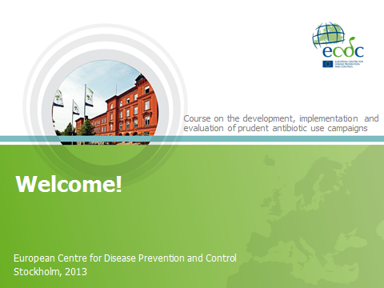 | Use this slide at the beginning of the course to welcome participants to the venue
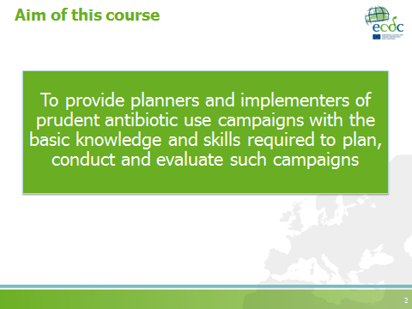 | Use this slide to:  - Clarify expectations  - Communicate the ultimate goal of the course: participants should know why social marketing is a good tool for planning EAAD campaigns and must feel that they are capable of achieving good results (self-efficacy)
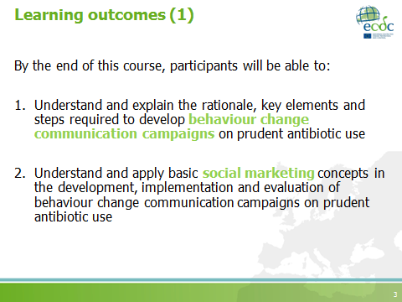 | Since participants have the workbooks with the learning outcomes, you can emphasise only what is highlighted in the slides.
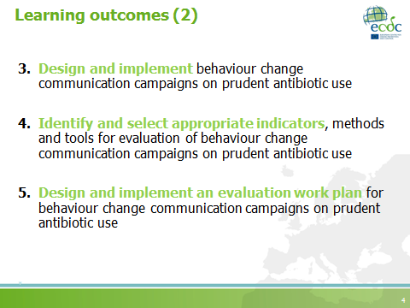 | Since participants have the workbooks with the learning outcomes, you can emphasise only what is highlighted in the slides.

European Antibiotic Awareness Day presentation (10 minutes)
A presentation on EAAD is provided in this toolkit. You can use it to inform the participants about EAAD and its current goals and vision. Be aware however that the presentation provided needs to be kept up-to-date with the most current EAAD campaign strategies. Therefore, if you choose to use it, modify it accordingly.

Coffee break
Duration: 30 minutes

Facilitator notes
Note that this coffee break includes a networking activity. Instructions to the activity are provided below.

NB. It is recommended that the activity last no longer than 15 minutes. However, please note that the time allocated to the actual networking activity can be modified according the number of participants.

Coffee break networking activity
Teaching objectives | To promote networking among participants
Time | 15-20 minutes
Materials | Post-it notes, pens, timer
Type of session | Interactive

- Before announcing the coffee break, explain to the activity’s rules to the participants.
- Each participant should have a pen and some post-it notes.
- During the coffee break the group will go on a ‘networking speed-dating’ activity.
- After participants have taken coffee and refreshments (approximately 15 minutes), a facilitator will announce the start of the speed-dating. It is recommended to use a bell or a sound-producing instrument, to indicate when to start the activity and when to change partners.
- Each round will last 5 minutes.
- Each participant should establish contact with at least two (ideally three) course participants, who are not from the same country and/or institution.
- During the 5-minute conversation, they should agree (at least) to:
  - one idea for future collaboration, OR
  - one activity to exchange experiences on campaign development (e.g. meeting during the course, e-mail contact).
The ‘agreement’ should be written on the post-it notes (one per person).

Feedback session: after the coffee break activity
Time | 10 minutes
Materials | Whiteboard, flipcharts, whiteboard markers, permanent markers
Type of session | Brainstorming (in plenary)
- Ask the participants about their impression of the speed-dating activity.
- You can also ask them to share some of the ‘agreements’ achieved during the coffee break.
- Take the opportunity to encourage them to develop new contacts/collaborations during the course.
- Also clarify that the course does not focus on networking activities but it can provide plenty of opportunities for interaction among the participants.

S1: Problem description
Teaching objectives | To explain the key elements to consider when identifying and defining the problem
Time | 1 hour 20 minutes
Materials | Whiteboard, whiteboard markers, PowerPoint presentation
Type of session | - Interactive discussion (40 minutes)  - Facilitator presentation (40 minutes)
Interactive discussion session (40 minutes)
Based on the pre-course assignments:
- Ask participants to share some of the ‘situations’ or ‘problems’ they are currently facing in their setting.
- Use the whiteboard to summarise key words and/or categories of the issues presented by participants.
- Encourage participants to approach those colleagues with similar problems.
- Use the session’s summary to introduce the presentation on ‘Problem description’.

PowerPoint presentation
Problem description
Number of slides: 25
Duration: 40 minutes
Slide | Key points
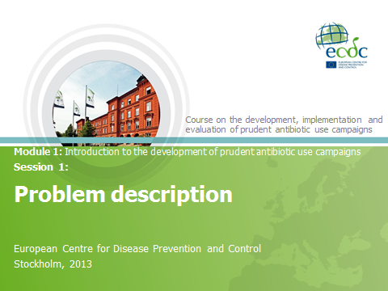
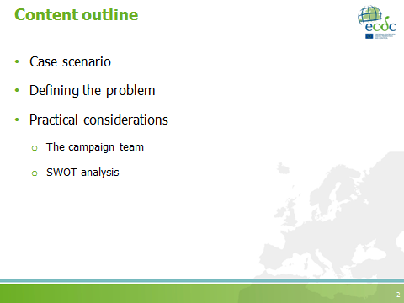 | SWOT (strengths, weaknesses, opportunities and threats)
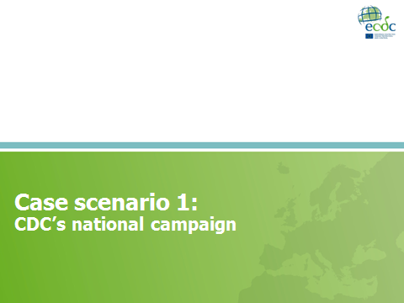 | CDC – Centers for Disease Control and Prevention (USA)  A case scenario from USA will be built in the following slides in order to set the stage for defining the problem. This will then be followed by theoretical content.
This case scenario is based on the article: “Promoting appropriate antibiotic use for pediatric patients: a social ecological framework” by Jennifer Weissman and Richard E. Besser (Semin Pediat Infect Dis. 2004 Jan;15(1):41-51).
- The main purpose of the case scenario is to present an example where ‘problem definition’, the different factors influencing it, as well as the use of social theories, have been taken into consideration.
- This slide presents the background of the national campaign developed by CDC in 1995.
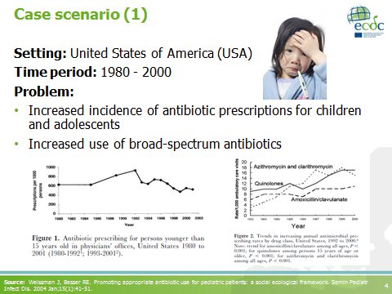
Figure 1 shows the decrease in the incidence of antibiotic prescriptions for children and adolescents between 1990 and 2000.
- Even though prescribing rates decreased, data suggested that, for all ages combined, more that 10 million antibiotic courses were prescribed each year for viral conditions that do not benefit from antibiotics.
Figure 2 shows the increased use of broad-spectrum antibiotics by clinicians.
- From 1991 to 1999, the use of broad-spectrum antibiotics doubled among adults (from 24% to 48% antibiotic prescriptions). Among children, the use of broad-spectrum antibiotics increased from 23% to 40% of all antibiotic prescriptions.
Source: Weissman J, Besser RE. Promoting appropriate antibiotic use for pediatric patients: a social ecological framework. Semin Pediatr Infect Dis. 2004 Jan;15(1):41-51.
During the second half of the 1990’s, CDC, many state and local health departments, and other organisations responded to the increased incidence in antibiotic prescribing and the prevalence of antibiotic resistance by designing and implementing interventions to promote appropriate antibiotic prescribing in the community.
- CDC used the socio-ecological framework to describe factors contributing to antibiotic prescription and use.
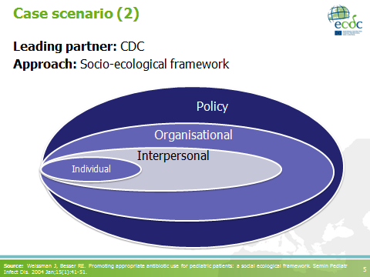
- The socio-ecological framework recognises the contributions of both individual influences (e.g. knowledge, attitudes, skills) and social environmental influences (e.g. social norms, organisational policies and practices) on health behaviour.
The outcome of interest - ”appropriate antibiotic use”- was analysed taking the following factors into account:
      - Individual factors: knowledge, attitudes, behaviours and skills.
- Interpersonal (groups or social networks) factors: including family, work and friendship networks.
- Organisational factors: social institutions and their organisational characteristics.
- Policy factors: laws and policies.
Source: Weissman J, Besser RE. Promoting appropriate antibiotic use for pediatric patients: a social ecological framework. Semin Pediatr Infect Dis. 2004 Jan;15(1):41-51.
Patients/parents:
- Knowledge, beliefs and attitudes towards antibiotic use: including their knowledge on the usefulness of antibiotics and their beliefs and attitudes towards previous antibiotic use.
- Expectations: for antibiotics.
- Communication skills: i.e. their skills of communicating with their healthcare provider.
Providers:
- Knowledge, beliefs and attitudes towards antibiotic prescribing
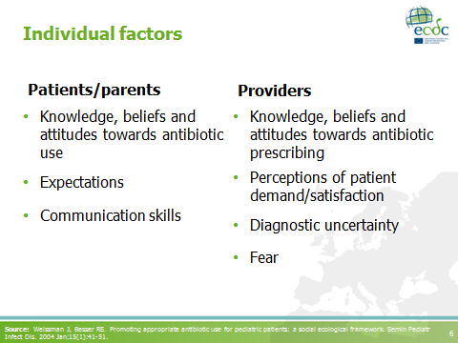
- Perceptions on patients’ demand/satisfaction: patient demands for antibiotics.
- Diagnostic uncertainty
- Fear: that patients will not return for follow-up visits.
Source: Weissman J, Besser RE. Promoting appropriate antibiotic use for pediatric patients: a social ecological framework. Semin Pediatr Infect Dis. 2004 Jan;15(1):41-51.
- The dynamics of groups and social networks can also contribute to antibiotic use and prescribing.

- Consumers may be influenced by the opinions and advice of friends and family.

- Work setting: e.g. co-workers.
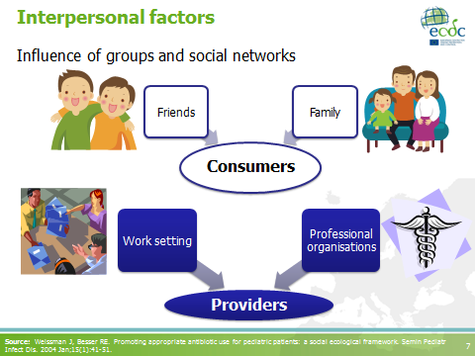
- Social networks among providers in the work setting and professional organisations can influence their prescribing, as can their knowledge and perceptions of the prescribing norms of other providers in the community.
Source: Weissman J, Besser RE. Promoting appropriate antibiotic use for pediatric patients: a social ecological framework. Semin Pediatr Infect Dis. 2004 Jan;15(1):41-51.
A variety of institutional and organisational factors contributed to antibiotic use:
- Parents stated the need to administer antibiotics before sending a child back to day care; an important factor which fuelled their expectations for antibiotics.
- Policies in the workplace can affect expectations for and receipt of antibiotics if workers are not permitted to return to work without having received antibiotic treatment.

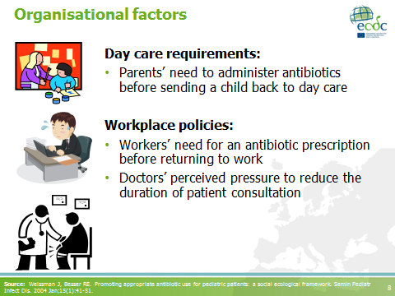
Managed care* system policies also had an effect on doctors’ behaviours. Doctors often felt pressured to reduce the duration of visits and prescribing antibiotics may have been seen as the quickest way to end a visit.
Source: Weissman J, Besser RE. Promoting appropriate antibiotic use for pediatric patients: a social ecological framework. Semin Pediatr Infect Dis. 2004 Jan;15(1):41-51.

* Managed care is a healthcare system with administrative control over primary healthcare services in medical group practices. The purpose is to abolish redundant facilities and services and to minimise costs. In this type of healthcare system, health education and promotion, and preventive medicine are emphasised. Patients may pay a flat fee for basic family care but may be charged additional costs for secondary care services. This system evolved from the traditional fee for service, i.e. patient pays the doctor directly for services performed. Instead it shifted towards health insurance organisations, which paid doctors and hospitals from premiums paid by the patients to the insurers (Source: Mosby’s Medical Dictionary. 9th edition. Missouri: Elsevier; 2013. Managed care; p.1087-1088.).
- Availability of antibiotics without prescription: contributes to the increased use of these drugs – “The availability of antibiotics without prescription particularly in states sharing a border with Mexico, contributes to increased use of these drugs”.
- Pharmaceutical marketing to doctors and patients: can influence attitudes, perceptions and behaviours towards antibiotic use and prescription
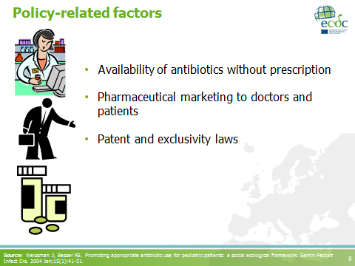
- Patent and exclusivity laws: preventing the sale of generic versions of new broad-spectrum antibiotics, can also lead to increased (often inappropriate) use of these drugs because pharmaceutical manufacturers concentrate their marketing efforts on patented, and thus must lucrative, medications.
Source: Weissman J, Besser RE. Promoting appropriate antibiotic use for pediatric patients: a social ecological framework. Semin Pediatr Infect Dis. 2004 Jan;15(1):41-51.
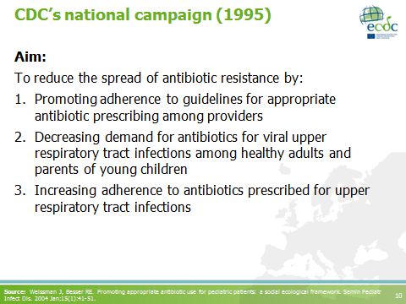 | - In 1995, CDC launched the campaign for appropriate antibiotic use in the community.  - The campaign targeted the 5 respiratory conditions that in 1992 accounted for more than 75% of all office-based prescriptions, for all ages combined:  - Otitis media  - Sinusitis  - Pharyngitis  - Bronchitis  - Common cold  Source: Weissman J, Besser RE. Promoting appropriate antibiotic use for pediatric patients: a social ecological framework. Semin Pediatr Infect Dis. 2004 Jan;15(1):41-51.
The CDC campaign included interventions targeted towards both the individual and social environmental factors described in the ecological framework.
Paediatric principles:
- Consisted of principles for appropriate antibiotic use for paediatric upper respiratory tract infections.
- Were developed in collaboration between CDC and, the American Academy of Paediatrics and the American Academy of Family Physicians.
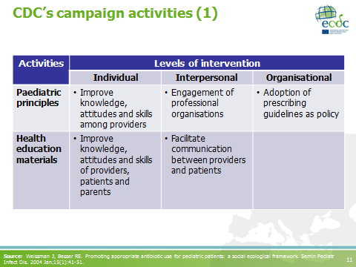
- At individual level: the guidelines served to change knowledge and attitudes of providers to improve antibiotic prescribing.
- At interpersonal level (includes groups and social networks): when presented to providers in group settings or by medical peers, these guidelines helped to change social norms among providers to support appropriate prescribing.
- At organisational level: adoption of the guidelines as a policy by a practice or an organisation can help bring about institutional change.
Health education materials:
- At individual level: the materials aimed to bring about changes in knowledge, attitudes and skills among providers, patients and parents.
- At interpersonal level: using the materials to stimulate discussion between parents and providers influenced groups and social networks.
Source: Weissman J, Besser RE. Promoting appropriate antibiotic use for pediatric patients: a social ecological framework. Semin Pediatr Infect Dis. 2004 Jan;15(1):41-51.
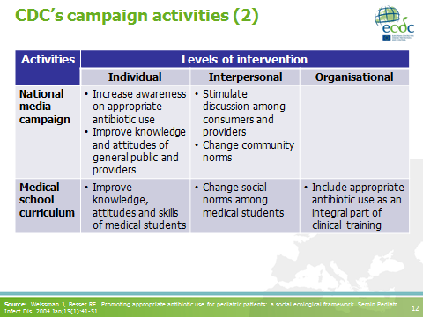 | National media campaign: more details on the campaign will be discussed in following sessions of the course.  Medical curriculum: influenced the individual, interpersonal and organisational level. Targets of change included knowledge, attitudes and skills of medical students, as well as social norms.  Source: Weissman J, Besser RE. Promoting appropriate antibiotic use for pediatric patients: a social ecological framework. Semin Pediatr Infect Dis. 2004 Jan;15(1):41-51.
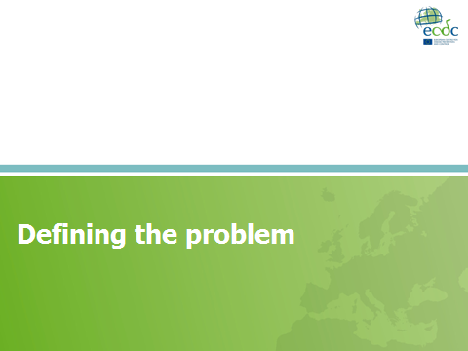
Note to the facilitators:
- The purpose of this section is to present the basic questions which need to be answered before one starts planning a campaign.
- The questions are sequential; each response informs the next.
- This approach is adapted from the BEHAVE framework, developed by the Academy of Educational Development (USA).
Source: Smith WA, Strand J. Social marketing behavior: a practical resource for social change professionals. Washington: Academy for Educational Development; 2008.
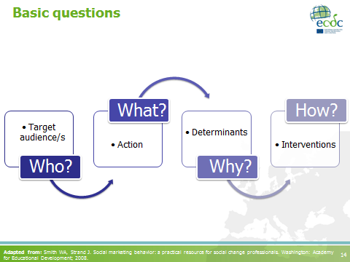
The questions
Before starting to plan a campaign we need to answer the following questions:
      - Who is your target audience and what is important to that audience?
      - What do you want your audience to do?
      - Why is the target audience performing the current behaviour? More specifically, what are the factors or determinants which influence their behaviour?
      - How can you influence their behaviour? What interventions will you implement to influence these factors?
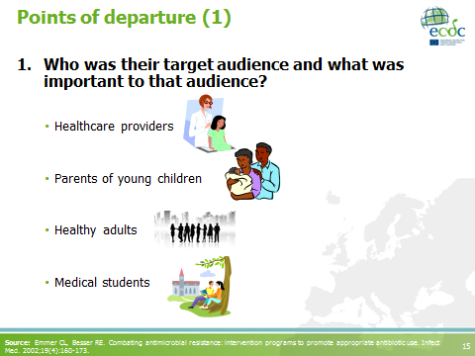
Referring back to the case scenario, the questions will be answered.
How did CDC know what was important to each audience?
- Focus groups with paediatricians and family doctors indicated that prescribers overprescribed due to their perceived parents’ and patients’ expectations.
- A national survey of paediatricians reported that 48% of parents pressured the doctors to prescribe antibiotics. Seventy-eight percent of surveyed paediatricians believed that educating parents about proper antibiotic use would be the single most important thing that could promote appropriate prescribing.
- Focus group discussions with parents showed that they would be satisfied with the medical visit if the doctor spent more time explaining the illness and treatment choices.
Source: Emmer CL, Besser RE. Combating antimicrobial resistance: intervention programs to promote appropriate antibiotic use. Infect Med. 2002;19(4):160-173.
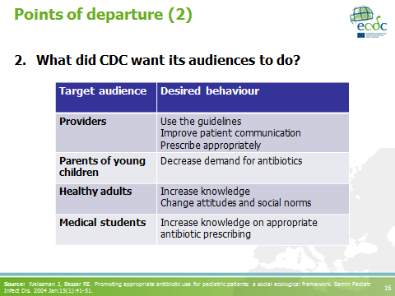 | Source: Weissman J, Besser RE. Promoting appropriate antibiotic use for pediatric patients: a social ecological framework. Semin Pediatr Infect Dis. 2004 Jan;15(1):41-51.
Note to the facilitators:
- Please refer to the notes of slide 15 were some of the methods used during the formative evaluation are mentioned.
- Also, it is important to mention how the use of social behavioural theory (i.e. the socio-ecological framework) helped to identify key determinants of the current behaviour for each target audience.
- Briefly summarise the different factors according to the different levels analysed.

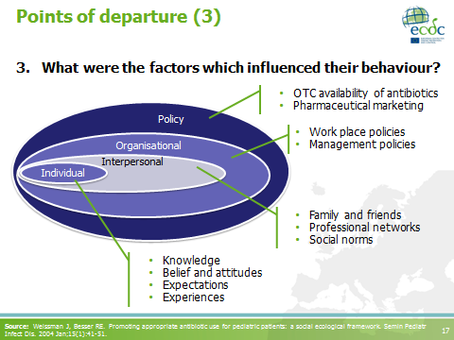
Source: Weissman J, Besser RE. Promoting appropriate antibiotic use for pediatric patients: a social ecological framework. Semin Pediatr Infect Dis. 2004 Jan;15(1):41-51.
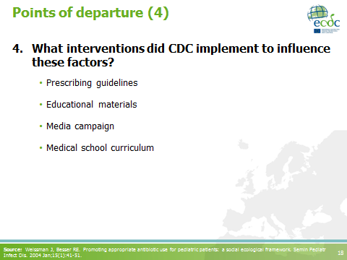 | Note to the facilitators:  - Details on how to plan and select the interventions or campaign activities will be discussed in other sessions.  - This question can be answered only when all the previous ones have been responded.  Source: Weissman J, Besser RE. Promoting appropriate antibiotic use for pediatric patients: a social ecological framework. Semin Pediatr Infect Dis. 2004 Jan;15(1):41-51.
Project description as a document
- It is recommended to prepare a document summarising the problem description. If everything is documented, it is easier to refer back to the document when decisions need to be justified. The problem description will become a working document that can be revised as the campaign develops.
- Unless you are planning to share this document with partners, it is not necessary to spend time ‘making it look nice’.

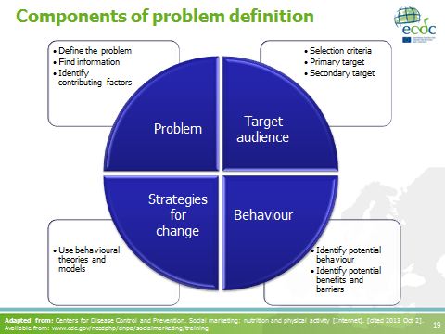
Project description elements
The project description should include a broad definition of the main components of the campaign plan: i.e. the problem, target audience, behaviour and strategies for change. As the campaign develops, the scope of these components should be narrowed down.

1. The problem: to define the problem, it is necessary to decide to frame the problem in relation to an outcome (e.g. appropriate antibiotic prescribing) or the current state of people’s behaviour (e.g. antibiotic demand). Either one of the alternatives is appropriate, so long as you are making a conscious choice.

Afterwards it is necessary to find existing information about the problem and to identify contributing factors.

In the CDC case scenario the problems were:
- Increased incidence of antibiotic prescriptions for upper respiratory tract infections of viral origin.
- Increased use of broad-spectrum antibiotics.
The factors associated with the problems varied depending on the individual, group and organisational levels.

Note to the facilitators:
- You can ask participants to complement the problem definition based on the case scenario presented earlier.
- You could ask about potential sources of information, according to participants’ own experiences. Some examples could include: epidemiological data, surveillance data, grey literature, behavioural and theoretical literature.
- Please note that some of these elements will be revisited and expanded on when talking about formative evaluation.

2. Target audience: it is also important to understand which groups of people need to change their behaviour to positively impact the problem. In the problem description phase, it is necessary to identify the target audience by:
- Determining the selection criteria: these criteria will help you narrow down your choices.
- Identifying potential primary target audiences (those who should change their behaviour): it can be described by age range, race or ethnicity, geographical location or by any other characteristic.
- Identifying potential secondary audiences (those who influence the primary target audience)

In the CDC example:
- Parents of young children (secondary).
- Healthy adults (secondary).
- Prescribers (primary).

3. Behaviour: choosing a broad behaviour begins the process of selecting specific behavioural objectives. Decisions made about the target audience and behaviour are closely related. Therefore, you will probably go back and forth when refining your decisions about them.
It is also important to consider the potential benefits the audience will receive when practising the current behaviour and the barriers they may face when practising the desired behaviour.

Note to the facilitators:
- Please mention that we will touch upon this particular component in other sessions of this course.

“Broad behaviours” mentioned in the CDC example:
- Adherence to guidelines.
- Decrease in antibiotic demand.

4. Strategies for change: this explains how and why you expect behaviour change to happen. Therefore, it is important to identify concepts from behavioural theories and models that may help explain behaviour change in your audience. Theories and models help describe the factors which can lead to change and what you could consider measuring.

In the CDC example:
- The use of the socio-ecological framework both for the analysis as well as the planning of the activities.

Adapted from: Centers for Disease Control and Prevention. Social marketing: nutrition and physical activity [Internet]. [cited 2013 Oct 2]. Available from: www.cdc.gov/nccdphp/dnpa/socialmarketing/training
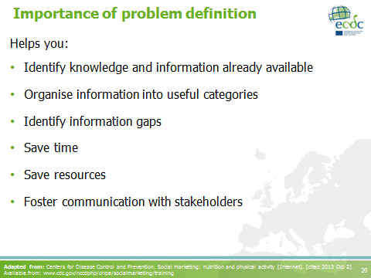 | - Identify information gaps which will be used to set the priorities for formative evaluation.  - Save time by establishing a framework to document and support decisions.  - Save resources by gathering information before additional costly data collection.  Adapted from: Centers for Disease Control and Prevention. Social marketing: nutrition and physical activity [Internet]. [cited 2013 Oct 2]. Available from: www.cdc.gov/nccdphp/dnpa/socialmarketing/training
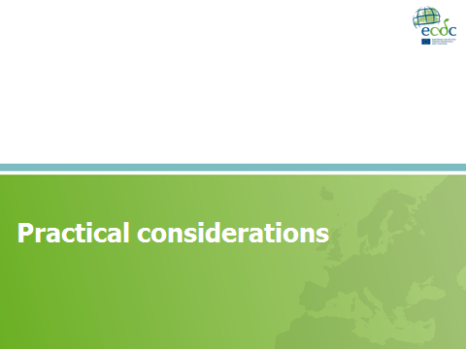
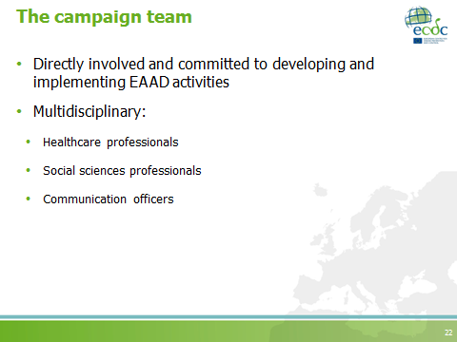 | Some considerations about the team:  - Does the team fit well together?  - Do we miss some competence?  - How can we add such competence?  - Recruit?  - Cooperate?  We will return to the issue of cooperation with other organisations later in the course.
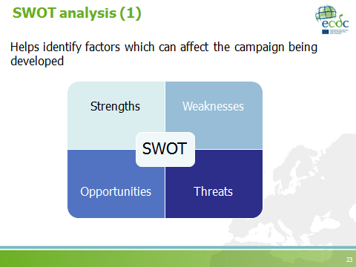
Remember that:
- Strengths and Weaknesses: are inside our organisation; our product relative to competing products (behaviours).
- Opportunities and Threats: are outside our organisation; can we mobilise/reduce?

SWOT analysis: a beneficial, structured method to view a project’s internal (strengths and weaknesses) and external (opportunities and threats) factors, to help you develop a clear plan of action. The objective of SWOT analysis is to utilise the organisation’s strengths to:
- take advantage of available opportunities,
- counterbalance or improve the stated weaknesses, and
- minimise the risk of potential threats.

When taking strengths, weaknesses, opportunities and threats into consideration, you will need to look at:
- potential sources of competition as well as existing opportunities and services which you may be able to take advantage of, and
- internal or external factors which may hinder or promote your campaign (e.g. funding, in-house resources, political resistance).

Source: French J, Blair-Stevens C, McVey D, Merritt R, editors. Social marketing and public health: theory and practice. Oxford: Oxford University Press; 2010.
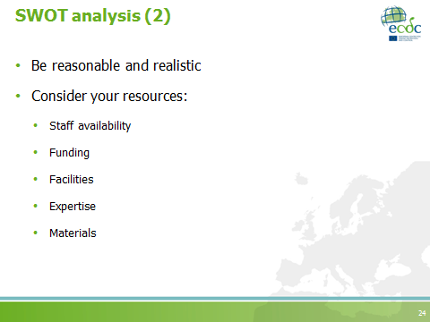
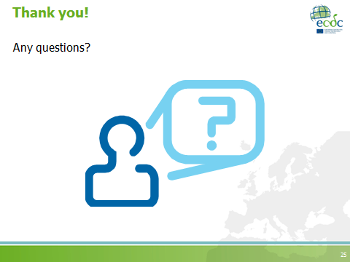

Lunch break
Duration: 1 hour

S2: Stepwise planning
Teaching objectives | - To introduce the different necessary steps when planning a campaign using a social marketing approach  - To explain the concept of behaviour
Time | 30 minutes
Materials | PowerPoint presentation
Type of session | Facilitator presentation

Facilitator notes
Optional activity: It is possible to introduce the session by asking participants (in plenary) to share some of their experiences by asking, “Based on your experience, what are some of the key elements you should consider when you are designing/planning the EAAD campaigns?”

PowerPoint presentation
Stepwise planning
Number of slides: 25
Estimated duration: 30 minutes
Slide | Key points
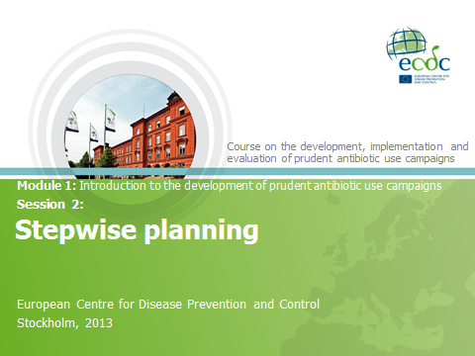
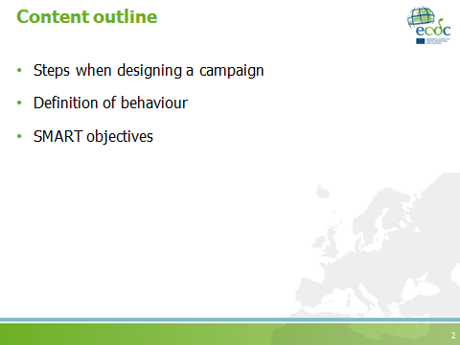
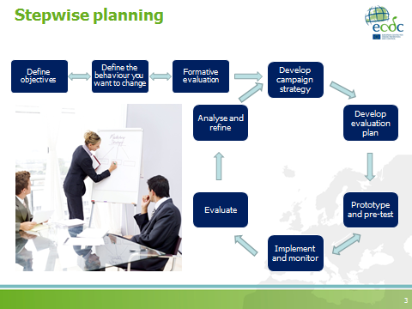 | Note to the facilitators:  - This presentation will summarise the key elements for all the steps listed on the slide. It will elaborate more on steps 1 and 2. The remaining steps will be developed in different sessions of the course.  - The purpose is to gradually introduce the social marketing components to the participants.  Adapted from: Family Health International. Core module 1: introduction to monitoring and evaluation. Monitoring HIV/AIDS programs: a facilitator’s training guide. USA: A USAID Resource for Prevention, Care and Treatment; 2004.
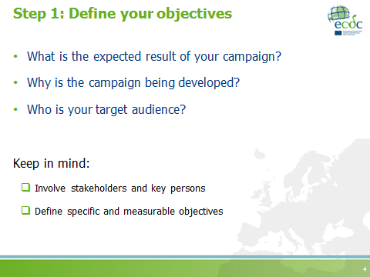 | “Every social marketing program has a behavioral goal. You want to change a behavior – people are doing one thing; you want them to do another. That’s what your project, or at least a specific campaign, is about”  - Clear and precise objectives: if the objectives are clearly defined, it is easier to select appropriate measures for evaluation.  - Start thinking about your campaign evaluation: already at this early stage one should think about the evaluation strategy for the campaign (more details on evaluation and techniques will be given in the following slides).  - The (behavioural) objectives help to determine the outcomes for evaluation.  Source: Smith WA, Strand J. Social marketing behavior: a practical resource for social change professionals. Washington: Academy for Educational Development; 2008.
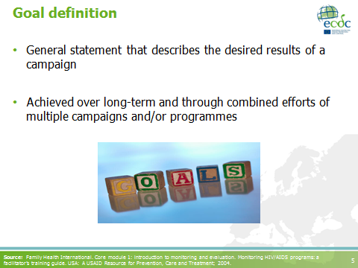 | Source: Family Health International. Core module 1: introduction to monitoring and evaluation. Monitoring HIV/AIDS programs: a facilitator’s training guide. USA: A USAID Resource for Prevention, Care and Treatment; 2004.
Action-oriented: includes an action verb

Note to the facilitators:
- The action-oriented characteristic of an objective must be linked to the behaviour that should be changed by the campaign.
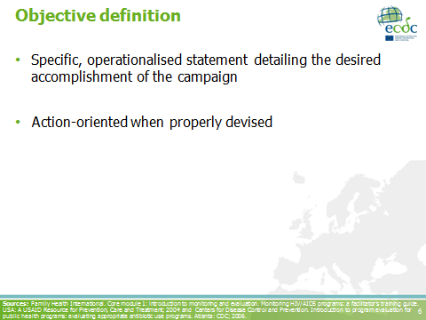
- In the subsequent slides/sessions it will be important to emphasise that a campaign which uses social marketing departs from the “behavioural objectives”, i.e. the behaviour that must be adopted or changed, and that has been stated clearly as part of the objectives.
Sources: Family Health International. Core module 1: introduction to monitoring and evaluation. Monitoring HIV/AIDS programs: a facilitator’s training guide. USA: A USAID Resource for Prevention, Care and Treatment; 2004 and Centers for Disease Control and Prevention. Introduction to program evaluation for public health programs: evaluating appropriate antibiotic use programs. Atlanta: CDC; 2006.
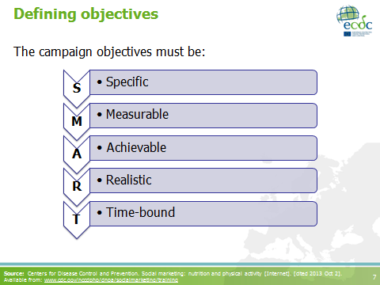
The purpose of SMART behavioural objectives is to be clear about the action (behaviour) that the target audience is requested to do in response to the campaign.
- Specific: relates to the issue to be addressed.
- Measurable: relates to the quantitative or qualitative difference in value. Status of the issue that can be measured at the beginning and at the end of the campaign to indicate results.
- Achievable: relates to the setting of target numbers, quantities or percentages that can reasonably be achieved.
- Realistic: not too overambitious, feasible.
- Time-bound: there should be a target date for achieving the desired result.

Source: Centers for Disease Control and Prevention. Social marketing: nutrition and physical activity [Internet]. [cited 2013 Oct 2]. Available from: www.cdc.gov/nccdphp/dnpa/socialmarketing/training
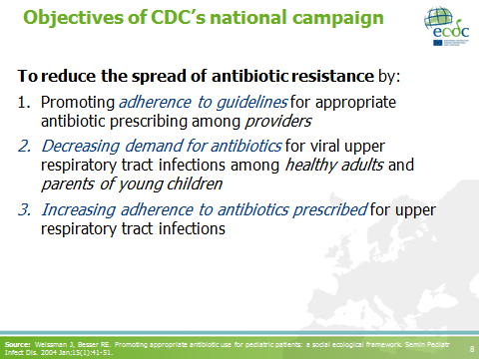
Revisiting case scenario 1:
The goal of the CDC campaign is highlighted in bold:
“To reduce the spread of antibiotic resistance”
The behaviours targeted in each objective are highlighted in blue:
- “adherence to guidelines”
- “decreasing demand for antibiotics”
- “increasing adherence to antibiotics prescribed”

Note to the facilitators:
- Discuss with the participants if these objectives fulfil the SMART criteria
- If time permits, ask participants to reformulate the objectives according to the SMART criteria
- If the criteria are not clear, use examples from other types of health promotion campaigns

Source: Weissman J, Besser RE. Promoting appropriate antibiotic use for pediatric patients: a social ecological framework. Semin Pediatr Infect Dis. 2004 Jan;15(1):41-51.
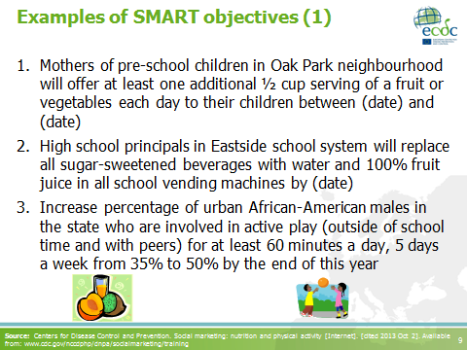 | The examples presented in this slide refer to nutrition, physical activity and obesity prevention programmes in USA.  Source: Centers for Disease Control and Prevention. Social marketing: nutrition and physical activity [Internet]. [cited 2013 Oct 2]. Available from: www.cdc.gov/nccdphp/dnpa/socialmarketing/training
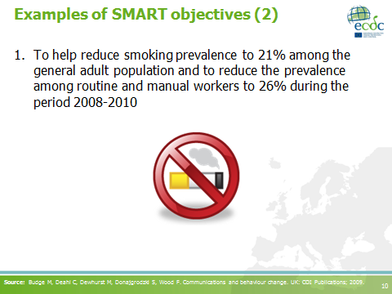 | This example is taken from the tobacco control campaign in the UK (2008-2010).  It is important to keep a critical eye on how ‘smart’ the SMART objectives actually are. For example in the example given here, the ‘general adult population’ is not specific enough. At what age will one be considered to fall within the adult group? Is there an upper age limit? The objective should clearly define the age range to include.  Source: Budge M, Deahl C, Dewhurst M, Donajgrodzki S, Wood F. Communications and behaviour change. UK: COI Publications; 2009.
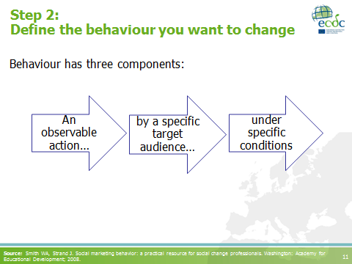 | After emphasising the main components of behaviour indicated in the arrow-shaped boxes, you could mention that some behaviours are more difficult to change than others.  NB. It is easier to change a behaviour than to stop one behaviour and adopt a completely new one. For example, it is easier to urge doctors to change from prescribing a non-recommended drug to a recommended one, than it is to tell them to stop prescribing altogether.  Source: Smith WA, Strand J. Social marketing behavior: a practical resource for social change professionals. Washington: Academy for Educational Development; 2008.
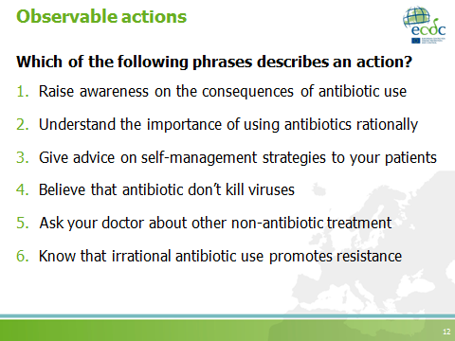 | The action should be observable, specific (time, place, quantity, duration, frequency), feasible, measurable, directly linked to an improved outcome.  The correct answers are nos. 3 and 5  This slide has a pre-determined animation feature to highlight the two statements that comply with the definition. (PRESS ENTER OR SPACE BAR TWICE TO SHOW THE CORRECT ANSWERS).
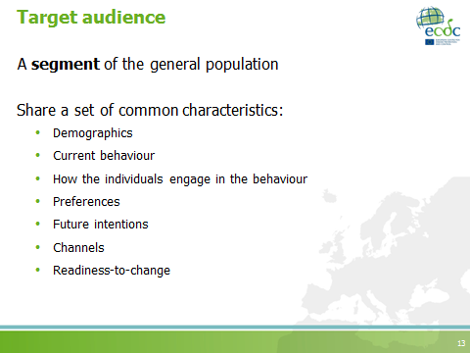 | People are different and need to be approached in different ways. While we may want to approach each person individually (‘1-to-1 marketing’), that is usually not possible. The solution is to find groups of people that are reasonably similar and can be approached in the same way. Then, one or more groups are chosen.  Segmentation is needed in order to identify groups of people that are similar and can be approached in the same way.
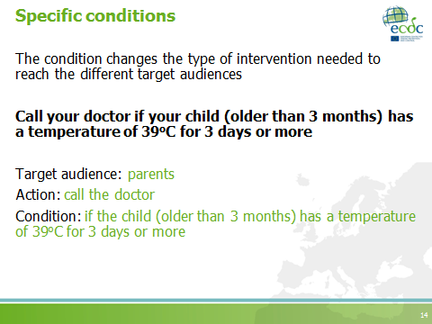
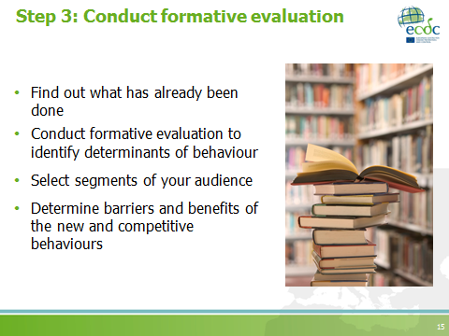 | - Formative evaluation is also known as formative research, primary research or marketing research.  - It has a ‘consumer orientation’ (i.e. it focuses on the target audience).  - It is intended to help us gain deeper understanding of the target audience.  Note to facilitators: this topic will be discussed in a separate session. The purpose of this slide is just to introduce the term and its general process.
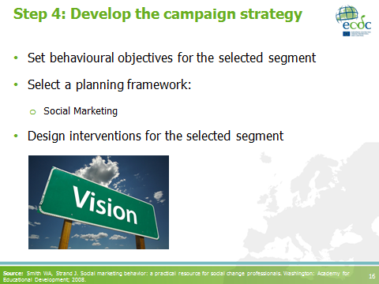
- Set behavioural objectives for the selected segment: behavioural objectives are those SMART objectives that clearly state the desired behaviour from the selected segment. After conducting the formative evaluation, the initial objectives must be refined and narrowed down, according the segment targeted.
- Select a planning framework: in this course we will use social marketing as the theoretical framework to plan a campaign. The main concepts related to social marketing will be introduced in the following slides. More details will be provided in different sessions, in combination with the case studies.
- Design interventions for the selected segment: these interventions or campaign components/activities will be designed based on the findings of the formative evaluation and following the key aspects of the social marketing approach.

Source: Smith WA, Strand J. Social marketing behavior: a practical resource for social change professionals. Washington: Academy for Educational Development; 2008.
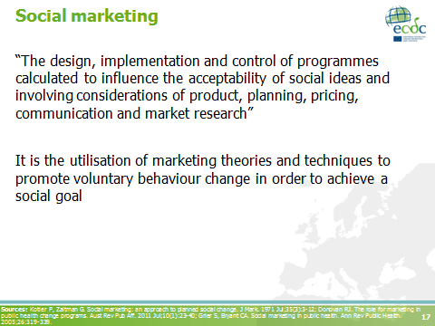 | Social marketing is:  - applying commercial marketing principles to health and human services  - behaviour change for societal benefits, not profit  Sources: Kotler P, Zaltman G. Social marketing: an approach to planned social change. J Mark. 1971 Jul;35(3):3-12; Donovan RJ. The role for marketing in public health change programs. Aust Rev Pub Aff. 2011 Jul;10(1):23-40; Grier S, Bryant CA. Social marketing in public health. Ann Rev Public Health. 2005;26:319-339.
- Knowledge & awareness alone are not enough for sustainable behaviour change.
- Many programmes are constructed without citizen/patient/consumer insight research.
- As a consequence the targeted people may misunderstand these interventions or view them as irrelevant and end up rejecting the proposed solutions.
Source: European Centre for Disease Prevention and Control. Social marketing guide for public health managers and practitioners. Stockholm: ECDC; 2014.
The marketing mix is also called the “4Ps”. It includes:
- Product, e.g. prescription guidelines
- Price, e.g. the time prescribers need to invest in explaining to patients why antibiotics are not needed in viral infections
- Place, e.g. the hospital or clinic where prescribers are expected to use the guidelines
- Promotion, e.g. the channels used to persuade prescribers to use the guidelines

Note to the facilitators:
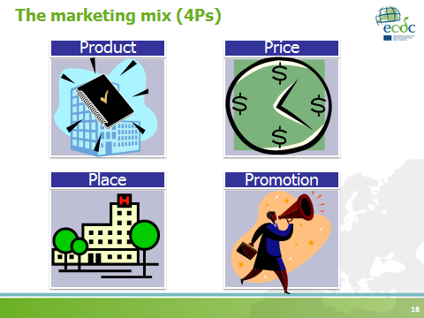
- The above mentioned examples are meant to give an overall idea of the 4Ps. More details will be provided in the following sessions.
- Suggestion: refer to the pre-course reading material to have an interactive session with the participants. Ask questions about these concepts and how the participants understood them.
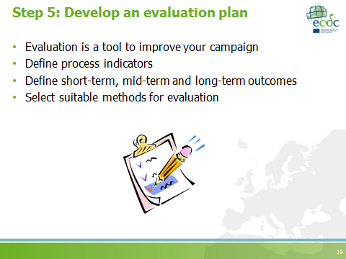 | - Evaluation is a tool to improve your campaign, therefore it is better to plan how the evaluation will be conducted before the campaign is implemented  - Define process indicators: they will allow you to determine if the campaign was conducted as planned  - Define short-term, mid-term and long-term outcomes: they will allow you to assess the overall impact of the campaign  - Select suitable methods for evaluation, according to the outcomes and indicators you have defined
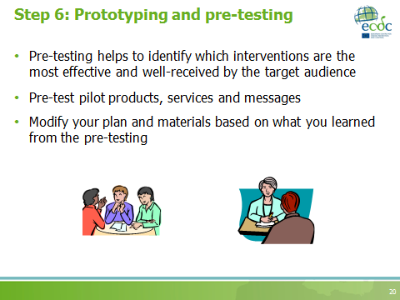 | The consumer is always at the centre of the social marketing process, that is why pre-testing is important.  Note to the facilitators: some definitions to consider (and explain to the participants if necessary)  - Pre-test:  - A test carried out prior to something, e.g. a pilot study – the full-scale version of the main study is rolled out among a smaller study population  - A test of the effectiveness of a “product” prior to its release to the intended audience  - Prototype:  - An original, full-scale, and usually working model of a new product or new version of an existing product  - A first or experimental working model of something to be manufactured
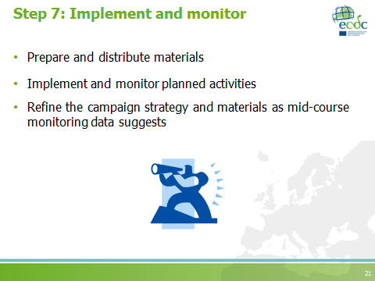 | Note to the facilitators: more details on implementation will be given in the corresponding session
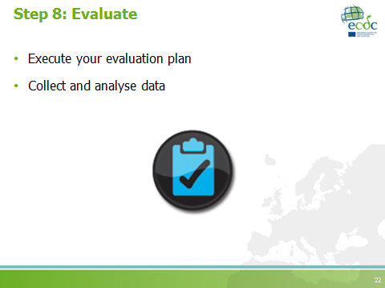 | After conducting your process and outcome evaluations, you should be able to answer the following questions:  - Did the campaign reach the target audience?  - Did the desired outcome occur? Why/why not?  - Did the campaign have an intended effect?
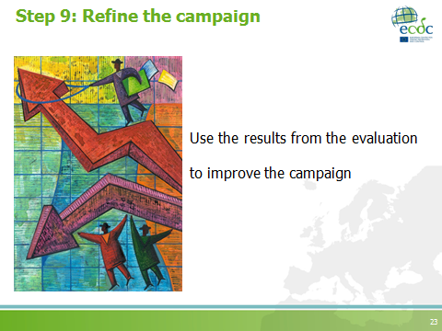
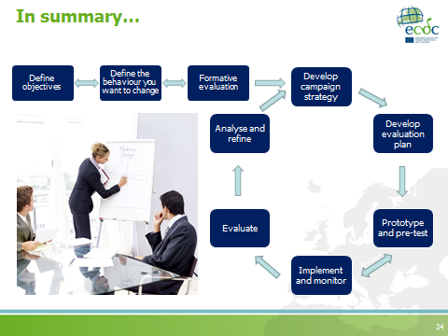 | - Planning is a recurrent process  Adapted from: Family Health International. Core module 1: introduction to monitoring and evaluation. Monitoring HIV/AIDS programs: a facilitator’s training guide. USA: A USAID Resource for Prevention, Care and Treatment; 2004.

S3: Formative evaluation
Teaching objectives | - To describe the key steps in conducting formative evaluation and target audience segmentation  - To explain the concept of behaviour change  - To introduce the stages of change model  - To introduce the concepts of competition and exchange, according to the social marketing framework  - To apply the concepts of social marketing in the analysis of case studies
Time | 1 hour
Materials | Whiteboard, flipchart, whiteboard markers, permanent markers, PowerPoint presentation
Type of session | - Case studies discussion (10 minutes)  - Interactive  - Facilitator presentation (50 minutes)

PowerPoint presentation
Formative evaluation
Number of slides: 29
Duration: 50 minutes
Slide | Key points
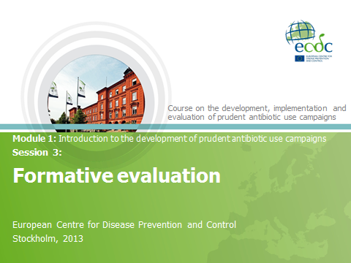
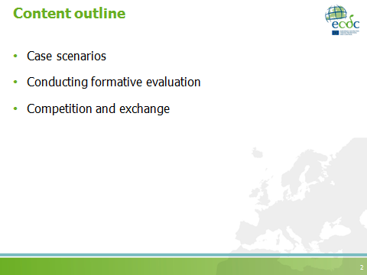
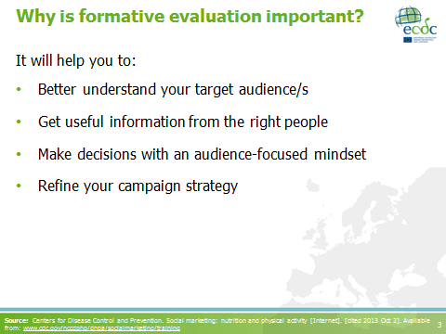 | Refine your campaign strategy: more specifically, it will help you define your marketing mix (product, price, place, promotion).  Source: Centers for Disease Control and Prevention. Social marketing: nutrition and physical activity [Internet]. [cited 2013 Oct 2]. Available from: www.cdc.gov/nccdphp/dnpa/socialmarketing/training
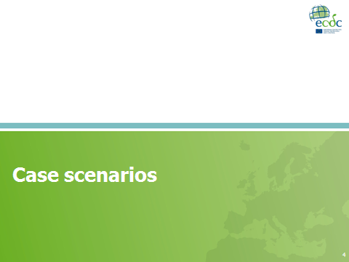 | Note to the facilitators: the purpose of this section is to provide some examples of the different approaches when conducting formative evaluation.  - On the slides, the example of the CDC campaign will be used.  - It is also recommended to use some of the case studies to promote interaction with course participants.
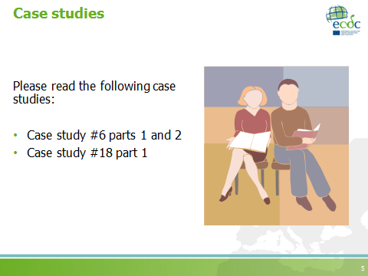 | NB. OPTIONAL SLIDE  Note to facilitators: This is an optional activity.  - Allocate approximately 10 minutes for readings  - Discuss the case studies as you move along with the rest of the presentation  - Case study 6 is an example on how to use quantitative methods to obtain information about the behaviour (survey).  - Case study 18 uses the information collected through antibiotic prescribing auditing (and feedback) as a source for the formative evaluation.
How did CDC know about what was important to each audience?
- Focus groups with paediatricians and family doctors indicated that prescribers over-prescribed due to perceived parents’ and patients’ expectations.
- A national survey of paediatricians reported that 48% of parents pressured the doctors to prescribe antibiotics. Seventy-eight percent of surveyed paediatricians believed that educating parents about the proper use of antibiotics would be the single most important thing that could promote appropriate prescribing.
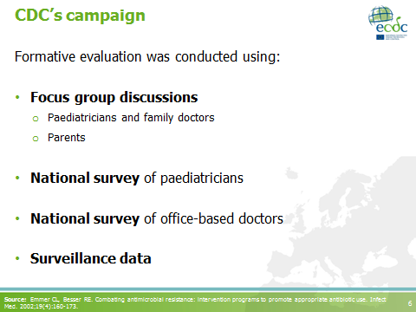
- Focus groups discussions with parents showed that they would be satisfied with the medical visit if the doctor spent more time explaining the illness and treatment choices.
- National survey of office-based doctors was used to obtain prescribing data.
- Surveillance data were used to analyse antibiotic resistance patterns.
Source: Emmer CL, Besser RE. Combating antimicrobial resistance: intervention programs to promote appropriate antibiotic use. Infect Med. 2002;19(4):160-173.
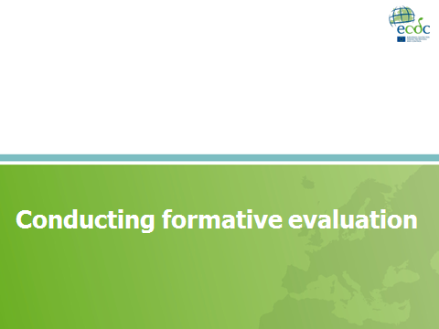
Key points
- Remind participants that formative evaluation is also known as formative research, primary research or marketing research.
- It is conducted to better understand the target audience.
- It aims at:
  - Filling any gaps in the information already available.
  - Gathering practical information before developing the marketing mix.

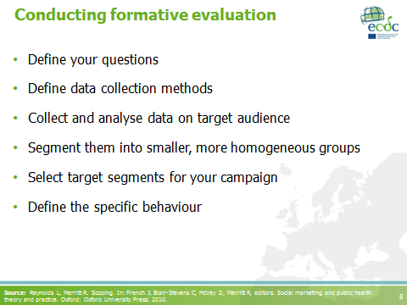
- Define your questions: define what you would like to know; it is necessary to clarify what you need to know about your target audience.
- Define data collection methods: after defining your research questions, which methods are more appropriate and feasible to use?
- Collect and analyse data on the target audience: summarise your main findings; they will guide the design of the interventions.
- Segment them into smaller, more homogeneous groups: the target audience must be divided into smaller groups or segments according to a range of characteristics.
- Select target segments for your campaign after prioritising those segments you might target.

Source: Reynolds L, Merritt R. Scoping. In: French J, Blair-Stevens C, McVey D, Merritt R, editors. Social marketing and public health: theory and practice. Oxford: Oxford University Press; 2010.
Before defining your questions: it is necessary to identify the information gaps. You might have already identified some of them when preparing the problem description. The questions presented in the slide are intended to help you define the questions you need to answer with the formative evaluation.

- What do you need to know about the issue? After consulting information already available.
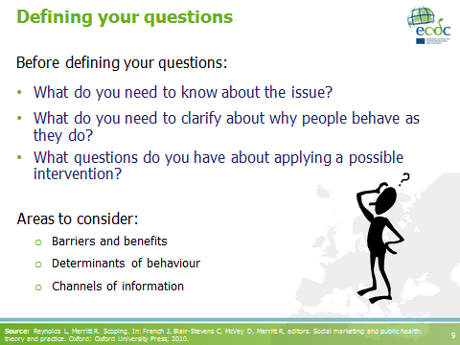
- What do you need to clarify about why people behave as they do? Considering your previous knowledge and/or assumptions about the target audience.
- What questions do you have about applying a possible intervention? I.e. how might it be received by your target audience? Are there any other options which might be more effective?

Areas to consider: These will help you to better understand your target audience.
    - Barriers and benefits of the recommended/desired behaviour and anything that might be considered as ‘competition’.
    - Determinants of behaviour: i.e. factors which might make the desired behaviour easier to adopt.
    - Channels of information used by the target audience: how do they acquire information?

Source: Reynolds L, Merritt R. Scoping. In: French J, Blair-Stevens C, McVey D, Merritt R, editors. Social marketing and public health: theory and practice. Oxford: Oxford University Press; 2010.
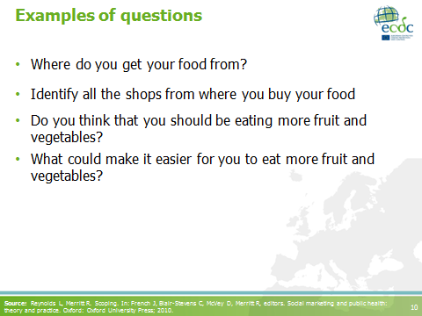 | These are some possible research questions taken from an initiative to increase fruit and vegetable intake.  Remember:  - Prioritise your questions.  - Discard questions that do not fill your gaps.  - Avoid collecting too much information.  Source: Reynolds L, Merritt R. Scoping. In: French J, Blair-Stevens C, McVey D, Merritt R, editors. Social marketing and public health: theory and practice. Oxford: Oxford University Press; 2010.
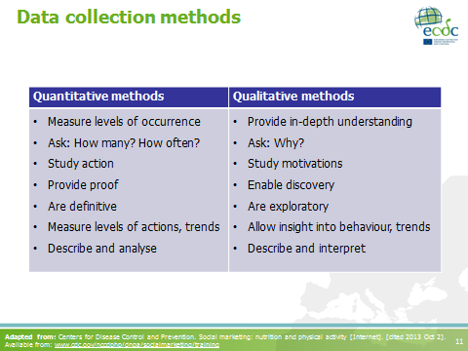 | Based on your research questions, you need to select the methods before data collection.  This slide compares quantitative and qualitative methods with the intention of presenting participants with the alternatives they have.  Adapted from: Centers for Disease Control and Prevention. Social marketing: nutrition and physical activity [Internet]. [cited 2013 Oct 2]. Available from: www.cdc.gov/nccdphp/dnpa/socialmarketing/training
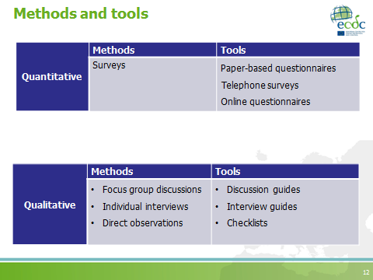 | - After selecting your methods, you will need to develop or adapt the data collection tools.  - Remember that you will need to pre-test your data collection tools.  - If the budget for conducting formative evaluation is limited, partner with a University (e.g. engaging undergraduate or Master’s students to take part) or get work sponsored by a private firm.  Note to the facilitators:  - You could mention examples from the CDC campaign.  - You could use the pre-course reading to bring up examples of qualitative methods and results on antibiotic prescribing.
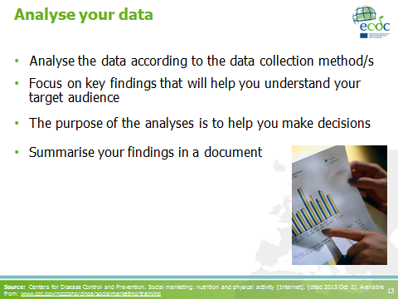
- Analyse the data according the data collection method/s: quantitative data might be analysed by hand or through computer software. Qualitative data analyses should provide a description of the topics/questions asked and can also be analysed by hand or through computer software.
- Focus on key findings that will help you understand your target audience: focus on the areas you can act upon.
- The purpose of the analyses is to help you make decisions: make sure you have enough information to choose the final audience segment, a specific behaviour change and that you have some ideas about intervention strategies.

- Summarise your findings in a document: the key findings of this phase should be accessible and easy to understand. The document should contain the following sections:
- Introduction: background about the issue and context, and the aim/purpose of the research.
- Methodology: description of the data collection methods, participants and analysis.
- Results: data could be organised by research question.
- Conclusion/s: description of relevant findings and suggestions on ways to use them in the development of the marketing mix.

Source: Centers for Disease Control and Prevention. Social marketing: nutrition and physical activity [Internet]. [cited 2013 Oct 2]. Available from: www.cdc.gov/nccdphp/dnpa/socialmarketing/training
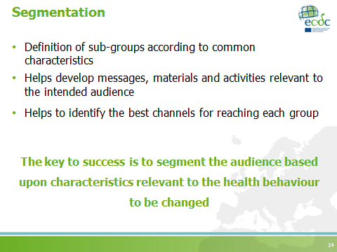 | There are five main segmentation criteria:  - Response differences: this is related to the health behaviour.  - Identifiability: the group must be identifiable. Health behaviour may not be visible, so can we find something else correlated and visible?  - Reachability: how can we reach this group?  - Profitability: in a health benefit context; is this a group which contributes significantly to the problem?  - Stability: if we design campaigns and interventions to work over a longer period, will this segment remain relevant?
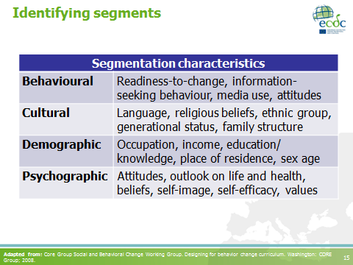
Segments can be defined according to a range of characteristics, some of which are presented in this table.
- Behavioural: health-related activities or choices, degree of readiness to change a behaviour, information-seeking behaviour, media use and lifestyle characteristics.
- Cultural: language proficiency and language preferences, religion, ethnicity, generation status, family structure, degree of acculturation, and lifestyle factors (e.g. special foods, activities).
- Demographic: occupation, income, educational attainment, family structure, and places of residence and work.
- Physical: sex, age, type and degree of exposure to health risks, medical condition, disorder and illnesses, and family health history.
- Psychographic: attitudes, outlook on life and health, self-image, opinions, beliefs, values, self-efficacy, life-stage and personality traits.

Adapted from: Core Group Social and Behavioral Change Working Group. Designing for behavior change curriculum. Washington: CORE Group; 2008.
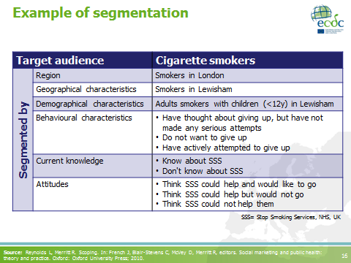 | Note to the facilitators:  Use this example to introduce the group activity by emphasising the behavioural characteristics of this audience.  Source: Reynolds L, Merritt R. Scoping. In: French J, Blair-Stevens C, McVey D, Merritt R, editors. Social marketing and public health: theory and practice. Oxford: Oxford University Press; 2010.
- Ask participants to remember a change they have made (or tried to make) in their own lives.
- Then ask them to try to recall the things they did to make and secure that change, how easy or difficult it was, and/or how long it took to make the change.
- Finally, ask them to reflect on the success of the change.
- Summarise the activity by pointing out that some changes come about easily and do not need to be planned for, whereas other behavioural changes are more difficult and need to be planned.

Notes to the facilitators:
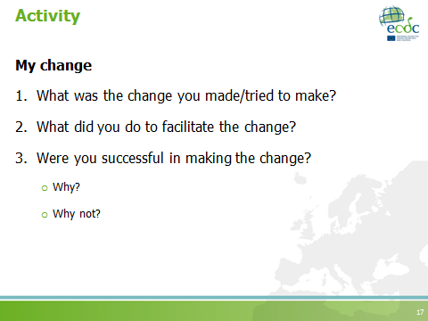
- This reflection could be done as a buzz group (4-5 persons) or individually.
- You could use this slide or write the questions on a whiteboard/flipchart
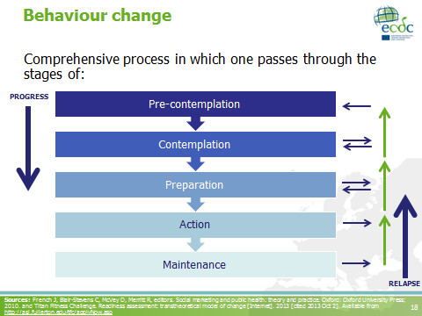
The example provided above is taken from the stages of change model (or transtheoretical model or Prochaska’s stages of change). It categorises key stages which individuals can (in specific contexts) experience when trying to adopt different behaviours. This theory sees behaviour as a process rather than as a one-time event; it also recognises that individuals have different motivational and readiness-to-change levels. It also suggests that individuals do not always progress through the stages at the same rate; some may remain at a particular stage for a long time. Therefore, it could be beneficial to look into what keeps some individuals from moving forward and others to do so.
- Pre-contemplation: individual is unaware, and has no consideration or intention to adopt a particular behaviour.
- Contemplation: individual is aware and starting to comprehend and consider adopting a behaviour, and may be ready to seek more information about it.
- Preparation: individual is actively thinking about adopting a certain behaviour and is starting to make a commitment towards it.
- Action: individual performs or starts to perform a given behaviour.
- Maintenance: individual maintains the behaviour and combines it with his/her regular routine. Possibility of ‘relapse’ or return to one’s previous behaviour exists.

In summary:
- Behaviour change is a gradual process consisting of identifiable steps.
- Persons, communities or organisations go through a series of steps in a non-lineal manner; sometimes moving forward, sometimes backward and sometimes skipping steps altogether.
- Relapses can occur even when the new behaviour has been adopted.

Note to the facilitators:
- This slide builds upon the stages of change model to explain people’s behaviour change.
- You could mention this theoretical background to emphasise the importance of using behavioural/ social theories and models.
- Time depending, you may discuss:
  - Are some steps more critical than others? (refer back to experiences shared in the previous activity)
  - Where are our campaign activities/interventions typically aimed?
This can be a way to point out the importance of using a more varied toolbox and not focusing excessively on information aimed towards creating awareness.

Sources: French J, Blair-Stevens C, McVey D, Merritt R, editors. Social marketing and public health: theory and practice. Oxford: Oxford University Press; 2010. and Titan Fitness Challenge. Readiness assessment: transtheoretical model of change [Internet]. 2013 [cited 2013 Oct 2]. Available from http://asi.fullerton.edu/tfc/applyNow.asp
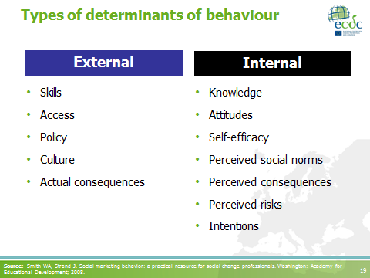
Note to the facilitators: THIS IS AN OPTIONAL SLIDE. It can be used to explain the different factors which influence behaviour.

- Skills: abilities needed to perform a given behaviour.
- Access: availability of services and products needed by an audience.
- Policy: laws and regulations which affect behaviours, and access to products and services.
- Culture: customs, lifestyle, values and practices within a self-defined group.
- Actual consequences: what actually happens after performing a particular behaviour.
- Knowledge: basic factual knowledge.
- Attitudes: what an individual thinks or feels about a particular issue.
- Self-efficacy: an individual’s belief that s/he can do a particular behaviour.
- Perceived social norms: what matters most to the person OR what the individual perceives people think s/he should do.
- Perceived consequences: what a person thinks will happen.
- Perceived risks: a person’s perception of his/her own vulnerability.
- Intentions: commitment to a future act.

Source: Smith WA, Strand J. Social marketing behavior: a practical resource for social change professionals. Washington: Academy for Educational Development; 2008.
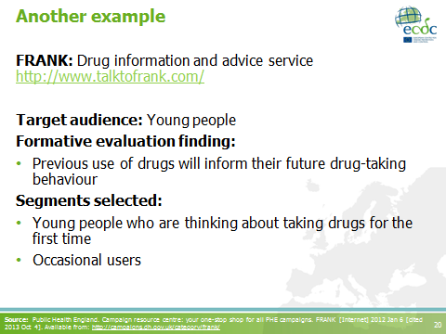
Note to the facilitators: THIS IS AN OPTIONAL SLIDE

- Through this example you can show how “staging” the target audience’s behaviour could be used for segmentation.
- Staging can also be used as a tool to set outcomes for the campaign (i.e. to increase the number of smokers actively attempting to give up smoking).

FRANK is the UK’s national drug information and advice service provided by the Department of Health, the Home Office and the Department for Education.

Source: Public Health England. Campaign resource centre: your one-stop shop for all PHE campaigns. FRANK [Internet] 2012 Jan 6 [cited 2013 Oct 4]. Available from: http://campaigns.dh.gov.uk/category/frank/
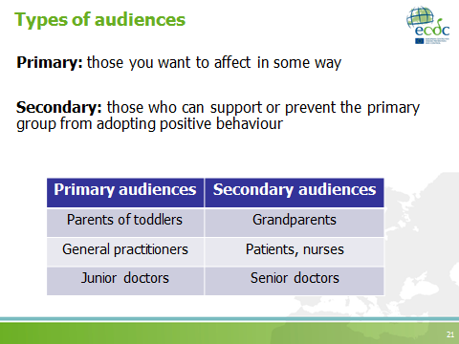 | - After identifying your segments, you will need to select those that will be targeted in the campaign.  - One may select more than one segment, and then decide who will be the primary and the secondary audience.  - When choosing segments it is necessary to clarify the behaviour you want them to do.  Note to the facilitators:  - Refer back to the CDC case scenario to remind participants about different types of audiences.  - The table in the slide contains some examples.
- When defining the behaviour you desire from your target audience, you need to know what your competition is.
- Competition is a concept from social marketing that helps you identify the current behaviour (i.e. the competitive behaviour) of your audience.
- A target audience can go somewhere else or do something else or maintain current behaviour. Therefore, it is important to understand what the target audience does that competes with the healthy behaviour we want them to do.
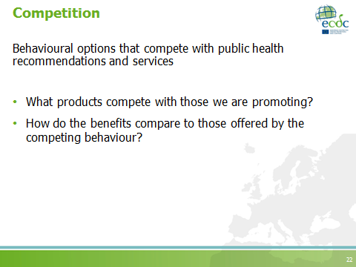
- By knowing this, the campaign can be modified to provide a product that makes the competing behaviour less attractive, less available or most costly.
Note to the facilitators:
- The concept of competition is relevant within social marketing.
- It is closely related to the concepts of exchange and competitive analysis, which will be explained in the following slides.
- Please make sure to clearly explain these concepts and refer back to them when appropriate.
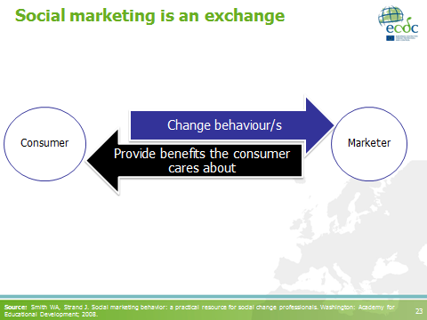 | - When using social marketing to plan a campaign, you become a marketer and your audiences are your consumers.  - As a marketer you need to recognise your side of the exchange; ‘you need to offer something’.  - In a commercial exchange, consumers receive a product or service for a cash outlay.  - ‘Value creation’ is a term often used in marketing. You can create value for your customers by increasing the value of your offer or by reducing the costs of the offer.  Source: Smith WA, Strand J. Social marketing behavior: a practical resource for social change professionals. Washington: Academy for Educational Development; 2008.
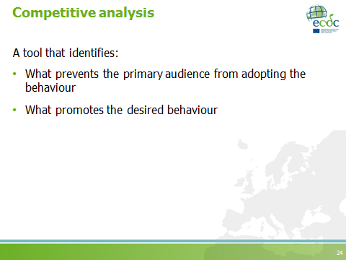 | - To identify the specific behaviour you will ask your audiences to perform, you need to take into account your competition and the exchanges that occur between the audience and the competitive behaviour.  - A competitive analysis will help you identify barriers and benefits of the desired behaviour and the competitive behaviour.
Notes to the facilitator:
Dedicate time to clarify and explain this diagram fully in order for participants to understand that in behaviour change communication campaign development, one aims to decrease the barriers and increase the benefits of the new action (behaviour), whilst also attempting to increase the barriers and decrease the benefits of the competing behaviour.
- Ideally, your campaign should aim at decreasing the barriers and increasing the benefits of the new behaviour. That way, the exchange will be more attractive to your target audience.
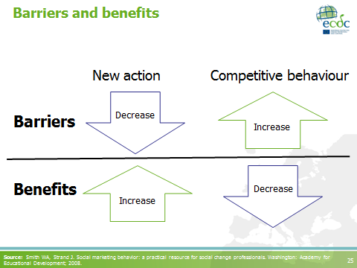
- Similarly, your campaign should aim at increasing the barriers and decreasing the benefits of the competitive behaviour in order to make the competing behaviour seem more difficult for your target audience to engage in.
- If the ultimate behavioural objective is not feasible, consider intermediary behaviours as objectives, which will allow the end-result to be reached via a series of smaller, more achievable steps.
Source: Smith WA, Strand J. Social marketing behavior: a practical resource for social change professionals. Washington: Academy for Educational Development; 2008.
This in an example of current and desired behaviours of selected segments for a breastfeeding campaign.
- Some of the barriers to breastfeeding perceived by women were the lack of support from family and friends.
- Therefore, the secondary audiences were included in this segment, as a strategy to minimise barriers.
- By targeting healthcare providers, the benefits of the ‘product’ (i.e. breastfeeding), could be presented to the primary target audience.

Important to remember:
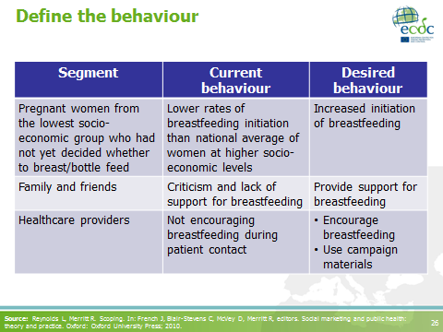
If the ultimate behavioural objective is not feasible, consider intermediary behaviours as objectives, which will allow the end-result to be reached via a series of smaller, more achievable steps.

Source: Reynolds L, Merritt R. Scoping. In: French J, Blair-Stevens C, McVey D, Merritt R, editors. Social marketing and public health: theory and practice. Oxford: Oxford University Press; 2010.
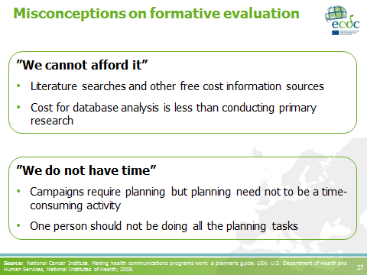 | Cooperation could take place with educational institutions:  - Education of healthcare professionals  - Business students in marketing or statistics  - A thesis competition can be a relatively inexpensive means  Source: National Cancer Institute. Making health communications programs work: a planner’s guide. USA: U.S. Department of Health and Human Services, National Institutes of Health; 2008.
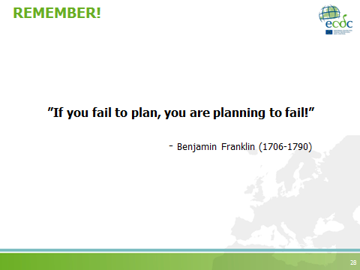
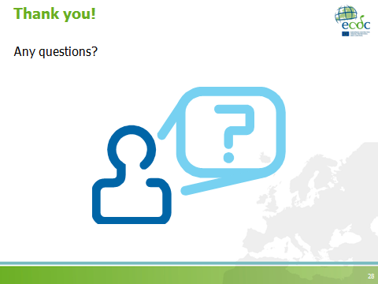

Coffee break
Duration: 20 minutes

Facilitator notes
If needed, the break can be reduced or merged with the next session. The coffee breaks could be used to assess the reaction of the participants (verbal feedbacks).
Group work activity: initial development of a campaign strategy
Instructions for the group work activity
Duration: 2 hours
- Divide the groups into six groups of five persons (assuming a total of 30 participants), according to the type of target audience as follows:
- Group 1: general public (the community),
- Group 2: outpatients visiting healthcare facilities,
- Group 3: primary care providers,
- Group 4: hospital prescribers,
- Group 5: other healthcare professionals (besides hospital prescribers and primary care providers), and
- Group 6: policy makers.
NB. (i) The grouping suggested above may be altered to suit your needs. Alternatively do not group groups according to pre-set target audiences but rather let them choose their own. If so, try and avoid that all groups select the same target audiences.
(ii) You may choose to divide the groups yourself or let the participants divide themselves within the working groups. Ensure that, as much as possible, group members are from different countries and have a diverse professional profile (i.e. persons with both communication and medical backgrounds). This will promote better and more fruitful discussions.
- Define group work rules and write them down on a flip chart for all to see.
NB. ‘The challenging team’ ice breaker could be used as an exercise with participants to determine the group work rules (Annex 2). There should be clear rules about the roles of group members. Namely, the group should identify a moderator and note-taker.
- Inform participants that this group work session is the first of two group work sessions dedicated to the development of a campaign strategy, and that on the last day of the course they will present their work to their course mates who will evaluate their work.

- Introduce the ‘opposition team’: The facilitators must pair the groups in order for them to oppose each other. Depending on the resources available, a PowerPoint presentation, a summary of the group work, or a flip chart presentation has to be prepared by the groups and submitted to the facilitators at a time most suitable to you, so that they can be distributed among participants for discussion on day three.
NB. Think about logistic arrangements, e.g. availability of a photocopy machine in the case of hard copies, access to internet, developing a PowerPoint template for the groups to work with, distributing flip chart papers and markers, etc.
- Instruct participants that instructions and group work sheets are found in their participant workbook under the section entitled, ‘Group work’, and that they should feel free to work on the campaign strategy at their own pace, so long as they are done by the end of day two. If you wish you may go through the group work sheets and instructions with the group.
NB. (i) Group work sheets can also be found in the manual in Annex 3.
(ii) Points worth mentioning to the participants: In the competitive analysis worksheet, the group can focus on the main target audience OR if time permits, they can focus on the audience segments also.
(iii) In the marketing mix section (section V), if possible, groups should discuss the core, actual and augmented products they wish to use.
The role of the facilitator in group work sessions:
Each group should have one facilitator assigned to them in order to assist them in the clarification of instructions and/or any other questions which may come up during the session. The different areas of expertise within the facilitation team should be clear among the facilitators so that when questions are raised, especially those requiring specialised knowledge, the most suitable facilitator can be contacted.

Facilitator notes
This group work session may be changed to a case study discussion if the facilitators believe that the group work activity suggested here is too demanding for the group. If so, a group presentation of the case study on day three of the course is still recommended.

Feedback session: group work progress
Teaching objectives | - To summarise the overall impressions of the first group work session  - To clarify general doubts
Time | 20 minutes
Materials | None in particular
Type of session | Interactive

Wrap-up of day 1
Teaching objectives | - To summarise the take home messages for the day  - To explain task assignment for next day  - To distribute daily evaluation forms (Annex 6)
Time | 20 minutes
Materials | Whiteboard, whiteboard markers, daily evaluation forms
Type of session | - Interactive  - Informative
Task assignment
Before closing the session, suggest that participants refine the group work that they initiated before the next day’s group work session (if time permits).

Evaluation of the day
 | Facilitation team meeting  Evaluation of day 1  Aim of the meeting:  - Summarise the day  - Focus on things to improve for next day  Duration: 30-60 minutes

2.2.4 Day 2 sessions
Remember
Before the start of day 2 organise the exhibition materials you collected in day 1, so that they are ready to be visited during the morning coffee break activity.

I2: Introduction to day 2
Teaching objectives | To clarify participants’ doubts on the content of module one presented the previous day
Time | 30 minutes
Materials | Whiteboard, flipchart, whiteboard markers, permanent markers
Type of session | Interactive

Task I2.1: Welcome
- Welcome participants to the second day of training
- Ask participants if they have any questions on the content from day one.
- Alternatively, you could select an energiser or quick assessment activity to warm up for the next session (Annexes 2 and 6)

S4: Strategy development
Teaching objectives | - To introduce key concepts related to social marketing  - To apply social marketing concepts in the analysis of case studies
Time | 1 hour
Materials | PowerPoint presentation, participant workbook
Type of session | - Facilitator presentation (25-30 minutes)  - Case studies (30 minutes)

PowerPoint presentation
Strategy development
Number of slides: 16
Duration: 25-30 minutes
Slide | Key points
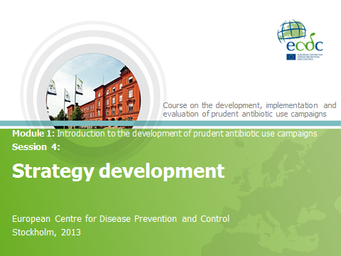
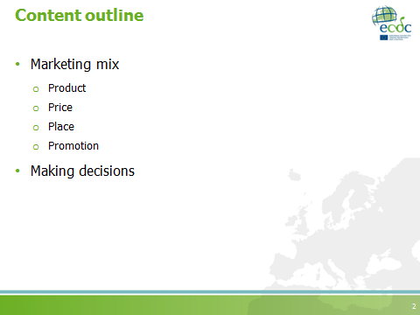
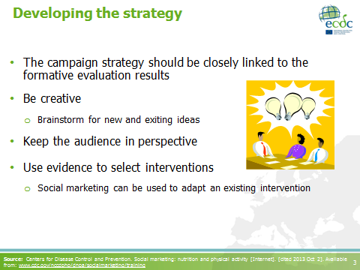 | - To develop the campaign strategy we need to get familiar with the components of the marketing mix and how to apply them.  - The terms marketing strategy, marketing plan or marketing mix can be used when referring to the campaign strategy, within the social marketing framework.  Source: Centers for Disease Control and Prevention. Social marketing: nutrition and physical activity [Internet]. [cited 2013 Oct 2]. Available from: www.cdc.gov/nccdphp/dnpa/socialmarketing/training
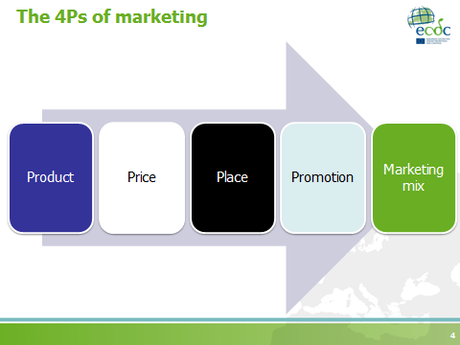 | - The marketing mix, also known as the 4Ps, refers to the combination of these components.  - A marketing mix should be:  - Integrated  - Planned systematically  - Consistent  NB. Refer to the pre-course reading material!
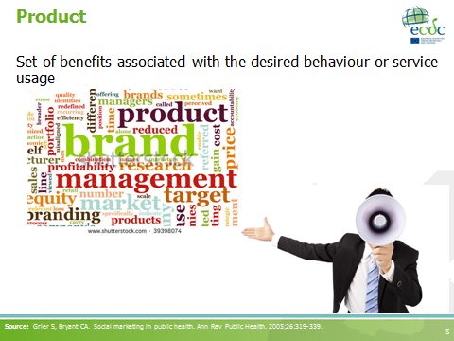 | Product is what you are selling: the desired behaviour and its associated benefits.  Source: Grier S, Bryant CA. Social marketing in public health. Ann Rev Public Health. 2005;26:319-339.
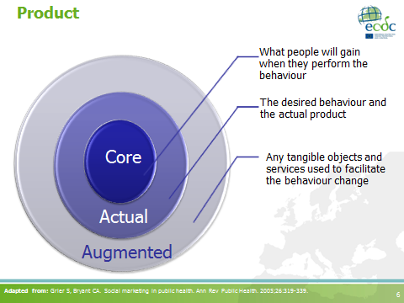
The concept of product comprises of:
- The core product: the underlying benefits that the consumer obtains by “buying” the product, e.g. improved health.
- The actual product: the product or service you develop to deliver the core product benefits.
- The augmented product: includes features that encourage and support uptake of the actual product, e.g. accessible timeframe to return leftover antibiotics to a pharmacy.

Key words:
- Core product the benefits (e.g. improvement in health, good reputation as a doctor, financial saving)
- Actual product the desired behaviour through the service you can offer (e.g. the prescription guidelines)
- Augmented product additional features to decrease the barriers (e.g. easily accessible guidelines)

Adapted from: Grier S, Bryant CA. Social marketing in public health. Ann Rev Public Health. 2005;26:319-339.
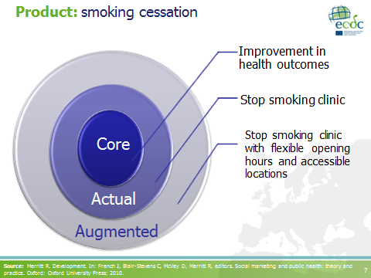 | In this example:  - The core product: includes all the improvements in health outcomes (e.g. reduced risk of heart disease and lung cancer) as well as a sense of personal achievement, and financial saving.  - The actual product: the stop smoking clinic and the services provided there.  - The augmented product: comprises not only flexible opening hours and accessible locations but also features such as, free nicotine replacement therapy and counselling.  Source: Merritt R. Development. In: French J, Blair-Stevens C, McVey D, Merritt R, editors. Social marketing and public health: theory and practice. Oxford: Oxford University Press; 2010.
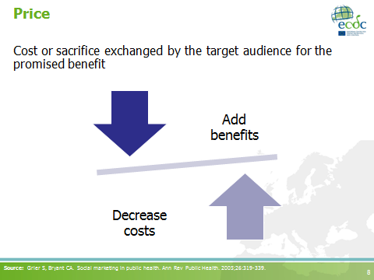
- The cost or sacrifice made to acquire the promised benefits; it is the downside of what we are asking the target audience to do.
- It should always be viewed from the consumer (i.e. target audience) standpoint; therefore it usually consists of intangible costs like time and discomfort, and the psychological hassle that often goes hand-in-hand with change, particularly when wishing to change deep-rooted habits.
- When setting the most appropriate price, one should know whether the consumers (i.e. target audience) are willing to pay more to obtain “value added” benefits and whether they believe that free products or low-cost products are inferior to more expensive ones.
- The perceived costs have to be less than the perceived benefits for people to act.
- Examples of price/costs:
  - Chafed hands from using hand disinfectant.
  - Not feeling like a good parent when not providing medicine for one’s child.

Source: Grier S, Bryant CA. Social marketing in public health. Ann Rev Public Health. 2005;26:319-339.
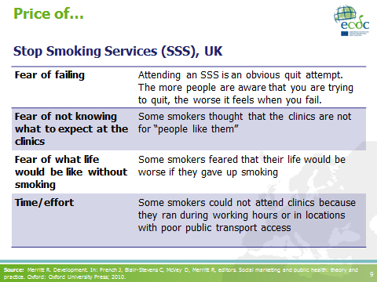 | Note to the facilitators:  - Remember to refer back to the concept of exchange.  - How much are you willing to pay for this product?  The benefits are often intangible, and are developed and communicated by the promotional element of the marketing mix.  Source: Merritt R. Development. In: French J, Blair-Stevens C, McVey D, Merritt R, editors. Social marketing and public health: theory and practice. Oxford: Oxford University Press; 2010.
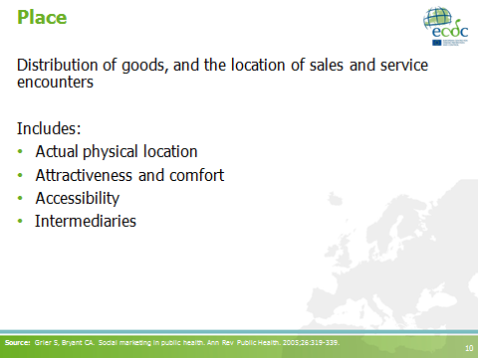 | - Place is where and when the target audience will perform the desired behaviour, acquire any tangible objects and receive any associated services.  - Channels through which products are available: both communication channels and the necessary elements to achieve the behaviour change (e.g. the disinfectant dispenser, or in the case of HIV behaviour change communication, an anonymous location to take the test).  Source: Grier S, Bryant CA. Social marketing in public health. Ann Rev Public Health. 2005;26:319-339.
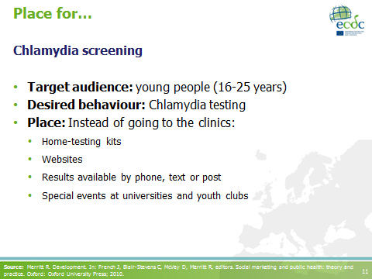 | - Home-testing kits: urine samples could be sent to the laboratory free-of-charge.  - Websites: providing information about the kits and Chlamydia.  - Results: delivered using the customer’s preferred channel.  - Special events at universities and youth clubs: where healthcare providers encourage young people to use the kit there and then.  Source: Merritt R. Development. In: French J, Blair-Stevens C, McVey D, Merritt R, editors. Social marketing and public health: theory and practice. Oxford: Oxford University Press; 2010.
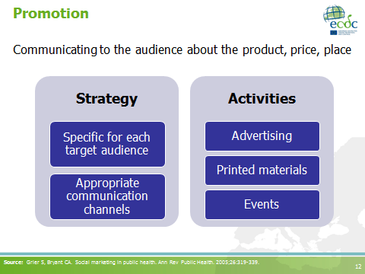
- The benefits are often intangible and are developed and communicated by the promotional element of the marketing mix.
- Promotion includes the promotional strategy and activities.
- The strategy includes a carefully designed set of activities, and selection of effective messages and channels.
- Besides the activities mentioned in the slide: public relations, promotional items, special events and displays in face-to-face settings.
- Promotion should be attention-grabbing; it should be memorable.
Source: Grier S, Bryant CA. Social marketing in public health. Ann Rev Public Health. 2005;26:319-339.
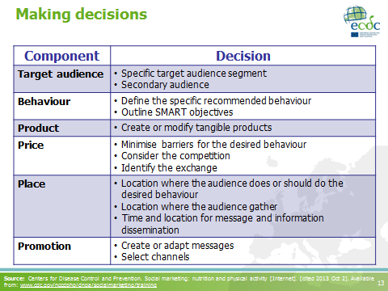 | This slide summarises the main decisions to be made when developing the strategy.  Source: Centers for Disease Control and Prevention. Social marketing: nutrition and physical activity [Internet]. [cited 2013 Oct 2]. Available from: www.cdc.gov/nccdphp/dnpa/socialmarketing/training
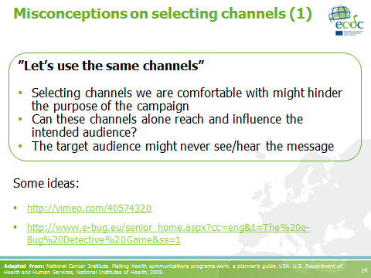
- Mention that many marketers are very excited about the concept of gamification. (Gamification is the use of game-thinking and game mechanics in non-gaming contexts in order to engage users and solve problems).
- Example on using gamification to promote environmentally-friendly driving practices among Scania truck drivers: http://vimeo.com/40574320.
- On antibiotic resistance:
  - http://www.e-bug.eu
  - http://www.e-bug.eu/senior_home.aspx?cc=eng&t=The%20e-Bug%20Detective%20Game&ss=1
  - https://www.facebook.com/keepantibioticsworking

Adapted from: National Cancer Institute. Making health communications programs work: a planner’s guide. USA: U.S. Department of Health and Human Services, National Institutes of Health; 2008.
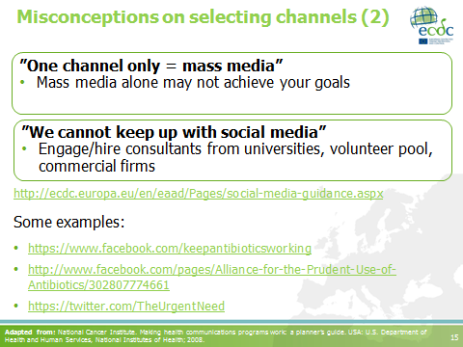 | ECDC has a guide available to help you prepare a social media strategy.  Adapted from: National Cancer Institute. Making health communications programs work: a planner’s guide. USA: U.S. Department of Health and Human Services, National Institutes of Health; 2008.
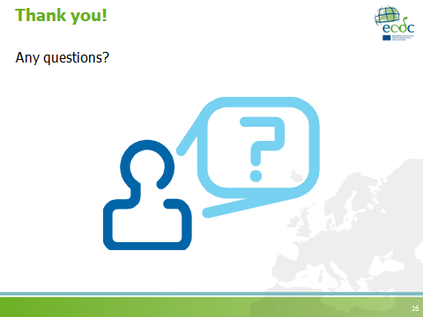

Case study session
Teaching objectives | To identify the key concepts of the marketing mix (product, price, place and promotion) in the case studies
Time | 30 minutes
Materials | Participant workbook
Type of session | Interactive

Facilitator notes
Facilitators should decide the following in advance:
- The case study to use
- Whether one case study will be used for the whole group or whether several case studies will be used, in which case participants should be divided into smaller groups
- Whether the session will be held in groups or individually but led by a facilitator
- If groups are to be formed, it is recommended to divide the groups differently that the groups organised on day one for the group work session.
IMPORTANTLY! Facilitators need to be familiar with the course material, particularly the case studies and need to decide how best to conduct this session.

- If the activity will be led by the facilitator and the discussion will be interactive during the presentation:
  - Ask participants to read the case study selected (can be found in their workbooks).
  - Clarify which parts of the case study you would like them to read (some case studies are divided into defined sections).
  - Be specific regarding which questions you would like them to respond.
  - Incorporate the discussion in the presentation.
    - Use the case studies to introduce/clarify new concepts.
    - Integrate participants’’ previous experiences.
- If the activity will be conducted in groups:
  - Ask participants to form groups.
    - Suggest that they interact with new people every time you form group activities, if possible.
    - Encourage them not to share group activities with colleagues from the same organisation or country.
  - Clarify which parts of the case study you would like them to read (some case studies are divided into defined sections).
  - Be specific regarding which questions you would like them to respond.
  - Indicate the time allocated for the group discussion.
  - Lead the plenary session.
    - Make sure to receive feedback from all groups.
    - Try to introduce/clarify new concepts as the discussion progresses.
    - Integrate participants’ previous experiences.

Coffee break
Duration: 30 minutes

Facilitator notes
Note that this coffee break includes an activity. Instructions to the activity are provided below.

NB. Since the activity should be conducted as part of the coffee break, allocate time for participants to take some refreshments before the session begins.

Coffee break activity: exhibition of campaign materials
Teaching objectives | - To exchange creative ideas on different campaign materials  - To introduce the concept of pre-testing
Time | 30 minutes
Materials | Exhibition area to present posters and other audio-visual materials provided by the participants pre-course
Type of session | Interactive

- The exhibition could be organised as a guided session, in which one of the facilitators takes the role of moderator in order to introduce the participants and their contributions.
- Participants can be asked to choose their favourite material (as well as their least favourite, if considered appropriate), as an introductory activity for the next session.

Feedback session: after the coffee break activity
Time | 10 minutes
Materials | Whiteboard, flipcharts, whiteboard markers, permanent markers
Type of session | Brainstorming (in plenary)
- Ask the participants to give you their general impression of the materials they saw.
- Ask them to say which material they considered their favourite and which (if you asked them to do so) was their least favourite, and why.
- Encourage them to continue exchanging ideas on how to create new messages/ materials.

S5: Prototyping and pre-testing
Teaching objectives | - To explain the steps involved in the pre-testing of materials and activities for campaigns  - To apply social marketing concepts in the analysis of case studies
Time | 1 hour 30 minutes
Materials | PowerPoint presentation, participant workbook
Type of session | - Facilitator presentation (30 minutes)  - Case studies (1 hour)

Optional activity: The “ε” game (10 minutes)
- Use the “ε” game as an introduction to this session. Detailed instructions can be found in the ice-breakers, energisers and group activities section (Annex 2).

PowerPoint presentation
Prototyping and pre-testing
Number of slides: 11
Duration: 30 minutes
Slide | Key points
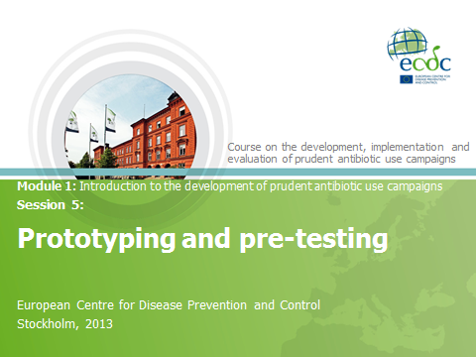
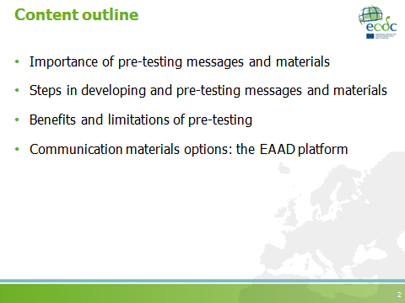
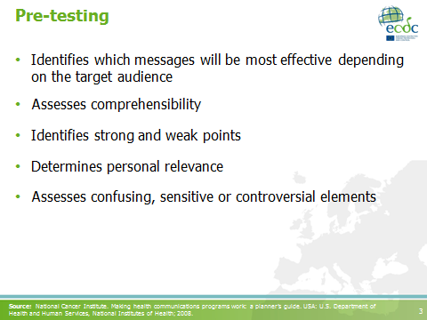 | - Knowing which materials will be most effective will save money by ensuring that you do not go through the entire development process.  - Positive results from the pre-testing can also give you arguments to use within your organisation to gain more support.  - Decide what materials to develop. Make sure they fit in with the activities and channels you selected.  - Personal relevance: does the intended audience identify with the materials?  Source: National Cancer Institute. Making health communications programs work: a planner’s guide. USA: U.S. Department of Health and Human Services, National Institutes of Health; 2008.
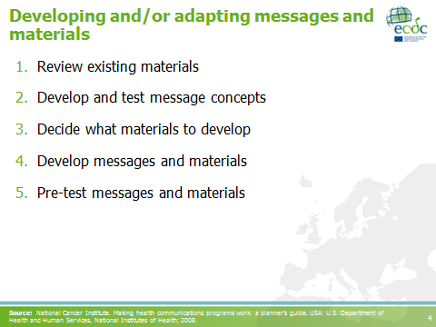
Ask participants about their own experiences when preparing materials for the campaign.
- Review existing materials: message and materials development and production can be time-consuming and costly. If you decide to adapt already existing materials, consider cultural differences (refer to the following articles on the subject:
(i) Borg M. National cultural dimensions as drivers of inappropriate ambulatory care consumption of antibiotics in Europe and their relevance to awareness campaigns. J Antimicrob Chemother. 2012 Mar;67(3):763-767.
(ii) Deschepper R, et al. Are cultural dimensions relevant for explaining cross-national differences in antibiotic use in Europe? BMC Health Serv Res. 2008;8:123.).
- Message concepts: are messages in rough form and represent ways of presenting information to the intended audiences. They may include statements only or statements and visuals. Message concepts have already been developed at ECDC-level. Ask about experiences developing their own messages. Have they included communication professionals in the team?
- Determine the format of the materials which best suit your campaign: the materials should fit the channels selected. Choose formats that your programme can afford. Do not allot so much of your budget to material production that you cannot afford in sufficient quantities, distribution, promotion, support or process evaluation.
- Same as #2.

Source: National Cancer Institute. Making health communications programs work: a planner’s guide. USA: U.S. Department of Health and Human Services, National Institutes of Health; 2008.
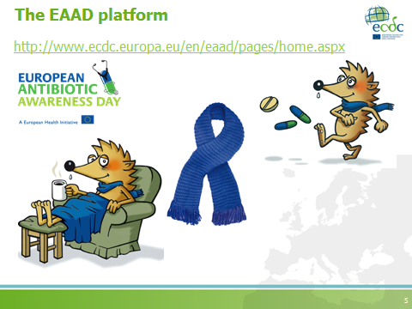
- If possible access the EAAD website and briefly ask the participants on their experiences when using the materials.
- It is worth bringing up in this slide how messages and concepts can be interpreted differently in different contexts, which is why pre-testing materials is so important. As an example: an attempt was made to use the EAAD materials in a country outside Europe. When pre-tested, the hedgehog was misinterpreted and misunderstood by participants, who preferred have real-life figures rather than cartoon figures on the campaign materials. Based on such results the materials were modified to suit the audience’s desires.
- Do promote discussion on this subject among the participants and ask if they have faced similar situations in their work.
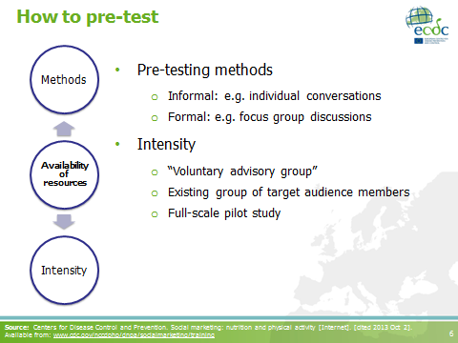 | Pre-testing can be done in a variety of ways depending on the level of resources you have:  - Voluntary advisory group: members of the target audience segment who can give you clear and honest feedback about the components you are proposing.  - Full-scale pilot study: to implement the complete campaign with a small portion of the target audience.  Source: Centers for Disease Control and Prevention. Social marketing: nutrition and physical activity [Internet]. [cited 2013 Oct 2]. Available from: www.cdc.gov/nccdphp/dnpa/socialmarketing/training
- Objectives: what do you want to learn and from whom? Which segments do you want to include and exclude in the testing. Write down the objectives.
- Methods: selection depends on the question you want to have answered, the type of materials, the audience, the time and resources available.
- Secure facilities: hire or train moderators for focus group discussions.
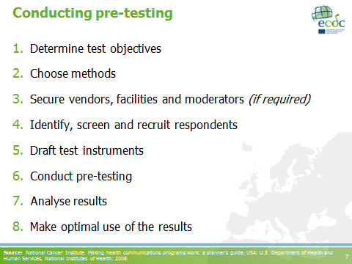
- Identify, screen and recruit respondents: the screening process consists of collecting data from potential participants in focus group discussions, when these data are not available. It implies going to the field (community-based) and asking some questions on demographic, health and information channels and willingness to participate in focus group discussions.
- Test instruments: discussion guides, questionnaires.
- Conduct pre-testing: involve other team members (creative professionals) and partners.
- Results: write a report outlining the process and the findings.
- Make optimal use of the results: pre-testing results can be used to solve problems, plan programmes, develop or refine materials and messages.
Source: National Cancer Institute. Making health communications programs work: a planner’s guide. USA: U.S. Department of Health and Human Services, National Institutes of Health; 2008.
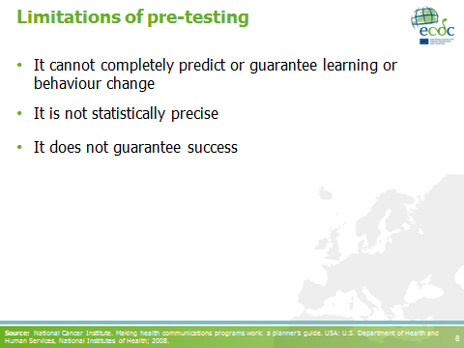 | Source: National Cancer Institute. Making health communications programs work: a planner’s guide. USA: U.S. Department of Health and Human Services, National Institutes of Health; 2008.
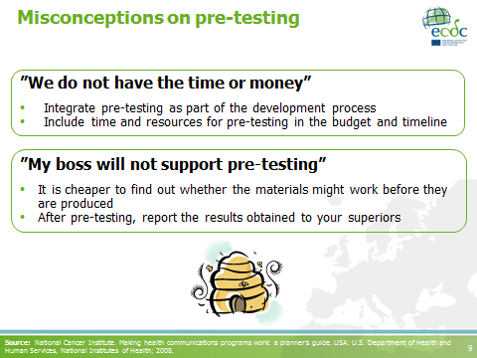
Convincing your superiors: build the case for pre-testing using quotes from the intended audience or anecdotes to illustrate the findings.

Note to the facilitators:
If time permits, ask the participants for examples of barriers to pre-testing and ideas for overcoming these barriers, possibly ones they have been testing. Could be in the form of a buzz group (marked by the beehive icon in the slide).

Source: National Cancer Institute. Making health communications programs work: a planner’s guide. USA: U.S. Department of Health and Human Services, National Institutes of Health; 2008.
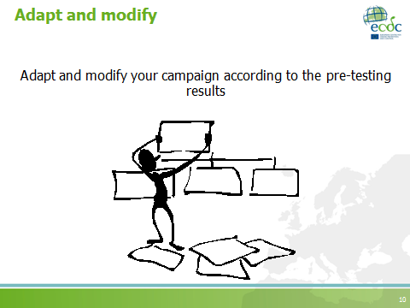 | Adaptations and modifications are not always required. Depending on your pre-testing results, do dedicate the time to adapt and modify your campaign accordingly.
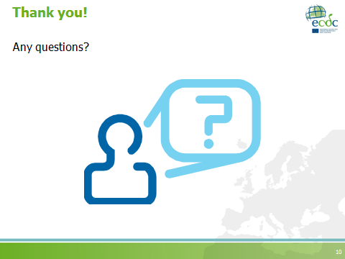

Case study session
Teaching objectives | To identify the key elements related to pre-testing
Time | 1 hour
Materials | Participant workbook
Type of session | Interactive

Facilitator notes
Facilitators should decide the following in advance:
- The case study to use
- Whether one case study will be used for the whole group or whether several case studies will be used, in which case participants should be divided into smaller groups
- Whether the session will be held in groups or individually but led by a facilitator
- If groups are to be formed, it is recommended to divide the groups differently that the groups organised on day one for the group work session.
IMPORTANTLY! Facilitators need to be familiar with the course material, particularly the case studies and need to decide how best to conduct this session.

- If only one case study will be used, case study 11 question 9 is recommended as a discussion point for this session.
- If the activity will be led by the facilitator and the discussion will be interactive during the presentation:
  - Ask participants to read the case study selected (can be found in their workbooks).
  - Clarify which parts of the case study you would like them to read (some case studies are divided into defined sections).
  - Be specific regarding which questions you would like them to respond.
  - Incorporate the discussion in the presentation.
    - Use the case studies to introduce/clarify new concepts.
    - Integrate participants’’ previous experiences.
- If the activity will be conducted in groups:
  - Ask participants to form groups.
    - Suggest that they interact with new people every time you form group activities, if possible.
    - Encourage them not to share group activities with colleagues from the same organisation or country.
  - Clarify which parts of the case study you would like them to read (some case studies are divided into defined sections).
  - Be specific regarding which questions you would like them to respond.
  - Indicate the time allocated for the group discussion.
  - Lead the plenary session.
    - Make sure to receive feedback from all groups.
    - Try to introduce/clarify new concepts as the discussion progresses.
    - Integrate participants’ previous experiences.

Lunch break
Duration: 1 hour

S6: Implementation
Teaching objectives | - To promote the exchange of implementation ideas and strategies among participants  - To provide basic knowledge on the establishment of partnerships for implementation of campaigns  - To describe alternative solutions for implementation of campaigns when budget and resources are scarce
Time | 1 hour 30 minutes
Materials | PowerPoint presentation, participant workbook (optional activity)
Type of session | - Interactive (1 hour)  - Facilitator presentation (30 minutes)

Learning coffee (1 hour)
- Participants will become the ‘facilitators’ of this session.
- Assign those participants willing to share implementation experiences (pre-determined before the course during the pre-course package) to specific tables labelled with the main topic of their expertise (e.g. establishing partnerships, influencing decision-makers, working with limited budget).
- Invite the remaining participants to sit at a table where the topic that interests them most will be discussed.
- Coffee should be made available during the discussions.
Remember
Instructions on how to lead this activity would have already been given to the participants who will lead this activity prior to the start of this course, during the pre-course package (Section 2.1).

Optional activity: case studies
If you do not wish to carry out a learning coffee activity you may also carry out the following suggested activity:
- Ask participants to discuss case study questions related to partnerships for implementation (see Annex 4).
- Participants may either work individually or in groups (same as earlier or different).
- Allow time for discussion with the whole group in plenary.
NB. Make sure to select either one or several case studies for discussion beforehand.
PowerPoint presentation
Implementation
Number of slides: 17
Duration: 30 minutes
Slide | Key points
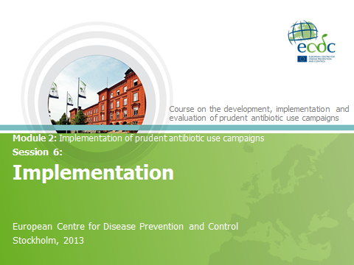
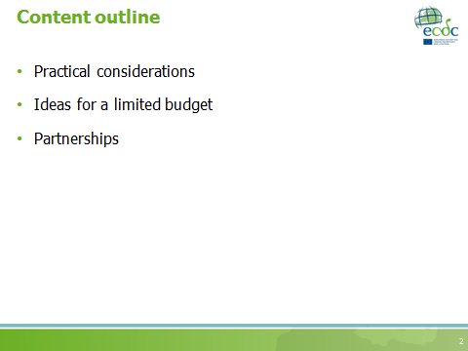
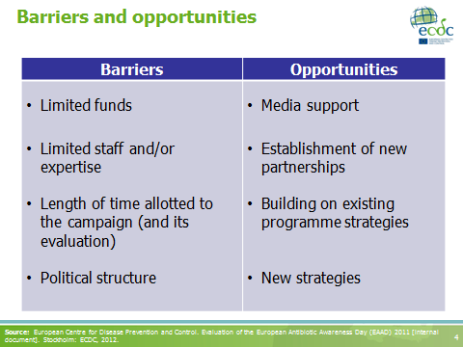 | Note to the facilitators:  - Try to promote interaction among participants: ask them to describe which barriers they have encountered when implementing their campaigns.  - You could also refer to the SWOT analysis presented on Day 1.  Source: European Centre for Disease Prevention and Control. Evaluation of the European Antibiotic Awareness Day (EAAD) 2011 [internal document]. Stockholm: ECDC, 2012.
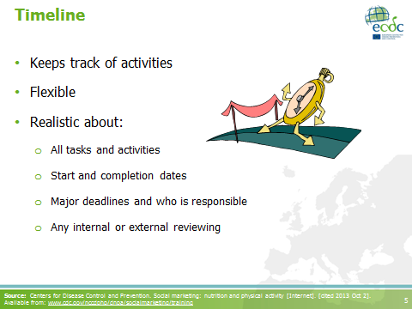
- Flexible: to allow for mid-course modifications
- Tasks and activities for planning, implementing and evaluating
- It helps you keep track of the activities

- Should be as flexible as possible

- It should be realistic about:
  - All tasks and activities
  - Start and completion dates
  - Major deadlines and who is responsible
  - Any internal or external review processes
Source: Centers for Disease Control and Prevention. Social marketing: nutrition and physical activity [Internet]. [cited 2013 Oct 2]. Available from: www.cdc.gov/nccdphp/dnpa/socialmarketing/training
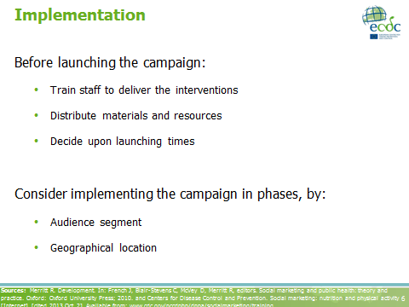 | Sources: Merritt R. Development. In: French J, Blair-Stevens C, McVey D, Merritt R, editors. Social marketing and public health: theory and practice. Oxford: Oxford University Press; 2010. and Centers for Disease Control and Prevention. Social marketing: nutrition and physical activity [Internet]. [cited 2013 Oct 2]. Available from: www.cdc.gov/nccdphp/dnpa/socialmarketing/training
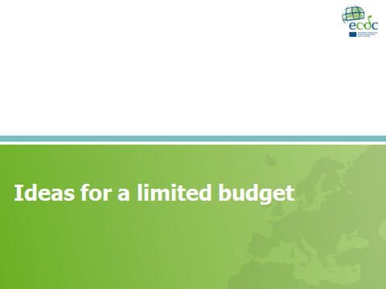 | - A shoestring budget does not make poor quality acceptable.  - The essential elements needed in a social marketing campaign, regardless of budget, are:  - absolute clarity about the particular behavioural challenge to be addressed,  - understanding of the target audience, and  - systematic set of processes to investigate, develop, implement, evaluate and share what has been learnt.  Source: French J. Social marketing on a shoestring budget. In: French J, Blair-Stevens C, McVey D, Merritt R, editors. Social marketing and public health: theory and practice. Oxford: Oxford University Press; 2010.
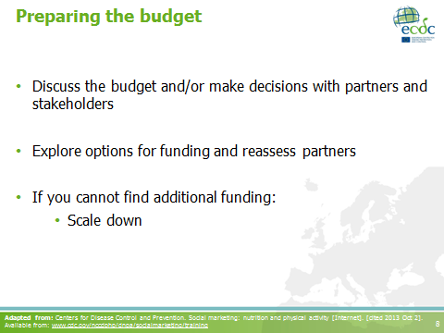 | - Discuss the budget: including partners and stakeholders in the discussion may smoothen the way for financial contributions.  - Explore options for funding: foundations and other funding agencies might be impressed if you approach them with a well-thought out plan that includes formative evaluation (i.e. formative research).  - Scale down: limit the target audience, decrease the number of objectives.  Adapted from: Centers for Disease Control and Prevention. Social marketing: nutrition and physical activity [Internet]. [cited 2013 Oct 2]. Available from: www.cdc.gov/nccdphp/dnpa/socialmarketing/training
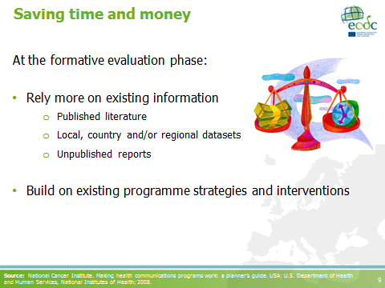 | Source: National Cancer Institute. Making health communications programs work: a planner’s guide. USA: U.S. Department of Health and Human Services, National Institutes of Health; 2008.
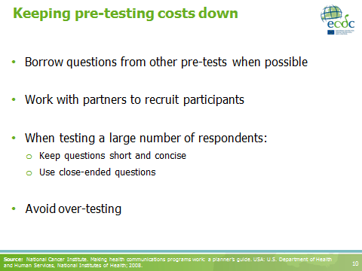 | Source: National Cancer Institute. Making health communications programs work: a planner’s guide. USA: U.S. Department of Health and Human Services, National Institutes of Health; 2008.
- Creative input for free:
- Get creative ideas by asking local schools or college students to work on ideas as a part of design, marketing, art or social programmes that they are studying.
- Local artists, designers, media workers and marketing firms can be persuaded to help for free.
- Using newsletters: good-quality printed or electronic newsletters can be used as channels to deliver highly targeted messages to your target audience.
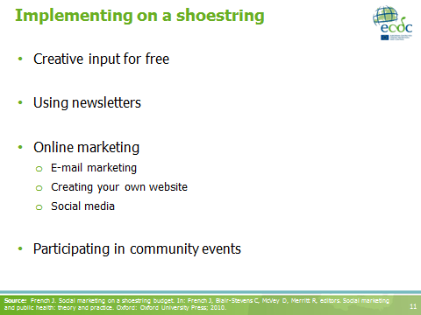
- Online marketing: a very local and global tool.
- Participating in community events: e.g. carnivals, parades, fairs and walks, to promote your intervention.

Source: French J. Social marketing on a shoestring budget. In: French J, Blair-Stevens C, McVey D, Merritt R, editors. Social marketing and public health: theory and practice. Oxford: Oxford University Press; 2010.
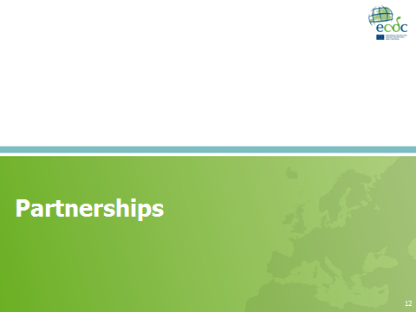
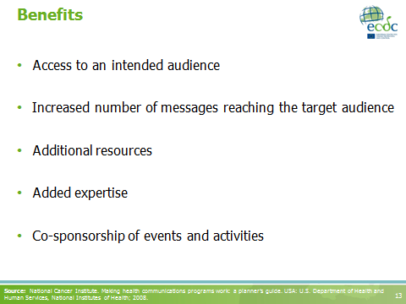 | Additional resources: either tangible or intangible.  Source: National Cancer Institute. Making health communications programs work: a planner’s guide. USA: U.S. Department of Health and Human Services, National Institutes of Health; 2008.
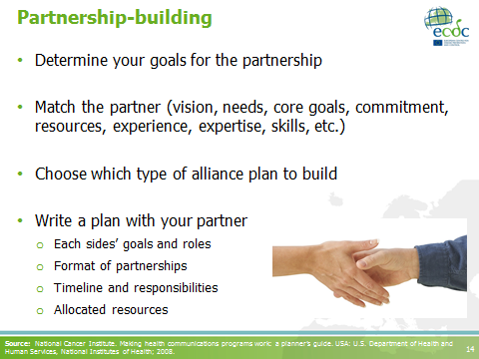 | - First you need to decide whether you want to develop a partnership or not.  - Type of partnerships: coalition, network, advisory board.  - For each partner consider:  - What specific activities can we collaborate on? What would the partner’s role be?  - What are the potential barriers to the partnership? How do we plan to overcome those barriers?  - What risks might this partnership involve? How do we mitigate those risks?  Source: National Cancer Institute. Making health communications programs work: a planner’s guide. USA: U.S. Department of Health and Human Services, National Institutes of Health; 2008.
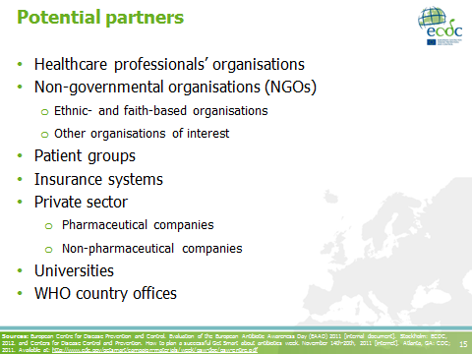 | Non-governmental organisations (NGOs): for example, ethnic- and faith-based organisations and/or other organisations of interest.  Sources: European Centre for Disease Prevention and Control. Evaluation of the European Antibiotic Awareness Day (EAAD) 2011 [internal document]. Stockholm: ECDC, 2012. and Centers for Disease Control and Prevention. How to plan a successful Get Smart about antibiotics week. November 14th-20th, 2011 [internet]. Atlanta, GA: CDC; 2011. Available at: http://www.cdc.gov/getsmart/campaign-materials/week/gsw-doc/gsw-entire.pdf
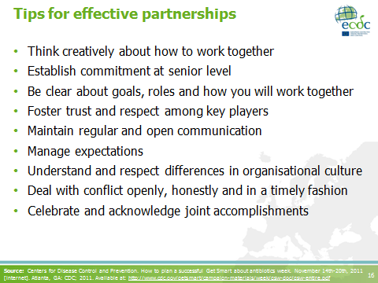 | - Manage expectations: do not promise anything you cannot deliver.  Source: Centers for Disease Control and Prevention. How to plan a successful Get Smart about antibiotics week. November 14th-20th, 2011 [internet]. Atlanta, GA: CDC; 2011. Available at: http://www.cdc.gov/getsmart/campaign-materials/week/gsw-doc/gsw-entire.pdf
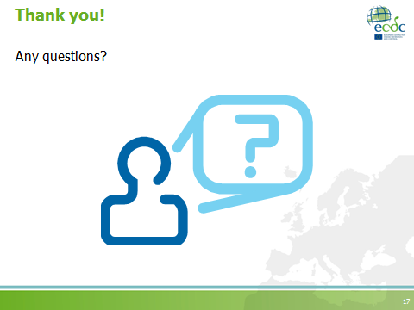

Coffee break
Duration: 15 minutes

S7: Evaluation
Teaching objectives | - To introduce general concepts on evaluation of campaigns  - To explain the characteristic of an appropriate indicator for evaluation of campaigns  - To apply concepts of evaluation in the analysis of case studies
Time | 1 hour
Materials | PowerPoint presentation, participant workbook
Type of session | - Facilitator presentation (30 minutes)  - Case studies (30 minutes)

PowerPoint presentation
Evaluation
Number of slides: 22
Duration: 30 minutes
Slide | Key points
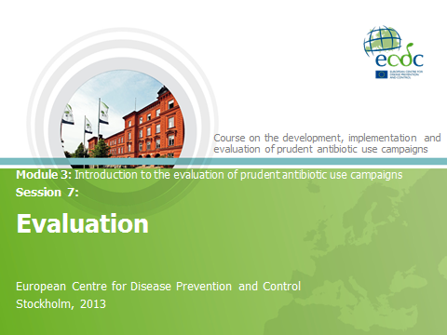
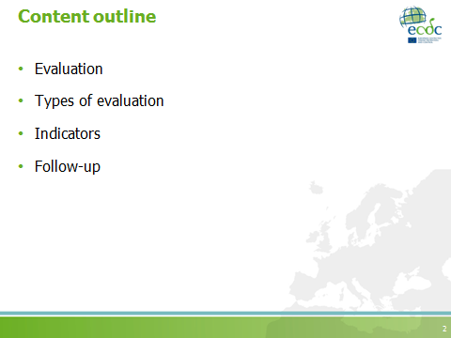
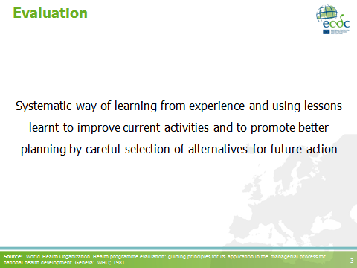 | Source: World Health Organization. Health programme evaluation: guiding principles for its application in the managerial process for national health development. Geneva: WHO; 1981.
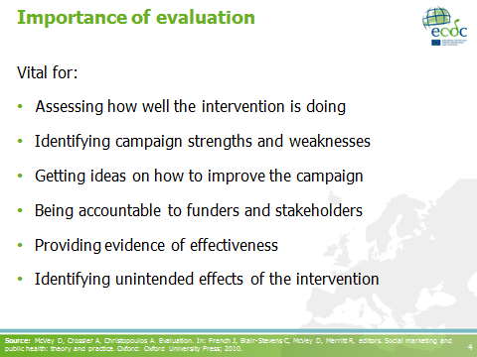 | Notes to the facilitators:  - Please refer to the pre-reading material: Huttner B, Goossens H, Verheij T, Harbarth S, CHAMP consortium. Characteristics and outcomes of public campaigns aimed at improving the use of antibiotics in outpatients in high-income countries. Lancet Infect Dis. 2010 Jan;10(1):17-31.  - Ask participants about their own experiences in campaign evaluations.  Source: McVey D, Crossier A, Christopoulos A. Evaluation. In: French J, Blair-Stevens C, McVey D, Merritt R, editors. Social marketing and public health: theory and practice. Oxford: Oxford University Press; 2010.
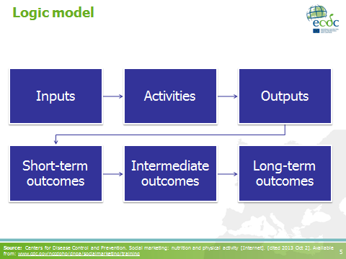 | A logic model:  - Describes the core components of the programme  - Illustrates the connection between programme components and expected outcomes  - Can help identify evaluation opportunities  - Can serve as an outcomes roadmap  Source: Centers for Disease Control and Prevention. Social marketing: nutrition and physical activity [Internet]. [cited 2013 Oct 2]. Available from: www.cdc.gov/nccdphp/dnpa/socialmarketing/training
- Formative evaluation: helps develop the campaign and its implementation.
- Process evaluation: is concerned with how the interventions were implemented and functioned.
- Outcome evaluation: focuses on short- and mid-term outcomes. It is vital that clear behavioural objectives are defined so that the evaluation can assess whether they have been satisfied.
- Impact evaluation: focuses on long-term effects as a result of the campaign’s aggregate effect on an individual’s behaviour and the behaviour’s sustainability.
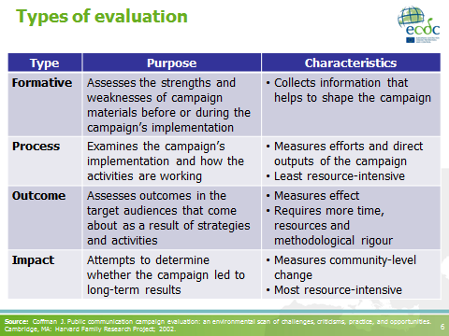
It is possible that the timescale or budget do not enable you to evaluate longer-term outcomes, which may mean that you cannot fully look into the campaign’s impact on behaviour. If so, it is important that your evaluation is tied with a behavioural change model (e.g. stages of change model remind participants about the model discussed in Session 3. You may want to bring up the earlier slide to clarify any questions on the stages of change model).

Note to the facilitators:
In the following slides, attention will be given to process, outcome and impact evaluations. Formative evaluation has been already discussed in previous sessions.

Sources: Coffman J. Public communication campaign evaluation: an environmental scan of challenges, criticisms, practice, and opportunities. Cambridge, MA: Harvard Family Research Project; 2002.

Saunders RP, Evans MH, Joshi P. Developing a process evaluation plan for assessing health promotion program implementation: a how-to guide. Health Promot Pract. 2005 Apr;6(2):134-147. and McVey D, Crossier A, Christopoulos A. Evaluation. In: French J, Blair-Stevens C, McVey D, Merritt R, editors. Social marketing and public health: theory and practice. Oxford: Oxford University Press; 2010.
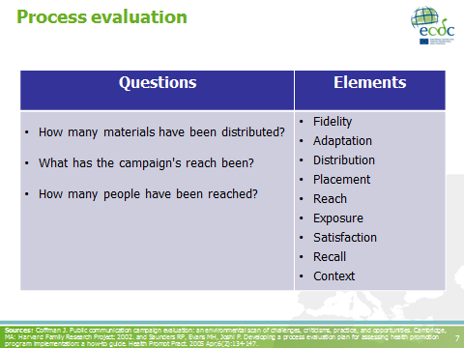
Note to the facilitators: this slide presents some of the questions which can be asked in a process evaluation and the elements/components it may include.

- How many materials have been distributed: both in terms of the different types of materials (e.g. brochures, bill boards, etc.) and how many of each (i.e. the quantity).
- Fidelity: extent to which the campaign was implemented as planned; quality = fidelity.
- Adaptation: (complementary to fidelity) to what degree and how does the implementation adapt and change in relation to the context?
- Distribution: types and number of products that the campaign has delivered, e.g. dose-delivered, completeness.
- Placement: media time, press or publicity received.
- Reach: proportion of the intended primary target audience that participates in the campaign activities, e.g. participation rate. Includes documentation on barriers for participation.
- Exposure: the degree to which the target audience encountered the campaign, e.g. dose received (the number of times they were exposed).
- Satisfaction: target audience’s satisfaction with the campaign and interaction with the staff, e.g. dose received.
- Recall: the degree to which the target audience recall (unaided) or recognise (aided) the campaign.
- Context: aspects of the environment which may influence the campaign implementation or its outcomes.

Sources: Coffman J. Public communication campaign evaluation: an environmental scan of challenges, criticisms, practice, and opportunities. Cambridge, MA: Harvard Family Research Project; 2002. and Saunders RP, Evans MH, Joshi P. Developing a process evaluation plan for assessing health promotion program implementation: a how-to guide. Health Promot Pract. 2005 Apr;6(2):134-147.
Note to the facilitators: the questions in an outcome evaluation relate to the behavioural objectives of the campaign.
This slide presents some of the questions that can be asked and the elements which can be included in this type of evaluation.
- Knowledge/awareness: can be one of the campaign’s first measures of progress, provided there is a baseline measure for comparison. Knowledge is important but does not give a complete picture of a campaign’s effect.
- Saliency: the importance of an issue. Although important/critical, it might be overlooked.
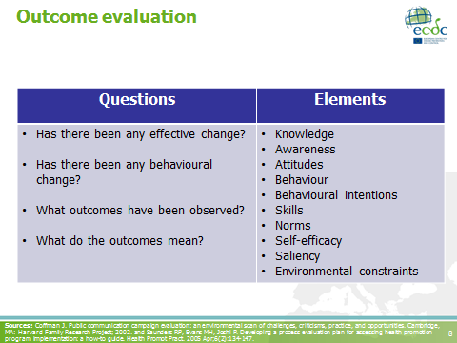
- Attitudes: a person’s effect for or against an object. Attitudes have a strong relationship to behaviour.
- Norms: perceived standards of acceptable attitudes and behaviours. Sometimes this is a critical factor in achieving behavioural change.
- Self-efficacy: a person’s belief that s/he has the ability or competency to perform a behaviour under different circumstances. It has a direct effect on a person’s intention to perform a behaviour.
- Behavioural intentions: a measure of the likelihood that a person will engage in a specific behaviour. According to the theory of reasoned action, there is a strong predictive relationship between people’s intention to perform a behaviour and whether they actually perform it.
- Skills: may be necessary to perform a particular behaviour.
- Behaviour: the most important campaign outcome, usually captured through self-reports.
- Environmental constraints: situational factors which can make the performance of a behaviour difficult or impossible.

Sources: Coffman J. Public communication campaign evaluation: an environmental scan of challenges, criticisms, practice, and opportunities. Cambridge, MA: Harvard Family Research Project; 2002. and Saunders RP, Evans MH, Joshi P. Developing a process evaluation plan for assessing health promotion program implementation: a how-to guide. Health Promot Pract. 2005 Apr;6(2):134-147.
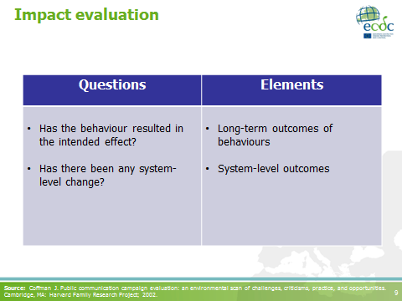 | Note to the facilitators: Please remind participants that impact evaluation focuses on long-term outcomes.  - Long-term outcomes of behaviours: measure of aggregated results - whether the campaign was successful in mounting behaviour change in a sizable number of individuals.  - System-level outcomes: might include long-term changes in service delivery, training or distribution.  Source: Coffman J. Public communication campaign evaluation: an environmental scan of challenges, criticisms, practice, and opportunities. Cambridge, MA: Harvard Family Research Project; 2002.
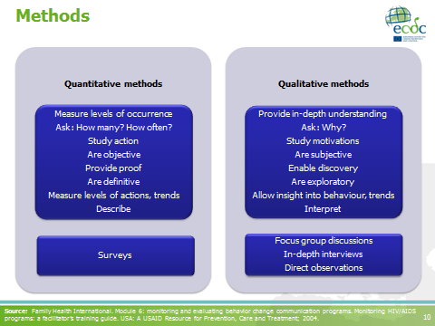 | Note to the facilitators:  This slide is just a reminder of the different types of methods which can be used to collect data in order to evaluate a social marketing campaign; the purposes of the different approaches and some methods which can be used are depicted in the diagram.  Source: Family Health International. Module 6: monitoring and evaluating behavior change communication programs. Monitoring HIV/AIDS programs: a facilitator’s training guide. USA: A USAID Resource for Prevention, Care and Treatment; 2004.
The hierarchies of evidence is a notion developed by researchers to determine the quality of evidence when assessing the effectiveness of an intervention.

Note to the facilitators:
The definitions of the different sources of evidence are provided in case you consider it necessary to explain each one of them in detail.
- Meta-analysis: statistical analysis that combines the results of several independent studies.
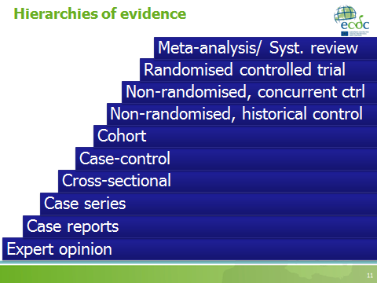
- Systematic review: review of a body of data that uses explicit methods to locate primary studies and explicit criteria to assess their quality.
- Randomised controlled trial: individuals or groups are randomly allocated to a ‘test’ group to receive a specific intervention or a ‘control’ group who do not receive the intervention which you would like to test. Data collection is carried out with both groups before and after the test intervention.
- Non-randomised, concurrent control
- Non-randomised, historical control
- Cohort studies: groups of people are selected on the basis of their exposure to a particular agent and followed up for specific outcomes.
- Case-control studies: ‘cases’ with the condition are matched with ’controls’ who do not exhibit the condition, and a retrospective analysis is used to look for differences between the two groups.
- Cross-sectional studies: consist of the observation of a whole population, or a representative subset, at a specific point in time.
- Cases series studies (also known as case reports): report based on a few patients or subjects; sometimes collected together into short series.
- Expert opinion: opinion from respected authorities and experts, based on clinical evidence, descriptive studies or reports from committees.

Source: McVey D, Crossier A, Christopoulos A. Evaluation. In: French J, Blair-Stevens C, McVey D, Merritt R, editors. Social marketing and public health: theory and practice. Oxford: Oxford University Press; 2010.
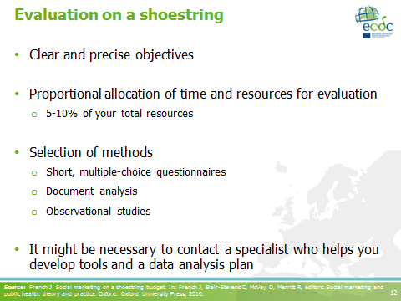 | - Clear and precise objectives: if the objectives are clearly defined, it is easier to select appropriate measures for evaluation.  - Proportional allocation of time and resources for evaluation: evaluation should not take more that 10% of your total resources. If the project value is less than €100,000, it should not be more than 5%.  - Selection of methods: some of the methods that can be used in a low budget campaign are suggested on the slide.  Source: French J. Social marketing on a shoestring budget. In: French J, Blair-Stevens C, McVey D, Merritt R, editors. Social marketing and public health: theory and practice. Oxford: Oxford University Press; 2010.
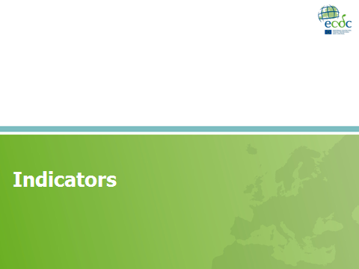
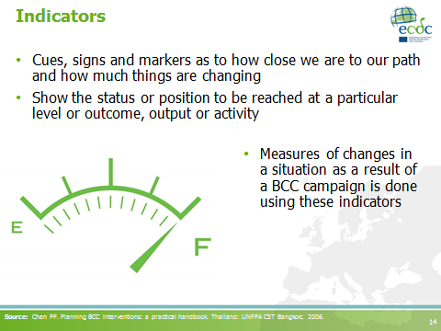 | BCC: behaviour change communication  Source: Chen PF. Planning BCC interventions: a practical handbook. Thailand: UNFPA CST Bangkok; 2006.
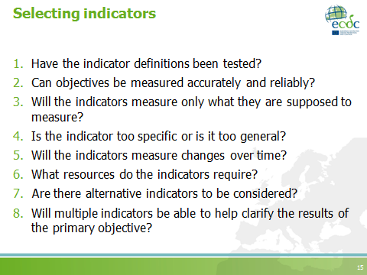 | Are there areas of overlap in the content of the indicator with that of other indicators? Is it specific, or is it too general?
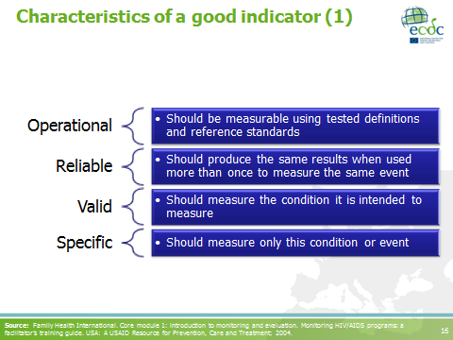 | Source: Family Health International. Core module 1: introduction to monitoring and evaluation. Monitoring HIV/AIDS programs: a facilitator’s training guide. USA: A USAID Resource for Prevention, Care and Treatment; 2004.
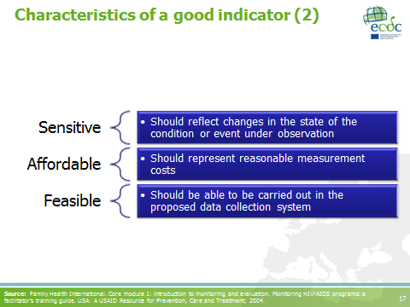 | Source: Family Health International. Core module 1: introduction to monitoring and evaluation. Monitoring HIV/AIDS programs: a facilitator’s training guide. USA: A USAID Resource for Prevention, Care and Treatment; 2004.
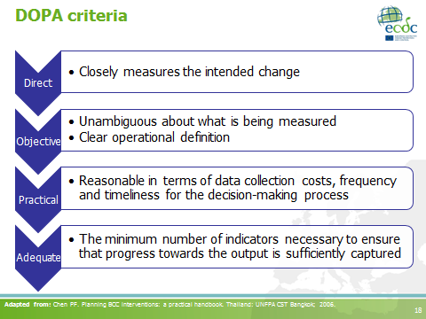 | Note to the facilitators:  Point out to the participants that they have an indicator list provided to them in their workbooks (Chapter 4), with a range of selected indictors. They can use this list for ideas during group work sessions.  Adapted from: Chen PF. Planning BCC interventions: a practical handbook. Thailand: UNFPA CST Bangkok; 2006.
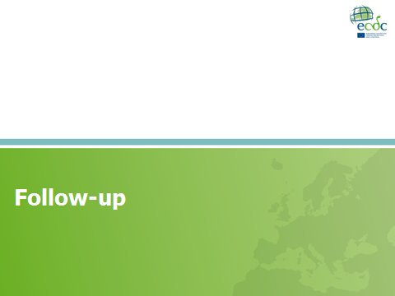
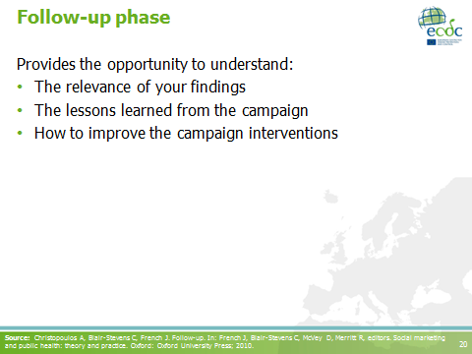
- If the campaign is ceased immediately after evaluation, one may miss out on the lessons learnt from the intervention, and fail to strengthen relationships with stakeholders built throughout the course of the campaign.
- The aim of the follow-up phase is to share and use findings from the evaluation (which otherwise may not reach those you would like it to reach) in order for future developments and campaigns to build on the successes and failures that have been learnt.
- It provides:
  - a shared understanding of what has been achieved through the campaign, and what can be improved,
  - stakeholders, partners or funders with information on what has been fulfilled and what results have been obtained, as well as a realistic understanding of the challenges faced during the process, and
  - project/campaign staff the time to reflect upon how to further improve the campaign.

Source: Christopoulos A, Blair-Stevens C, French J. Follow-up. In: French J, Blair-Stevens C, McVey D, Merritt R, editors. Social marketing and public health: theory and practice. Oxford: Oxford University Press; 2010.
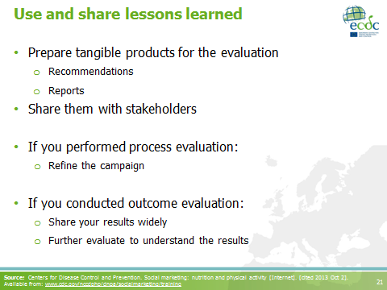 | If possible share your results in scientific papers!  Source: Centers for Disease Control and Prevention. Social marketing: nutrition and physical activity [Internet]. [cited 2013 Oct 2]. Available from: www.cdc.gov/nccdphp/dnpa/socialmarketing/training
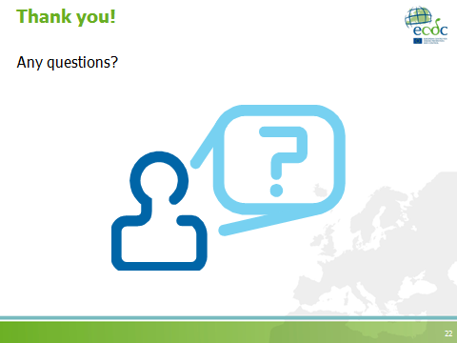

Case study session
Teaching objectives | To identify the key concepts on evaluation, emphasising on:  - the evaluation plan,  - evaluation design/methods, and  - indicators
Time | 30 minutes
Materials | Participant workbook
Type of session | Interactive

Facilitator notes
Facilitators should decide the following in advance:
- The case study to use
- Whether one case study will be used for the whole group or whether several case studies will be used, in which case participants should be divided into smaller groups
- Whether the session will be held in groups or individually but led by a facilitator
- If groups are to be formed, it is recommended to divide the groups differently that the groups organised on day one for the group work session.
IMPORTANTLY! Facilitators need to be familiar with the course material, particularly the case studies and need to decide how best to conduct this session.

- If the activity will be led by the facilitator and the discussion will be interactive during the presentation:
  - Ask participants to read the case study selected (can be found in their workbooks).
  - Clarify which parts of the case study you would like them to read (some case studies are divided into defined sections).
  - Be specific regarding which questions you would like them to respond.
  - Incorporate the discussion in the presentation.
    - Use the case studies to introduce/clarify new concepts.
    - Integrate participants’’ previous experiences.
- If the activity will be conducted in groups:
  - Ask participants to form groups.
    - Suggest that they interact with new people every time you form group activities, if possible.
    - Encourage them not to share group activities with colleagues from the same organisation or country.
  - Clarify which parts of the case study you would like them to read (some case studies are divided into defined sections).
  - Be specific regarding which questions you would like them to respond.
  - Indicate the time allocated for the group discussion.
  - Lead the plenary session.
    - Make sure to receive feedback from all groups.
    - Try to introduce/clarify new concepts as the discussion progresses.
    - Integrate participants’ previous experiences.

Group work activity: development of a campaign strategy
Instructions for the group work activity
Duration: 2 hours
- Ask participants to re-group with the groups they were working with during the previous day’s group work session.
- Remind participants about the group work rules defined previously.
- Remind participants that they will present their work to their course mates who will evaluate their work on day three and to prepare the necessary documents for this.
NB. Think about logistic arrangements, e.g. availability of a photocopy machine in the case of hard copies, access to internet, developing a PowerPoint template for the groups to work with, distributing flip chart papers and markers, etc.
- Confirm that the ‘opposition team’ is set and that their roles are clear among all participants.
- Instruct participants that instructions and group work sheets are found in their participant workbook under the section entitled, ‘Group work’, and that they should now complete their campaign strategy. If you wish you may go through the group work sheets and instructions with the group. NB. Group work sheets can also be found in the manual in Annex 3.
- Provide specific feedback if necessary.
- Clarify instructions and what is expected from the groups.
The role of the facilitator in group work sessions:
Each group should have one facilitator assigned to them in order to assist them in the clarification of instructions and/or any other questions which may come up during the session. The different areas of expertise within the facilitation team should be clear among the facilitators so that when questions are raised, especially those requiring specialised knowledge, the most suitable facilitator can be contacted.

Facilitator notes
This group work session may be changed to a case study discussion if the facilitators believe that the group work activity suggested here is too demanding for the group. If so, a group presentation of the case study on day three of the course is still recommended.

Wrap-up of day 2
Teaching objectives | - To summarise the take home messages of the day  - To distribute daily evaluation forms (Annex 6)
Time | 15 minutes
Materials | None in particular
Type of session | Informative
Task assignment
Before closing the session, give all the necessary instructions on the following day’s group work presentations:
- Ensure that everyone has received copies (hard or soft) of the other group’s presentations/group work summaries.
- Confirm that the opposition teams know their roles and if not, re-clarify the instructions.
- Give instructions on the group presentations (see below).
- Ask participants to be on time the next day.

Instructions for the group work presentations
  - Final preparations: Each group will be given 20 minutes to finalise preparing their presentations.
  - Presentation: Each group will have 10 minutes to present their work, followed by a 10-minute discussion with the ‘opposition team’ or ‘commenting group’ (2 hours).
  - Plenary: summarise the presentations with a plenary, led by a facilitator (30 minutes).

Evaluation of the day
Facilitation team meeting
Evaluation of day 2
Aim of the meeting:
- Summarise the day
- Focus on things to improve for next day
Duration: 30-60 minutes

2.2.5 Day 3 sessions

I3: Introduction to day 3
Teaching objectives | To clarify participants doubts on the previous day’s content
Time | 30 minutes
Materials | Whiteboard, whiteboard markers, flipchart, permanent markers
Type of session | Interactive
Task I3.1: Welcome
- Welcome participants to the third day of training.
- Ask participants if they have any questions the content of day two.
- Alternatively, you could select an energiser or quick assessment activity to warm up for the next session (Annexes 2 and 6).

Group presentations
Instructions for the group work presentations
Time allocated to this group work session: 2 hours 30 minutes.

- Final preparations: Each group will be given 20 minutes to finalise preparing their presentations.
- Presentation: Each group will have 10 minutes to present their work, followed by a 10-minute discussion with the “commenting group” (2 hours).
- Evaluation score matrixes (found at the end of the group work chapter) will be used to assess each other’s work. [NB. Decide in advance whether you would want participants to score other groups individually or as a group]. The necessary instructions can be found just prior to the score matrixes in the group work chapter (Annex 3 in this manual).
- Plenary: summarise the presentations with a plenary, led by a facilitator (30 minutes).
- Coffee should be available during this session.
- Time management is the facilitator’s responsibility, who will have the role of moderator.

Wrap-up of day 3
Teaching objectives | - To summarise the take home messages of the day and the course in general  - To distribute end of face-to-face course evaluation sheets (Annex 6)  - To explain the procedures for the post-course work package
Time | 30 minutes
Materials | Whiteboard, whiteboard markers
Type of session | Interactive

Course evaluation
Facilitation team meeting
Evaluation of day 3 and the course in general
Aim of the meeting:
- Summarise the day
- Summarise the course
Duration: 90 minutes

2.3 Post-course package
The post-course package is not compulsory but optional to those who would like to complete it. If desired, our recommendations below cater for an online package using a web-based platform. However, as with the pre-course package, other more conventional methods such as electronic mail or post are also possible, therefore the suggestions provided may be altered as necessary.
After completion of the face-to-face course, participants will receive a written feedback report summarising comments from other participants and the facilitator team regarding their work during the training sessions. This feedback report should be sent out to the participants within two weeks after completion of the course. Simultaneously, participants will be asked to complete a web-based post-training exercise no later than one month after finishing the training, to reduce the risk of them forgetting specific components of the course. This exercise will be identical to the pre-course exercise in order to assess the additional knowledge acquired during the course. Additionally, an impact survey could be distributed to participants three months after completion of the training course.
The post-course package could also include follow-up discussions, using electronic communications (e-mail, video conference, social networks, as appropriate) to support participants reflection process after the training sessions and the country-specific campaign development process (if applicable).
Everything with regards to evaluation can be found in the next Chapter on ‘Training evaluation plan and tools’ (Chapter 3).

Course on the development, implementation and evaluation of prudent antibiotic use campaigns

Training evaluation plan and tools

3.1 Introduction to course evaluation
Evaluation of training activities is fundamental to ensure that the training has served the purpose for which it was intended.
Reasons for training evaluation include:
- Tracking the development of people’s knowledge and skills
- Finding out whether the training was appropriate to the participant and whether what was learnt is being applied
- Identifying gaps and future needs in training
- Finding out if the investment in training was worthwhile or whether alternative methods to improve performance are needed instead
- Obtaining information on which to base future training plans and strategies
For evaluation, Kirkpatrick’s model of evaluation is recommended, as proposed by the WHO training evaluation guidelines. This training evaluation focuses on levels 1-3 of the training impact and evaluation model as follows:
Level | Focus | Evaluation methods
1 | Reaction | - Quick assessments  - Formal verbal feedback  - Lunchtime questionnaire  - Daily evaluation form  - End-of-course evaluation (6-point Likert scale)
2 | Learning | - Pre- and post-test  - Exercises to be completed during the training
3 | Behaviour | - Post-training feedback survey
These different levels of evaluation are an integral part of a course and should therefore be developed in good time and as part of the course design. Evaluation in levels 1 and 2 happen during the training. In level 3, evaluation takes place at a later stage (several months later), when the participant is performing what the training was intended to help him/her do better. Explaining to the participants what method of evaluation will be used during the course before the training begins and during the training itself is advised.
On the following pages each individual level is clearly described. Examples of quick assignments and different evaluation tools and methods are given in Annex 6. The evaluation tools provided are only suggestions; feel free to adapt them to your needs.
The course evaluation guide is based on the ‘Evaluation training in WHO’ and the ‘Training resource toolkit by I-TECH’. For complementary reading, the ‘Evaluation training in WHO’ is recommended, in which a comprehensive and applicable overview of evaluation models and techniques is provided.
3.1.1 Overview of suggested evaluation tools
The overview gives suggestions on evaluation tools which may be used, according to the three levels of evaluation mentioned earlier. The different evaluation tools complement each other with the aim to achieve a holistic view of the training procedure.

 |  | Suggested schedule
 |  | 2.5-day course
Level 1  (reaction) | Tools for assessment as the training occurs | Quick assessments
Level 1  (reaction) | Tools for assessment as the training occurs | Formal verbal feedback
Level 1  (reaction) | Tools for assessment as the training occurs | Daily evaluation form
Level 1  (reaction) | Tools for post-course assessment | End-of-course questionnaire
Level 2  (learning) |  | Pre- & post-test
Level 2  (learning) |  | Exercises during training
Level 3 (behaviour) |  | Post-training feedback survey

3.2 Evaluation level one (reaction)
The purpose of this level of evaluation is to find out how participants react to the training. Do they feel that it met their needs? Was it organised efficiently? Were the premises suitable? Basically, participants should appreciate their training period and should be satisfied with it.
3.2.1 Tools for assessment as the training takes place
Quick assessments
Quick assessments can be used throughout the course. They help to transform passively heard information into reproducible active knowledge. Furthermore, quick assessments are a useful tool for the trainer to get immediate feedback on what the participants are learning and the quality of the trainers teaching. If a quite minor concept in the course is seen by the participants as the ‘main point’, either the trainer or the participants have a problem.
It is recommended to plan time during the lecture, at the end of the day or during a morning session, where the participants are given the opportunity to summarise knowledge acquired during the (previous) day and may discuss unanswered questions in order to clarify concepts. For ideas on how to perform quick assessments, please refer to Annex 6.
Formal verbal feedback
Formal verbal feedback helps to learn and determine whether the course is meeting its objectives. It supports and validates other forms of evaluation. In order to encourage participants to provide constructive feedback you should ensure that their verbal comments are:
- Specific
- Immediately after the event itself or shortly afterwards, not at a future date
- Based on issues: any criticism should be directed at aspects of the event itself not at the facilitator or trainer!
- Helpful
- Forward looking: feedback should look to the future, developing solutions to problems
Daily evaluation form
If the training extends over several days, it is helpful to hand out a daily feedback form at the end of each day’s training in order to see what the participants think of the training so far and whether any element of the training needs improvement. Two versions of how to pose the daily evaluation can be found in Annex 6.

3.2.2 Tools for assessment after the training
End-of-course questionnaire
For overall evaluation of the training, the end-of-course questionnaire is recommended (Annex 6). It is the most commonly used evaluation tool. Keep in mind that this form of evaluation only covers the reaction to the course and will not tell you much about the participant’s understanding and subsequent behaviour change.
It is important that this kind of evaluation form is answered directly or in very close succession after the course ends. Inform the participants in advance that they will receive the evaluation form and the importance of their answers to the course development. Time has to be planned for participants to answer the questionnaire before they rush home, sightseeing or to their next meeting. The end-of-course questionnaire has to be short enough for the participants to feel motivated to answer it but detailed enough for you to get information on the participant’s reaction to the course.

Source: European Centre for Disease Prevention and Control Public Health Training Section. Epidemiological methods applied to vaccine preventable diseases: train the trainers; 2012 Feb 21-23; Florence, Italy. Stockholm, ECDC; 2012.

3.3 Evaluation level two (learning)
The purpose of the evaluation should be to assess specific knowledge or skills, i.e. have the learning objectives been achieved?
During the course, learning may be assessed in two ways:
Pre- and post-training exercise
An identical test is sent out to the participants pre- and post-training (Annex 6). The objective of this activity is to assess the participants’ experiences and knowledge on social marketing and behaviour change communication campaigns as well as evaluation methods before and after the course. This exercise suggested here consists of two parts. Part one is a case study and part two relates to the participants own experience when developing, implementing and evaluating prudent antibiotic use campaigns.
Exercises to be completed during the training
- Group work
- Case studies

3.4 Evaluation level three (behaviour)
The purpose of a level three evaluation is to assess the extent to which the participant is applying new knowledge and skills at the workplace, i.e. has the instructional goal been achieved?
Post-training feedback survey (Annex 6)
For level three evaluation, a feedback survey is sent out to the participants after three months. It is important to have informed the participants before and during the course that this form of evaluation will be used and that it will be sent out several months after the training. The post-training feedback survey yields information on whether the training has had any impact on the participants work. It will even give useful comments to make adjustments for future courses.

Course on the development, implementation and evaluation of prudent antibiotic use campaigns

Bibliography

Adriaenssens N, Coenen S, Tonkin-Crine S, Verheij TJM, Little P, Goossens H, on behalf of the ESAC Project Group. European surveillance of antimicrobial consumption (ESAC): disease-specific quality indicators for outpatient antibiotic prescribing. BMJ Qual Saf. 2011 Mar 21;Epub ahead of print.
Agenzia Italiana del Framaco. “Antibiotici. Difendi la tua difesa. Usali con cautela”. [internet]. 2012 [cited 2012 Oct 5]. Available from: http://www.agenziafarmaco.gov.it/it/content/antibiotici-difendi-la-tua-difesa-usali-con-cautela-0
Andreasen A. Marketing and social change: changing behaviours to promote health, social development and the environment. San Francisco: Jossey-Bass; 1995.
Andreasen AR. Marketing social marketing in the social change marketplace. J Public Policy Mark. 2002 Spring;21(1):3-13.
Ashe D, Patrick PA, Stempel MM, Shi Q, Brand DA. Educational posters to reduce antibiotic use. J Pediatr Health Care. 2006 May-June;20(3):192-197.
Biggs J. Teaching for quality learning at university. 2nd ed. Buckingham: The Society for Research into Higher Education and Open University Press; 2003.
Blair-Stevens C, Reynolds L, Christopoulos A. Behavioural theory: understanding the key influences on human behaviour. In: French J, Blair-Stevens C, McVey D, Merritt R, editors. Social marketing and public health: theory and practice. Oxford: Oxford University Press; 2010.
Borg M. National cultural dimensions as drivers of inappropriate ambulatory care consumption of antibiotics in Europe and their relevance to awareness campaigns. J Antimicrob Chemother. 2012 Mar;67(3):763-767.
Borg MA, Scicluna EA. Over-the-counter acquisition of antibiotics in the Maltese general population. Int J Antimicrob Agents. 2002 Oct;20(4):253-257.
Budge M, Deahl C, Dewhurst M, Donajgrodzki S, Wood F. Communications and behaviour change. UK: COI Publications; 2009.
Centers for Disease Control and Prevention. How to plan a successful Get Smart about antibiotics week. November 14th-20th, 2011 [internet]. Atlanta, GA: CDC; 2011. Available at: http://www.cdc.gov/getsmart/campaign-materials/week/gsw-doc/gsw-entire.pdf
Centers for Disease Control and Prevention. Introduction to program evaluation for public health programs: evaluating appropriate antibiotic use programs. Atlanta: CDC; 2006.
Centers for Disease Control and Prevention. Social marketing: nutrition and physical activity [Internet]. [cited 2013 Oct 2]. Available from: www.cdc.gov/nccdphp/dnpa/socialmarketing/training
Centers for Disease Control and Prevention. Workplace health promotion: glossary [Internet]. 2013 [updated 2011 Apr 25; cited 2013 Oct 2]. Available from: http://www.cdc.gov/workplacehealthpromotion/glossary/index.html#H
Charani E, Edwards R, Sevdalis N, Alexandrou B, Sibley E, Mullett D, Franklin BD, Holmes A. Behavior change strategies to influence antimicrobial prescribing in acute care: a systematic review. Clin Infect Dis. 2011 Oct;53(7):651-662.
Chen PF. Planning BCC interventions: a practical handbook. Thailand: UNFPA CST Bangkok; 2006.
Christmann S. Communique de presse: journée européenne consacrée à la résistance aux antibiotiques (European Antibiotic Awareness Day). Luxembourg: Le Gouvernement du Grand-Duché de Luxembourg; 2008.
Coenen S, Ferech M, Haaijer-Ruskamp FM, Butler CC, Vander Stichele RH, Verheij TJ, Monnet DL, Little P; Goossens H,ESAC Project Group. European surveillance of antimicrobial consumption (ESAC): quality indicators for outpatient antibiotic use in Europe. Qual Saf Health Care. 2007 Dec;16(6):440-445.
Coffman J. Public communication campaign evaluation: an environmental scan of challenges, criticisms, practice, and opportunities. Cambridge, MA: Harvard Family Research Project; 2002.
Colegio Oficial de Farmacéuticos de Asturias. Consejos de Salud. [internet]. 2012 [cited 2012 Oct 8]. Available from: http://www.farmasturias.org/GESCOF/cms/contenidos/contenido.asp?id=173&IdMenu=119
Core Group Social and Behavioral Change Working Group. Designing for behavior change curriculum. Washington: CORE Group; 2008.
Deschepper R, Grigoryan L, Stålsby Lundborg C, Hofstede G, Cohen J, Van Der Kelen G, Deliens L, Haaijer-Ruskamp FM. Are cultural dimensions relevant for explaining cross-national differences in antibiotic use in Europe? BMC Health Serv Res. 2008;8:123.
Donovan RJ. The role for marketing in public health change programs. Aust Rev Pub Aff. 2011 Jul;10(1):23-40.
Earnshaw S, Monnet DL, Duncan B, O’Toole J, Ekdahl K, Goossens H, European Antibiotic Awareness Day Technical Advisory Committee, European Antibiotic Awareness Day Collaborative Group. European antibiotic awareness day, 2008 - the first Europe-wide public information campaign on prudent antibiotic use: methods and survey of activities in participant countries. Euro Surveill. 2009 Jul 30;14(30):19280.
Europa press. Europa press. [internet] 2012 [cited 2012 Oct 8]. Available from: http://www.europapress.es/
Emmer CL, Besser RE. Combating antimicrobial resistance: intervention programs to promote appropriate antibiotic use. Infect Med. 2002;19(4):160-173.
European Antimicrobial Resistance Surveillance System. EARSS annual report 2008: on-going surveillance of S. pneumoniae, S. aureus, E. coli, E. faecium, E. faecalis, K. pneumoniae, P. aeruginosa. Bilthoven, The Netherlands: EARSS Management Team, members of the Advisory Board, and national representatives of EARSS; 2009.
European Centre for Disease Prevention and Control. Evaluation of the European Antibiotic Awareness Day (EAAD) 2011 [internal document]. Stockholm: ECDC, 2012.
European Centre for Disease Prevention and Control Public Health Training Section. Epidemiological methods applied to vaccine preventable diseases: train the trainers; 2012 Feb 21-23; Florence, Italy. Stockholm: ECDC; 2012.
European Surveillance of Antimicrobial Consumption. ESAC yearbook 2009. Antwerp, Belgium: ESAC Management Team, the ESAC Scientific Advisory Board and the ESAC National Networks; 2010.
Family Health International. Core module 1: introduction to monitoring and evaluation. Monitoring HIV/AIDS programs: a facilitator’s training guide. USA: A USAID Resource for Prevention, Care and Treatment; 2004.
Family Health International. Module 6: monitoring and evaluating behavior change communication programs. Monitoring HIV/AIDS programs: a facilitator’s training guide. USA: A USAID Resource for Prevention, Care and Treatment; 2004.
French J. Social marketing on a shoestring budget. In: French J, Blair-Stevens C, McVey D, Merritt R, editors. Social marketing and public health: theory and practice. Oxford: Oxford University Press; 2010.
French J, Blair-Stevens C, McVey D, Merritt R, editors. Social marketing and public health: theory and practice. Oxford: Oxford University Press; 2010.
Goberno de España. Sin tu ayuda, los antibióticos pueden perder su eficacia. 2012 [cited 2012 Oct 8]. Available from: www.antibioticos.msc.es
Gonzales R, Corbett KK, Leeman-Castillo BA, Glazner J, Erbacher K, Darr CA, Wong S, Maselli JH, Sauaia A, Kafadar K. The minimizing antibiotic resistance in Colorado project: impact of patient education in improving antibiotic use in private office practices. Health Serv Res. 2005 Feb;40(1):101-116.
Gonzales R, Corbett KK, Wong S, Glazner JE, Deas A, Leeman-Castillo B, Maselli JH, Sebert-Kuhlmann A, Wigton RS, Flores E, Kafadar K. Get smart Colorado: impact of a mass media campaign to improve community antibiotic use. Med Care. 2008 Jun;46(6):597-605.
Goossens H. Expert-proposed European strategies to monitor and control infection, antibiotic use, and resistance in health-care facilities. Lancet Infect Dis. 2011 Apr 7;11(5):338-340.
Goossens H, Coenen S, Costers M, De Corte S, De Sutter A, Gordts B, Laurier L, Struelens M. Achievements of the Belgian Antibiotic Policy Coordination Committee (BAPCOC). Euro Surveill. 2008 Nov 13;13(46):pii 19036.
Goossens H, Guillemot D, Ferech M, Schlemmer B, Costers M, van Breda M, Baker LJ, Cars O, Davey PG. National campaigns to improve antibiotic use. Eur J Clin Pharmacol. 2006 May;62(5):373-379.
Grier S, Bryant CA. Social marketing in public health. Ann Rev Public Health. 2005;26:319-339.
Hastings G, Angus K, Bryant C, editors. The SAGE handbook of social marketing. London: SAGE Publications Ltd.; 2011.
Health, the Elderly and Community Care. National antibiotic committee. [internet]. 2012 [cited 2012 Oct 13]. Available from: https://ehealth.gov.mt/HealthPortal/others/regulatory_councils/national_antibiotic_committee/download_material.aspx
Hemo B, Shamir-Shtein NH, Silverman BG, Tsamir J, Heymann AD, Tsehori S, Friedman NL. Can a nationwide media campaign affect antibiotic use? Am J Manag Care. 2009 Aug;15(8):529-534.
Huttner B, Goossens H, Verheij T, Harbarth S, CHAMP consortium. Characteristics and outcomes of public campaigns aimed at improving the use of antibiotics in outpatients in high-income countries. Lancet Infect Dis. 2010 Jan;10(1):17-31.
Huttner B, Harbarth S. “Antibiotics are not automatic anymore”: the French national campaign to cut antibiotic overuse. PLoS Med. 2009 Jun 2;6(6):e1000080.
Independent Evaluation Group of the World Bank, in collaboration with the DAC Secretariat. Impact evaluation: an overview and some issues for discussion. 4th meeting, 30-31 March 2006. DAC network on development evaluation; 2006.
International HIV/AIDS Alliance. 100 ways to energise groups: games to use in workshops, meetings and the community. Brighton: The International HIV/AIDS Alliance; 2002.
International Training and Education Center for Health. Ice breaker activities for training sessions [Internet]. 2004 August [cited 2012 Nov 16]. Available from: www.go2itech.org/HTML/TT06/.../IceBreakerActivTrngSess.doc
International Training and Education Center for Health. Training evaluation framework and tools (TEFT). 2011 [cited 2013 Jan 9]. Available from: http://www.go2itech.org/resources/TEFT
International Training and Education Center for Health. Training toolkit [Internet]. 2006 [cited 2013 Oct 2]. Available from: http://www.go2itech.org/HTML/TT06/toolkit/about/about.html
Istituto Superiore di Sanità. Antibiotici, usali con cautela: campagna di communicazione per un uso corretto degli antibiotic. [internet]. 2012 [cited 2012 Oct 3]. Available from: http://www.iss.it/binary/pres/cont/antibio09.pdf
Kaufman DM. ABC of learning and teaching in medicine: applying educational theory in practice. BMJ. 2003 Jan 25;326:213-216.
Knowles MS. Andragogy in action: applying modern principles of adult learning. San Francisco: Jossey-Bass; 1984.
Kolb D. Experiential learning: experience as the source of learning and development. Englewood Cliffs, New Jersey: Prentice-Hall; 1984.
Kotler P, Zaltman G. Social marketing: an approach to planned social change. J Mark. 1971 Jul;35(3):3-12.
Kristinsson KG. Modification of prescribers’ behavior: the Icelandic approach. Clin Microbiol Infect. 1999 Aug;5 (Suppl 4):S43-47.
Macdonald L, Cairns G, Angus K, Stead M. Evidence review: social marketing for the prevention and control of communicable disease. Stockholm: ECDC; 2012.
McLeroy KR, Bibeau D, Steckler A, Glanz K. An ecological perspective on health promotion programs. Health Educ Q. 1988 Winter;15(4):351-377.
McNulty CAM, Nichols T, Boyle P, Woodhead M, Davey P. The English antibiotic awareness campaigns: did they change the public’s knowledge of and attitudes to antibiotic use. J Antimicrob Chemother. 2010;65(7):1526-1533.
McVey D, Crossier A, Christopoulos A. Evaluation. In: French J, Blair-Stevens C, McVey D, Merritt R, editors. Social marketing and public health: theory and practice. Oxford: Oxford University Press; 2010.
Merritt R. Development. In: French J, Blair-Stevens C, McVey D, Merritt R, editors. Social marketing and public health: theory and practice. Oxford: Oxford University Press; 2010.
Mitsi G, Jelastopulu E, Basiaris H, Skoutelis A, Gogos C. Patterns of antibiotic use among adults and parents in the community: a questionnaire-based survey in a Greek urban population. Int J Antimicrob Agents. 2005 May;25(5):439-443.
Mosby’s Medical Dictionary. 9th edition. Missouri: Elsevier; 2013. Managed care; p.1087-1088.
Mölstad S, Erntell M, Hanberger H, Melander E, Norman C, Skoog G, Lundborg CS, Söderström A, Torell E, Cars O. Sustained reduction of antibiotic use and low bacterial resistance: 10-year follow-up of the Swedish Strama programme. Lancet Infect Dis. 2008 Feb;8(2):125-132.
National Antibiotic Committee. Annual report. [internet]. 2009 [cited 2012 Oct 15]. Available from: https://ehealth.gov.mt/HealthPortal/others/regulatory_councils/national_antibiotic_committee/download_material.aspx
National Cancer Institute. Making health communications programs work: a planner’s guide. USA: U.S. Department of Health and Human Services, National Institutes of Health; 2008.
National Cancer Institute. Theory at a glance: a guide for health promotion practice. 2nd ed. USA: U.S. Department of Health and Human Services, National Institutes of Health; 2005.
Neiger BL, Thackeray R, Van Wagenen SA, Hanson CL, West JH, Barnes MD, Fagen MC. Use of social media in health promotion: purposes, key performance indicators, and evaluation metrics. Health Promot Pract 2012 Mar;13(2):159-164.
Pantosti A, Del Grosso M, editors. Giornata europea degli antibiotici: uso responsabile per il controllo dell’antibiotico-resistenza. Rome: Istituto Superiore di Sanità; 2009.
Public Health England. Campaign resource centre: your one-stop shop for all PHE campaigns. FRANK [Internet] 2012 Jan 6 [cited 2013 Oct 4]. Available from: http://campaigns.dh.gov.uk/category/frank/
Reynolds L, Merritt R. Scoping. In: French J, Blair-Stevens C, McVey D, Merritt R, editors. Social marketing and public health: theory and practice. Oxford: Oxford University Press; 2010.
Ripoll Lozano MÁ. Con los antibióticos no se juega. Medicina General. 2002;42:167-168.
Sabuncu E, David J, Bernède-Bauduin C, Pépin S, Leroy M, Boëlle PY, Watier L, Guillemot D. Significant reduction of antibiotic use in the community after a nationwide campaign in France, 2002-2007. PLoS Med. 2009 Jun 2;6(6):e1000084.
Saunders RP, Evans MH, Joshi P. Developing a process evaluation plan for assessing health promotion program implementation: a how-to guide. Health Promot Pract. 2005 Apr;6(2):134-147.
Schön DA. Educating the reflective practitioner: toward a new design for teaching and learning in the professions. San Francisco: Jossey-Bass; 1990.
Schön DA. The reflective practitioner: how professionals think in action. Aldershot, England: Arena; 1995.
Smith WA, Strand J. Social marketing behavior: a practical resource for social change professionals. Washington: Academy for Educational Development; 2008.
Special Eurobarometer 338. Antimicrobial resistance: report. Brussels: TNS Opinion & Social; 2010.
Stokols D. Translating social ecological theory into guidelines for community health promotion. Am J Health Promot. 1996 Mar-Apr;10(4):282-298.
Tiley SM, MacDonald JJ, Doherty PL, Ferguson JK, Fergusson JE. Active promotion of antibiotic guidelines: an intensive programme. Commun Dis Intell Q Rep. 2003;27(Suppl):S13-18.
Titan Fitness Challenge. Readiness assessment: transtheoretical model of change [Internet]. 2013 [cited 2013 Oct 2]. Available from: http://asi.fullerton.edu/tfc/applyNow.asp
Turning point. Social marketing and public health: lessons from the field. New York: Turning Point National Program Office at the University of Washington; 2003.
Vlahović-Palčevski V. Reducing antibiotic use in Croatia. Lancet Infect Dis. 2010 Oct;10(10):670-671.
Weissman J, Besser RE. Promoting appropriate antibiotic use for pediatric patients: a social ecological framework. Semin Pediatr Infect Dis. 2004 Jan;15(1):41-51.
Wold C. Module 1: overview of health indicators (part 1) [Internet]. [cited 2013 Oct 2]. Available from: www.nlm.nih.gov/
World Health Organization. Evaluating training in WHO. Geneva: WHO; 2010.
World Health Organization. Evaluation of cost and effects of psychoactive substance use treatment: facilitator’s workshop guide. Geneva: WHO; 2000.
World Health Organization. Health programme evaluation: guiding principles for its application in the managerial process for national health development. Geneva: WHO; 1981.

Course on the development, implementation and evaluation of prudent antibiotic use campaigns

Glossary

Barriers |  | Factors which keep the target audience from adopting the targeted behaviour/s. Interventions use tactics which seek to remove or minimise these barriers.
Behaviour |  | Refer to ‘Health behaviour’
Behaviour change |  | An intervention which aims to alter a behaviour/s and has explicit measurable behavioural objectives.
Behaviour change communication |  | A method of any intervention involving individuals, communities and/or societies, to develop communication strategies to promote positive behaviours, which in turn provides a supportive environment to enable persons to initiate and sustain positive and desirable behaviour change
Benefits |  | The advantage of adopting a behaviour as perceived by the target audience. It need not be a monetary benefit.
Competition |  | Competing forces to the proposed behaviour change. Interventions use approaches which seek to remove or minimise this competition.
Consumer orientation |  | Interventions are based on an understanding of consumer experiences, values and needs, identified through formative evaluation. Intervention elements are then pre-tested with the target group.
Evaluation
 | Formative | Interventions are generally based on a clear understanding of the target audience’s experiences, values and needs. Formative evaluation is carried it prior to an intervention in order to identify these, after which the intervention elements are pre-tested among the target audience.
 | Process | Process evaluation focuses on programme activities and is used to assess whether a programme is being implemented as intended.
 | Outcome | Outcome evaluation is used to assess the degree to which programme activities are making progress on the sequence of outcomes or effects that the programme aims to address – in this case, appropriate antibiotic use and antibiotic resistance. Outcomes can be differentiated into short-term, intermediate, and long-term outcomes.  Short-term outcomes for appropriate antibiotic use programmes might include:  - Increased public knowledge and awareness of appropriate antibiotic use messages  - Increased knowledge and awareness among providers of appropriate antibiotic use  - Increased skills among providers to communicate appropriate antibiotic use messages to patients  - Adoption of appropriate prescribing guidelines by provider practice or organisation  - Changes in childcare or workplace policies regarding return to school or work after an illness  Intermediate outcomes for appropriate antibiotic use programmes might include:  - Changes in norms among providers to favour appropriate antibiotic prescribing  - Increased adherence to appropriate antibiotic use prescribing guidelines among providers  - Decreased patient demand for antibiotics  - Increased adherence to prescribed antibiotics among consumers  Long-term outcomes for appropriate antibiotic use programmes might include:  - Decreased inappropriate antibiotic prescribing  - Decreased inappropriate antibiotic use  - Decrease in the rate of rise of antibiotic resistance
 | Impact | Impact evaluation looks at the effect of an intervention on final development outcomes, rather than just campaign outputs, or a process evaluation which focuses on implementation. It is concerned with determining the difference the campaign made. Impact evaluation is also considered as evaluation carried out after some time, e.g. 5-10 years after the campaign has ended, in order to examine the long-term effects.
Exchange |  | Interventions consider motivators that will engage people to participate in the intervention voluntarily, and offers them something beneficial in return. The benefit/s offered may be intangible (e.g. personal satisfaction) or tangible (e.g. rewards for participating in the programme and making the desired behavioural changes).
Health behaviour |  | An action taken by an individual or a group of people to alter or sustain their health status, or prevent illness or injury.
Health indicator |  | Health indicators measure the health of people in a given context. They are powerful tools for evaluation and communicating critical information on the status reached at a particular level or outcome, output or activity, how much things are changing, as well as quantifying whether a goal/s has been achieved. They can be sub-divided into process, output and outcome indicators. Process indicators measure ways in which campaign services and materials are being provided, and their quantities. Outcome indicators measure the broader results achieved through the provision campaign materials and/or services.  Indicators are also used to:  - support planning (set priorities, develop and target resources, identify benchmarks),  - engage partners into civic and collaborative action (create an awareness of the problems and trends),  - inform policy and policy makers, and  - promote accountability among governmental and non-governmental agencies.
Indicator |  | Refer to ‘Health indicator’
Marketing mix |  | Consists of the four Ps: product, price, place and promotion. Other Ps might include policy change or people (e.g. training is provided to intervention delivery agents). Interventions which only use promotion are social advertising, not social marketing. Below are the definitions of each of the four components of the marketing mix.
 | Product | The ultimate goal of the intervention, e.g. adoption of an idea, belief or attitude, or adoption of a one-off or sustained behaviour.
 | Price | The costs that the audience have to accept and barriers they have to overcome to adopt the targeted behaviour/s. Costs/barriers are not only financial but can also be, psychological, emotional, cultural, practical, physical etc.
 | Place | The channels through which behaviour change is promoted and the places where the change is supported and encouraged.
 | Promotion | The means by which behaviour change is promoted to the target audience and may include, but is not restricted to, advertising.
Pre-testing |  | The consumer is always placed at the centre of the social marketing process in any campaign, therefore one must test intervention materials thoroughly with the target audience. During this pre-testing period, several intervention strategies are tested in order to determine which ones are most effective and best received by the target audience. Through the feedback received one will be able to fine-tune the campaign. It may take several refinements before the campaign can be re-launched.
Prototype |  | An early sample of one’s campaign materials or services, developed to test the final product before it is released.
Segmentation and targeting |  | A process of taking an audience and seeking to identify clear, manageable sub-groups (segments) that may have comparable needs, attitudes or behaviours. Different segmentation criteria are considered when selecting the intervention target audience. The intervention strategy is then tailored towards the selected segment/s.
Social marketing |  | There are numerous definitions for social marketing. The following is one of several: an increasingly popular behavioural approach to achieve positive and sustainable effects on the lives of individuals and/or groups. In essence it involves the application of commercial marketing techniques to the analysis, planning, execution and evaluation of programmes created to influence the voluntary behaviour of target audiences in order to improve their personal welfare and that of society.
Socio-ecological framework |  | This approach to health promotion recognises the contributions of both individual influences (e.g. knowledge, attitudes and skills) and social environmental influences (e.g. social norms, and organisational policies and practices) on health behaviour. It assimilates person-focused efforts to modify people’s health behaviour with environment-focused interventions to enhance their physical and social surroundings. Using an ecological framework, as presented by McLeroy et al., can be useful to focus one’s attention on both individual and social environmental factors as campaign targets when promoting appropriate antibiotic use. Using this framework, the outcome of interest, i.e. appropriate antibiotic use, is seen as being determined by:  - Individual or intrapersonal factors, e.g. knowledge, attitudes, behaviours, and skills.  - Groups or social networks, e.g. family, work, and friendship networks.  - Organisational factors, e.g. social institutions and their organisational characteristics.  - Community factors, e.g. relationships among organisations and institutions within defined boundaries.  - Public policy: laws and policies.
Stages of change model |  | Also known as the transtheoretical model, it is one of the most frequently discussed behavioural theories. It categorises key stages which individuals can (in specific contexts) experience when trying to adopt different behaviours. This theory sees behaviour as a process rather than as a one-time event; it also recognises that individuals have different motivational and readiness-to-change levels. It also suggests that individuals do not always progress through the stages at the same rate; some may remain at a particular stage for a long time. Therefore, it could be beneficial to look into what keeps some individuals from moving forward and others to do so.  Below is a diagram depicting the stage of change model. Note that it is not a linear, one-way process but rather individuals may go back and forth, and up or down the stages along the way.
 |  | 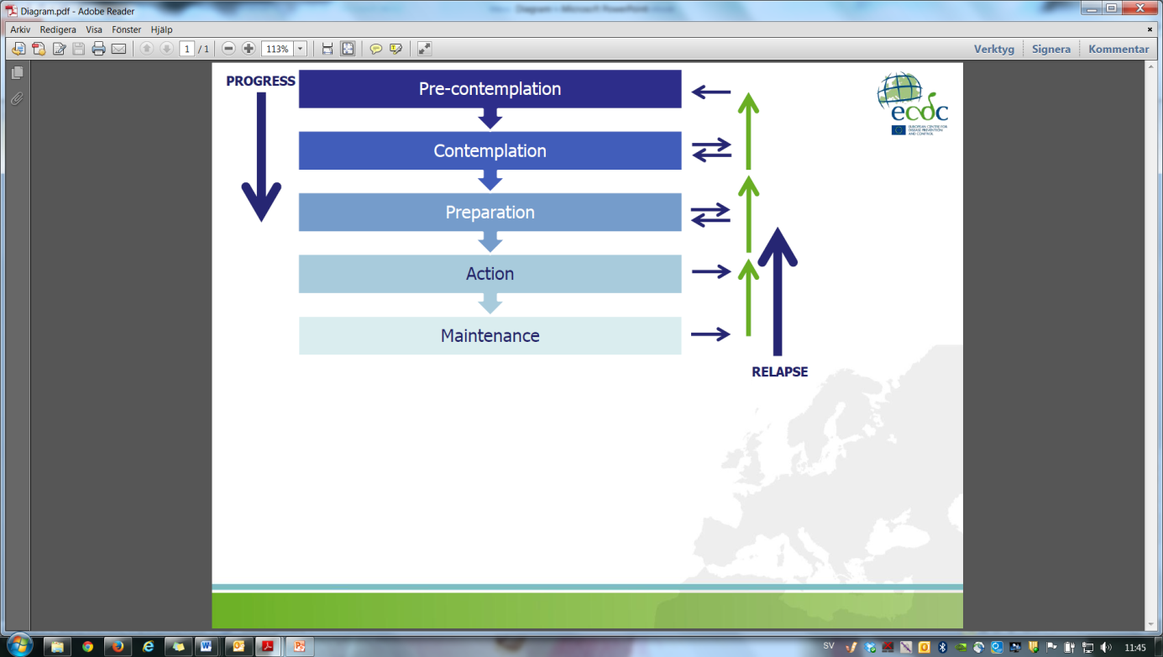
 | Pre-contemplation | Individual is unaware, and has no consideration or intention to adopt a particular behaviour.
 | Contemplation | Individual is aware and starting to comprehend and consider adopting a behaviour, and may be ready to seek more information about it.
 | Preparation | Individual is actively thinking about adopting a certain behaviour and is starting to make a commitment towards it.
 | Action | Individual performs or starts to perform a given behaviour.
 | Maintenance | Individual maintains the behaviour and combines it with his/her regular routine. Possibility of ‘relapse’ or return to one’s previous behaviour exists.
Stakeholder/s |  | Persons or organisations who are invested in the campaign, are interested in the evaluation results, and/or play a role in what will results from the evaluation. Representing their needs and interests throughout the process is fundamental to good campaign evaluation.  Key stakeholders in public health campaigns fall into three major groups:  Those involved in campaign operations:  - Programme managers and staff  - Local, state and regional coalitions interested in reducing inappropriate antibiotic use  - State and local health departments  - Funding agencies, such as national and state governments  Those served or affected by the campaign:  - Doctors, nurse practitioners, pharmacists and other healthcare providers  - Healthcare systems and the medical community  - Healthcare delivery organisations  - Healthcare insurers and insurer organisations  - Schools and educational groups  - Universities and educational institutions  - Childcare providers and organisations of childcare providers  - Community organisations  - Consumer advocacy groups  - Patients and the general public  The intended users of the evaluation results will vary with each specific evaluation and often the users comprise a subset of the individuals and groups listed in the prior two categories.
SWOT |  | A useful, structured way of depicting internal factors (strengths and weaknesses) and external factors (opportunities and threats) of a campaign in order for one to develop a clear action plan. The aim of this analysis is to use one’s strengths to: (i) take advantage of the available opportunities, (ii) counterbalance or improve the identified weaknesses, and (iii) lower the risk of potential threats, whilst also considering: (i) potential competition as well as existing opportunities and services that one may be able to make use of, and (ii) internal or external factors which may hinder or promote your campaign (e.g. funding). In summary:
 | Strengths |  | Weaknesses
Opportunities | How do we use the strengths to take advantage of these opportunities? |  | How do we overcome the weaknesses that prevent us taking advantage of these opportunities?
Threats | How do we use our strengths to reduce the likelihood and impact of these threats? |  | How do we overcome the weaknesses that will make these threats a reality?

Target audience |  | In order to develop a campaign strategy one must understand which groups of people need to change their behaviour. Once identified, this is what is called the target audience. A target audience may then be sub-divided into primary and secondary. The primary target audience is the main audience one wishes to target and the secondary audience is a group of individuals who influence the primary target audience in one way or other. They are not individuals who may be secondarily exposed to part of the campaign activities. Refer to ‘Segmentation and targeting’ for more information.

Sources:
- Andreasen A. Marketing and social change: changing behaviours to promote health, social development and the environment. San Francisco: Jossey-Bass; 1995.

- Andreasen AR. Marketing social marketing in the social change marketplace. J Public Policy Mark. 2002 Spring;21(1):3-13.

- Blair-Stevens C, Reynolds L, Christopoulos A. Behavioural theory: understanding the key influences on human behaviour. In: French J, Blair-Stevens C, McVey D, Merritt R, editors. Social marketing and public health: theory and practice. Oxford: Oxford University Press; 2010.

- Centers for Disease Control and Prevention. Introduction to program evaluation for public health programs: evaluating appropriate antibiotic use programs. Atlanta: CDC; 2006.

- Centers for Disease Control and Prevention. Social marketing: nutrition and physical activity [Internet]. [cited 2013 Oct 2]. Available from: www.cdc.gov/nccdphp/dnpa/socialmarketing/training

- Centers for Disease Control and Prevention. Workplace health promotion: glossary [Internet]. 2013 [updated 2011 Apr 25; cited 2013 Oct 2]. Available from: http://www.cdc.gov/workplacehealthpromotion/glossary/index.html#H

- Chen PF. Planning BCC interventions: a practical handbook. Thailand: UNFPA CST Bangkok; 2006.

- French J, Blair-Stevens C, McVey D, Merritt R, editors. Social marketing and public health: theory and practice. Oxford: Oxford University Press; 2010.

- Hastings G, Angus K, Bryant C, editors. The SAGE handbook of social marketing. London: SAGE Publications Ltd.; 2011.

- Independent Evaluation Group of the World Bank, in collaboration with the DAC Secretariat. Impact evaluation: an overview and some issues for discussion. 4th meeting, 30-31 March 2006. DAC network on development evaluation; 2006.

- Macdonald L, Cairns G, Angus K, Stead M. Evidence review: social marketing for the prevention and control of communicable disease. Stockholm: ECDC; 2012.

- McLeroy KR, Bibeau D, Steckler A, Glanz K. An ecological perspective on health promotion programs. Health Educ Q. 1988 Winter;15(4):351-377.

- Merritt R. Development. In: French J, Blair-Stevens C, McVey D, Merritt R, editors. Social marketing and public health: theory and practice. Oxford: Oxford University Press; 2010.

- National Cancer Institute. Theory at a glance: a guide for health promotion practice. 2nd ed. USA: U.S. Department of Health and Human Services, National Institutes of Health; 2005.

- Reynolds L, Merritt R. Scoping. In: French J, Blair-Stevens C, McVey D, Merritt R, editors. Social marketing and public health: theory and practice. Oxford: Oxford University Press; 2010.

- Stokols D. Translating social ecological theory into guidelines for community health promotion. Am J Health Promot. 1996 Mar-Apr;10(4):282-298.

- Titan Fitness Challenge. Readiness assessment: transtheoretical model of change [Internet]. 2013 [cited 2013 Oct 2]. Available from http://asi.fullerton.edu/tfc/applyNow.asp

- Weissman J, Besser RE. Promoting appropriate antibiotic use for pediatric patients: a social ecological framework. Semin Pediatr Infect Dis. 2004 Jan;15(1):41-51.

- Wold C. Module 1: overview of health indicators (part 1) [Internet]. [cited 2013 Oct 2]. Available from: www.nlm.nih.gov/

Course on the development, implementation and evaluation of prudent antibiotic use campaigns

Annex one:
Checklists

Checklist no. 1
Initial planning and preparation (three months prior the training)
Define the training team
Draft training budget and planning timeline
Send announcements to potential participants
Select participants (and prepare a reserve list)
Identify and reserve the face-to-face course venue
Send invitations to selected participants
Book lodging for out-of-town participants
Arrange for travel and per diem reimbursements for out-of-town participants
Adapted from: Core Group Social and Behavioral Change Working Group. Designing for behavior change curriculum. Washington: CORE Group; 2008.

Checklist no. 2
Before the pre-course package (two months prior to the training)

If you are using a web-based platform to communicate with participants:
- Design or adapt the web-based tool for training purposes
- Upload reading materials and exercises
- Send usernames, passwords and instructions on how to access the web-based platform to participants
If you are using e-mails to communicate with participants:
- Verify contact information of each participant
- Prepare electronic files to be sent to the participants
- Prepare a message template containing general instructions for the pre-course package
- Send e-mails with all the attached documents
- Confirm receipt of delivery of the information by all participants
If you are using post and phone calls to communicate with participants:
- Verify contact information of each participant
- Prepare copies of the documents to be sent to the participants
- Prepare a letter template containing general instructions for the pre-course package
- Send post with all the documents
- Confirm receipt of delivery of the information by all participants
Adapted from: Core Group Social and Behavioral Change Working Group. Designing for behavior change curriculum. Washington: CORE Group; 2008.

Checklist no. 3
Before the face-to-face course (one month prior to the training)
Prepare training materials
Purchase all training-related supplies:
- Whiteboard markers
- Permanent markers
- Flipcharts
- Name tags
- Note pads
- Folders or binders for participant’s material pack
- Post-it notes (different colours)
- Magnets
- Tape
Book catering services for coffee-breaks and lunches
Conduct facilitator planning and team-building meetings

Checklist no. 4
Supplies and equipment (one week prior to the face-to-face course)
Assemble participants’ packs containing:
- Participant workbook
- Notepads
- Pens and/or pencils
- Reading material (articles, reports, etc.) to distribute during the course
Prepare or photocopy handouts
(NB. Handouts are not provided in this manual. If developed by the team, they should be prepared after the PowerPoint presentations have been adapted or modified.)
Confirm participants’ arrival times, lodging arrangements, travel and per diem reimbursements
Equipment:
- Laptop
- Projector and screen
- Whiteboard
- Flipcharts
- Camera (to document the training sessions if desired)
- Secure access to copier and/or printer
- If possible, internet connection
PowerPoint presentations and speaker notes
Extra schedules

Course on the development, implementation and evaluation of prudent antibiotic use campaigns

Annex two:
Ice breakers, energisers and group activities

Ice breakers, energisers and group activities
In this section you will find a selection of ice breakers, energisers and group activities.
This list can be used throughout the duration of the course. To give you a quick overview, icons indicate which functions the exercises fulfil. A description of the purpose of the activity, how to lead it and materials needed are also given. The activities provided are only suggestions and can be adapted according to the participants’ needs.
Through the ice breakers, the participants get the opportunity to introduce themselves and get to know one another. The energiser activities can be used frequently throughout the course, especially when participants begin to look inattentive and sleepy, or as a break between different sessions.

Below are the icons used to categorise the exercises and what they signify:
 | Ice breakers: getting to know one another
 | Energisers: reviving a tired group
 | Team building exercises
 | Refreshers (revision exercises) and teaching exercises

Good morning…
This activity is only suitable with participants of different nationalities.
Ask everyone to form a circle. You shall lead this activity. Describe the exercise to participants. A volunteer is to say good morning in his/her native language to the person to his/her left followed by his/her own name. The participant to the left shall then reply by saying good morning in his/her native language followed by the name of the person sitting to his/her right and then continue to the participants to the left saying good morning followed by his/her own name. This continues, going around the whole circle in a clockwise fashion.
Introducing your partner
Divide the group into pairs. The pairs get 5 minutes to learn as much as possible about his/her partner. Afterwards, every person should describe his/her partner to the whole group, including two unique characteristics of that person.

The movie of your life
When the group is introducing themselves to the rest of the group (name, nationality, profession, etc.), also ask them what movie they think best describes their life.

Super heroes
When the group is introducing themselves to the rest of the group (name, nationality, profession, etc.), also ask them what super hero they would be if they had a choice.

Dinner date
Ask each participant to complete the following sentence after introducing him/herself to the group: “If I could have dinner with any person, living or dead, it would be with _______________ because _______________”.

“You did what?!”
Hand out cards to the participants and ask them to write something true that nobody else in the room knows about them, e.g. “I survived a shark attack in Hawaii” or “I did a sky dive two years ago”. Then ask them to place their cards in a box or bag. Each person must then pick a card and read it out loud for participants to try and guess who wrote the card.
Materials needed: small cards (1 per participant); box or bag.

What if…?
Instruct participants that after they introduce themselves to the rest of the group (name, nationality, profession, etc.), they are to answer to the question, “What if…?” and you (the facilitator) finish it off as you think. Example: “What if you won the lottery tomorrow, what would you do?” or “What if you became stranded on a desert island, what would you do?”

Something new
Should be carried out on the second or third day of the course in order for participants to begin familiarising themselves with each other.
Ask the participants to share one thing they have learnt about another person in the course on the previous day without mentioning who the person is. Have the other participants try and guess who the person being described is.
 | Anything in common?  Split the group into pairs. Each pair has 30 seconds to find out five things that they have in common with each other. After 30 seconds have ended, the pair must pair up with another pair and the four of them now have one minute to find one thing that all four have in common with each other. At the end of the activity, each group can present a list of things that they have in common.

Two-minute mixer
This is similar to a speed-dating exercise. Everyone gets two minutes to find out as much as s/he can about a participant in the group. When two minutes are over on the stopwatch the facilitator blows the whistle and everyone has to reshuffle and get to know somebody else. This continues until approximately everyone has been able to have a two-minute chat with people in the group.
Materials needed: stopwatch; whistle.

Find someone who…
The activity sheet (next page) is only an example and may be modified accordingly depending on the participants and individual contexts.
Hand out one activity sheet per person and instruct the participants that they shall walk around the room attempting to find someone in the group who has a special characteristic as specified in the handout. One cannot use the same person twice and the person with that special characteristic needs to write down his/her own name.
Materials needed: handout, next page (1 per participant) and pens.

Find someone who…
can play a musical instrument: | can touch his/her nose with his/her tongue: | drives a motorcycle: | lectures at a university:
has broken a limb in the past: | has taken a workshop before: | is a microbiologist: | has been involved in an antibiotic awareness campaign in the past:
works in a hospital: | was born in the 60s: | can dance salsa: | is taller than 6 feet:
works in the media: | is enthusiastic about football: | has a pet cat: | can whistle the main melody of the ‘Star Wars’ movie:
considers him/herself addicted to coffee: | has green eyes: | has curly hair: | is a pharmacist:

 | Finish the sentence  Ask the group to form a circle for this activity. Send a box/bag around the group. The first person picks a paper, reads it out loud and then attempts to finish the sentence. The box/bag is then sent to the next person, and so on and so forth. Examples of unfinished statements could include: ”The best job I ever had was…”, “The worst project I ever worked on was…”, “The riskiest thing I ever did was…”, “I am in this course because…”, “The four Ps of marketing are…”, “A process indicator measures…”, “A target audience is…”, “Antibiotic resistance is…”, “EAAD stands for…”, “The European Antibiotic Awareness Day began in…”, “European Antibiotic Awareness Day was initiated by…”, “The main stages for the development of a campaign are…”, and “The first time I felt most stressed because I did not plan was…”.  Materials needed: carton box or paper bag (as long as one cannot see through it); papers with pre-written, unfinished statements on them (enough to have 1 per participant).

‘Dos and don’ts’
When the group is introducing themselves, ask them to also give a “Do” or “Don’t” tip that they have learnt when carrying out antibiotic campaigns. Write down these tips on the flip chart. You can refer to them throughout the course.
Materials needed: flip chart; 1 permanent marker.

Find the matching card
Before this activity, choose a variety of well-known phrases and write half on one paper and the other half on another paper (make sure to have enough papers for the whole group). Fold the papers and place them in a box/bag for participants to pick. Each participant must try to find the other person with the matching half of the phrase.
Materials needed: papers with matching phrases; a box or bag.
 | Follow the leader  Split the group into pairs and ask one participant to put on a blindfold. The partner then leads the participant without touching him/her, making sure s/he does not bump into anything. The participants then swap roles and afterwards discuss their experience and how they felt having to trust someone to keep them safe.  Materials needed: blindfolds (enough for half the group)
 | Pass the parcel  Alternatively can be used as a refresher exercise if the commands are phrased into questions instead.  Ask the group to form a circle. A small gift wrapped several times and with commands/questions (e.g. “sing a song”, “hug the person next to you”, and “define the principles of the marketing mix”) in each layer must have been prepared beforehand. Start the music (alternatively clap hands if no music is available) and tell participants to pass the parcel around the circle. When the music stops, the person with the parcel must open a layer and do the action or answer the question on the paper. The game continues until all layers are removed and the last person finds the small gift which s/he gets to keep.  Materials needed: 1 parcel with a small gift, wrapped several times with questions in each layer; music.

The ‘worst team’
This activity could be used to set rules for the group work.
Ask participants to describe the most challenging situation they have ever encountered whilst working in a team and why. Jot down these characteristics on a flip chart. Engage participants to identify ways to avoid the ‘worst team’ characteristics and which may later be used as a pediment for group work rules.
Materials needed: flip chart; 1 permanent marker.

Creating logos
Divide the group into smaller groups of approximately 5 people. Get all participants to empty their bags, wallets, and/or pockets and to use the items collected to create a logo related to the theme of the course. Afterwards they must explain to the rest of the group how and why they came up with the logo.

Messengers
Prior to the activity, build something out of blocks and cover it with a large sheet so that participants cannot see it. Then divide the group into smaller teams and give them a set of blocks. Each group must then choose a ‘messenger’ to peak under the sheet and who will then report what s/he saw back to his/her team. S/he must instruct the team on how to build the same thing without touching the blocks or showing the team how it is done. The messenger may only describe what the structure looked like. The teams also have the chance to send the messenger to take a second look at the structure. When all teams are done, the newly built structures are compared to the original one.
Materials needed: building blocks; large sheet.

Let’s draw!
Split the group into pairs and tell them to sit back to back. One person has a paper with a simple drawing and the other a blank paper and pencil. The person with the drawing must describe it in enough detail for his/her partner to be able to reproduce it.
Materials needed: papers with a simple drawing; blank papers; pencils (1 per pair).

 | Brainstorm race  Divide the group into smaller groups of approximately 5 persons. Instruct participants that there must absolutely be no talking during this exercise. Give out one large paper to each group. Each group must now brainstorm together and jot down notes on the statement given on the sheet of paper……without talking!  Materials needed: large pieces of paper with a different statement on each (1 per group); 2 permanent markers per group.

The ‘Ɛ’ game
This activity is recommended when teaching pre-testing of materials for campaigns and pilot studies, to give participants an insight on the different perspectives by which people perceive things depending on which angle they look at things.
Ask the group to form a circle for this activity. You shall have prepared a large piece of paper with a curvy ‘E’ (Ɛ) on it. This shall be placed in the middle of the group. Ask the participants what they see on the paper. Depending on where they are sitting/standing they will see the drawing differently. Some will see an ‘M’, others an ‘E’, ‘3’ or ‘W’. You may then ask participants to move position to see the letter from a different perspective. An alternate version to this activity is to place a person in the middle of the circle instead and to ask people in the circle to describe what they see.
Materials needed: large paper with the letter ‘Ɛ’ drawn on it.

Ball of tape
Ask the group to form a circle for this activity. You shall have prepared a ball of masking tape with pre-written questions beforehand, depending on what was covered during the previous day. The masking tape ball is made by cutting small pieces of masking tape and writing down questions on each section. The pieces are then stuck together to make a ball. Then, toss the ball of masking tape to a participant who will then remove the uppermost strip of masking tape and answer its question. If the person does not know the answer someone else in the group may help to respond.
Materials needed: masking tape; 1 permanent marker.

Toss the ball
Ask the group to form a circle for this activity. You shall have prepared a number of questions to ask the participants beforehand, depending on what was covered during the previous day. Then, begin to toss the ball to a participant asking a question at the same time. This ensures that everyone is well-attentive. The person who catches the ball must answer the question. If the person does not know the answer someone else in the group can help respond.
Materials needed: 1 small ball.

Sources:
- International HIV/AIDS Alliance. 100 ways to energise groups: games to use in workshops, meetings and the community. Brighton: The International HIV/AIDS Alliance; 2002.
- International Training and Education Center for Health. Ice breaker activities for training sessions [Internet]. 2004 August [cited 2012 Nov 16]. Available from: www.go2itech.org/HTML/TT06/.../IceBreakerActivTrngSess.doc

Course on the development, implementation and evaluation of prudent antibiotic use campaigns

Annex three:
Group work

Social marketing plan

In this section you will find instructions and tools which will guide you when developing your social marketing plan during group work sessions. You can work at your own pace during the two sessions allocated for group work.
On day three of the course, you will be expected to present your work to the rest of the group for discussion; therefore you should select one person in the group to be a moderator and another to be note-taker during the group work sessions.

Group number: __________
Target audience: _______________________________
Group members (name, nationality and profession):
- _____________________________________________________________________
- _____________________________________________________________________
- _____________________________________________________________________
- _____________________________________________________________________
- _____________________________________________________________________

I. General description
Setting | Preferably represented by someone in the group
Country/  region | If applicable
Broad target audience | Define the broad audience you wish to target
Problem definition | Identify and define a specific problem related to antibiotic use and/or resistance affecting your target audience, problem, including the behavioural component
II. Practical considerations
Composition of the strategy/  campaign team | Define the team (i.e. the general professional profile or expertise required)
Potential partners | List potential partners you could consider for this particular campaign
III. Formative evaluation
Research questions | What do you need to know about your audience?
Methods | Enumerate probable methods for conducting the formative evaluation
Behavioural determinants | Describe the potential behavioural determinants influencing your target audience segment
Competitive analysis | Fill in table on next page
Define your target audience segments | Identify and segment your target audience

Competitive analysis
 |  | Current behaviour  (competing behaviour) |  | Desired behaviour
Please describe: |  | The current problematic behaviour |  | The behaviour you expect from the audience or that you wish for them to adopt
Benefits
(identify potential benefits linked to the behaviour)
Barriers
(identify potential barriers linked to the behaviour)

IV. Objectives
List your objectives here. What action/s are you trying to influence?

V. Marketing mix
The 4Ps of marketing | Product | What is the product being offered and what are its benefits?
The 4Ps of marketing | Price | What is the cost of the product?
The 4Ps of marketing | Place | Where and through what channels are you promoting your product (access)?
The 4Ps of marketing | Promotion | How will you promote the campaign?
Key benefits |  | What will the audience get from the campaign that they want?
VI. Pre-testing
Probable methods for pre-testing

VII. Evaluation plan
Instructions:
According to the type of evaluation, please define the:
- Evaluation questions
  - What do you want to know though your evaluation?
  - Examples: How many materials have been distributed [process indicator]? Has there been any behavioural change [outcome indicator]? Has the behaviour resulted in the intended effect [impact indicator]?
- Methods that may be used for evaluation
- Tools that may be used to gather the data required
- Potential indicators which may be used to measure progress towards the goals, objectives and evaluation questions which you defined (you can refer to your list of indicators in a separate section for ideas)

VII. Evaluation plan
Type of evaluation | Evaluation questions | Data collection methods | Data collection tools | Indicators
Process

Outcome

Impact
(if applicable)

Presentation evaluation using a score matrix
The evaluation score matrix should be used when assessing presentations given by other groups during the course. Below you will find an explanation on how to use it.

Instructions:
- The table below is to be used for evaluating the presentations of your peers’ group work, excluding that of your own group.
- Each principle must be marked from a scale of 1-10, with 10 representing “a strong application, describing, or addressing that principle” and 1 corresponding to “weak applying, addressing, or describing of the principle”.
- The exceptions to the above scale are ‘audience’ and behaviour’. These should be marked with an ‘X’ if mentioned/described or left blank if they are never indicated in the presentation.

Example table:
Audience | Behaviour | Product | Price  (benefits/barriers) | Place | Promotion | Competition | Evaluation
 |  |  | Price  (benefits/barriers) |  |  |  | Formative  research | Process  evaluation | Impact/  outcome  evaluation
X |  | 8 | 3 | 10 | 10 | 1 | 7 | 6 | 4

Source: Turning point. Social marketing and public health: lessons from the field. USA: Turning Point National Program Office at the University of Washington; 2003.
Group number: __________ Target audience: _________________________________
Audience | Behaviour | Product | Price  (benefits/barriers) | Place | Promotion | Competition | Evaluation
 |  |  | Price  (benefits/barriers) |  |  |  | Formative  research | Process  evaluation | Impact/  outcome  evaluation

Group number: __________ Target audience: _________________________________
Audience | Behaviour | Product | Price  (benefits/barriers) | Place | Promotion | Competition | Evaluation
 |  |  | Price  (benefits/barriers) |  |  |  | Formative  research | Process  evaluation | Impact/  outcome  evaluation

Group number: __________ Target audience: _________________________________
Audience | Behaviour | Product | Price  (benefits/barriers) | Place | Promotion | Competition | Evaluation
 |  |  | Price  (benefits/barriers) |  |  |  | Formative  research | Process  evaluation | Impact/  outcome  evaluation

Group number: __________ Target audience: _________________________________
Audience | Behaviour | Product | Price  (benefits/barriers) | Place | Promotion | Competition | Evaluation
 |  |  | Price  (benefits/barriers) |  |  |  | Formative  research | Process  evaluation | Impact/  outcome  evaluation

Group number: __________ Target audience: _________________________________
Audience | Behaviour | Product | Price  (benefits/barriers) | Place | Promotion | Competition | Evaluation
 |  |  | Price  (benefits/barriers) |  |  |  | Formative  research | Process  evaluation | Impact/  outcome  evaluation

Course on the development, implementation and evaluation of prudent antibiotic use campaigns

Annex four:
Case studies

A4.1 Introduction
This section includes a choice of case studies which can be used throughout the duration of the course. The method by which the case studies can be integrated into the course is rather flexible; however it is recommended that they are used in group work activities rather than individually, in order to facilitate discussions within the smaller teams as well as with the whole group. It is also recommended that each team is given a different case study to discuss, as this helps to cover and identify a wider range of topics. The case studies may also be used as examples during plenary sessions.
A4.1.1 Participant workbook
The case studies are sorted according to the topic they cover, and are indicated by a number and title. Each case study begins with a brief description of the campaign or intervention, followed by a set of questions which participants should discuss and answer. The purpose of the case studies is educational, with the aim of the engaging participants in the thinking process as a marketer rather than to discuss or scrutinise the details of a given scenario.
A4.1.2 Facilitator guidelines
In the facilitator guide, the cases are also sorted according to the topic they cover and are indicated by a number and title. For you to be able to easily pre-select case studies for discussion throughout the duration of the course, a general overview of the case studies and the key concepts covered in their content is given in Table 1 below. Furthermore, each case study has a guided front cover displaying the topics covered in the case study as well as the main discussion points to the majority of questions found after each case study. It is strongly advised to follow a systematic outline (see Figure 1 below) when facilitating a discussion.

Figure 1: Systematic guideline for discussions.
You will also find this figure on the guided front cover of the case studies. The darker highlighted box in the figure will indicate to you the concept that you should emphasise more when facilitating discussions.

Attention
In a number of case studies, there could be lack of reporting of certain aspects of the campaign which might raise queries. This too is a source of learning and as the facilitator you should promote such discussions.
As in the participant workbook, each case study also includes a brief description of the campaign or intervention. In the facilitator guide, key phrases are highlighted in the text in order to help deduce reasoning during discussions of the case studies and for easier selection of key points in text. The description is followed by the same questions posed in the participant workbook with a few suggested answers and points of discussion. This should only serve as a guide and should be open for group discussion. They must not be seen as the only possible answers. Do feel free to adapt them accordingly and to discuss the answers with the rest of the facilitator team before the course. You may also add or modify questions suggested here.
A4.2 Teaching objectives
The main teaching objectives of the case studies are:
- to integrate concepts of social marketing in campaign development, and
- to promote and strengthen the thinking process behind the social marketing strategies of BCC campaigns.
A4.3 Intended learning outcomes
Following completion of this exercise, participants should be able to:
- understand and apply the social marketing process of campaign development,
- understand and apply the evaluation process of campaign development, and
- critically appraise campaigns on prudent antibiotic use in different settings.
A4.4 Instructions
- Pre-select the case studies that you would like the group to read and discuss. Don’t forget to use the overview in Table 1 below as a guide when selecting case studies with particular topics for discussion.
Attention
You can choose to give the task as group work or individual work; however it is recommended that they are used in group work activities. It is also advised that each team is given a different case study to discuss. Depending on the identified knowledge gaps and/or needs of the participants, you can indicate a particular cases study to a group.
- Inform participants that all case studies are found in their participant workbook in the ‘case studies’ chapter and that they are sorted according to the case number, title and the topics covered.
- Instruct participants that they are to:
  - read the relevant case study carefully,
  - if they are working in teams, they should discuss the case study and its questions briefly within their groups, and
  - answer the subsequent questions.

Remember
Remind participants that while discussing and answering the questions, they should focus on the thinking process of a marketer rather than the exact answers to the questions.
- Each group should preferably elect a moderator to guide the discussion and ensure:
  - that all questions are discussed,
  - that time is kept vigilantly,
  - a balanced group discussion, ensuring that all group members participate, and
  - the summing-up of the discussion in key points.
- After having worked individually or as a group, the participants of the course should be given the opportunity to present the key points in the case study to the rest of the group. This can be done in two ways, either by leading an informal discussion with the whole group whilst highlighting keys concepts and areas of improvement, or by instructing the teams to present their work more formally to the rest of the group.

A4.5 General overview of the case studies
 |  | Components of campaign development
 |  | Objectives | Target audience/s | Marketing mix (4Ps) | Stakeholders | SWOT analysis | Formative evaluation | Pre-testing | Competitors, barriers & benefits for the target audience | Networks & partnerships | Evaluation – design, methods & outcomes | Indicators | Overall strengths & weaknesses
Case studies | 1 – Just a taster | • | • | •
Case studies | 2 – A hospital intervention | • | • | •
Case studies | 3 – Maximising media coverage | • | • | • |  | •
Case studies | 4 – Political support and commitment |  |  |  | • |  |  |  |  | •
Case studies | 5 – An alternate strategy |  |  |  |  |  |  |  |  | • | •
Case studies | 6 – Don’t do it yourself! |  |  |  | • |  |  | • | • | •
Case studies | 7 – Going big | • | • | • |  |  |  |  | • |  | • | • | •
Case studies | 8 – Involving actors for change | • | • | • |  |  |  |  | • | • | • | • | •
Case studies | 9 – Knowing your audience | • | • | • |  |  |  | • | • | • | • | • | •
Case studies | 10 – Maximising a small budget | • | • | • |  | • |  |  | • | • | • | • | •
Case studies | 11 – A poster intervention | • | • | • |  |  |  | • |  |  | • | • | •
Case studies | 12 – Campaign progression over the years | • | • | • |  | • |  |  |  |  | • | • | •
Case studies | 13 – A multi-targeted intervention | • |  | • |  |  |  |  |  |  | • | • | •
Case studies | 14 – Comprehensive mass media campaign | • | • | • |  |  |  |  |  |  | • | • | •
Case studies | 15 – A multi-faceted strategy | • | • | • |  |  |  |  |  |  | • | • | •
Case studies | 16 – Getting creative | • | • | • |  |  |  |  |  | • | • | • | •
Case studies | 17 – Embracing EAAD | • | • | • |  |  |  |  |  |  | • | •
Case studies | 18 – Addressing minority groups |  |  | • |  |  | • | • |  |  | • | •
Table 1: An overview of the general key concepts covered in the case studies.
Case study one
“Just a taster”
Content outline:
- Objectives
- Target audience/s
- Marketing mix (4Ps)

Main suggested discussion points for this case study

When discussing this case study, it is suggested to emphasise on:
- the planning phase of the campaign, especially with regards to the campaign’s objectives,
- the marketing strategy of the campaign, and
- selection and segmentation of target audiences.

Remember
Do not forget to touch upon the concepts of exchange and competition when discussing the planning and marketing strategy of the campaign.

Attention
Often the behavioural objective causes confusion. It is not simply an objective, goal or aim of the campaign, but it is an objective which identifies an action or behaviour that one expects to influence and/or change after the intervention.

Description
In 2000, antibiotic use and bacterial resistance in France was among the highest in Europe. In 2002, France initiated a long-term national campaign entitled, “Keep antibiotics working”, and was designed to reduce the irrational use of antibiotics and to improve quality of care both in the community and in hospitals. The overall goal of the community campaign was to reduce antibiotic use in children aged 0-6 years and for the treatment of upper and lower respiratory tract infections. The campaign was mainly driven by the National Health Insurance System, with the main message being, “Les antibiotiques, c’est pas automatique” (“Antibiotics are not automatic”). The general public was targeted using written materials and television ads. General practitioners were targeted using academic detailing, peer-to-peer visits and promotion of streptococcal rapid diagnostic tests for sore throats. In hospitals, the campaign favoured stricter antibiotic policies implemented by Antibiotic Policy Committees, surveys of antibiotic use, identification of anti-infective specialists, and promotion of a multidisciplinary approach involving clinicians, microbiologists and pharmacists.
The campaign was presented in 2001 by the publication of a National plan to preserve antibiotic efficacy, which was reinforced by a consensus Conference statement on antibiotic policies in hospitals by the French Society of Infectious Diseases in 2002.
Initial results comparing the period between October-March showed a 13% decrease in total antibiotic use between 2001-2002 and 2004-2005. A 19% decrease was observed in children under 15 years. Over the years, the greatest antibiotic reduction rates were seen in penicillins, macrolides and cephalosporins. Moreover, successive public opinion polls showed shifts in knowledge about antibiotics and their role in general medical practice.
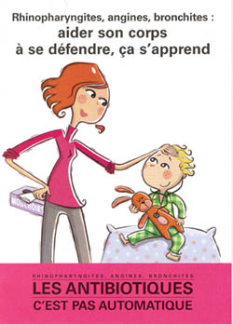


Figure 1: Use of mass media in France.

Adapted from: Goossens H, Guillemot D, Ferech M, Schlemmer B, Costers M, van Breda M, Baker LJ, Cars O, Davey PG. National campaigns to improve antibiotic use. Eur J Clin Pharmacol. 2006 May;62(5):373-379.
Q & As
  - What was the behavioural objective/s in this campaign?
- To reduce irrational use of antibiotics and improve quality of care in the community and in hospitals (more of a long term aim).
- To reduce antibiotic use in children aged 0-6 years (assuming that prescribers and parents are the targets).
- To reduce antibiotic use for the treatment of upper and lower respiratory tract infections (assuming that prescribers are the targets).
Facilitator notes
The behavioural objective is not very clear but other objectives are mentioned. Emphasise the need to link one’s objectives to one’s behavioural objectives. You can ask participants to discuss how they would phrase the behavioural objective themselves.
  - Who was the target audience in this campaign?
- General public
- General practitioners
- Hospital staff (mainly clinicians, microbiologists and pharmacists)

  - Is there any evidence, in your view, that the principles of the marketing mix were used in the planning of this campaign? Use the table below for your answers.
Target audience/s | Product | Price | Place | Promotion
General public | - Written materials  - TV ads | No indication on the price | Not extremely obvious but one may assume:  - Public spaces | - Ads in mass media  - Distribution of printed media
General practitioners | - Streptococcal rapid diagnostic tests  - Publication of a National plan | No indication on the price | Not extremely obvious but one may assume:  - Practitioners’ offices/clinics | - Peer-to-peer visits and academic detailing
Hospital staff | - Stricter antibiotic policies  - Recognition of anti-infective specialists | No indication on the price | Not extremely obvious but one may assume:  - Hospitals | - Multi-disciplinary approach  - Appointing anti-infective specialists
  - Through what channels was the audience reached?
- Conventional mass media (e.g. TV)
- Printed materials
- Peer-to-peer visits and academic detailing

Case study two
“A hospital intervention”
Content outline:
- Objectives
- Target audience/s
- Marketing mix (4Ps)

Main discussion points for this case study

When discussing this case study, it is suggested to emphasise on:
- the planning phase of the campaign, especially with regards to the campaign’s objectives,
- the marketing strategy of the campaign, and
- selection and segmentation of target audiences.

Remember
Do not forget to touch upon the concepts of exchange and competition when discussing the planning and marketing strategy of the campaign.

Attention
Often the behavioural objective causes confusion. It is not simply an objective, goal or aim of the campaign, but it is an objective which identifies an action or behaviour that one expects to influence and/or change after the intervention.

Description
A 600-bed tertiary referral centre used an antimicrobial working team consisting of representatives from pharmacy, microbiology and infectious disease departments to develop, implement and evaluate guidelines for prudent use of antimicrobials. They carried out several activities to do so, including, the development and promotion of a restricted antimicrobial policy, and specific guidelines for the management of pneumonia, surgical prophylaxis and wound infection. The guidelines were made available on the hospital’s intranet, on hard copies in all wards, and on laminated cards attached to hospital identification tags. Active promotion of the guidelines was carried out at orientation and via a two-week intensive period four times a year (corresponding to the registrar rotation), weekly meetings and follow-up of non-compliance courses directly with the attending medical officer. Education and feedback to specific groups was provided as required. Other projects included a campaign to encourage oral antibiotics where indicated. To promote this change, posters and postcards were distributed to individual doctors and bright orange stickers were placed in the medical records of patients on intravenous antibiotics. Regular drug utilisation evaluations were undertaken to measure outcomes, along with other indicators of antibiotic use such as the prevalence of antimicrobial resistance. Moreover, regular reviewing and updating of antibiotic guidelines was carried out to ensure their relevance.
Since the start of the intervention to promote adequate use of antimicrobials in this hospital, the prevalence of certain organisms associated with healthcare-acquired infections dropped. As a matter of fact, between 1997 and 2000, healthcare-acquired Clostridium difficile infection rate fell from 9.8 cases per 105 patient days to 4.0 cases per 105 patient days.
Adapted from: Tiley SM, MacDonald JJ, Doherty PL, Ferguson JK, Fergusson JE. Active promotion of antibiotic guidelines: an intensive programme. Commun Dis Intell Q Rep. 2003;27(Suppl):S13-18.

Q & As
- What was the behavioural objective/s in this intervention?
- To develop, implement and evaluate guidelines for prudent use of antimicrobials at a 600-bed tertiary referral centre (the overall objective).
- To make the prescribers abide by the guidelines under specific conditions, e.g. pneumonia, surgical prophylaxis and wound infection (the behavioural objective).
- To encourage oral antibiotic prescribing by hospital prescribers (the behavioural objective).
Facilitator notes
The behavioural objective is not very clear but an overall objective is given. From the given case scenario one may deduce the behavioural objectives given above. Emphasise the need to link one’s objectives to one’s behavioural objectives. You can ask participants to discuss how they would phrase the behavioural objective themselves.
- Who was the target audience in this campaign?
Hospital prescribers
Facilitator notes
The target audience is not made extremely evident however one can assume that it is the hospital prescribers being targeted given the intervention scenario.
- Is there any evidence, in your view, that the principles of the marketing mix were used in the planning of this campaign? Please use the table below for your answers.
Target audience/s | Product | Price | Place | Promotion
- Hospital prescribers | - Guidelines  - Policies | No indication on the price | - 600-bed tertiary referral centre  - Intranet  - ID tags  - Medical records  - Communal areas | - Active promotion at orientation  - Active promotion during a two-week intensive period four times a year  - Weekly meetings  - Follow-up of non-compliance courses  - Education  - Feedback  - Laminated cards  - Orange stickers for when patient is on IV antibiotics
- Through what channels was the audience reached?
- Printed materials (e.g. posters, postcards)
- Website
- Active promotion
- Weekly meetings
- Education

Case study three
“Maximising media coverage”
Content outline:
- Objectives
- Target audience/s
- Marketing mix (4Ps)
- SWOT analysis

Main suggested discussion points for this case study

When discussing this case study, it is suggested to emphasise on:
- the planning phase of the campaign, especially with regards to the campaign’s objectives,
- the marketing strategy of the campaign,
- selection and segmentation of target audiences, and
- conducting a SWOT analysis.

Remember
Do not forget to touch upon the concepts of exchange and competition when discussing the planning and marketing strategy of the campaign.

Attention
Often the behavioural objective causes confusion. It is not simply an objective, goal or aim of the campaign, but it is an objective which identifies an action or behaviour that one expects to influence and/or change after the intervention.

Description
Penicillin-non-susceptible pneumococci in Iceland were first detected in 1988, spreading rapidly in a five year period to reach an incidence of 20% by 1993. This rise was not expected due to the high restrictions in antimicrobial use since they could only be obtained on prescription. Additionally, this rise was observed during a time when penicillin-non-susceptible pneumococci were low in northern European settings.
In order to stop the development of pneumococcal resistance, Icelandic authorities realised the need of identifying the risk factors contributing to this problem. However, these were not completely understood, showing the need for research in the area. Consequently, the most important risk factors for antimicrobial resistance in Iceland were reported to be: (i) young age, (ii) antimicrobial use, and (iii) day care centre attendance.
Intervention measures to reduce the overuse of antimicrobials were initiated in 1991 and continued till 1997. They were not introduced in an orderly fashion, nor were they overseen by an official body; they were mainly carried out by key opinion leaders, especially in clinical microbiology, infectious diseases, general practice and paediatrics. Interventions focused on the overuse of antimicrobials in children. Since almost everyone in Iceland had access to a TV and/or radio and newspapers were bought by most households at the time, messages were conveyed via television, radio and newspaper interviews, as well as through articles in the Icelandic Medical Journal, and at medical meetings and conferences. Moreover, doctors were urged to attend medical meetings, not to prescribe antibiotics for viral infections, and to give antibiotics less frequently for otitis media, sinusitis and bronchitis in children. New prescribing guidelines were formulated for general practitioners, and the issue of prudent antibiotic use was discussed in numerous meetings and in the Icelandic Medical Association.
The rapid rise in the incidence of resistant pneumococci and an increase in the number of hospital admissions in young children needing parenteral antibiotics for otitis media attracted the media’s attention. This was used to notify the public that antibiotics are not always helpful and may sometimes be harmful. Infection control interventions were mainly applied to infected patients in hospitals, especially in wards treating patients with chronic lung diseases. Infected patients were moved to single or isolation rooms.
The general impression of Icelandic doctors was that the media propaganda changed parents’ attitudes towards antibiotics. Instead of demanding antibiotics when their children had an upper respiratory tract infection, they began questioning doctors who decided to prescribe antibiotics. Moreover, a telephone survey of 524 parents of young children showed that 98.9% agreed that overuse of antibiotics can lead to reduced efficacy of the drugs. Antimicrobial use has been declining in Iceland since 1991.
Adapted from: Kristinsson KG. Modification of prescribers’ behavior: the Icelandic approach. Clin Microbiol Infect. 1999 Aug;5 (Suppl 4):S43-47.
Q & As
- What was the behavioural objective/s in this intervention?
Only an overall objective is given: to decrease he overuse of antimicrobials in children.
Facilitator notes
No behavioural objective is mentioned in the text but a general objective of the campaign is given. Emphasise the need to link one’s objectives to one’s behavioural objectives. You can ask participants to discuss how they would phrase the behavioural objective themselves.
- Who was the target audience in this intervention?
- General public (not clear but taken for granted from the text)
- General practitioners (not said so explicitly but also taken for granted from how the intervention is described in the text).
Facilitator notes
The target audience is not clear cut. Discuss the importance of being very clear when defining a target audience, target audience segment, and/or a secondary audience.
- Is there any evidence, in your view, that the principles of the marketing mix were used in the planning of this campaign? Please use the table below for your answers.
Target audience/s | Product | Price | Place | Promotion
- General public | - Printed materials  - TV interviews  - Radio interviews | No indication on the price | Not specifically mentioned in the text but one can assume:  - Public spaces | - Use of mass media
- General practitioners | - New prescribing guidelines  - Printed materials  - Articles | No indication on the price | Not specifically mentioned in the text but one can assume:  - Hospitals  - Wards  - Meetings  - Conferences  - Icelandic Medical Journal | - Medical meetings  - Conferences
- Through what channels was the audience reached?
- Conventional mass media
- Medical meetings
- Conferences
- Icelandic Medical Journal

- Finally, carry out a SWOT analysis of the intervention. Use the table below for your answers.
Facilitator notes
This question is very much open for discussion, therefore no suggestions are given. However, here are a few points you could highlight when discussing this question:
- Did the strategy team use their strengths to take advantage of their opportunities? How?
- Did the strategy team overcome their weaknesses which would have prevented them from taking advantage of their opportunities? How?
- Did the strategy team use their strengths to reduce the likelihood and impact of the threats they faced? How?
- Did the strategy team overcome their weaknesses that could have made their threats a reality? How? Did any of their threats become a reality?

 | Strengths |  | Weaknesses
Opportunities
Threats

Case study four
“Political support and commitment”
Content outline:
- Stakeholders
- Networks and partnerships

Main discussion points for this case study

When discussing this case study, it is suggested to emphasise on:
- the different roles of stakeholders and the importance of including them in the campaign throughout all phases of campaign development, and
- the roles of networks and partnerships and the importance of engaging them throughout campaign development.

Facilitator notes
This case study is more open for discussion than many other case studies given here. It should therefore be used as a tool for discussing the role and importance of stakeholders, networks and partnerships. There are therefore no concrete answers and thus only brief suggestions, if at all, will be given in order for you to allow participants to delve into a deep discussion on these issues.

Description
In 2011, a local campaign was launched in Asturias, Spain, which ran in parallel to the national campaign. In a press conference, the President of the Asturian Pharmacists Professional Association presented the campaign, ”Antibioticos? Solo los necesarios” (”Antibiotics? Only the necessary”), with the participation of 500 Asturian pharmacies that wished to promote the rational use of prescribed antibiotics.
This initiative was started simultaneously with the European Antibiotics Awareness Day celebrated on November 18th, which is supported by all pharmacists as public health providers and takes the opportunity of direct contact with users to guarantee informed treatment. This is not the first time this campaign took place. According to data from the Eurobarometer, in the previous five years, the request of antibiotics without prescription decreased from 30% to 3%.
The Asturian Pharmacists Professional Association prepared 500 posters and 20,000 diptychs with the basic indications for the rational use of antibiotics. They explained that antibiotics are only efficacious against bacterial infections and are therefore not useful against colds, flu and sore throats. It was also emphasised that only a doctor or a dentist can prescribe antibiotics and that self-medication is not recommended. It was also said that it is fundamental to complete the treatment, otherwise it can promote relapses and increase antibiotic resistance.
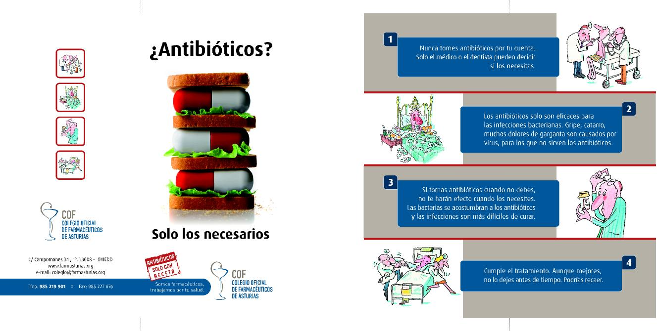
The President of the Asturian Pharmacists Professional Association indicated the importance of pharmacists’ participation in health promotion activities, disease prevention and early detection of specific conditions, such as HIV. This was supported by the General Director of the Asturian Public Health Office, who also guaranteed political support in the campaign.
Figure 1: Tools used in the local campaign.
Adapted from:
- Europa press. Europa press. [internet] 2012 [cited 2012 Oct 8]. Available from: http://www.europapress.es/
- Colegio Oficial de Farmacéuticos de Asturias. Consejos de Salud. [internet]. 2012 [cited 2012 Oct 8]. Available from: http://www.farmasturias.org/GESCOF/cms/contenidos/contenido.asp?id=173&IdMenu=119

Q & As
- Discuss the involvement of stakeholders in this campaign. Were they relevant/important? Do you think that there could have been any conflicts of interest?
- The role of the stakeholders in this campaign (namely, the Asturian Pharmacists Professional Association, the President of the Asturian Pharmacists Professional Association, the Asturian pharmacies and the General Director of the Asturian Public Health Office), appear to have played a crucial part in the success of how the campaign was unrolled.
- Pharmaceutical industry: a potential source of conflict of interest.
- Although no evaluation results are given the collaboration between all stakeholders appears to have been very beneficial for this campaign.
Facilitator notes
This question is very much open for discussion. There are therefore no concrete answers to this question. You should facilitate the discussion on the role of networks and stakeholders in the above campaign but also the important role of engaging stakeholders when planning a campaign and to involve them in all phases of campaign development. Also beneficial to discuss the advantages and disadvantages of involving stakeholders, giving concrete examples.
- Discuss the importance of political commitment in antibiotic campaigns.

Facilitator notes
This question is very much open for discussion. There are therefore no concrete answers to this question. You should facilitate the discussion on the role of political commitment in the above campaign but also the important role of political commitment when planning a campaign. Also beneficial to discuss the advantages and disadvantages of political involvement, giving concrete examples.

Case study five
“An alternate strategy”
Content outline:
- Networks and partnerships
- Evaluation

Main discussion points for this case study

When discussing this case study, it is suggested to emphasise on:
- the roles of networks and partnerships and the importance of engaging them throughout campaign development, and
- the impact of a different strategy such as the one given in this scenario.

Facilitator notes
This case study is open for discussion. It should therefore be used as a tool for discussing the role and importance of networks and partnerships, as well as facilitating a discussion on the different strategy employed in the Swedish scenario. There are therefore no concrete answers and thus only brief suggestions, if at all, will be given in order for you to allow participants to delve into a deep discussion on these issues.

Description
In the early 1990s, increasing antibiotic use and the detection of resistant pneumococcal clones among young children, alarmed medics and medical authorities in Sweden. This prompted a coordinated effort to prevent further spread. As a result, in 1994, a national organisation called Strama (Swedish Strategic Programme for the Rational Use of Antimicrobial Agents and Surveillance of Resistance) was founded, coming into action in 1995, to provide surveillance of antibiotic use and resistance, and to implement the rational use of antibiotics and development of novel knowledge. The overall aim of Strama is to maintain the effectiveness of antimicrobial agents and although Strama initially targeted pneumococcal resistance in the community, the programme has since expanded and today includes activities within many fields including, primary and hospital care, nursing homes and day care centres. Since 2000, Strama has been receiving financial support from the Swedish government.
Strama is structured into national and regional groups. The national group’s main objectives are to organise activities, including trend analysis in antibiotic resistance and consumption, identification of knowledge gaps and studies to fill these gaps, and priority setting for interventions to inhibit antibiotic resistance at national level. A committee meets monthly (approximately) with the role of working out yearly action plans, coordinating activities, and supporting regional Strama groups. Since 1998, a public website has been made available which is regularly updated on regional and national data on antibiotic use and resistance, treatment guidelines, and results from Strama-funded projects and local activities of the local regional groups. Moreover, an annual national meeting together with all regional Strama group and other interested parties is held, where updates on antibiotic resistance, annual statistics on antibiotic use and resistance, and results and analysis of studies, interventions, and educational programmes are discussed.
The regional groups are often led by the county medical officer for communicable disease control, and they monitor regional antibiotic use and resistance, and distribute knowledge and locally-adapted guidelines on the prevention and treatment of infections to healthcare professionals. They also work in close collaboration with the regional drug and therapeutics committees.
Below are the results of interventions led by Strama and their outcomes:
Antibiotics use and their indications for use
Between 1995 and 2004, antibiotic use for outpatients in Sweden decreased from 15.7 to 12.6 defined daily doses (DDD) per 1,000 inhabitants per day and from 536 to 410 prescriptions per 1,000 inhabitants per year. The reduction was most noticeable in children aged 5-14 years (52%) and for macrolides (65%). During this period, the number of hospital admissions for acute mastoiditis, rhinosinusitis, and quinsy (peritonsillar abscess) was stable or declining. Even though the epidemic spread in southern Sweden of penicillin-resistant Streptococcus pneumoniae was restrained, the national frequency increased from 4-6%. However, during this period, resistance in most other bacterial species remained low.
Although, the distribution of antibiotic sales data (especially geographical variation) has drawn a lot of attention and interest, such data excludes indications on antibiotic use and thus cannot be used to assess the quality of antibiotic prescribing. As a result, Strama began numerous large-scale surveys on the indications of antibiotic prescriptions.
Antibiotic resistance
Since 1994, laboratories around Sweden have collected quantitative antibiotic susceptibility data (zone diameters) for specific antibiotics in a minimum of 100 consecutive clinical isolates of 6 bacterial species annually. The data are entered into an internet-based software programme which allows annual monitoring at national level of resistance among clinical isolates of S. pneumoniae, S. aureus, P. aeruginosa, H. influenzae, S. pyogenes, and E. coli.
In 1999, a national programme was initiated in intensive care units (ICUs) in order to raise awareness of antibiotic resistance and infection control problems among ICU doctors (ICU-Strama). This surveillance programme has shown low prevalence of antibiotic-resistant S. aureus (MRSA), E. coli, and Klebsiella spp., despite high antibiotic consumption. However, experience from other countries and ICUs shows that the situation can quickly change, therefore continuous surveillance is necessary to design interventions in antibiotic policy or hygiene procedures when needed.
Infection control
Since the 1970s, the use of alcohol hand rub rather than soap has been recommended for hand disinfection between patient visits. Sweden has been one of few countries with less than 1% resistance to methicillin among invasive isolates of S. aureus. However, recent spread of MRSA in a few Swedish hospitals has highlighted the need for increasing activities in the infection control arena. Between 1997 and 2000, there was the largest Swedish outbreak of an endemic strain of MRSA (EMRSA-16) at a hospital in Gothenburg. The outbreak was successfully terminated by use of aggressive infection-control measures and a large high-cost sampling programme. What was learnt from this outbreak was that the measures taken were cost-effective and that the previously recommended barrier precautions, which were implemented when identifying new carriers of MRSA, were often introduced too late to be able to inhibit an outbreak. In an effort to be one step ahead of MRSA spread, uniform use of basic hygiene precautions was introduced during the outbreak, which applied to all patients and staff and included banning the use of private clothes and wearing rings, bracelets and watches at work. A dress code was also introduced which enforced that all healthcare workers wear short sleeves. Also, the use of alcohol hand rub before and after every patient contact and the use of gowns with every close patient contact were recommended. In addition, Strama initiated the formation of a national expert group on hygiene and infection control to record relevant areas for future actions and interventions.
In 2000, the National Board of Health and Welfare, in close cooperation with Strama, prepared a national action plan to contain antibiotic resistance in Sweden and the objectives of this plan are being used when developing annual work plans for Strama activities. Also in 2000, new national guidelines were established for the treatment of acute otitis media, acute pharyngotonsillitis and impetigo in 2002, and for acute sinusitis in 2005. The guidelines for the treatment of urinary tract infections were updated in 2006, and new guidelines for lower respiratory tract infections were issued in 2008.
The Strama project was designed to be an on-going coordinated national effort to decrease antibiotic use and spread of resistance, not to be scientifically evaluated. Although no coordinated public campaign has been launched in Sweden, as in other European countries, regular collaboration with news media, both national and regional, has been one of Strama’s priorities; this multidisciplinary, coordinated programme has shown to have contributed to the reduction of antibiotic use without measurable negative consequences. Indeed, discussion in the public media probably led to a substantial contribution to the decrease in antibiotic use in the year prior to Strama’s formal launch.
Adapted from: Mölstad S, Erntell M, Hanberger H, Melander E, Norman C, Skoog G, Lundborg CS, Söderström A, Torell E, Cars O. Sustained reduction of antibiotic use and low bacterial resistance: 10-year follow-up of the Swedish Strama programme. Lancet Infect Dis. 2008 Feb;8(2):125-132.

Q & As
- Describe the role of networks and partnerships in this intervention. How does one engage partners and organise networks? How does one gain political support?

Facilitator notes
This question is very much open for discussion. There are therefore no concrete answers to this question. You should facilitate the discussion on the role of networks and partnerships in the particular scenario as well as in campaign development in general. Moreover you should discuss how to gain political support and commitment with the participants. Also beneficial to discuss the advantages and disadvantages of political involvement, giving concrete examples.
- How was the sustainability of this large-scale intervention maintained throughout the years?
- On-going coordinated national effort to decrease antibiotic use and spread of resistance
- Financial support from Swedish government
- National and regional groups
- Regular national and local meetings
- Monitoring
- Distribute knowledge
- Locally-adapted guidelines
- Close collaboration with the regional drug and therapeutics committees
- Close cooperation with National Board of Health and Welfare
- Regular collaboration with news media
- Multidisciplinary
Facilitator notes
Apart from discussing the sustainability of the Swedish intervention, also discuss the possible ways by which campaigns may be sustained.
- What evaluation methods did they use?
Important role of continuous surveillance in this scenario is evident

Facilitator notes
It is not as clear, therefore discuss the possible methods of evaluation used in this scenario.
- What is your opinion on the strategy employed by Swedish authorities and the Strama group?

Facilitator notes
This question is subjective but the aim is to get participants to think about what their own opinion is on adopting such a different approach to control and preventing antibiotic resistance and encouraging prudent antibiotic use.

Case study six
“Don’t do it yourself!”
Content outline:
PART 1 PART 2
- Stakeholders - Competitors, benefits and barriers for
- Networks and partnerships the target audience

PART 3
- Pre-testing

Main discussion points for this case study

When discussing this case study, it is suggested to emphasise on:
- the different roles of stakeholders and the importance of including them in the campaign throughout all phases of campaign development,
- the roles of networks and partnerships and the importance of engaging them throughout campaign development,
- the importance of pre-testing materials

Remember
Do not forget to touch upon the concepts of exchange and competition when discussing competition, benefits and barriers.

Description
Part 1
In a survey carried out in 2002 in Spain, it was shown that, two out of three citizens consume antibiotics every day. Consequentially, in 2002, Spain conducted its second national campaign entitled, “Con los antibióticos no se juega” (“Don’t play with antibiotics”). It was a joint activity between the Ministries of Health, the pharmaceutical industry and the Professional Associations of Physicians and Pharmacists of Spain. The main objective for this campaign was to stop the irrational use of antibiotics through information and education, focusing mainly on self-medication and non-compliance.
In order to better comprehend the true situation of antibiotic consumption in Spain, the campaign organisers conducted a national survey on antibiotic consumption, exploring users’ attitudes, behaviour and beliefs. The survey demonstrated that self-medication was practiced by 10.9% of the population and that 10% did not comply with treatment. Previous studies reported a self-medication prevalence of 32% whereas non-compliance was between 42-61%. According to experts, this decrease in the figures was attributed to the impact of informative campaigns.
Adapted from: Ripoll Lozano MÁ. Con los antibióticos no se juega. Medicina General. 2002;42:167-168.
Q & As
- Who were the stakeholders involved in this campaign?
- The Ministry of Health
- The pharmaceutical industry
- Professional Associations of Physicians and Pharmacists
- Pharmacists
- Doctors
- General public

- How does one engage stakeholders and develop partnerships for campaign development? Please give suggestions.
- Stakeholder analysis
- What is the benefit for the stakeholders?
- Make contact
- What benefit can be offered?

Facilitator notes
This question is very much open for discussion. There are therefore no concrete answers to this question. You should facilitate the discussion on the role of partnerships, networks and stakeholders in the above campaign but also the important role of engaging stakeholders when planning a campaign and to involve them in all phases of campaign development. Also beneficial to discuss the advantages and disadvantages of involving stakeholders and partners, giving concrete examples.
Part 2
Among the cases of self-medication, 40% acquired antibiotics from their medicine cabinet at home whilst 59% acquired them from pharmacies. The main reasons for this practice were, knowledge of treatment based on previous prescriptions (50%), inability to go for a consultation (22%) and familiarity with the product (16%). On the other hand, causes for non-compliance were improvement of symptoms (75%) and side effects (8%). Most participants (58%), especially young citizens, affirmed that they used antibiotics for colds and flu. Thirteen percent considered that antibiotic prescription is only needed in severe cases and 25% thought that prescriptions are not needed at all for antibiotic dispensation.
Adapted from: Ripoll Lozano MÁ. Con los antibióticos no se juega. Medicina General. 2002;42:167-168.

Q & As
- What do you think were the competing behaviours in this population group?
- Perceived knowledge on how to treat infections based on previous prescriptions sometimes results in self-medication
- Inability to go for a consultation (could be financial, time-wise, among others) which sometimes results in self-medication
- Perceived familiarities with the product (presumably the product being the antibiotic itself) sometimes results in self-medication
- Improved symptoms which result in premature cessation of antibiotic therapy
- Side effects also result in premature cessation of antibiotic therapy
- Utilisation of antibiotics for treatment of the cold and flu
- Belief that antibiotic prescriptions are not essential and if anything only required in severe cases of infection
Facilitator notes
This question is very subjective and very much open for discussion as one cannot really tell what the competing behaviours were from the text. One can get an idea however and as a facilitator it is good to extract these thoughts and build an extensive discussion around them. Therefore, for this question, participants will get most out of it if you (the facilitator) delve into the concept of exchange and competition and their effects on the planning phase and how the campaign is eventually unrolled.
- Can you suggest how one could conduct a competitive analysis to change these behaviours?
- Consider benefits and barriers for the target audience
- Consider competition
- Think about marketing as an exchange: What can you offer participants? What do you expect them to change?
Facilitator notes
Remind participants to think about barriers and benefits as perceived by the target audience and the concept of exchange. Ensure to include these points in the following discussion.
- How would you address these challenging behaviours if you were the head of the committee organising the intervention?

Facilitator notes
This is a very subjective question therefore leave it in the participants’ hands to discuss. It would be beneficial to extract key points mentioned by the participants and writing them down on a flip chart or a whiteboard in order to facilitate further discussions.
Part 3
The campaign lasted three months (February to April), during which several dissemination and informative activities took place. For example, information counters were placed in healthcare centres to inform the general population. Pamphlets with information explaining the consequences of non-compliance and self-medication, promoting the use of prescribed antibiotics, encouraging the public to consult a healthcare provider when in doubt of treatment, and explaining the differences between bacteria and viruses, were distributed.
Some of the messages targeted towards the general public were: If you take antibiotics when you do not need them: (i) they will not have any effect when you need them, (ii) the bacteria will get used to the antibiotic and will become resistant, and (iii) the antibiotics’ efficacy decreases and the infections are more difficult to treat.
Another leaflet was also made, aimed towards healthcare professionals (doctors and pharmacists), focusing on the problem of antibiotic resistance. It motivated them to actively promote the rational use of antibiotics by: (i) convincing the patient when visiting the clinic to complete treatment and follow the indications in order to avoid the consequences of irrational use, (ii) informing the patient when visiting the pharmacy about the importance of completing treatment and reminding them of the correct doses/instructions for treatment, and (iii) using empiric treatment only when strictly needed and requesting cultures and antibiograms while in hospital.
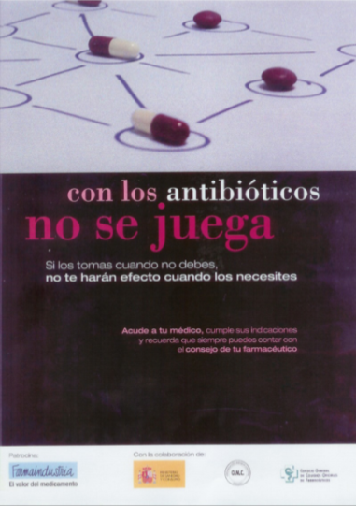

Figure 1: The poster used in the campaign.

Adapted from: Ripoll Lozano MÁ. Con los antibióticos no se juega. Medicina General. 2002;42:167-168.
Q & As
- Suggest how the campaign messages and materials could have been pilot tested.
Conducting focus group discussions for example, using the leaflets and pamphlets and asking participants what their thoughts are on them, whether they can relate to the content, whether they find it interesting or important, whether they may find some issues rather sensitive, etc. One could ask whether the message is clear and catchy, whether it would have an effect on them and would entice them to change their behaviours, etc.

Case study seven
“Going big”
Content outline:
PART 1 PART 2
- Objectives - Competitors, barriers and benefits for
- Target audience/s the target audience
- Marketing mix (4 P’s) - Evaluation
- Indicators
- Overall strengths and weaknesses

Main discussion points for this case study

When discussing this case study, it is suggested to emphasise on:
- the main competitors, benefits and barriers for the intended target audiences,
- the evaluation design, especially the indicators used to evaluate, and
- identifying the overall strengths and weaknesses of the campaign.

Remember
Do not forget to touch upon the concepts of exchange and competition when discussing the planning and marketing strategy of the campaign.

Attention
Often the behavioural objective causes confusion. It is not simply an objective, goal or aim of the campaign, but it is an objective which identifies an action or behaviour that one expects to influence and/or change after the intervention.
Description
Part 1
In 2008, it was highlighted by the European Health Council that antimicrobial resistance was still an augmenting health problem leading to increased morbidity and mortality, in addition to higher healthcare costs. Consequently, England, similar to other European countries, has conducted campaigns to encourage the general public to demand fewer antibiotics. In February of 2008, England launched a nation-wide campaign targeting antibiotic resistance, featuring three posters displayed in magazines and newspapers. The key message was, “The best way to treat most colds, coughs or sore throats is plenty of fluids and rest. For advice talk to your pharmacist or doctor”. A copy of the posters and some copies of an A5 patient advice leaflet (given to patients instead of antibiotic prescriptions) were sent, by post, to English (not Scottish) general practice surgeries and independent pharmacies. An accompanying letter from the Inspector of Microbiology and the Chief Pharmaceutical Officer indicated that extra copies could be ordered free of charge via phone, fax or from the order line website. A copy of this letter was also sent electronically to acute hospital trusts and health promotion units. When in November 2008, the European Union launched its first annual European Antibiotic Awareness Day (EAAD), England and Scotland participated and the English Department of Health repeated the February 2008 campaign in exactly the same way the following November, simply adding the EAAD logo to all materials.
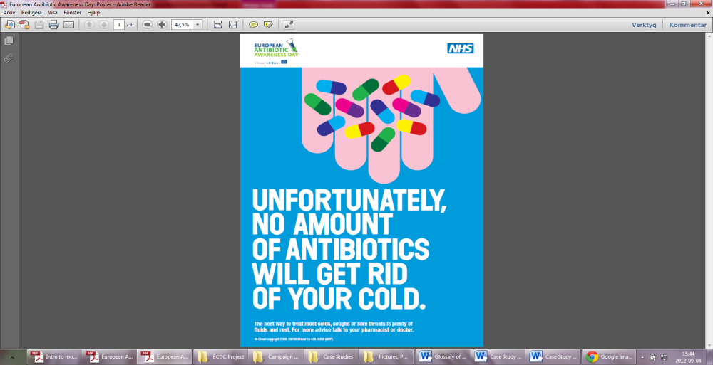
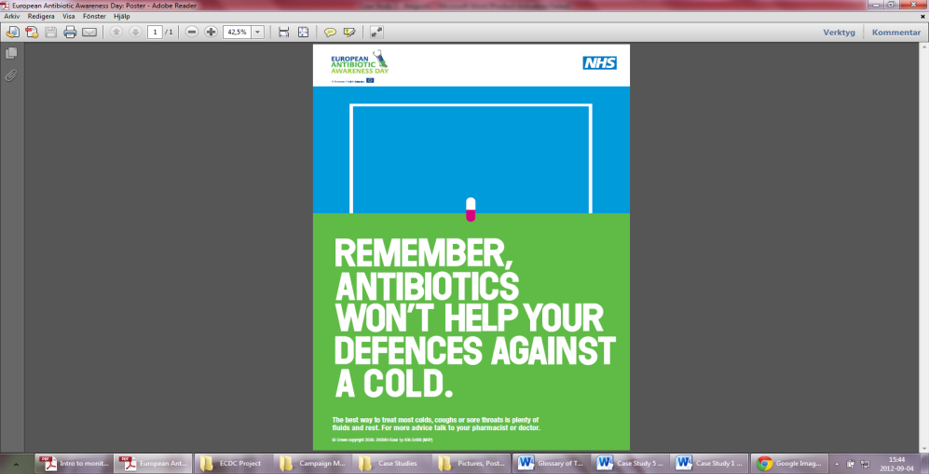

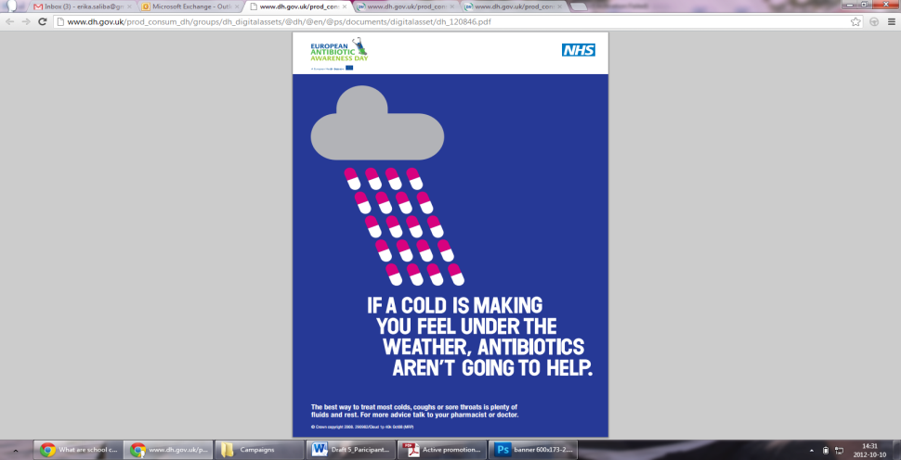

Figure 1: The leaflet (first picture on the left) and three posters used in the UK campaign.
In July 2008, the National Institute for Health and Clinical Excellence published guidelines on the primary care management of common, acute, self-limiting, respiratory tract infections (RTIs). It was recommended that general practitioners should agree to a ‘no antibiotic prescribing strategy’ or a ‘delayed antibiotic prescribing strategy’ for patients with RTIs, and that they should advise patients about the natural course of the illness, the lack of importance of antibiotics and their side effects, and how to manage symptoms using other medications.
Adapted from: McNulty CAM, Nichols T, Boyle P, Woodhead M, Davey P. The English antibiotic awareness campaigns: did they change the public’s knowledge of and attitudes to antibiotic use. J Antimicrob Chemother. 2010;65(7):1526-1533.
Q & As
- What was the behavioural objective/s in this campaign?
- To drink plenty of fluids and rest when suffering from a cold, cough or sore throat (general public)
- To visit a pharmacist or doctor for advice if in doubt on how to treat (general public)
- Not to prescribe antibiotics or to delay the prescription, for patients with respiratory tract infections (general practitioners)

Facilitator notes
No behavioural objective is mentioned in the text but a message and a statement on recommended practice is given. Emphasise the need to link one’s objectives to one’s behavioural objectives. You can ask participants to discuss how they would phrase the behavioural objective themselves.
- Who was the target audience in this campaign?
Not extremely obvious but one may assume:
- General public (appear that it was more specifically towards patients)
- General practitioners
- Pharmacists
Facilitator notes
The target audience is not clear cut. In fact, in the text it is said that they targeted antibiotic resistance, not a target audience. Discuss the importance of being very clear when defining a target audience, target audience segment, and/or a secondary audience.
- Is there any evidence, in your view, that the principles of the marketing mix were used in the planning of this campaign? Please use the table below for your answers.
Target audience/s | Product | Price | Place | Promotion
General public | - Printed materials | No indication on the price | Not extremely obvious but one may assume:  - Public spaces  - Clinics  - Pharmacies | - Distribution of printed media
General practitioners | - Printed materials | No indication on the price | - General practice surgeries | - Distribution of printed media  - Letter from the Inspector of Microbiology and the Chief Pharmaceutical Officer
Pharmacists | - Printed materials |  | - Independent pharmacies | - Distribution of printed media  - Letter from the Inspector of Microbiology and the Chief Pharmaceutical Officer

- Through what channels was the audience reached?
Printed materials

Part 2
A large before and after household survey done through telephone interviews, was carried out in both England and Scotland just before the start of the first antibiotic campaign in February of 2008 and then again the following year. The aim was to determine the effects of the 2008 public antibiotic campaigns on the public’s knowledge, attitudes and behaviour with respect to antibiotic use and to determine whether there were any differences between patient groups in the English and the Scottish settings. The first sample in January 2008 consisted of 1888 adults (1706 in England and 182 in Scotland) and 1830 adults the subsequent year (1707 in England and 123 in Scotland).
The results showed little evidence that the 2008 campaign had a positive effect. No improvement was detected in either England or Scotland, or any difference between England and Scotland in the public understanding of the lack of benefit of antibiotics for coughs and colds. They did not detect any improvement in the reported use of antibiotics in both England and Scotland either. There was a small but significant increase in public recall of the campaign posters (mostly the ‘hand’ poster) in England, but the increase was only 2.3% greater than the increase in Scotland. Moreover, an increase in the retention of leftover antibiotics was seen from 2008-2009. Also, English respondents were significantly more likely to disagree with the statement, “Resistance to antibiotics is a problem in British hospitals” in 2009 than in 2008. However, it was noted that patient-based interventions were in fact being used in general practice; 0.20% of all participants recalled discussing antibiotics with their general practitioner or nurse in the period from 2008 to 2009. Advice for delayed antibiotic prescription in 2009 was reported significantly more often by English than by Scottish participants and English participants received more advice from healthcare providers regarding appropriate treatment of colds and flu in 2009 than in 2008.
Adapted from: McNulty CAM, Nichols T, Boyle P, Woodhead M, Davey P. The English antibiotic awareness campaigns: did they change the public’s knowledge of and attitudes to antibiotic use. J Antimicrob Chemother. 2010;65(7):1526-1533.

Q & As
- In your opinion, what were the main specific barriers and benefits to reach the final intended audience of the campaign?

Target audience | Barriers | Benefits
General public | - Misconceptions  (e.g. perceived knowledge on how to treat infections based on previous prescriptions) | Better health not taking antibiotics in vain
General public | - Inability to go to doctor or pharmacist  (could be financial, time-wise, among others) | Preserving the environment
General public | - Perceived familiarities with the product (presumably the product being the antibiotic itself) sometimes results in self-medication | Wanting the best for their children
General public | - Extended time off work | Plenty of fluids & rest is the best cure
General public | - Improved symptoms which result in premature cessation of antibiotic therapy | Reduce antibiotic resistance
General public | - Side effects may result in premature cessation of antibiotic therapy | Trust in the prescriber
General public | - Patient expectations  (some patient may expect antibiotics from their prescribers otherwise they are perceived as worse prescribers and patients may go elsewhere to gain the prescription they expected or purchase what they initially wanted)
General practitioners | - Creating an imbalance between doctor and patient  (it is possible that some doctors might not want to give patients too much freedom to question and challenge them) | Providing incentives
General practitioners | - Could lose patients who go elsewhere for antibiotics | Reduce antibiotic resistance
General practitioners | - Time constraints  (it is time-consuming to discuss the prudent use of antibiotics to patients at each visit, especially when there is a large queue of patients waiting to be seen)
General practitioners | - Prescribing habits  (old habits are hard to change)
Pharmacists | - Creating an imbalance between pharmacist and patient | - Providing incentives
Pharmacists | - Financial losses in terms of sales  (if the pharmacy is privately-owned or the doctor is able to sell medications, not prescribing antibiotics might been seen as a monetary loss for the prescriber) | - Reduce antibiotic resistance

Facilitator notes
This question is very subjective and very much open for discussion as one cannot really tell what the benefits and barriers were from the text. One can get an idea however and as a facilitator it is good to extract these thoughts and build an extensive discussion around them. Therefore, for this question, participants will get most out of it if you (the facilitator) also delve into the concept of exchange and competition and their effects on the planning phase and how the campaign is eventually unrolled.

- How (design, method/s and outcome variable/s) was the success/failure of the intervention measured? Would you have evaluated it differently? If so, how?
- Before and after household survey
- Telephone interviews
- Public’s knowledge, attitudes and behaviour with respect to antibiotic use

- Identify and/or develop key indicators as well as data collection methods and tools that could be used to evaluate the given campaign.

Facilitator notes
Below are only a few suggestions for indicators but numerous indicators can be developed therefore discussion should be encouraged.

Remember
Not all outcome indicators can directly attribute certain outcomes as direct effects of the campaign. Some indicators may be used as proxy indicators but are not necessarily a direct result of the campaign. They may however give an overview of the situation post-campaign and aid to set targeted goals for future campaigns.

Key activities | Specific objectives | Key indicators |  | Data collection methods/tools
 |  | Process | Outcome
Leaflets and posters | - To increase knowledge on prudent antibiotic use  - To increase awareness on prudent antibiotic use  - To change behaviour when treating cold, sore throat and cough | - # (total) printed materials printed  - # (total) printed materials disseminated | - % people with correct knowledge on antibiotics and their use  - % population who self-medicate  - % population who save leftover antibiotics | - Records of printing agency involved in the campaign  - Pre- and post-campaign surveys (could be as questionnaires, focus group discussions, interviews, etc.)  - (On-going) surveillance
Letters | - To explain about the importance of engaging in the campaign (assumption)  - To emphasise the consequence of the emergence of antibiotic resistance (assumption)  - To inform about the appropriate antibiotic prescription (assumption)  - To change prescribing behaviour when treating respiratory tract infections | - # (total) printed letters printed  - # (total) printed letters disseminated | - % antibiotic prescription specific to the diagnosis  - % antibiotic dispensation per pharmacy | - Medical records  - Doctor’s reports  - Pharmacy records  - Records of printing agency involved in the campaign  - (On-going) surveillance  - Pre- and post-campaign survey with prescribers (could be as questionnaires, focus group discussions, interviews, etc.)

- In your view, what were the strengths of this campaign?
- Clear message
- Posters are catchy (good use of colour and text)
- Good use of printed materials
- Cooperation from the Inspector of Microbiology and the Chief Pharmaceutical Officer
- Involvement of several levels of healthcare
Facilitator notes
The above answers are purely suggestions and many more answers might come up whilst discussing this question. Since no concrete answers will be found in the text, it may be rather subjective and is thus open for discussion.
- What do you think were the weaknesses of this campaign? What do you think could have been improved and how? Keeping the social marketing principles in mind, what would you have done differently in order to improve the campaign in your given scenario? Please discuss and write down your own suggestions.
- Some posters were a little bit too busy
- The campaign did not seem to have a great impact on the general public
- General prescribers were not included in the evaluation of the campaign
- Lacks extensive unrolling of campaign (only printed materials used). Could have perhaps been beneficial to use mass media (e.g. TV and radio) as well for example
Facilitator notes
The above answers are purely suggestions and many more answers might come up whilst discussing this question. Since no concrete answers will be found in the text, it may be rather subjective and is thus open for discussion.
- What were the desired/intended outcomes of the campaign and were they reached? Were there any unintended outcomes?
- The desired outcome was that people refrain from using antibiotics to treat colds, sore throats and coughs and that prescribers do not prescribe antibiotics in vain for respiratory tract infections
- It does not appear that they were reached. Whilst prescribing behaviour of doctors and pharmacists is unknown since they were not included in the evaluation, it does not appear that the campaign had a positive effect on the general public. Public recall of the posters was small although there was a slight increase from the previous year and the reported use of antibiotics did not improve.
- It appear that there were some unintended outcomes: (i) there was an increase in retention of leftover antibiotics from 2008 to 2009 and (ii) English respondents were significantly more likely to disagree with the statement, “Resistance to antibiotics is a problem in British hospitals”.

Case study eight
“Involving actors for change”
Content outline:
- Objectives
- Target audience/s
- Marketing mix (4Ps)
- Competitors, barriers and benefits for the target audience
- Evaluation
- Indicators
- Overall strengths and weaknesses

Main suggested discussion points for this case study

When discussing this case study, it is suggested to emphasise on:
- the main competitors, benefits and barriers for the intended target audiences,
- the evaluation design, especially the indicators used, and
- identifying the overall strengths and weaknesses of the campaign.

Remember
Do not forget to touch upon the concepts of exchange and competition when discussing the planning and marketing strategy of the campaign.

Description
In 1998, Belgium had the second highest rate of antibiotic consumption in the community in Europe. Consequently, in November 2000, the Belgian Antibiotic Policy Co-ordination Committee launched nation-wide campaigns promoting rational use of antibiotics in the community with a budget of €400,000. Their goals were to: (i) provide the general public with a better understanding of the natural course of infections such as the common cold, acute bronchitis and influenza, (ii) explain when antibiotics are needed, (iii) underline the consequences of the emergence of resistance to antibiotics, and (iv) facilitate patient-doctor and patient-pharmacist discussion on the prudent use of antibiotics. The three successive, three-month long annual campaigns targeted both the public and prescribers during winter (November to February). The three main messages were: “Use antibiotics less frequently but better”, “Save antibiotics, they may save your life”, and “Talk to you doctor, talk to your pharmacist”. The public was targeted via television, radio, posters, brochures and information folders. General practitioners (GPs), paediatricians, pneumonologists, ear nose and throat specialists and community pharmacists received personal letters together with campaign materials for patients.
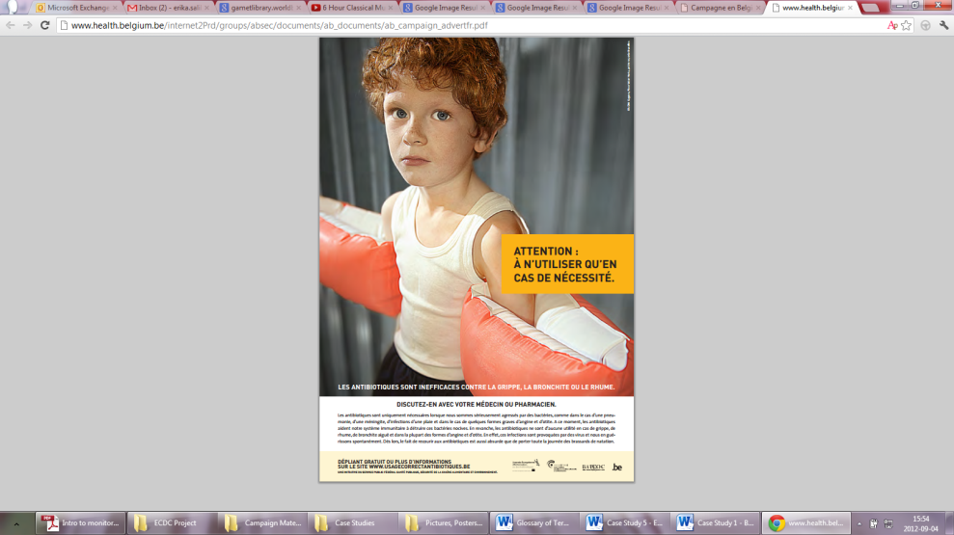
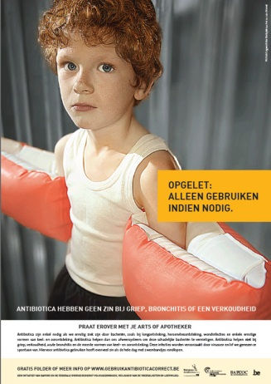

Figure 1: In the nation-wide campaign, posters were distributed both in Flemish and in French.

The impact of the first two campaigns was evaluated through: (i) pre- and post- campaign face-to-face interviews with the general public, with good representation of the national population in terms of age, socioeconomic status, region and geographical area, and (ii) post-campaign surveys with GPs.
The post-campaign survey, which was carried out 1-2.5 months after the end of the first campaign, showed that, 46% of the public recalled the campaign (79% through television, 17% through newspapers and 14% through radio). The first campaign also had high visibility for GPs (100%), was given positive feedback and shifted opinion in favour of using antibiotics more carefully (75% public; 63% GPs). Expectations for antibiotics also decreased significantly (p<0.05) for acute bronchitis, flu, sore-throat, common cold and diarrhoea. To assess the campaign’s effectiveness, a statistical time-series analysis, controlled for the influence of seasonal variation of influenza-like illness in 2000-2001 and 2001-2002, as compared to previous years, was carried out in a separate study. Antibiotic reimbursement data between 1997 and 2003 expressed in defined daily doses, and antibiotic packages, shows a decline in antibiotic use in the community since 2000.
Adapted from:
- Goossens H, Coenen S, Costers M, De Corte S, De Sutter A, Gordts B, Laurier L, Struelens M. Achievements of the Belgian Antibiotic Policy Coordination Committee (BAPCOC). Euro Surveill. 2008 Nov 13;13(46):pii 19036.
- Goossens H, Guillemot D, Ferech M, Schlemmer B, Costers M, van Breda M, Baker LJ, Cars O, Davey PG. National campaigns to improve antibiotic use. Eur J Clin Pharmacol. 2006 May;62(5):373-379.

Q & As
- What was the behavioural objective/s in this campaign?
- For the general public to better understand the natural course of infections such as the common cold, acute bronchitis and influenza (not exactly a behavioural objective)
- To facilitate patient-doctor and patient-pharmacist discussion on the prudent use of antibiotics (not phrased exactly as a behavioural objective, however the message was clearly focused on behaviour)
Facilitator notes
The case scenario does not provide defined behavioural objectives. Although the information is relatively speaking available, they are not constructed appropriately and must be rephrased in order to be made into behavioural objectives. Emphasise that in the construction of behavioural objectives one must include (i) who one would like to do an observable action, (ii) the observable action itself and (iii) under which conditions/circumstances.
- Who was the target audience in this campaign?
- General public [primary]
- Prescribers (namely GPs, paediatricians, pneumonologists, ear nose and throat specialists, and community pharmacists) [secondary]

- Is there any evidence, in your view, that the principles of the marketing mix were used in the planning of this campaign? Use the marketing mix score matrix* below to assess to which degree you think the social marketing principles were applied, described or addressed.
Product | Price  (benefits/barriers) | Place | Promotion
……………………………………………………………………………………………………………
* Each principle must be marked from a scale of 1-10, with 10 representing “a strong application, description or addressing of the principle” and 1 corresponding to “weak application, description or addressing of the principle”.

Facilitator notes
The above question is subjective and for that reason no suggestions are given. Nonetheless it is advised that you facilitate a short discussion around the principles of marketing. Please note that you should not over-emphasise this concept, rather place the emphasis later on when discussing evaluation.
- Through what channels was the audience reached?
- Conventional mass media (e.g. TV, radio)
- Printed materials (e.g. posters, brochures, letters)

- What/Who do you think were the main competitors for the target audience?

Facilitator notes
The above answers are purely suggestions and many more answers might come up whilst discussing this question. Since no concrete answers will be found in the text, it may be rather subjective and is thus open for discussion.
- In your opinion, what were the main specific barriers and benefits to reach the final intended audience of the campaign?
Target audience | Barriers | Benefits
General public | - Cost of visiting a doctors for an antibiotic prescription | - Trust in the prescriber  - Better communication
General public | - Misconceptions  (e.g. perceived knowledge on how to treat infections based on previous prescriptions) | - Wanting the best for their children
General public | - Patient expectations  (some patients may expect antibiotics from their prescribers otherwise they are perceived as worse prescribers and patients may go elsewhere to gain the prescription they expected or purchase what they initially wanted) | - Less side effects

Target audience | Barriers | Benefits
Prescribers | - Imbalance in patient-doctor/patient-pharmacist relationship  (it is possible that some prescribers might not want to give patients too much freedom to question and challenge them) | - Providing incentives
Prescribers | - Time constraints  (it is time-consuming to discuss the prudent use of antibiotics to patients at each visit, especially when there is a large queue of patients waiting to be seen) | - Better knowledge
Prescribers | - Prescribing habits  (old habits are hard to change) | - Easier communication  - Better patient communication
- Decreased sales
(if the pharmacy is privately-owned or the doctor is able to sell medications, not prescribing antibiotics might been seen as a monetary loss for the prescriber)
- Loss of clients
(some patients may expect antibiotics from their prescribers otherwise they are perceived as worse prescribers and patients may go elsewhere to gain the prescription they expected or purchase what they initially wanted which may result in the first prescriber losing those clients)
 | - Uncertainty

Facilitator notes
The above answers are purely suggestions and many more answers might come up whilst discussing this question. Since no concrete answers will be found in the text, it may be rather subjective and is thus open for discussion.
- How (design, method/s and outcome variable/s) was the success/failure of the intervention measured? Would you have evaluated it differently? If so, how?
- Pre- and post- campaign face-to-face interviews with the general public
- Post-campaign surveys with general practitioners
- Time-series analysis

Facilitator notes
For the interviews with the general public it is good that it is mentioned in the text that there was good representation of the national population. With regards to the post-campaign surveys with general practitioners the question why no pre-campaign survey was carried out should be brought up and also why the other prescribers were not included in the survey after they were included in the target group.
- Identify and/or develop key indicators as well as appropriate data collection methods and tools that could be used to evaluate the given campaign.

Facilitator notes
Below are only a few suggestions for indicators but numerous indicators can be developed therefore discussion should be encouraged.

Remember
Not all outcome indicators can directly attribute certain outcomes as direct effects of the campaign. Some indicators may be used as proxy indicators but are not necessarily a direct result of the campaign. They may however give an overview of the situation post-campaign and aid to set targeted goals for future campaigns.

Key activities | Specific objectives | Key indicators |  | Data collection methods/tools
 |  | Process | Outcome
Television and radio ads | - To increase knowledge on prudent antibiotic use  - To increase awareness on prudent antibiotic use | - # viewers/ listeners  - # (total) ads aired  - # (total) air time  - # (total) TV/radio stations involved | - % people with correct knowledge on antibiotics and their use  - % population who self-medicate  - % population who save leftover antibiotics | - Log books and records from TV/radio stations on number of viewers/listeners, number of callers (if people can call talk shows to ask questions), etc.  - Pre- and post-campaign surveys (could be as questionnaires, focus group discussions, interviews, etc.)  - (On-going) surveillance
Brochure, poster and information folder dissemination | - To increase knowledge on prudent antibiotic use  - To increase awareness on prudent antibiotic use | - # (total) printed materials printed  - # (total) printed materials disseminated | - % people with correct knowledge on antibiotics and their use  - % population who self-medicate  - % population who save leftover antibiotics | - Records of printing agency involved in the campaign  - Pre- and post-campaign surveys (could be as questionnaires, focus group discussions, interviews, etc.)  - (On-going) surveillance
Personal letters | - To explain about the importance of engaging in the campaign (assumption)  - To emphasise the consequence of the emergence of antibiotic resistance (assumption)  - To inform about the appropriate antibiotic prescription (assumption) | - # (total) personal letters printed  - # (total) personal letters disseminated  - % prescribers (per prescriber population) to whom personal letters were distributed | - % antibiotic prescription specific to the diagnosis | - Medical records  - Doctor’s reports  - Pharmacy records  - Records of printing agency involved in the campaign  - Pre- and post-campaign survey with prescribers (could be as questionnaires, focus group discussions, interviews, etc.)  - (On-going) surveillance

- In your view, what were the strengths of this campaign?
- Clear messages
- Clear target group
- Good time period to run the campaign (peak influenza season – November to February)
- Evaluation (pre- and post-campaign surveys as well as time series analysis)
Facilitator notes
The above answers are purely suggestions and many more answers might come up whilst discussing this question. Since no concrete answers will be found in the text, it may be rather subjective and is thus open for discussion.
- What do you think were the weaknesses of this campaign? What do you think could have been improved and how? Keeping the social marketing principles in mind, what would you have done differently in order to improve the campaign in your given scenario? Please discuss and write down your own suggestions.
- No pre-campaign survey for doctors
- Although one of the target groups was prescribers, in the evaluation, on doctors as prescribers were surveyed, excluding the others.
- Slightly weak targeting of prescribers (only personal letters). How about workshops? Peer-to-peer visits? Conferences? Guideline dissemination? Etc.)
- Need for more formative evaluation
Facilitator notes
The above answers are purely suggestions and many more answers might come up whilst discussing this question. Since no concrete answers will be found in the text, it may be rather subjective and is thus open for discussion.
- What were the desired/intended outcomes of the campaign and were they reached? Were there any unintended outcomes?
- The intended outcomes were that: (i) the general public gain a better understanding of the natural course of infections such as the common cold, acute bronchitis and influenza, (ii) the general public understand when antibiotics are needed, (iii) the general public understand the consequences of antibiotic resistance, and (iv) there is increased discussion between patient-doctor and patient-pharmacist on the prudent use of antibiotics.
- Although there isn’t a very clear indication as to whether these goals were in fact reached, it is shown that 46% of the public recalled the campaign and that visibility was 100% for general practitioners. It also shifted their opinion towards using antibiotics more cautiously. Antibiotic reimbursement data also showed a decline in antibiotic use in the community.
- No unintended outcomes are apparent in the text.

Case study nine
“Knowing your audience”
Content outline:
PART 1 PART 2
- Objectives - Evaluation
- Target audience/s - Indicators
- Marketing mix (4Ps) - Overall strengths and weaknesses
- Formative evaluation
- Pre-testing
- Competitors, barriers and benefits
for the target audience

Main discussion points for this case study

When discussing this case study, it is suggested to emphasise on:
- the planning phase of the campaign, especially with regards to pre-testing and formative evaluation.

Remember
Do not forget the important role of evaluation! Nevertheless, for this case study the emphasis should lie on the pre-testing and formative evaluation.

Attention
Often the behavioural objective causes confusion. It is not simply an objective, goal or aim of the campaign, but is it an objective which identifies an action or behaviour that one expects to influence and/or change after the intervention.

Description
Part 1
With the realisation of excess antibiotic use in ambulatory care and the rapid rise in antibiotic resistance in community-acquired bacterial pathogens, a controlled trial of the impact of a mass media campaign to reduce community-level antibiotic use was conducted. The mass media campaign was delivered in Denver, Colorado, a large city of around 2.2 million inhabitants, and targeted young children and primary care doctors. The results of the campaign were then compared to Colorado Springs, a city located 100kms away with a population of around 550,000 people with similar demographic distribution to the intervention city, but with entirely separate TV, radio and newspaper organisations. The campaign was launched in November 2002 and media events were planned for each month up until February, 2003.
The strategy for the campaign included: out-of-home advertising, mass media events and the initiation of community advocacy. Some of the mass media included: billboards (n=5), posters on the outside of buses (n=40), bus stop posters (n=20), signs in interior of buses (n=150), and radio spots (n=60). In addition, airing (n=112) was also done in Spanish (the second main language spoken in the area) free of cost by a local Spanish network. The cost of the purchased advertising space and public relations services in 2002 was approximately $88,500 for the four-month intervention.
The campaign messages and dissemination strategy were developed following focus groups, interviews and surveys, held both in English and Spanish, and conducted by the investigators in collaboration with advertising/marketing and public relations companies and through consultation with social marketing experts. In the early design phase of the mass media campaign, two focus groups (N=16) were held addressing the message concept options for the mass media materials. Later, two groups were held in with English speakers (N=26) and four groups with Spanish-speaking Latinos (N=27) to place their input on logo options and specific message and phrases for the campaign.
Ultimately, the underlying key messages for the English speakers were determined to be: (i) Our antibiotics are becoming less effective and it’s a serious public health issue, (ii) Taking antibiotics today when you don’t need them means they may not work in the future when you really do need them, and (iii) You don’t need antibiotics every time you get sick. Ask your healthcare provider to be sure. The key slogan for the English language campaign was “Get smart: use antibiotics wisely”. Simple translation of the campaign’s slogan to Spanish was determined to be misleading and would rather be interpreted as an approval of self-medication. Consequently, the slogan was altered slightly to read, “Use antibióticos solo si un doctor se lo receta” (“Use antibiotics only if a doctor prescribes them”) instead.
Monthly earned media events for the “Get smart Colorado” campaign included: designation of “Antibiotic Awareness Week” by the city council, Winter Health Fairs (n=2), and “Antibiotics Amnesty Month”, an initiative which encouraged people to return leftover antibiotics to their local pharmacies. An opinion article was also published in a prominent local newspaper during this period. Doctor advocacy activities enhanced the paid advertising campaign by utilising the same logos, messages and materials in doctors’ offices. Primary care doctors (n=1167) were sent a postcard asking for their support (by signing and returning the postcard) in the campaign. Office materials posted to requesting doctors included: waiting and examination room posters on appropriate antibiotic use for pharyngitis and bronchitis, patient brochures relating to appropriate antibiotic use and antibiotic resistance, and stethoscope clips with the campaign’s logo. The estimated cost of materials and staff support for the earned media activities in 2002 was about $30,000.
Adapted from: Gonzales R, Corbett KK, Wong S, Glazner JE, Deas A, Leeman-Castillo B, Maselli JH, Sebert-Kuhlmann A, Wigton RS, Flores E, Kafadar K. Get smart Colorado: impact of a mass media campaign to improve community antibiotic use. Med Care. 2008 Jun;46(6):597-605.

Q & As
- What was the behavioural objective/s in this campaign?
To reduce community-level antibiotic use (more of a long term aim).
Facilitator notes
The behavioural objective is not very clear but other objectives are mentioned. Emphasise the need to link one’s objectives to one’s behavioural objectives. You can ask participants to discuss how they would phrase the behavioural objective themselves.
- Who was the target audience in this campaign?
Young children and primary care doctors (Presumably the researchers targeted parents of young children not the young children directly)

- Is there any evidence, in your view, that the principles of the marketing mix were used in the planning of this campaign? Use the marketing mix score matrix* below to assess to which degree you think the social marketing principles were applied, described or addressed.
Product | Price  (benefits/barriers) | Place | Promotion
……………………………………………………………………………………………………………
* Each principle must be marked from a scale of 1-10, with 10 representing “a strong application, description or addressing of the principle” and 1 corresponding to “weak application, description or addressing of the principle”.

Facilitator notes
The above question is subjective and for that reason no suggestions are given. Nonetheless it is advised that you facilitate a short discussion around the principles of marketing. Please note that you should not over-emphasise this concept, rather place the emphasis later on when discussing evaluation.
- Through what channels was the audience reached?
- Out-of-home advertising
- Mass media events (billboards, posters on the outside of buses, bus stop posters, signs in interior of buses, radio spots)
- Community advocacy
- Postcards
- Office materials
- Waiting and examination room posters
- Patient brochures
- Stethoscope clips with the campaign’s logo

- What/Who do you think were the main competitors in this campaign?

Facilitator notes
Not explicitly clear in text – open for discussion.
- Describe how the tools for this campaign were pre-tested.
- Focus groups, interviews and surveys, held both in English and Spanish
- In the early design phase, two focus groups held addressing the message concept options for the mass media materials
- Later, two groups were held in with English speakers and four groups with Spanish-speaking Latinos to place their input on logo options and specific message and phrases for the campaign

- Discuss the importance of formative evaluation before implementing campaigns.
Thanks to the formative evaluation carried out before the intervention, the intervention team was able to adapt intervention materials as well as identify the need to change messages and slogans appropriately according to the language of the targeted segments.
Facilitator notes
It is evident from the text that the intervention team carried out quite a bit of research before they unrolled their intervention. In fact they were able to identify the need to adapt slogans according to the language of the target segments. Be sure to discuss the importance of formative evaluation with participants.
- In your opinion, what were the main specific barriers and benefits to reach the final intended audience of the campaign?

Target audience | Barriers | Benefits
Facilitator notes
Not explicitly clear in text – open for discussion.

Part 2
In order to determine whether residents of the intervention community were exposed to appropriate antibiotic use messages to a greater extent than the control community, cross-sectional, random-digit-dialled telephone surveys of adults residing in the intervention and control communities were conducted in both languages. Telephone surveys were conducted during a pre-baseline winter period (October-November, 2001), the baseline winter period (January-March, 2002) and the intervention winter period (February 7 to March 10, 2003). Community-level antibiotic dispensing data from retail pharmacies (about 89% of all pharmacies in the area) for 2002 and 2003 was also collected. Ambulatory doctor office visits, emergency department visits, and antibiotic prescription rates were based on administrative claims. Since the mass media campaign materials’ emphasis was on the prudent use of antibiotics for acute respiratory tract infections, these ambulatory visits were separated from non-acute respiratory tract infection visits.
During the campaign, survey respondents residing in the intervention community reported seeing or hearing ads or news on the campaign more than the control community (51% vs. 39%). Similarly, among respondents visiting a doctor’s office during the campaign, 43% of those living in the intervention community reported seeing materials related to the consequences of antibiotic overuse, versus 24% in the control community. The frequency of seeing or hearing ads or news about antibiotic resistance during the intervention phase did not vary between the groups.
In 2002, retail pharmacies dispensed 1.08 million antibiotic prescriptions in the intervention community versus 0.28 million in the control group. Following the campaign, the rate of antibiotic prescribing declined in both groups. The net difference in monthly antibiotic prescription rates between the intervention and control groups decreased sharply and incrementally within the five months following the launch of the mass media campaign. Most of the change in antibiotic prescription rates for the mass media versus the comparison communities occurred among paediatric patients (<18 years). After the mass media campaign, office visit rates, primarily for acute respiratory tract infection among paediatric patients residing in the intervention community declined in relation to visit rates among those residing in control group. No major change was seen in adult visit rates after the campaign.
Adapted from: Gonzales R, Corbett KK, Wong S, Glazner JE, Deas A, Leeman-Castillo B, Maselli JH, Sebert-Kuhlmann A, Wigton RS, Flores E, Kafadar K. Get smart Colorado: impact of a mass media campaign to improve community antibiotic use. Med Care. 2008 Jun;46(6):597-605.

Q & As
- How (design, method/s and outcome variable/s) was the success/failure of the intervention measured? Would you have evaluated it differently? If so, how?
- Cross-sectional, random-digit-dialled telephone surveys of adults residing in the intervention and control communities
- Telephone surveys conducted during a pre-baseline winter period, baseline winter period and intervention winter period
- Community-level antibiotic dispensing data from retail pharmacies was also collected
- Ambulatory doctor office visits, emergency department visits, and antibiotic prescription rates were based on administrative claims

- Identify and/or develop key indicators as well as data collection methods and tools that could be used to evaluate the given campaign.
Facilitator notes
Below are only a few suggestions for indicators but numerous indicators can be developed therefore discussion should be encouraged.

Remember
Not all outcome indicators can directly attribute certain outcomes as direct effects of the campaign. Some indicators may be used as proxy indicators but are not necessarily a direct result of the campaign. They may however give an overview of the situation post-campaign and aid to set targeted goals for future campaigns.

Key activities | Specific objectives | Key indicators |  | Data collection methods/tools
 |  | Process | Outcome
Printed materials | - To reduce community-level antibiotic use | - # (total) printed materials printed  - # (total) printed materials disseminated  - # (total) printed materials printed (specific to the printed material)  - # (total) printed materials disseminated (specific to the printed material) | - % people with correct knowledge on antibiotics and their use  - % population who self-medicate  - % population who cease antibiotic therapy prematurely | - Records of printing agency involved in the campaign  - Pre- and post-campaign surveys (could be as questionnaires, focus group discussions, interviews, etc.)  - (On-going) surveillance
Ads in mass media (radio) | - To reduce community-level antibiotic use | - # (total) ads aired  - # (total) air time  - # (total) radio stations involved | - % people with correct knowledge on antibiotics and their use  - % population who self-medicate  - % population who cease antibiotic therapy prematurely | - Log books and records from radio station on number of viewers/listeners, number of callers, etc.  - Pre- and post-campaign surveys (could be as questionnaires, focus group discussions, interviews, etc.)  - (On-going) surveillance

- In your view, what were the strengths of the campaign?
- Large selection of materials disseminated multi-faceted approach
- Strong pre-testing
- Very good evaluation
- Appropriate data collection
Facilitator notes
The above answers are purely suggestions and many more answers might come up whilst discussing this question. Since no concrete answers will be found in the text, it may be rather subjective and is thus open for discussion.
- What do you think were the weaknesses of the campaign? What do you think could have been improved and how? Keeping the social marketing principles in mind, what would you have done differently in order to improve the campaign in your given scenario? Please discuss and write down your own suggestions.
- Behavioural objective not clearly defined
- Target segments could have been defined better
Facilitator notes
The above answers are purely suggestions and many more answers might come up whilst discussing this question. Since no concrete answers will be found in the text, it may be rather subjective and is thus open for discussion. Ask participants to discuss alternative strategies to reach the intended audience and alternative strategies for evaluation.

Case study ten
“Maximising a small budget”
Content outline:
- Objectives
- Target audience/s
- Marketing mix (4Ps)
- SWOT analysis
- Competitors, barriers and benefits for the target audience
- Indicators
- Overall strengths and weaknesses

Main discussion points for this case study

When discussing this case study, it is suggested to emphasise on:
- maximising resources in resource-limited settings.

Attention
Often the behavioural objective causes confusion. It is not simply an objective, goal or aim of the campaign, but is it an objective which identifies an action or behaviour that one expects to influence and/or change after the intervention.

Description
In a survey carried out by Eurobarometer before and after the 2009 European Antibiotic Awareness Day (EAAD) campaign indicated that, 55% of the Maltese population had taken antibiotics in the previous year (the second highest antibiotic consumption in Europe); 26% of respondents saying they took antibiotics for the flu and 31% for a sore throat. Furthermore, in 2002, it was shown that over-the-counter acquisition of antibiotics was up at 19%.
For almost a decade, the Maltese Health Department (and then the National Antibiotic Committee since its establishment in 2008) held several initiatives, mainly addressing non-prescribed use and over-the-counter dispensing of antibiotics. These were complemented by increased regulatory pressure on pharmacists to adhere to national legislation prohibiting the sale of antibiotics without a medical prescription. Due to lack of a financial budget, formal campaigns like those held in France and Belgium could not be achieved. Initiatives therefore relied heavily on maximising free media opportunities through participation in radio and television chat shows (primarily in the winter) as well as newspaper interviews and articles. With the launch of EAAD, some funds were put towards the campaign enabling the production of a small amount of promotional materials such as leaflets, posters and billboards. The billboards were erected in two heavily used roads in the country; the posters and leaflets were distributed to health centres, private doctors’ clinics as well as local councils. In total, two non-commercial posters with the slogan: “Saħħtek ibża’ għaliha, tabbużax mill-antibijotiċi” (“Take good care of your health, do not abuse of antibiotics”), were used throughout the month of November and one television spot was aired on the EAAD before the evening news report on the national television station. This used the ECDC hedgehog clip translated into Maltese. The main messages, in addition to the primary slogan, were, “Isalvaw il-ħajja imma jekk tabbuża minnhom, jistgħu jagħmlu ħsara lilek u lil ta’ madwarek” (“They save lives but if abused they can cause harm both to you and to those around you”) and “Tissikkax lit-tabib jew spiżjar biex jagħtik l-antibijotiċi” (“Do not put pressure on your doctor or pharmacist to give you antibiotics”). A press conference was also held on 17th November by the Parliamentary Secretary. The budget for the 2009 campaign was €3000, €4000 less than the previous year. The campaign was primarily targeted at the general population.
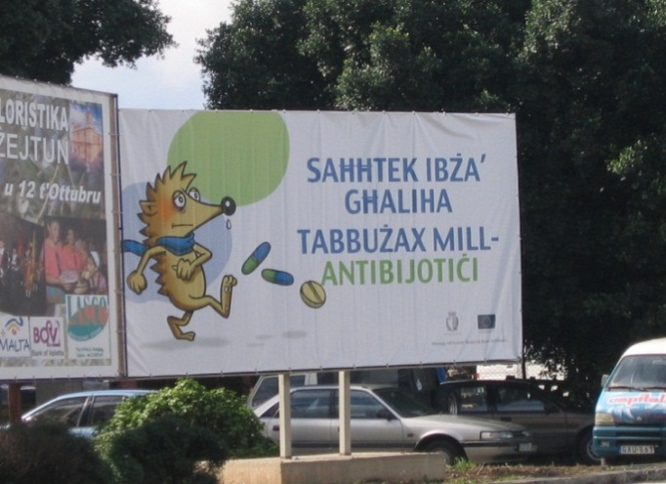


Figure 1: Posters and billboards distributed in the campaign.

Formal evaluation of the impact of the campaign was not possible due to lack of resources. However, following the campaign, a Eurobarometer survey showed that dispensing of antibiotics over-the-counter had fallen to 4%. Nonetheless, knowledge on antibiotic function and use was low; only 10% of respondents got 4 out of 4 answers correct. Despite this, 94% of respondents knew that unnecessary use of antibiotics make them ineffective. With regards to retrieval of information, respondents believed that doctors are the most trustworthy source of information (95%). However, only 16% reported being told by a doctor about not taking antibiotics unnecessarily.
Regarding the direct impact of campaign material, Eurobarometer showed that 34% of participants remembered receiving information about not taking antibiotics. The most effective means of delivery of information in the Maltese context appeared to be the media, with 30% remembering the television advertisement. However, overall it was shown that only 47% said that the information they received changed their views on antibiotics, although 88% stated that they will in future consult a doctor when they think that they need an antibiotic.
Adapted from:
- Borg MA, Scicluna EA. Over-the-counter acquisition of antibiotics in the Maltese general population. Int J Antimicrob Agents. 2002 Oct;20(4):253-257.
- Health, the Elderly and Community Care. National antibiotic committee. [internet]. 2012 [cited 2012 Oct 13]. Available from: https://ehealth.gov.mt/HealthPortal/others/regulatory_councils/national_antibiotic_committee/download_material.aspx
- National Antibiotic Committee. Annual report. [internet]. 2009 [cited 2012 Oct 15]. Available from: https://ehealth.gov.mt/HealthPortal/others/regulatory_councils/national_antibiotic_committee/download_material.aspx
- Special Eurobarometer 338. Antimicrobial resistance: report. Brussels: TNS Opinion & Social; 2010.

Q & As
- What was the behavioural objective/s in this campaign?
Campaign messages are clear but not the behavioural objective discuss a possible behavioural objective with the participants.

- Who was the target audience in this campaign?
The general population

- Is there any evidence, in your view, that the principles of the marketing mix were used in the planning of this campaign? Use the marketing mix score matrix* below to assess to which degree you think the social marketing principles were applied, described or addressed.

Product | Price  (benefits/barriers) | Place | Promotion
……………………………………………………………………………………………………………
* Each principle must be marked from a scale of 1-10, with 10 representing “a strong application, description or addressing of the principle” and 1 corresponding to “weak application, description or addressing of the principle”.

Facilitator notes
The above question is subjective and for that reason no suggestions are given. Nonetheless it is advised that you facilitate a short discussion around the principles of marketing. Please note that you should not over-emphasise this concept, rather place the emphasis later on when limited budgets.
- Through what channels was the audience reached?
- Participation in radio and television chat shows
- Newspaper interviews and articles
- Small amount of leaflets, posters and billboards
- One television spot aired on the EAAD before the evening news using the ECDC hedgehog clip translated into Maltese

- In your opinion, what were the main specific barriers and benefits to reach the final intended audience of the campaign?
Target audience | Barriers | Benefits

Facilitator notes
Not explicitly clear in text – open for discussion.
- Given the low budget (€3,000), a thorough evaluation of the campaign was not deemed feasible. Give suggestions on how a campaign with a tight budget can be effectively evaluated.
- Rely more on existing information
- Free cost information sources
Facilitator notes
Above are only some suggestions. This question is very much open for discussion among participants.
- Identify and/or develop key indicators as well as data collection methods and tools that could have been used to evaluate the given campaign.
Facilitator notes
Below are only a few suggestions for indicators but numerous indicators can be developed therefore discussion should be encouraged.

Remember
Not all outcome indicators can directly attribute certain outcomes as direct effects of the campaign. Some indicators may be used as proxy indicators but are not necessarily a direct result of the campaign. They may however give an overview of the situation post-campaign and aid to set targeted goals for future campaigns.

Key activities | Specific objectives | Key indicators |  | Data collection methods/tools
 |  | Process | Outcome
Ads in mass media (TV) | Not clear but one can assume:  - To inform the public about antibiotic use and antibiotic resistance  - To decrease antibiotic use for viral infections  - To decrease self-mediation  - To decrease the early/premature cessation of antibiotic therapy | - # (total) ads aired  - # (total) air time  - # (total) TV involved | - % people with correct knowledge on antibiotics and their use  - % population who self-medicate  - % population who cease antibiotic therapy prematurely | - Log books and records from TV station on number of viewers/listeners, number of callers, etc.  - Pre- and post-campaign surveys (could be as questionnaires, focus group discussions, interviews, etc.)  - (On-going) surveillance
Printed materials | Not clear but one can assume:  - To inform the public about antibiotic use and antibiotic resistance  - To decrease antibiotic use for viral infections  - To decrease self-mediation  - To decrease the early/premature cessation of antibiotic therapy | - # (total) printed materials printed  - # (total) printed materials disseminated | - % people with correct knowledge on antibiotics and their use  - % population who self-medicate  - % population who cease antibiotic therapy prematurely | - Medical records  - Doctor’s reports  - Pharmacy records  - Records of printing agency involved in the campaign  - Pre- and post-campaign surveys (could be as questionnaires, focus group discussions, interviews, etc.)  - (On-going) surveillance

- Given the low budget of €3,000, brainstorm and suggest alternative strategies for all phases of campaign development (planning, implementation and evaluation), that could be used when developing an antibiotic campaign on a small budget.

Facilitator notes
This question is very much open for discussion. Facilitate a discussion on limited budgets among participants.
- In your view, what were the strengths of this campaign?
- Maximisation of free media opportunities in a resource-limited setting
- Use of EAAD materials provided by ECDC
Facilitator notes
The above answers are purely suggestions and many more answers might come up whilst discussing this question. Since no concrete answers will be found in the text, it may be rather subjective and is thus open for discussion.
- What do you think were the weaknesses of this campaign? What do you think could have been improved and how? Keeping the social marketing principles in mind, what would you have done differently in order to improve the campaign in your given scenario? Please discuss and write down your own suggestions.
- Lack of evaluation of the campaigns effectiveness
- No clear behavioural objective for the intervention
- A focused intervention on a smaller segment may have been better to maximise resources
Facilitator notes
The above answers are purely suggestions and many more answers might come up whilst discussing this question. Since no concrete answers will be found in the text, it may be rather subjective and is thus open for discussion. Ask participants to discuss alternative strategies to reach the intended audience and alternative strategies for evaluation.
- Finally, carry out a SWOT analysis of the campaign. Use the table below for your answers.

Facilitator notes
This question is very much open for discussion, therefore no suggestions are given. However, here are a few points you could highlight when discussing this question:
- Did the strategy team use their strengths to take advantage of their opportunities? How?
- Did the strategy team overcome their weaknesses which would have prevented them from taking advantage of their opportunities? How?
- Did the strategy team use their strengths to reduce the likelihood and impact of the threats they faced? How?
- Did the strategy team overcome their weaknesses that could have made their threats a reality? How? Did any of their threats become a reality?

 | Strengths |  | Weaknesses
Opportunities
Threats

Case study eleven
“A poster intervention”
Content outline:
- Objectives
- Target audience/s
- Marketing mix (4Ps)
- Pre-testing
- Evaluation
- Indicators
- Overall strengths and weaknesses

Main discussion points for this case study

When discussing this case study, it is suggested to emphasise on:
- the planning phase of the campaign, especially with regards to pre-testing the poster, and
- selection and segmentation of target audiences.

Remember
Do not forget the important role of evaluation! Nevertheless, for this case study the emphasis should lie on the pre-testing of the poster.

Attention
Often the behavioural objective causes confusion. It is not simply an objective, goal or aim of the campaign, but is it an objective which identifies an action or behaviour that one expects to influence and/or change after the intervention.
Description
Research shows that 10-22% of children below the age of 18 years received antibiotics from their healthcare providers for common colds or upper respiratory tract infections. Given the extent of the problem, researchers attempted to test the efficacy of educational posters on antibiotic use as a single intervention in three private paediatric group practices belonging to a network of office practices, in Westchester County, New York. Seven doctors working at these clinics accepted to participate and share medical records with the research team.
The aim of study was to evaluate whether an educational poster placed in the reception area of a clinic would lead to a decrease in the frequency of antibiotic prescriptions for children with symptoms of respiratory illness. The study duration was one month and historical controls were also carried out. Children between 6 months and 10 years at time of visit were enrolled. Posters measuring 40cm x 56cm, were placed in the reception area of each clinic on December 1st, 2001 and provided short answers to the following questions: ‘What causes a runny nose during a cold?’, ‘How is a viral respiratory infection treated?’, ‘What are antibiotics and when are they needed?’ and ‘Why not take antibiotics now?’.
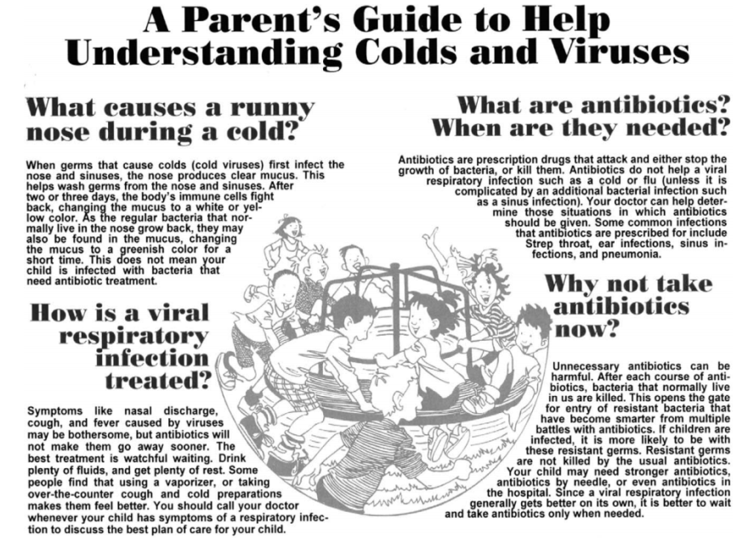

Figure 1: Poster placed in clinic reception areas.

Antibiotic prescription for children with respiratory illnesses during the study period were compared to those given during the three, one-month historical control periods (November 2000, December 2000 and November 2001), using the proportion of visits that resulted in an antibiotic prescription as the outcome measure. Out of the 720 participants (51.3% boys and 28.8% girls), mean age of 4.2 years, 45.2% were treated with an antibiotic. Multiple logistic regression showed no statistically significant difference in the proportion of visits resulting in an antibiotic prescription among the four study months (p=.79), suggesting that public education through a poster did not have a great impact on antibiotic use or a decrease in antibiotic prescriptions.
Adapted from: Ashe D, Patrick PA, Stempel MM, Shi Q, Brand DA. Educational posters to reduce antibiotic use. J Pediatr Health Care. 2006 May-June;20(3):192-197.
Q & As
- What was the behavioural objective/s in this campaign?
To decrease the frequency of antibiotic prescriptions for children with symptoms of respiratory illness.

Facilitator notes
The behavioural objective is not very clear but an overall aim is given. From the given case scenario one may deduce the behavioural objectives given above. Emphasise the need to link one’s objectives to one’s behavioural objectives. You can ask participants to discuss how they would phrase the behavioural objective themselves.

- Who was the target audience in this campaign?
Assumed that intended target audience were parents of children ages 6 months to 10 years.

- Is there any evidence, in your view, that the principles of the marketing mix were used in the planning of this campaign? Use the marketing mix score matrix* below to assess to which degree you think the social marketing principles were applied, described or addressed.
Product | Price  (benefits/barriers) | Place | Promotion
……………………………………………………………………………………………………………
* Each principle must be marked from a scale of 1-10, with 10 representing “a strong application, description or addressing of the principle” and 1 corresponding to “weak application, description or addressing of the principle”.

Facilitator notes
The above question is subjective and for that reason no suggestions are given. Nonetheless it is advised that you facilitate a short discussion around the principles of marketing. Please note that you should not over-emphasise this concept, rather place the emphasis later on when discussing pre-testing.
- Through what channels was the audience reached?
- Printed material
- Doctors’ offices

- How (design, method/s and outcome variable/s) was the success/failure of the intervention evaluated? Would you have evaluated it differently? If so, how?
- Historical controls
- “45.2% of patients were treated with an antibiotic” – as the aim of the intervention relates to prescribing, the target should have been the prescriber (i.e. the doctor). Moreover, the verb ‘treated’ in the above result is ambiguous; was the antibiotic prescribed, or was it dispensed? The researchers should also have described what antibiotics the children were actually given.

- Identify and/or develop key indicators, as well as data collection methods and tools that could be used to evaluate the given intervention.

Facilitator notes
The indicators in text on their own are good (% of patients treated with an antibiotic), but they do not relate to the entire strategy and neither do they accurately relate to the aim. Below are only a few suggestions for indicators but numerous indicators can be developed therefore discussion should be encouraged.

Remember
Not all outcome indicators can directly attribute certain outcomes as direct effects of the campaign. Some indicators may be used as proxy indicators but are not necessarily a direct result of the campaign. They may however give an overview of the situation post-campaign and aid to set targeted goals for future campaigns.

Key activities | Specific objectives | Key indicators |  | Data collection methods/tools
 |  | Process | Outcome
Poster dissemination | - To increase knowledge on prudent antibiotic use  - To increase awareness on prudent antibiotic use | - # (total) posters distributed per facility | - % patients prescribed an antibiotic specific to the diagnosis | - Pre- and post-campaign surveys (could be as questionnaires, focus group discussions, interviews, etc.)  - Medical records  - (On-going) surveillance

- In your view, what do you think were the strengths of this campaign?
- Good segmentation of target audience
- Clear and concise aim

Facilitator notes
The above answers are purely suggestions and many more answers might come up whilst discussing this question. Since no concrete answers will be found in the text, it may be rather subjective and is thus open for discussion.

- What do you think were the weaknesses of this campaign? What do you think could have been improved and how? Keeping the social marketing principles in mind, what would you have done differently in order to improve the campaign in your given scenario? Please discuss and write down your own suggestions.
- Although the target audience is clearly segmented it does not appear to be ideal to target parents only. It would have been more beneficial to target practitioners primarily as they have the upper hand when prescribing antibiotics.
- Even though the aim of the study intervention is clear and concise, it does not really add up to the target audience since the aim was to “evaluate whether an educational poster placed in the reception area of a clinic would lead to a decrease in the frequency of antibiotic prescriptions for children with symptoms of respiratory illness”.
- The role of the general practitioner in the development stage of the intervention is not clear.
- A multi-faceted approach may have been more optimal.
- Pre-testing not done.
- The messages were not bad or incorrect but they could have delivered them differently.

Facilitator notes
The above answers are purely suggestions and many more answers might come up whilst discussing this question. Since no concrete answers will be found in the text, it may be rather subjective and is thus open for discussion. Ask participants to discuss alternative strategies to reach the intended audience and alternative strategies for evaluation.

- Take a look at the poster used in the intervention in Figure 1. Give your own comments and opinion about the layout, structure and messages of the tool shown. Below are a few hints which may help you.
- What strikes you about it?
- How do you think it conveys the intended message?
- Do you think it has the potential to reach the intended audience? Explain.
- Would you change the poster in any way? If so, how?
- Do participants think the poster catches the eye?
- What do participants think about the picture utilised?
- Poster very crowded
- Small text
- Messages were not bad or incorrect but they could have delivered them differently.
Facilitator notes
The above answers are purely suggestions and many more answers might come up whilst discussing this question. Since no concrete answers will be found in the text, it may be rather subjective and is thus open for discussion. It is crucial to discuss pre-testing and adaptation!

Case study twelve
“Campaign progression over the years”
Content outline:
PART 1 PART 2
- Objectives - Evaluation
- Target audience/s - Indicators
- Marketing mix (4Ps) - Overall strengths and weaknesses
- SWOT analysis

PART 3 PART 4
- Evolution and sustainability - New channels
- Adaptation

Main discussion points for this case study

When discussing this case study, it is suggested to emphasise on:
- the planning phase of the campaign, especially with regards to pre-testing the poster, and
- selection and segmentation of target audiences.

Remember
Do not forget the important role of evaluation! Nevertheless, for this case study the emphasis should lie on the pre-testing of the poster.

Attention
Often the behavioural objective causes confusion. It is not simply an objective, goal or aim of the campaign, but is it an objective which identifies an action or behaviour that one expects to influence and/or change after the intervention.
Description
Part 1
The use of antibiotics in Italy is continuously on the rise. In fact, at the time of the first campaign, Italy is one of the European countries with the highest consumption of antibiotics, preceded only by France and Cyprus. In 2008, 44% of the population received at least one prescription for antibiotics, and this was mostly observed in paediatric and geriatric patients.
In light of this problem, following the ECDC initiative of European Antibiotic Awareness Day in 2008, the Italian Medicines Agency, the Italian Institute of the National Health Service, and the Ministry of Labour, Health and Social Politics, implemented an antibiotics awareness campaign with the message, “Antibiotici si, ma con cautela” (“Antibiotics yes, but with caution”), the underlying messages being: (i) prudent use of antibiotics depending on pathology of illness; antibiotics work against bacteria but not against viral flus, (ii) the necessary prescription of antibiotics by a doctor, (iii) the importance of completing antibiotic therapy, (iv) the incorrect use of antibiotics augments bacterial resistance, making available antibiotics less effective against bacterial infection, and (v) the responsible use of antibiotics takes care of everyone’s health, not just your own.
The main objective was to inform the general public of the importance of not using antibiotics to treat cold and flu, to take antibiotics only when absolutely necessary and with a medical prescription, and not to stop antibiotic therapy before the indicated time unless otherwise specified by a doctor. The campaign was launched during a press conference where antibiotic use in Italy and in Europe, as well as, the phenomenon of antibiotic resistance and resistance data, was conveyed to the media.
In order to reach the whole population, the campaign utilised several methods of communication, including adverts in: national and local newspapers, women’s magazines, 30 second television and radio spots both at national and local level, websites, and at cinemas. Messages were also spread via posters in train stations, communal spaces, publicity on buses, and on a special website designed for the campaign: www.antibioticoresponsabile.it. Finally, the public was also able to call the Italian Medicines Agency for free to ask questions on the correct use of antibiotics.
Adapted from:
- Agenzia Italiana del Framaco. “Antibiotici. Difendi la tua difesa. Usali con cautela”. [internet]. 2012 [cited 2012 Oct 5]. Available from: http://www.agenziafarmaco.gov.it/it/content/antibiotici-difendi-la-tua-difesa-usali-con-cautela-0
- Istituto Superiore di Sanità. Antibiotici, usali con cautela: campagna di communicazione per un uso corretto degli antibiotic. [internet]. 2012 [cited 2012 Oct 3]. Available from: http://www.iss.it/binary/pres/cont/antibio09.pdf

Pantosti A, Del Grosso M, editors. Giornata europea degli antibiotici: uso responsabile per il controllo dell’antibiotico-resistenza. Rome: Istituto Superiore di Sanità; 2009.

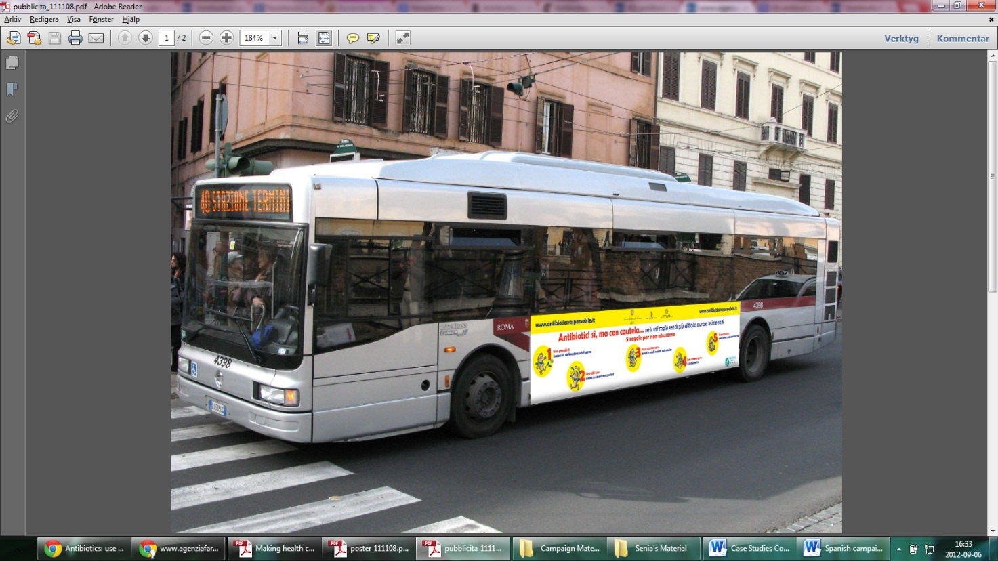
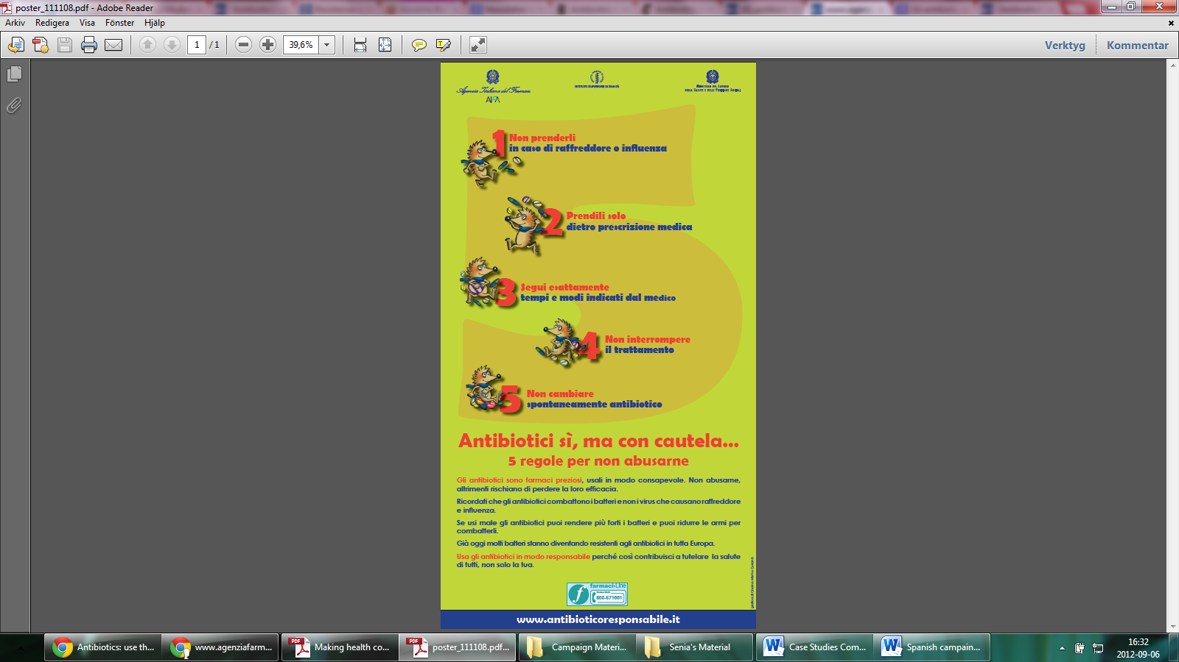
Figure 1: Some of the mass media used in the 2008 campaign.

Q & As
- What was the behavioural objective/s in this campaign?
For the general public:
- not to use antibiotics to treat colds and flus,
- to take antibiotics only when necessary and against prescription, and
- not to stop antibiotic therapy before indicated.
Facilitator notes
The behavioural objective is not very clear but overall objectives are given. From the given case scenario one may deduce the behavioural objectives given above. Emphasise the need to link one’s objectives to one’s behavioural objectives. You can ask participants to discuss how they would phrase the behavioural objectives themselves.
- Who was the target audience in this campaign?
The general public

- Is there any evidence, in your view, that the principles of the marketing mix were used in the planning of this campaign?
    - What was the product?
    - What was the price/cost of the campaign?
    - Where did the campaign take place?
    - What were the key activities implemented?
Product
- Internet-based information
- TV/radio/cinema ads
- Posters
- Ads in printed media (newspapers, magazines, etc.)
- Call line service
Price/cost
- No indication on the price/cost
Place
- Public spaces
- Online
- Printed mass media
- Local/regional level
Activities/promotion
- Press conference
- Ads in mass media
- Website
- Distribution of printed material

- Through what channels was the audience reached?
- Mass media
- Internet
- Press conference
- Call line

Part 2
An evaluation requested by the Italian Medicines Agency showed that, albeit the limited time (28 days), budget constraints and no appeal to re-convey messages on television spots, the communication methods gave superior results that were not shown by previous institutional campaigns of longer duration and more comprehensive communication methods. Post-campaign, it was found that, the overall antibiotic consumption in January 2009 as compared to January 2008 decreased by 8% and there was a decrease in expenditure by 16.4% corresponding to approximately 18.5 million euros. Moreover, 66.5% of people interviewed found the messages conveyed useful to induce them to change their behaviour, 72.2% also claimed that the campaign made them reflect, and 88% remembered the campaign’s messages clearly.
Adapted from:
- Agenzia Italiana del Framaco. “Antibiotici. Difendi la tua difesa. Usali con cautela”. [internet]. 2012 [cited 2012 Oct 5]. Available from: http://www.agenziafarmaco.gov.it/it/content/antibiotici-difendi-la-tua-difesa-usali-con-cautela-0
- Istituto Superiore di Sanità. Antibiotici, usali con cautela: campagna di communicazione per un uso corretto degli antibiotic. [internet]. 2012 [cited 2012 Oct 3]. Available from: http://www.iss.it/binary/pres/cont/antibio09.pdf

Pantosti A, Del Grosso M, editors. Giornata europea degli antibiotici: uso responsabile per il controllo dell’antibiotico-resistenza. Rome: Istituto Superiore di Sanità; 2009.

Facilitator notes
More in-depth methodology is not mentioned in the text. Even so, do discuss the use of percentages and figures with the participants!

Q & As
- How (design, method/s, outcome variable/s) was the success/failure of the intervention measured?
- Post-intervention uncontrolled study (design)
- Survey (method)
- Overall antibiotic consumption decreased (outcome variable)
- Antibiotic expenditure decreased (outcome variable)
- The message was perceived by the public as useful to induce behaviour change and to reflect (outcome variable)
- High recall of the campaign (outcome variable)
Facilitator notes
Regarding the recall of the campaign, please be aware that it was not stated how long after the campaign the survey was conducted, therefore it is hard to tell whether the high recall is of any significance!

- Identify and/or develop key indicators as well as data collection methods and tools that could be used to evaluate the given campaign.
Facilitator notes
Below are only a few suggestions for indicators but numerous indicators can be developed therefore discussion should be encouraged.

Remember
Not all outcome indicators can directly attribute certain outcomes as direct effects of the campaign. Some indicators may be used as proxy indicators but are not necessarily a direct result of the campaign. They may however give an overview of the situation post-campaign and aid to set targeted goals for future campaigns.

Key activities | Specific objectives | Key indicators |  | Data collection methods/tools
 |  | Process | Outcome
Website | - To inform the public about antibiotic use and antibiotic resistance  - To decrease antibiotic use for viral infections  - To decrease self-mediation  - To decrease the early/premature cessation of antibiotic therapy | - # visitors by reason of visit/interest group  - # website shares | - % people with correct knowledge on antibiotics and their use  - % population who self-medicate  - % population who cease antibiotic therapy prematurely | - Log book  - Pre- and post-campaign surveys (could be as questionnaires, focus group discussions, interviews, etc.)  - On-going surveillance of website  - Surveillance
Ads in mass media (TV/radio/cinema) | - To inform the public about antibiotic use and antibiotic resistance  - To decrease antibiotic use for viral infections  - To decrease self-mediation  - To decrease the early/premature cessation of antibiotic therapy | - # (total) ads aired  - # (total) air time  - # (total) TV/radio/ stations/cinemas involved | - % people with correct knowledge on antibiotics and their use  - % population who self-medicate  - % population who cease antibiotic therapy prematurely | - Log books and records from TV/radio station/cinemas on number of viewers/listeners, number of callers, etc.  - Pre- and post-campaign surveys (could be as questionnaires, focus group discussions, interviews, etc.)  - (On-going) surveillance
Printed materials | - To inform the public about antibiotic use and antibiotic resistance  - To decrease antibiotic use for viral infections  - To decrease self-mediation  - To decrease the early/premature cessation of antibiotic therapy | - # (total) printed materials printed  - # (total) printed materials disseminated | - % people with correct knowledge on antibiotics and their use  - % population who self-medicate  - % population who cease antibiotic therapy prematurely | - Medical records  - Doctor’s reports  - Pharmacy records  - Records of printing agency involved in the campaign  - Pre- and post-campaign surveys (could be as questionnaires, focus group discussions, interviews, etc.)  - (On-going) surveillance
Key activities | Specific objectives | Key indicators |  | Data collection methods/tools
 |  | Process | Outcome
Call line | - To inform the public about antibiotic use and antibiotic resistance  - To clarify queries and misconceptions | - # (total) calls by reason of call | - % people with correct knowledge on antibiotics and their use  - % population who self-medicate  - % population who cease antibiotic therapy prematurely | - Call logs at call centre  - Pre- and post-campaign surveys (could be as questionnaires, focus group discussions, interviews, etc.)  - Surveillance
Press conference | - To inform the public about antibiotic use and antibiotic resistance | - # attendees at the conference | - % people with correct knowledge on antibiotics and their use  - % population who self-medicate  - % population who cease antibiotic therapy prematurely | - Pre- and post-campaign surveys (could be as questionnaires, focus group discussions, interviews, etc.)

- In your view, what were the strengths of the campaign?
- Comprehensive activities disseminated to a wide range of locations and through numerous channels
- Clear and comprehensive messages
- Clear objectives (albeit not exactly behavioural objectives) and target audience identification
- Evaluation was conducted

Facilitator notes
The above answers are purely suggestions and many more answers might come up whilst discussing this question. Since no concrete answers will be found in the text, it may be rather subjective and is thus open for discussion.
- What do you think were the weaknesses of this campaign? What do you think could have been improved and how? Keeping the social marketing principles in mind, what would you have done differently in order to improve the campaign in your given scenario? Please discuss and write down your own suggestions.
- No segmentation of the target audience (very broad target group with may make it harder to reach using appropriate methods)
- No pre-testing/pilot study of materials
- No pre-campaign survey
- No evidence of formative evaluation
Facilitator notes
The above answers are purely suggestions and many more answers might come up whilst discussing this question. Since no concrete answers will be found in the text, it may be rather subjective and is thus open for discussion.
- What were the desired/intended outcomes of the campaign and were they reached? Were there any unintended outcomes?
- The intended outcomes were: (i) increased awareness and knowledge on the importance of not taking antibiotics to sure viral infections such as the cold and flu, (ii) increased awareness about taking antibiotics only when absolutely necessary and against medical prescription, (iii) to decrease self-medication among the general public, and (iv) to decreased premature antibiotic therapy cessation among the general public.
- Although there isn’t a very clear indication as to whether these goals were in fact reached, it was shown that (i) the communication methods gave superior results that those of previous institutional campaigns of longer duration and more comprehensive communication methods, (ii) overall antibiotic consumption in January 2009 as compared to January 2008 decreased by 8%, (iii) there was a decrease in expenditure by 16.4% corresponding to approximately 18.5 million euros, (iv) 66.5% of people interviewed found the messages conveyed useful to induce them to change their behaviour, (v) 72.2% of people claimed that the campaign made them reflect, and (vi) 88% of people remembered the campaign’s messages clearly.
- No unintended outcomes are apparent in the text.
Facilitator notes
Be aware that how the authors reached such conclusions regarding the end-result of the campaign is not clear therefore one must look at their conclusions on the evaluation with a critical eye. This could be a useful point of discussion during the course.
- Finally, carry out a SWOT analysis of the campaign. Use the table below for your answers.

Facilitator notes
This question is very much open for discussion, therefore no suggestions are given. However, here are a few points you could highlight when discussing this question:
- Did the strategy team use their strengths to take advantage of their opportunities? How?
- Did the strategy team overcome their weaknesses which would have prevented them from taking advantage of their opportunities? How?
- Did the strategy team use their strengths to reduce the likelihood and impact of the threats they faced? How?
- Did the strategy team overcome their weaknesses that could have made their threats a reality? How? Did any of their threats become a reality?

 | Strengths |  | Weaknesses
Opportunities
Threats

Part 3
In 2009, the campaign was re-launched, this time the overall message being, “Antibiotici, usali con cautela” (“Antibiotics, use with caution”), with the following underlying messages: (i) do not use antibiotics for cold and flu, (ii) take antibiotics only with a prescription, and (iii) take correct dosage and duration of therapy. The objective was to promote the prudent use of antibiotics and to reduce the development of antibiotic resistance, targeting the general population. This was again done through a press conference, 30 second spots on television, cinema and radio, publicity on buses, bill boards, magazines, posters at check-in lounges at airports, train stations and communal spaces, freephone for questions from the public, and websites.


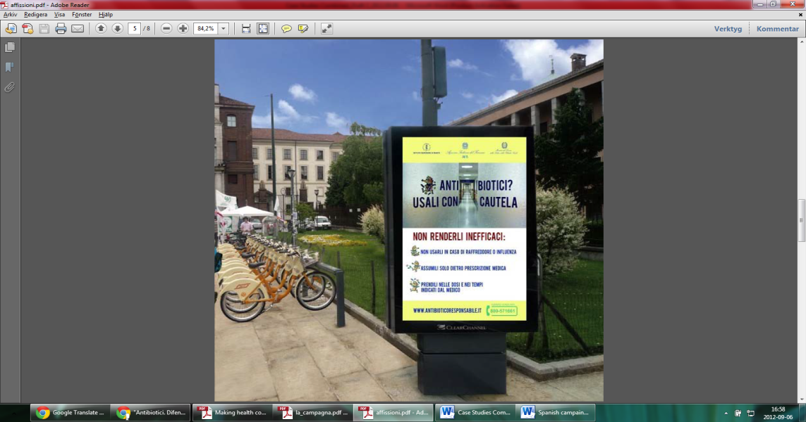

Figure 2: Posters in communal and public areas during the 2009 campaign.

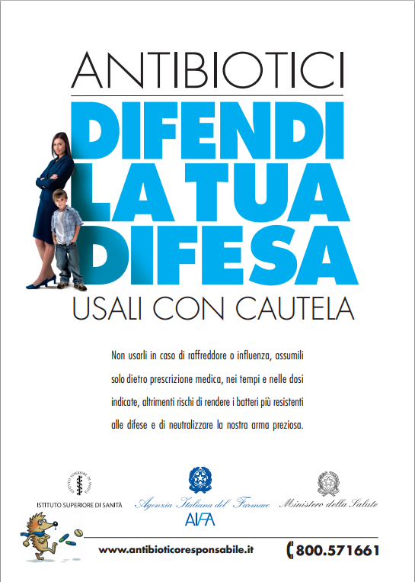
In 2010, the campaign was launched again, with the overall message being, “Antibiotici. Difendi la tua difesa. Usali con cautela.” (“Antibiotics. Defend your defence. Use with caution”). The target population remained the general public and the underlying messages were the same as well as the means of communication, however this time the campaign was centred on the prudent use of antibiotics in hospitals and also targeted healthcare providers. This was initiated as the importance of antibiotic resistance within hospitals was realised as a growing problem which needed to be tackled. The objective of this year’s campaign was to: (i) promote the prudent use of antibiotics, (ii) reduce the development of antibiotic resistance, (iii) limit the excessive use of resources and direct them towards innovation, and (iv) reduce adverse effects.

Figure 3: The poster used in the 2010 campaign.
Adapted from:
- Agenzia Italiana del Framaco. “Antibiotici. Difendi la tua difesa. Usali con cautela”. [internet]. 2012 [cited 2012 Oct 5]. Available from: http://www.agenziafarmaco.gov.it/it/content/antibiotici-difendi-la-tua-difesa-usali-con-cautela-0
- Istituto Superiore di Sanità. Antibiotici, usali con cautela: campagna di communicazione per un uso corretto degli antibiotic. [internet]. 2012 [cited 2012 Oct 3]. Available from: http://www.iss.it/binary/pres/cont/antibio09.pdf

Pantosti A, Del Grosso M, editors. Giornata europea degli antibiotici: uso responsabile per il controllo dell’antibiotico-resistenza. Rome: Istituto Superiore di Sanità; 2009.

Q & As
- What were the changes made to the campaign as compared to previous years?
  - How did the behavioural objective evolve over the years?
  - How did the target audience/s evolve over the years?
  - How did the messages evolve during these two years?
  - Did they make use of new channels? If so, which?
- The behavioural objective is not clearly defined in the text (not in Part 1, nor in Part 2); however, the objective did change slightly over the years. Whilst the objectives remained relatively similar from 2008 to 2009, in 2010 they changed slightly (as did the target audience) whilst maintaining the earlier objectives too. In the 2010 campaign, they also wanted to: (i) promote prudent use of antibiotics, (ii) decrease the development of antibiotic resistance, (iii) limit the excessive use of resources and direct them towards innovation, and (iv) decrease adverse effects.
- The target audience remained the general public in 2008, 2009 and 2010 but in 2010 the added a new target audience, healthcare prescribers, particularly those within hospitals.
- The messages appear to have gotten more specific to their target audience and objectives from 2008 to 2010.
- From the text it does not appear that any changes were made with regards to the channels.
Facilitator notes
- Hint: it is good to refer back to Part 1 for this question.
- Again, the behavioural objective is not very clear in Part 3 of the case scenario but overall objectives are given. Re-emphasise the need to link one’s objectives to one’s behavioural objectives.
- Discuss the use of channels with participants and the importance of making adaptations as necessary, particularly when the goals, objectives, target audiences, etc. are adapted in future campaigns.
- How was the sustainability of the campaign maintained?
- One cannot entirely tell how the campaign was sustained from the text; this question should rather be used as a point of discussion for sustainability of campaigns.
- Nonetheless, one can assume that the sustainability of the campaign was maintained through, for example, dedication, continued interest, constant support from external sources, persistency, among others.
Facilitator notes
Discuss the possible ways by which campaigns may be sustained.
- Referring back to Part 1, compare the layout, structure and messages of the mass media tools shown in Figures 1, 2 and 3, and give your own comments and opinion about them. Below are a few hints which may help you.
  - What strikes you about them?
  - Do you think they convey the intended message well? If so, how?
  - Do you think they have the potential to reach the intended audience? If so, how?
  - Would you change anything?
- Good use of colour.
- In general, messages are short, concise and to-the-point which makes them catchy and more likely to be read.
- Nonetheless the posters are not very striking in 2008 and 2009, and appear tedious to read. In 2010 however, the poster is changed, making it look more striking and making it more likely to be read. Also, the poster is more relatable in 2010 than in the previous two years.
- On the whole, good text size.
- Some posters are a little bit too busy, inhibiting them from being read by passers-by perhaps.

Facilitator notes
For this question, emphasise on the discussion behind the steps of altering key messages in the media and pre-testing. With regards to the posters used and how they were changed, no answer is probably absolutely wrong or right, and it could get rather subjective. Above are just suggestions; please be open to other thoughts and ideas from the participants.
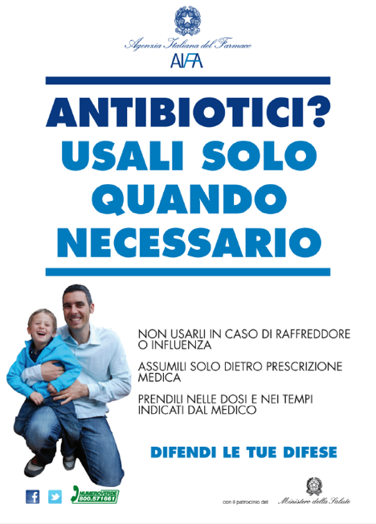
Part 4
The upcoming 2012 campaign the message, “Antibiotici? Usali solo quando necessaro” (“Antibiotics? Use only when necessary”) was employed, and they concentrated on the use of websites and social media such as Facebook and Twitter to deliver their messages, amongst other means, in order to target the overall population on the importance of: (i) consuming antibiotics only when necessary and when prescribed appropriately by a doctor, (ii) not interrupting antibiotic therapy earlier than prescribed unless specifically indicated by a doctor or following doctor’s advice, and (iii) not consuming antibiotics to cure viral infections.

Figure 4: The poster used in the 2012 campaign.
Adapted from:
- Agenzia Italiana del Framaco. “Antibiotici. Difendi la tua difesa. Usali con cautela”. [internet]. 2012 [cited 2012 Oct 5]. Available from: http://www.agenziafarmaco.gov.it/it/content/antibiotici-difendi-la-tua-difesa-usali-con-cautela-0
- Istituto Superiore di Sanità. Antibiotici, usali con cautela: campagna di communicazione per un uso corretto degli antibiotic. [internet]. 2012 [cited 2012 Oct 3]. Available from: http://www.iss.it/binary/pres/cont/antibio09.pdf

Pantosti A, Del Grosso M, editors. Giornata europea degli antibiotici: uso responsabile per il controllo dell’antibiotico-resistenza. Rome: Istituto Superiore di Sanità; 2009.

Q & As
- What were the new channels introduced in the 2012 campaign?
- Social media – Facebook and Twitter.
- Other more conventional media appear to be given less importance in the 2012 campaign.

- What, in your opinion, are the advantages and disadvantages of introducing the new channels to the campaign?
- The world is moving towards social media as a common means of communication.
- Social media is used extensively, especially among youths and young adults, therefore social media may be very beneficial when targeting such groups.

Facilitator notes
Facilitate a discussion around the use of social media. Important to mention that ECDC has a free tool on how to use social media which is available to all EU member states. Above are some suggested points of discussion.

Case study thirteen
“A multi-targeted intervention”
Content outline:
PART 1 PART 2
- Objectives - Campaign messages

PART 3
- Marketing mix (4Ps)
- Evaluation
- Indicators
- Overall strengths and weaknesses

Main discussion points for this case study

When discussing this case study, it is suggested to emphasise on:
- the implementation, and
- evaluation of the campaign.

Attention
Often the behavioural objective causes confusion. It is not simply an objective, goal or aim of the campaign, but is it an objective which identifies an action or behaviour that one expects to influence and/or change after the intervention.

Description
Part 1
In 2006-2007, Spain conducted a national antibiotic campaign with the overall message being, “Uso responsable de antibióticos. Usándolos bien hoy, mañana nos protegerán” (“Responsible use of antibiotics. Using them correctly today, they will protect us tomorrow”). The main objectives of this campaign were to: (i) achieve an attitude change in the population in relation to the indiscriminate use of antibiotics in situations where they are not required, (ii) inform and sensitise society about the usefulness of antibiotics when prescribed by a doctor to treat bacterial infections. Sometimes antibiotics might represent a risk; their inadequate use accelerates the appearance of resistant bacteria thus making antibiotics no longer efficacious to treat infections caused by these types of bacteria, and (iii) avoid risks associated with the abuse of unnecessary antibiotic consumption.
Adapted from: Goberno de España. Sin tu ayuda, los antibióticos pueden perder su eficacia. 2012 [cited 2012 Oct 8]. Available from: www.antibioticos.msc.es

Q & As
- Given the above scenario, how would you formulate your campaign objective?
- To promote prudent use of antibiotics in the target population
- To inform the target population not to take antibiotics unnecessarily and when they are given a doctor’s prescription for antibiotics, to follow it properly.
Facilitator notes
Emphasise the difference between the behavioural objective and a campaign’s overall objective. Emphasise the need to link one’s objectives to one’s behavioural objectives. You can ask participants to discuss how they would phrase the behavioural objectives themselves.

Part 2
The campaign was directed towards the general population, parents of children and healthcare professionals (doctors and pharmacists). It ran for two months and was allocated a budget of 6.4 million euros.
Several messages were constructed, according to the audience. Below are a few of them.
- General population:
  - Without your help antibiotics can stop working.
  - Antibiotic treatment should be indicated by your doctor.
  - If we continue abusing antibiotics, we might have serious difficulties to combat severe infections, since we will not have any antibiotics left to treat bacteria
  - In cases where the doctor gives you antibiotic treatment, it is essential to abide by and obey given instructions regarding the duration of treatment and the required dose.
- Parents of young children:
  - Colds and flus are caused by viruses. They can present with fever but will not improve nor avoid their spread with antibiotics
  - Providing unnecessary antibiotics to your child may be harmful to his/her health and it may be more difficult for your child to be cured if s/he has an infection with resistant bacteria
- Healthcare professionals:
  - Without your help, antibiotics might lose their efficacy.
Adapted from: Goberno de España. Sin tu ayuda, los antibióticos pueden perder su eficacia. 2012 [cited 2012 Oct 8]. Available from: www.antibioticos.msc.es

Q & As
- How relevant were the campaign messages for the target populations they wished to target? Would you have altered/changed their messages in any way? If yes, why and how?
Messages are very relevant however there may be too many which may be confusing to certain populations. Sometimes a more simple and concise message gets across better to certain target populations

Part 3
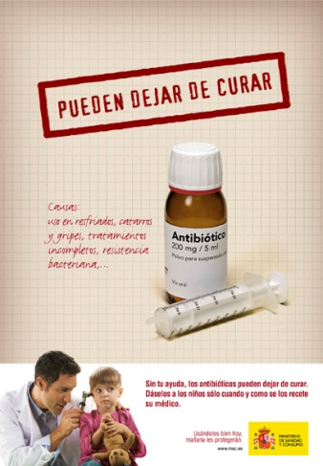
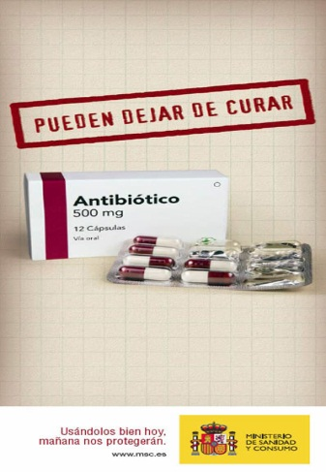
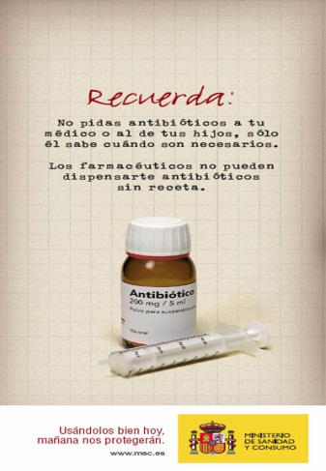
The outreach for the general population and parents was done through 3,000 television commercials (10 and 25 seconds), 600 radio spots, printed material, the internet, leaflets and posters. Healthcare professionals were reached by preparing and distributing a scientific report, of which 100,000 copies were sent to general practitioners and 21,000 copies were sent to pharmacists and other professional associations. A website was also constructed for this purpose.

Figure 1: Some of the materials used in the campaign.

Adapted from: Goberno de España. Sin tu ayuda, los antibióticos pueden perder su eficacia. 2012 [cited 2012 Oct 8]. Available from: www.antibioticos.msc.es

Q & As
- Give suggestions on how the success/failure of the intervention can be evaluated.

Facilitator notes
This gives you the opportunity to brainstorm with participants on what they have learnt in class. Bring up different methods for evaluation of campaigns.
- Identify and/or develop key indicators as well as data collection methods and tools that could be used to evaluate the given campaign.
Facilitator notes
Below are only a few suggestions for indicators but numerous indicators can be developed therefore discussion should be encouraged.

Remember
Not all outcome indicators can directly attribute certain outcomes as direct effects of the campaign. Some indicators may be used as proxy indicators but are not necessarily a direct result of the campaign. They may however give an overview of the situation post-campaign and aid to set targeted goals for future campaigns.

Key activities | Specific objectives | Key indicators |  | Data collection methods/tools
 |  | Process | Outcome
Printed materials | None provided. Base this on the answer provided in question 1 of part 1. | - # (total) printed materials printed  - # (total) printed materials disseminated | - % people with correct knowledge on antibiotics and their use  - % population who self-medicate  - % population who cease antibiotic therapy prematurely | - Medical records  - Doctor’s reports  - Pharmacy records  - Records of printing agency involved in the campaign  - Pre- and post-campaign surveys (could be as questionnaires, focus group discussions, interviews, etc.)  - (On-going) surveillance
Ads in mass media (TV/radio) | None provided. Base this on the answer provided in question 1 of part 1. | - # (total) ads aired  - # (total) air time  - # (total) TV/radio/ stations involved | - % people with correct knowledge on antibiotics and their use  - % population who self-medicate  - % population who cease antibiotic therapy prematurely | - Log books and records from TV/radio station on number of viewers/listeners, number of callers, etc.  - Pre- and post-campaign surveys (could be as questionnaires, focus group discussions, interviews, etc.)  - (On-going) surveillance
Website | None provided. Base this on the answer provided in question 1 of part 1. | - # visitors by reason of visit/interest group  - # website shares | - % people with correct knowledge on antibiotics and their use  - % population who self-medicate  - % population who cease antibiotic therapy prematurely | - Log book  - Pre- and post-campaign surveys (could be as questionnaires, focus group discussions, interviews, etc.)  - On-going surveillance of website -  - Surveillance

- In your view, what were the strengths of this campaign?
- Large budget
- Many target populations reached
- Extensive campaign messages
Facilitator notes
The above answers are purely suggestions and many more answers might come up whilst discussing this question. Since no concrete answers will be found in the text, it may be rather subjective and is thus open for discussion.
- What do you think were the weaknesses of this campaign? What do you think could have been improved and how? Keeping the social marketing principles in mind, what would you have done differently in order to improve the campaign in your given scenario? Please discuss and write down your own suggestions.
- Limited innovative ideas in terms of materials used considering the size of the budget
- The number of campaign messages may get confusing and overwhelming; sometimes better to have shorter and more concise campaign messages in order to get the message across well
Facilitator notes
The above answers are purely suggestions and many more answers might come up whilst discussing this question. Since no concrete answers will be found in the text, it may be rather subjective and is thus open for discussion. Ask participants to discuss alternative strategies to reach the intended audience and alternative strategies for evaluation.

Case study fourteen
“Comprehensive mass media campaign”
Content outline:
PART 1
- Objectives
- Target audience/s
- Marketing mix (4Ps)
- Evaluation
- Indicators
- Overall strengths and weaknesses

Main discussion points for this case study

When discussing this case study, it is suggested to emphasise on:
- the implementation, and
- evaluation of the campaign.

Attention
Often the behavioural objective causes confusion. It is not simply an objective, goal or aim of the campaign, but is it an objective which identifies an action or behaviour that one expects to influence and/or change after the intervention.

Description
Antibiotic over-prescription is a problem in the Israeli healthcare system, particularly those antibiotics used to treat viral upper respiratory infections (URI) and influenza. It is estimated that up to 10% of the Israeli population suffers from influenza annually, creating a considerable burden on healthcare services. During the winter of 2005-2006 Maccabi Healthcare Services (MHS), Israel’s second largest health maintenance organisation, initiated a nationwide media campaign with the aim of increasing awareness on the misuse of antibiotics among the general public. The main emphasis of the campaign was placed on the inappropriate use of antibiotics in the treatment of influenza and URI.
In January 2006, MHS initiated a comprehensive mass media campaign consisting of radio and television advertisements, together with a concurrent four-part television series, targeted towards parents of children. The ads delivered a general message that antibiotics are not the appropriate treatment for colds and other viral URI, whilst the television series presented the serious repercussions of antibiotic misuse. The media campaign ran for a two-week period in January in order to target the annual peak of antibiotic use in January and February.
A population-based study was later conducted to evaluate the impact of the campaign on parental knowledge and awareness of appropriate antibiotic use for the treatment of acute viral conditions, as well as on patterns of actual antibiotic use. The effectiveness of the campaign was evaluated in two ways. Firstly, to determine whether the campaign affected actual antibiotic use, an analysis of medical and administrative information drawn from the MHS central computer database was conducted. The impact of the campaign on antibiotic use was assessed by comparing monthly antibiotic purchasing rates during the pre-intervention (November to December, 2005) and post-intervention (January to February, 2006) phases of the study with the corresponding periods of the baseline winter (November 2004 until February 2005). Secondly, a random sample of parents whose children were diagnosed with URI were surveyed by phone to assess attitude changes towards antibiotic use. The survey was intended to assess exposure to the campaign and to be able to compare attitudes towards antibiotic use among respondents exposed and unexposed to the campaign. The telephone survey, which consisted of 860 randomly selected parents who were also MHS members, started several days after the campaign officially came to an end and was conducted over two weeks.
A reduction in antibiotic purchases for URI, pharyngitis and otitis media during the post-intervention phase as compared to the parallel period in the baseline winter was noted. With regards to exposure to the campaign, more than half of the survey respondents (54%) stated that they were exposed to the media campaign. Moreover, exposure to the media campaign was positively associated with appropriate attitudes toward antibiotic use; parents of children with URI exposed to the media campaign were more likely to express agreement with standards of appropriate antibiotic use than those parents not exposed.
Adapted from: Hemo B, Shamir-Shtein NH, Silverman BG, Tsamir J, Heymann AD, Tsehori S, Friedman NL. Can a nationwide media campaign affect antibiotic use? Am J Manag Care. 2009 Aug;15(8):529-534.
Q & As
- What was the behavioural objective/s in this campaign?
To increase awareness on the misuse of antibiotics in the treatment of influenza and URI
Facilitator notes
Although an objective is given, it is not the behavioural objective. Emphasise the need to link one’s objectives to one’s behavioural objectives. You can ask participants to discuss how they would phrase the behavioural objectives themselves.
- Who was the target audience in this campaign?
The general public

- Is there any evidence, in your view, that the principles of the marketing mix were used in the planning of this campaign? Use the marketing mix score matrix* below to assess to which degree you think the social marketing principles were applied, described or addressed.
Product | Price  (benefits/barriers) | Place | Promotion
……………………………………………………………………………………………………………
* Each principle must be marked from a scale of 1-10, with 10 representing “a strong application, description or addressing of the principle” and 1 corresponding to “weak application, description or addressing of the principle”.

Facilitator notes
The above question is subjective and for that reason no suggestions are given. Nonetheless it is advised that you facilitate a short discussion around the principles of marketing. Please note that you should not over-emphasise this concept, rather place the emphasis later on when discussing evaluation.
- Through what channels was the audience reached?
- Radio and TV ads
- A concurrent four-part television series

- How (design, method/s and outcome variable/s) was the success/failure of the intervention measured? Would you have evaluated it differently? If so, how?
- Population-based study
- Analysis of medical and administrative information drawn from the MHS central computer database
- Comparison of monthly antibiotic purchasing rates during the pre-intervention (November to December, 2005) and post-intervention (January to February, 2006) phases of the study with the corresponding periods of the baseline winter (November 2004 until February 2005)
- Telephone surveys with parents whose children were diagnosed with URI
- Antibiotic purchases for URI, pharyngitis and otitis media during the post-intervention phase compared to the parallel period in the baseline winter
- % of target population exposed to the campaign
- Association between exposure and appropriate antibiotic use
- Identify and/or develop key indicators as well as data collection methods and tools that could be used to evaluate the given campaign.
Facilitator notes
Below are only a few suggestions for indicators but numerous indicators can be developed therefore discussion should be encouraged.

Remember
Not all outcome indicators can directly attribute certain outcomes as direct effects of the campaign. Some indicators may be used as proxy indicators but are not necessarily a direct result of the campaign. They may however give an overview of the situation post-campaign and aid to set targeted goals for future campaigns.

Key activities | Specific objectives | Key indicators |  | Data collection methods/tools
 |  | Process | Outcome
Ads in mass media (TV/radio) | To increase awareness on the misuse of antibiotics in the treatment of influenza and URI | - # (total) ads aired  - # (total) air time  - # (total) TV/radio/ stations involved | - % people with correct knowledge on antibiotics and their use  - % population who self-medicate  - % population who cease antibiotic therapy prematurely | - Log books and records from TV/radio station on number of viewers/listeners, number of callers, etc.  - Pre- and post-campaign surveys (could be as questionnaires, focus group discussions, interviews, etc.)  - (On-going) surveillance
Television series | To increase awareness on the misuse of antibiotics in the treatment of influenza and URI | - # viewers | - % people with correct knowledge on antibiotics and their use  - % population who self-medicate  - % population who cease antibiotic therapy prematurely | - Log book  - Pre- and post-campaign surveys (could be as questionnaires, focus group discussions, interviews, etc.)  - On-going surveillance of website  - Surveillance

- In your view, what were the strengths of this campaign?
- Innovative – use of TV series to get messages across to the target population
- Rather thorough evaluation of the campaign
Facilitator notes
The above answers are purely suggestions and many more answers might come up whilst discussing this question. Since no concrete answers will be found in the text, it may be rather subjective and is thus open for discussion.
- What do you think were the weaknesses of this campaign? What do you think could have been improved and how? Keeping the social marketing principles in mind, what would you have done differently in order to improve the campaign in your given scenario? Please discuss and write down your own suggestions.
- Behavioural objective not well defined
- No indication on budget
Facilitator notes
The above answers are purely suggestions and many more answers might come up whilst discussing this question. Since no concrete answers will be found in the text, it may be rather subjective and is thus open for discussion. Ask participants to discuss alternative strategies to reach the intended audience and alternative strategies for evaluation.
- What were the desired/intended outcomes of the campaign and were they reached? Were there any unintended outcomes?
- The overall desired outcome was to increase awareness on the misuse of antibiotics in the treatment of influenza and URI
- A reduction in antibiotic purchases for URI, pharyngitis and otitis media during the post-intervention phase as compared to the parallel period in the baseline winter was noted
- More than half of the survey respondents (54%) stated that they were exposed to the media campaign
- Exposure to the media campaign was positively associated with appropriate attitudes toward antibiotic use
- There is no indication of any unintended outcomes

- Discuss the methods used for evaluation of the campaign and their importance in interventions such as this.

Facilitator notes
This gives you the opportunity to brainstorm with participants on what they have learnt in class. Bring up different methods for evaluation of campaigns.

Case study fifteen
“A multi-faceted strategy”
Content outline:
PART 1 PART 2
- Objectives - Evaluation
- Target audience/s - Indicators
- Marketing mix (4Ps) - Overall strengths and weaknesses

Main suggested discussion points for this case study

When discussing this case study, it is suggested to emphasise on:
- the planning phase of the campaign, especially with regards to the campaign’s objectives,
- the marketing strategy of the campaign,
- selection and segmentation of target audiences, and
- indicators for evaluation.

Remember
Do not forget to touch upon the concepts of exchange and competition when discussing the planning and marketing strategy of the campaign.

Attention
Often the behavioural objective causes confusion. It is not simply an objective, goal or aim of the campaign, but it is an objective which identifies an action or behaviour that one expects to influence and/or change after the intervention.

Description
Part 1
In the early 2000s, antibiotic consumption in France was shown to be among the highest in Europe, with one of the highest antibiotic users worldwide. Thus, the French government launched a long-term, nation-wide campaign to reduce antibiotic overuse and to control the spread of bacterial resistance in the community. In 2001, the national programme entitled, “Keep antibiotics working” was launched, targeting the general public and healthcare professionals (HCPs) with the aim of promoting antibiotic surveillance and more specific antibiotic use.
Since 2002, the French National Health Insurance (NHI) has launched nationwide campaigns in the community, focusing mainly on the unnecessary use of antibiotics in viral respiratory infections (VRI) in young children. The aim from its initiation was to decrease the total use of antibiotics in the community by 25%. The central theme of the campaign was, “Les antibiotiques c’est pas automatique” (“Antibiotics are not automatic”). The campaign was launched each winter (October-March), and aimed at altering behaviour for antibiotic treatment of VRI.
The public campaign mainly targeted children and their parents, emphasising that: (i) antibiotic efficacy is endangered by bacterial resistance and it is essential to preserve their efficacy; (ii) higher consumption rates are linked to higher resistance levels; (iii) antibiotics do not cure VRI; (iv) majority of upper respiratory infection are of viral origin; (v) antibiotics do not lower fever, lessen pain, or shorten duration of illness; and (vi) it is vital to abide by treatment duration and dosage prescribed. The general public campaign appeared in national media outlets, including, prime-time television and radio, newspapers and websites, and in doctor’s offices, including booklets, handouts and posters in doctor’s waiting rooms. A travelling educational exhibition about microbes was also created.

Figure 1: Example of a poster used in the campaign.

An educational campaign was also initiated for HCPs, with face-to-face education and guideline dissemination. In addition to providing information on appropriate antibiotic use, the campaign promoted the use of rapid tests to diagnose group A streptococci (RTAS) tonsillitis. Physicians were invited to county-level training on how to use RTAS and optimise antibiotic use. They were also visited by NHI doctors for face-to-face peer education sessions. Free tests were provided to doctors who attended training. Antibiotic guidelines were sent to targeted practitioners and distributed during trainings and visits.
Of ~2,400,000 children aged <3 years, one quarter attend day care. Day care workers were therefore trained to not systematically require antibiotic treatment as a condition for day care attendance of children with VRI and to relay the message of optimal antibiotic use to parents.
Adapted from:
- Huttner B, Harbarth S. “Antibiotics are not automatic anymore”: the French national campaign to cut antibiotic overuse. PLoS Med. 2009 Jun 2;6(6):e1000080.
- Sabuncu E, David J, Bernède-Bauduin C, Pépin S, Leroy M, Boëlle PY, Watier L, Guillemot D. Significant reduction of antibiotic use in the community after a nationwide campaign in France, 2002-2007. PLoS Med. 2009 Jun 2;6(6):e1000084.

Q & As
- What was the behavioural objective/s in this campaign?
- To altering the behaviour for antibiotic treatment of viral respiratory treat infections (this is very closely related to a behavioural objective)
- To decrease the total use of antibiotics in the community
- To promote antibiotic surveillance
- To promote more specific antibiotic use
Facilitator notes
The behavioural objective is not very clear but overall objectives are mentioned. Emphasise the need to link one’s objectives to one’s behavioural objectives. You can ask participants to discuss how they would have phrased the behavioural objective themselves.
- Who was the target audience in this campaign?
- General public and more specifically children and parents
- Healthcare professionals doctors
- Day care workers

- Is there any evidence, in your view, that the principles of the marketing mix were used in the planning of this campaign?
    - What was the product?
    - What was the price/cost of the campaign?
    - Where did the campaign take place?
    - What were the key activities implemented?

Product
- Internet-based information
- TV/radio ads
- Printer materials (booklets, handouts, posters)
- Ads in printed media (newspapers, magazines, etc.)
- Guidelines
- Rapid diagnostic tests
Price/cost
- No indication on the price/cost
Place
- Public spaces
- Online
- Printed mass media
- Doctor’s clinics
- Day care centres
Activities/promotion
- Educational exhibition
- Ads in mass media
- Website
- Distribution of printed material
- Face-to-face peer education for doctors
- Guideline dissemination
- Training for doctors

- Through what channels was the audience reached?
- Mass media
- Internet
- Press conference
- Call line
- Exhibition

Part 2
An analysis of the campaign data estimated that 8 million RTAS were distributed to doctors and paediatricians between 2002-2007. Furthermore, 45,000 general practitioners had at least one peer visit with an NHI doctor between 2003-2005. From 2002-2008, the cost of the campaign was estimated to be €500,000,000, i.e. ~€1.40/inhabitant/year. Between 2002-2007, direct savings related to decreased antibiotic use was estimated to be €850,000,000, i.e. ~€2.80/inhabitant/year.
The French NHI also carried out a follow-up survey of doctors and general public knowledge and attitudes. It was found that parents expected an antibiotic prescription in 37% of VRI consultations in 2002 and in 23% of VRI consultations in 2007. Thirty percent of people knew that antibiotics are only effective against bacteria in 2002, but this figure rose to 40% in 2007. Eight out of ten physicians were more confident in their decisions not to prescribe unnecessary antibiotics in 2007.

Q & As
Adapted from:
- Huttner B, Harbarth S. “Antibiotics are not automatic anymore”: the French national campaign to cut antibiotic overuse. PLoS Med. 2009 Jun 2;6(6):e1000080.
- Sabuncu E, David J, Bernède-Bauduin C, Pépin S, Leroy M, Boëlle PY, Watier L, Guillemot D. Significant reduction of antibiotic use in the community after a nationwide campaign in France, 2002-2007. PLoS Med. 2009 Jun 2;6(6):e1000084.
- How (design, method/s and outcome variable/s) was the success/failure of the intervention measured? Would you have evaluated it differently? If so, how?
- Follow-up survey of doctors and general public knowledge and attitudes
- Analysis of the campaign data
- Number of RTAS distributed
- Number of doctors who had at least one peer visit
- Cost of the campaign
- Percentage of parents expecting an antibiotic prescription in viral respiratory tract infection consultations
- Percentage of people who know that antibiotics are only effective against bacteria

- Identify and/or develop key indicators as well as appropriate data collection methods and tools that could be used to evaluate the given campaign.
Facilitator notes
Below are only a few suggestions for indicators but numerous indicators can be developed therefore discussion should be encouraged.

Remember
Not all outcome indicators can directly attribute certain outcomes as direct effects of the campaign. Some indicators may be used as proxy indicators but are not necessarily a direct result of the campaign. They may however give an overview of the situation post-campaign and aid to set targeted goals for future campaigns.

Key activities | Specific objectives | Key indicators |  | Data collection methods/tools
 |  | Process | Outcome
Ads in mass media (TV and radio) | - To increase knowledge on prudent antibiotic use  - To increase awareness on prudent antibiotic use  - To inform the public about antibiotic use and antibiotic resistance  - To decrease antibiotic use for viral infections  - To decrease self-mediation  - To decrease the early/premature cessation of antibiotic therapy | - # viewers/ listeners  - # (total) ads aired  - # (total) air time  - # (total) media stations involved | - % people with correct knowledge on antibiotics and their use  - % population who self-medicate  - % public who expect antibiotics for a viral respiratory tract infection  - % public who know that antibiotics are only effective against bacteria | - Log books and records from media stations on number of viewers/listeners, number of callers, etc.  - Pre- and post-campaign surveys (could be as questionnaires, focus group discussions, interviews, etc.)  - (On-going) surveillance
Printed materials | - To increase knowledge on prudent antibiotic use  - To increase awareness on prudent antibiotic use  - To reduce consumption of antibiotics  - To advise the public to seek doctors for advice on how and when to use antibiotics responsibly | - # (total) printed materials printed  - # (total) printed materials disseminated | - % people with correct knowledge on antibiotics and their use  - % population who self-medicate  - % public who expect antibiotics for a viral respiratory tract infection  - % public who know that antibiotics are only effective against bacteria | - Records of printing agency involved in the campaign  - Pre- and post-campaign surveys (could be as questionnaires, focus group discussions, interviews, etc.)  - (On-going) surveillance

Key activities | Specific objectives | Key indicators |  | Data collection methods/tools
 |  | Process | Outcome
Travelling educational exhibition | - To inform about antibiotic use and antibiotic resistance  - To clarify queries and misconceptions  - To inform on how to treat viral respiratory tract infection | - # (total) attendees | - % people with correct knowledge on antibiotics and their use  - % population who self-medicate  - % public who expect antibiotics for a viral respiratory tract infection  - % public who know that antibiotics are only effective against bacteria | - Pre- and post-campaign surveys (could be as questionnaires, focus group discussions, interviews, etc.)  - (On-going) surveillance
Website | - To inform the public about antibiotic use and antibiotic resistance  - To decrease antibiotic use for viral infections  - To decrease self-mediation  - To decrease the early/premature cessation of antibiotic therapy | - # visitors by reason of visit/interest group  - # website shares | - % people with correct knowledge on antibiotics and their use  - % population who self-medicate  - % public who expect antibiotics for a viral respiratory tract infection  - % public who know that antibiotics are only effective against bacteria | - Log book  - Pre- and post-campaign surveys (could be as questionnaires, focus group discussions, interviews, etc.)  - On-going surveillance of website  - Surveillance

Key activities | Specific objectives | Key indicators |  | Data collection methods/tools
 |  | Process | Outcome
Face-to-face peer education | - To clarify queries and misconceptions  - To inform on how to treat common infections  - To explain about the importance of engaging in the campaign  - To emphasise the consequence of the emergence of antibiotic resistance  - To inform about the appropriate antibiotic prescription  - To change prescribing behaviour when treating respiratory tract infections  - To educate on how to use RTAS | - # of doctors who have had at least one peer visit | - % doctors who found the face-to-face education informative and effective  - % doctors to believe that their views and behaviours have changed thanks to the face-to-face peer education  - % antibiotic prescription specific to the diagnosis | - Pre- and post-campaign surveys (could be as questionnaires, focus group discussions, interviews, etc.)  - (On-going) surveillance
Guideline dissemination | - To inform on how to treat common infections  - To inform about the appropriate antibiotic prescription  - To change prescribing behaviour when treating respiratory tract infections | - # (total) guidelines printed  - # (total) guidelines disseminated | - % doctors who found guidelines useful/ informative  - % doctors to believe that their views and behaviours have changed due to the guidelines  - % antibiotic prescription specific to the diagnosis | - Pre- and post-campaign surveys (could be as questionnaires, focus group discussions, interviews, etc.)  - (On-going) surveillance
Key activities | Specific objectives | Key indicators |  | Data collection methods/tools
 |  | Process | Outcome
Distribution of RTAS | - To promote testing uncertain diagnoses prior to prescribing antibiotics | - # of RTAS distributed | - % doctors who found the RTAS useful  - % doctors to believe that their views and behaviours have changed thanks to the RTAS  - % antibiotic prescription specific to the diagnosis | - Pre- and post-campaign surveys (could be as questionnaires, focus group discussions, interviews, etc.)  - (On-going) surveillance

- In your view, what were the strengths of this campaign?
- Multi-faceted interventions
- Involvement and engagement of governmental sectors
- Creative (travelling educational exhibition)
- Target audiences reached with appropriate methods/interventions
- Good aim and objectives
Facilitator notes
The above answers are purely suggestions and many more answers might come up whilst discussing this question. Since no concrete answers will be found in the text, it may be rather subjective and is thus open for discussion.
- What do you think were the weaknesses of this campaign? What do you think could have been improved and how? Keeping the social marketing principles in mind, what would you have done differently in order to improve the campaign in your given scenario? Please discuss and write down your own suggestions.
- No evidence of pre-campaign survey although it is evident that post-campaign surveys were carried out yearly
- No pre-testing was done
- No indication on changes made to improve the campaign throughout the years
- “Eight out of ten physicians were more confident in their decisions not to prescribe unnecessary antibiotic in 2007” what about in 2002? Comparisons are made before but not in the aspect.
- Not clear in the evaluation if specific aspects of the campaign had any effect or change in behaviour
Facilitator notes
The above answers are purely suggestions and many more answers might come up whilst discussing this question. Since no concrete answers will be found in the text, it may be rather subjective and is thus open for discussion. Ask participants to discuss alternative strategies to reach the intended audience and alternative strategies for evaluation.
- What were the desired/intended outcomes of the campaign and were they reached? Were there any unintended outcomes?
- The overall intended outcome was to decrease the total use of antibiotics in the community by 25%.
- No indication if there was in fact an overall decrease in the total use of antibiotics in the community.
- Reach of the campaign appears to be high: 8 million RTAS distributed between 2002-2007; 45,000 general practitioners had at least one peer visit between 2003-2005
- -Direct savings related to decreased antibiotic use was estimated at €850,000,000
- There is some indication that part of the intended outcome were reached: parents’ expectations for antibiotic prescriptions decreased from 37% to 23%; knowledge that antibiotics are only effective against bacteria increased from 30% to 40%; 8/10 doctors felt more confident in their decisions not to prescribe unnecessary antibiotics in 2007.
- There is no indication of any unintended outcomes.

Case study sixteen
“Getting creative”
Content outline:
PART 1 PART 2
- Objectives - Evaluation
- Target audience/s - Indicators
- Marketing mix (4Ps) - Overall strengths and weaknesses
- Networks and partnerships

Main suggested discussion points for this case study

When discussing this case study, it is suggested to emphasise on:
- the planning phase of the campaign, especially with regards to the campaign’s objectives,
- the marketing strategy of the campaign,
- selection and segmentation of target audiences, and
- indicators for evaluation.

Remember
Do not forget to touch upon the concepts of exchange and competition when discussing the planning and marketing strategy of the campaign.

Attention
Often the behavioural objective causes confusion. It is not simply an objective, goal or aim of the campaign, but it is an objective which identifies an action or behaviour that one expects to influence and/or change after the intervention.

Description
Part 1
Antibiotic consumption in Croatia, similar to other countries, is high. As part of an initiative to reduce this high rate of consumption, a campaign was launched in February/March 2009, and again in February/March 2010, supported by the Croatian Government, by the City of Rijeka Government at a regional level, and the Primorje-Gorski kotar County. The regional campaigns lasted for one month and cost approximately €50,000 (excludes staff salaries). A voluntary, multidisciplinary team was involved in the campaign, consisting of; specialists in clinical pharmacology, paediatrics and public health; general practitioners; a psychologist; pharmacists; and medical students. Similar to other campaigns, the campaign concentrated on respiratory tract infections, and targeted general care, public care and primary care doctors.
The campaign delivered multi-faceted interventions with its key messages being: (i) respiratory tract infections are caused by viruses and cannot be treated with antibiotics, (ii) misuse of antibiotics promotes bacterial resistance, and (iii) physician advice on how and when to take antibiotics should be followed. Permission was obtained from ECDC’s campaign communication materials for EAAD to obtain visual identity. Interventions targeting the public included: press conferences, media ads and interviews, ads on public transport, leaflets, freephone helplines, a weekend stand in a main pedestrian zone with merchandise carrying the message “cold or flu – no antibiotics”, and doctor’s advice on how to consume antibiotics responsibly.
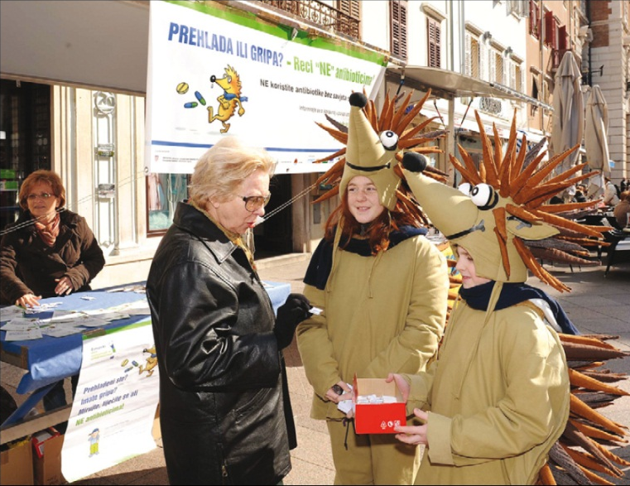

Figure 1: Stand in a main pedestrian street during the 2010 campaign in Rijeka, Croatia.

In addition, lectures were delivered to high school students, parents of children attending primary schools and to teachers in day care centres. Healthcare professionals were targeted through primarily informing doctors about the public campaign and inviting them to actively engage in it, and anonymous questionnaires were distributed to all primary care doctors around the county. A symposium was held on the EAAD (November 18th), 2009, with sessions focusing on the treatment of most common infections. Guidelines for the use of antibiotics in primary care were distributed in the form of a comprehensive booklet covering various infections. The 2010 campaign included the same activities as in 2009.
Adapted from: Vlahović-Palčevski V. Reducing antibiotic use in Croatia. Lancet Infect Dis. 2010 Oct;10(10):670-671.

Q & As
- What was the behavioural objective/s in this campaign?
- To reduce the high rate of antibiotic consumption/prescription
- To reduce the number of antibiotic prescription for respiratory tract infections caused by viruses
- To seek advice on how and when to take antibiotics
Facilitator notes
The behavioural objective is not very clear but their overall objective is mentioned. Emphasise the need to link one’s objectives to one’s behavioural objectives. You can ask participants to discuss how they would phrase the behavioural objective themselves.
- Who was the target audience in this campaign?
- General care, public care and primary care doctors
- General public
- High school students
- Parents of children attending primary schools
- Teachers in day care centres
Facilitator notes
The target audience is not clearly defined. New target audiences come up throughout the text when new interventions are being described.
- Is there any evidence, in your view, that the principles of the marketing mix were used in the planning of this campaign? Please use the table below for your answers.

Facilitator notes
The product, (i.e. not materials such as ads, leaflets, posters), but what one is providing the target audience, is not provided, therefore facilitate a discussion so that participants can come up with valid ideas on what the product could have been in this scenario.

Target audience/s | Product | Price | Place | Promotion
General care, public care and primary care doctors | Not provided | Approximately €50,000  (total cost excluding staff salaries) | Not extremely obvious but one may assume:  - Hospitals  - Clinics | - Anonymous questionnaires  - Information dissemination  - Symposium  - Guidelines within a comprehensive booklet
General public | Not provided | Approximately €50,000  (total cost excluding staff salaries) | - Public spaces  - Hospitals and clinics | - Ads in mass media  - Distribution of printed media  - Press conferences  - Interviews  - Freephone helplines  - Weekend stand in a main pedestrian zone  - Doctor’s advice
High school students | Not provided | Approximately €50,000  (total cost excluding staff salaries) | Not extremely obvious but one may assume:  - High schools | - Lectures
Parents of children attending primary schools | Not provided | Approximately €50,000  (total cost excluding staff salaries) | Not extremely obvious but one may assume:  - Primary schools | - Lectures
Teachers in day care centres | Not provided | Approximately €50,000  (total cost excluding staff salaries) | Not extremely obvious but one may assume:  - Day care centres | - Lectures
- Through what channels was the audience reached?
- Printed materials (e.g. questionnaires, guidelines, posters)
- Freephone
- Active promotion
- Press conferences
- Education through lectures and a symposium
- Mass media

- Who were the stakeholders involved in this campaign?
- General public (including also more specifically, parents of primary school children, teachers at day care centres and high school students)
- Healthcare professionals
- Croatian Government
- City of Rijeka Government
- Primorje-Gorski kotar County
- All involved in team unrolling the campaign (specialists in clinical pharmacology, paediatrics and public health; general practitioners; a psychologist; pharmacists; medical students)
- How does one engage stakeholders and develop partnerships for campaign development? Please give suggestions.

Facilitator notes
This question is very much open for discussion. There are therefore no concrete answers to this question. You should facilitate the discussion on the role of partnerships, networks and stakeholders in the above campaign but also the important role of engaging stakeholders when planning a campaign and to involve them in all phases of campaign development. Also beneficial to discuss the advantages and disadvantages of involving stakeholders and partners, giving concrete examples.

Part 2
Only short-term outcomes of the campaigns, such as patient’s knowledge and attitudes towards antibiotics, were possible to assess. Findings of an anonymous questionnaire administered to the general population, noted that 35% of patients prior to the first campaign, and 25% after it, thought that antibiotics are drugs that treat influenza. Mid-term outcomes could be measured by the amount of antibiotics used. Although a decline in antibiotic use after the first campaign was not expected, the use of prescribed co-amoxiclav fell by 4%. Long-term outcomes and changes in resistance patterns cannot be seen as of yet.
Adapted from: Vlahović-Palčevski V. Reducing antibiotic use in Croatia. Lancet Infect Dis. 2010 Oct;10(10):670-671.

Q & As
- How (design, method/s and outcome variable/s) was the success/failure of the intervention measured? Would you have evaluated it differently? If so, how?
- Anonymous questionnaire to the general public – could have been beneficial to include the prescribers directly also to assess prescribing patterns and attitudes
- Knowledge on the use of antibiotics
- Patterns of antibiotic use

Facilitator notes
Not much information is given to answer this question therefore some good points to bring up for discussion are: sample size (is the sample representative?); Why were prescribers seemingly excluded from the evaluation even thought they were included as a target group? And no pre-campaign survey was carried out.

- Identify and/or develop key indicators as well as data collection methods and tools that could be used to evaluate the given campaign.
Facilitator notes
Below are only a few suggestions for indicators but numerous indicators can be developed therefore discussion should be encouraged.

Remember
Not all outcome indicators can directly attribute certain outcomes as direct effects of the campaign. Some indicators may be used as proxy indicators but are not necessarily a direct result of the campaign. They may however give an overview of the situation post-campaign and aid to set targeted goals for future campaigns.

Key activities | Specific objectives | Key indicators |  | Data collection methods/tools
 |  | Process | Outcome
Printed materials | - To increase knowledge on prudent antibiotic use  - To increase awareness on prudent antibiotic use  - To reduce consumption of antibiotics  - To advise the public to seek doctors for advice on how and when to use antibiotics responsibly | - # (total) printed materials printed  - # (total) printed materials disseminated | - % people with correct knowledge on antibiotics and their use  - % population who self-medicate  - % population who cease antibiotic therapy prematurely  - % population who save leftover antibiotics | - Records of printing agency involved in the campaign  - Pre- and post-campaign surveys (could be as questionnaires, focus group discussions, interviews, etc.)  - (On-going) surveillance
Comprehensive booklet with guidelines | - To explain about the importance of engaging in the campaign (prescribers)  - To emphasise the consequence of the emergence of antibiotic resistance (prescribers)  - To inform about the appropriate antibiotic prescription (prescribers)  - To change prescribing behaviour when treating respiratory tract infections (prescribers) | - # (total) printed booklets printed  - # (total) printed booklets disseminated | - % antibiotic prescription specific to the diagnosis  - % antibiotic dispensation per pharmacy | - Medical records  - Doctor’s reports  - Pharmacy records  - Records of printing agency involved in the campaign  - Pre- and post-campaign survey with prescribers (could be as questionnaires, focus group discussions, interviews, etc.)  - On-going surveillance

Key activities | Specific objectives | Key indicators |  | Data collection methods/tools
 |  | Process | Outcome
Freephone helplines | - To inform the public about antibiotic use and antibiotic resistance  - To clarify queries and misconceptions | - # (total) calls by reason of call | - % people with correct knowledge on antibiotics and their use  - % population who self-medicate  - % population who cease antibiotic therapy prematurely  - % population who save leftover antibiotics | - Call logs at call centre  - Pre- and post-campaign surveys (could be as questionnaires, focus group discussions, interviews, etc.)  - Surveillance
Ads in mass media | - To increase knowledge on prudent antibiotic use  - To increase awareness on prudent antibiotic use  - To inform the public about antibiotic use and antibiotic resistance  - To decrease antibiotic use for viral infections  - To decrease self-mediation  - To decrease the early/premature cessation of antibiotic therapy | - # viewers/ listeners  - # (total) ads aired  - # (total) air time  - # (total) media stations involved | - % people with correct knowledge on antibiotics and their use  - % population who self-medicate  - % population who cease antibiotic therapy prematurely  - % population who save leftover antibiotics | - Log books and records from media stations on number of viewers/listeners, number of callers, etc.  - Pre- and post-campaign surveys (could be as questionnaires, focus group discussions, interviews, etc.)  - (On-going) surveillance

Key activities | Specific objectives | Key indicators |  | Data collection methods/tools
 |  | Process | Outcome
Educational activities (symposium and lectures) | - To inform about antibiotic use and antibiotic resistance  - To clarify queries and misconceptions  - To inform on how to treat common infections | - # (total) attendees | - % people with correct knowledge on antibiotics and their use  - % population who self-medicate  - % population who cease antibiotic therapy prematurely  - % population who save leftover antibiotics  - % doctors who prescribe antibiotics appropriately  - % antibiotic prescription specific to the diagnosis | - Pre- and post-campaign surveys (could be as questionnaires, focus group discussions, interviews, etc.)  - (On-going) surveillance
Weekend stand | - To inform about antibiotic use and antibiotic resistance  - To clarify queries and misconceptions  - To inform on how to treat common infections | - # (total) passers-by | - % public who found the stand useful  - % people with correct knowledge on antibiotics and their use  - % population who self-medicate  - % population who cease antibiotic therapy prematurely | - Pre- and post-campaign surveys (could be as questionnaires, focus group discussions, interviews, etc.)  - (On-going) surveillance
Key activities | Specific objectives | Key indicators |  | Data collection methods/tools
 |  | Process | Outcome
Press conference | - To inform the public about antibiotic use and antibiotic resistance | - # attendees at the conference | - % people with correct knowledge on antibiotics and their use  - % population who self-medicate  - % population who cease antibiotic therapy prematurely  - % population who save leftover antibiotics | - Pre- and post-campaign surveys (could be as questionnaires, focus group discussions, interviews, etc.)

- In your view, what were the strengths of the campaign?
- Multi-faceted interventions
- Good use of a small budget
- Multidisciplinary team involved
- Involvement and engagement of governmental sectors
- Creative use of the EAAD communication materials (especially the weekend stand)
- Target audiences reached with appropriate methods/interventions
Facilitator notes
The above answers are purely suggestions and many more answers might come up whilst discussing this question. Since no concrete answers will be found in the text, it may be rather subjective and is thus open for discussion.
- What do you think were the weaknesses of this campaign? What do you think could have been improved and how? Keeping the social marketing principles in mind, what would you have done differently in order to improve the campaign in your given scenario? Please discuss and write down your own suggestions.
- Prescribers should have been included in the evaluation
- Behavioural objectives not clearly defined
- A more specifically targeted approach towards prescribers could have been done to promote not proscribing antibiotics in vain
- In the evaluation, there is no indication on sample size and whether it was representative of the general population
- No pre-testing of materials mentioned
Facilitator notes
The above answers are purely suggestions and many more answers might come up whilst discussing this question. Since no concrete answers will be found in the text, it may be rather subjective and is thus open for discussion. Ask participants to discuss alternative strategies to reach the intended audience and alternative strategies for evaluation.
- What were the desired/intended outcomes of the campaign and were they reached? Were there any unintended outcomes?
- The overall desired outcome was to reduce the high rate of antibiotic consumption.
- There is some indication that there was an improvement in public knowledge on treating influenza with antibiotics after the second campaign (fell from 35% to 25%). However, there is no indication on how antibiotics were consumed for treating influenza which seems to have been the initial general objective (“to reduce the high rate of antibiotic consumption).
- There is no indication of any unintended outcomes.

Case study seventeen
“Embracing EAAD”
Content outline:
- Objectives
- Target audience/s
- Marketing mix (4Ps)
- Evaluation
- Indicators

Main discussion points for this case study

When discussing this case study, it is suggested to emphasise on:
- budget, and
- evaluation.

Attention
Often the behavioural objective causes confusion. It is not simply an objective, goal or aim of the campaign, but it is an objective which identifies an action or behaviour that one expects to influence and/or change after the intervention.

Description
In 2006, the prevalence of MRSA in Luxembourg ranged between 10-25%, and Luxembourg was also the 6th country in Europe with highest total antibiotic use. As a result, in 2008, Luxembourg joined with the European campaign on the prudent use of antibiotics to prevent the emergence of antibiotic-resistant bacteria. Their message was, “Les antibiotiques sont inefficaces contre les virus: Utilisons-les à bon escient” (“Antibiotics are ineffective against viruses: Use them wisely”).
With the launch of the European Antibiotic Awareness Day, Luxembourg held a press conference which informed the media, both in writing and orally, about the subject. Posters and leaflets were distributed to doctors, pharmacists, hospitals and clinics, communal administration departments, schools, day-care centres, halfway houses, some ministries, and public places, e.g. trains, and the Union of sickness funds. Radio, TV and cinematic spots were also produced both in Luxembourgish and Portuguese which explained to the public about the phenomenon of antibiotic resistance, unnecessary prescription and inadequate consumption, through a conversation between two antibiotic capsules when faced by a virus.
They also had an interactive online quiz with a set of questions and responses which complemented the campaign and allowed people to test their knowledge on the subject. The budget for the campaign was €50,000.
Adapted from: Christmann S. Communique de presse: journée européenne consacrée à la résistance aux antibiotiques (European Antibiotic Awareness Day). Luxembourg: Le Gouvernement du Grand-Duché de Luxembourg; 2008.

Q & As
- What was the behavioural objective/s in this campaign?

Facilitator notes
The behavioural objective is not clear and neither is an overall objective given. Emphasise the need to link one’s objectives to one’s behavioural objectives. You can ask participants to discuss how they would have phrased the behavioural objective themselves.

- Who was the target audience in this campaign?
The general public

- Is there any evidence, in your view, that the principles of the marketing mix were used in the planning of this campaign? Use the marketing mix score matrix* below to assess to which degree you think the social marketing principles were applied, described or addressed.
Product | Price  (benefits/barriers) | Place | Promotion
……………………………………………………………………………………………………………
* Each principle must be marked from a scale of 1-10, with 10 representing “a strong application, description or addressing of the principle” and 1 corresponding to “weak application, description or addressing of the principle”.

Facilitator notes
The above question is subjective and for that reason no suggestions are given. Nonetheless it is advised that you facilitate a short discussion around the principles of marketing. Please note that you should not over-emphasise this concept, rather place the emphasis later on when discussing evaluation, and budgeting.
- Through what channels was the audience reached?
- Printed materials (e.g. posters, leaflets)
- TV, radio and cinematic spots
- Online interactive quiz
- Press conference

- With the given budget (€50,000), suggest alternative ways by which the above campaign could have been unrolled.

Facilitator notes
The above question is open for discussion. Lead a discussion around budgeting and alternative strategies for limited budgets.
- Give suggestions on how the campaign can be evaluated and re-implemented.

Facilitator notes
Again this question could get rather subjective therefore no suggestions are given. Allow participants to guide the discussion.
- Identify and/or develop key indicators as well as data collection methods and tools that could be used to evaluate the given campaign.

Facilitator notes
Below are only a few suggestions for indicators but numerous indicators can be developed therefore discussion should be encouraged.

Remember
Not all outcome indicators can directly attribute certain outcomes as direct effects of the campaign. Some indicators may be used as proxy indicators but are not necessarily a direct result of the campaign. They may however give an overview of the situation post-campaign and aid to set targeted goals for future campaigns.

Key activities | Specific objectives | Key indicators |  | Data collection methods/tools
 |  | Process | Outcome
Poster and leaflet dissemination | - To increase knowledge on prudent antibiotic use (assumption)  - To increase awareness on prudent antibiotic use (assumption)  - To change behaviour when treating cold, sore throat and cough (assumption) | - # (total) printed materials printed  - # (total) printed materials disseminated | - % people with correct knowledge on antibiotics and their use  - % population who self-medicate  - % population who save leftover antibiotics  - % population who cease antibiotic therapy prematurely | - Records of printing agency involved in the campaign  - Pre- and post-campaign surveys (could be as questionnaires, focus group discussions, interviews, etc.)  - (On-going) surveillance
Press conference | - To inform the public through the media (assumption)  - To increase knowledge on prudent antibiotic use (assumption)  - To increase awareness on prudent antibiotic use (assumption)  - To change behaviour when treating cold, sore throat and cough (assumption) | - # of press conferences held | - % people with correct knowledge on antibiotics and their use  - % population who self-medicate  - % population who save leftover antibiotics  - % population who cease antibiotic therapy prematurely | - Pre- and post-campaign surveys (could be as questionnaires, focus group discussions, interviews, etc.)  - (On-going) surveillance

Key activities | Specific objectives | Key indicators |  | Data collection methods/tools
 |  | Process | Outcome
Interactive online quiz | - To teach the public about antibiotics and antibiotic resistance (assumption)  - To increase knowledge on prudent antibiotic use (assumption)  - To increase awareness on prudent antibiotic use (assumption)  - To change behaviour when treating cold, sore throat and cough (assumption) | - # visitors  - % correct answers | - % people with correct knowledge on antibiotics and their use  - % population who self-medicate  - % population who save leftover antibiotics  - % population who cease antibiotic therapy prematurely | - Pre- and post-campaign surveys (could be as questionnaires, focus group discussions, interviews, etc.)  - On-going website surveillance  - Surveillance

Case study eighteen
“Addressing minority groups”
Content outline:
PART 1 PART 2
- Formative evaluation - Pre-testing

PART 3 PART 4
- Marketing mix (4Ps) - Evaluation
- Adaptation - Indicators

Main discussion points for this case study

When discussing this case study, it is suggested to emphasise on:
- formative evaluation and pilot testing.

Remember
Do not forget the important role of evaluation! Nevertheless, for this case study the emphasis should lie on the formative evaluation and pre-testing of the campaign.

Description
Part 1
In the past decade, two key observations have become a target for several interventions: antibiotic resistance among community-acquired bacterial pathogens and the recent use of antibiotics as one of the strongest risk factors for carriage or infection with resistant bacteria. In the current scenario, acute respiratory tract infections account for the vast majority of antibiotic prescriptions in ambulatory care.
In 2001, an intervention was designed in Colorado to assess the impact of including household-based and doctor’s office-based patient education in an existing doctor-centred intervention aimed at reducing antibiotic prescribing for children with pharyngitis and adults with acute bronchitis. The major hypothesis was that a joint patient and doctor intervention would be more effective in reducing excess antibiotic use in private office practices than a doctor-centred intervention alone.
Since 1999 (two years prior to the intervention), primary care doctors had been receiving individual prescribing profiles showing: the proportion of adult bronchitis patients receiving antibiotic treatment (target ≤10%), the proportion of these antibiotics belonging to a first-line group (target ≥70%), and the proportion of these antibiotics ineffective against diagnosed bacterial cases of uncomplicated acute bronchitis (target 0%). Likewise, doctors providing care to children with pharyngitis were also mailed profiles showing: the proportion of all pharyngitis patients having a group A streptococcus identification test performed, the proportion of pharyngitis patients not receiving a group A streptococcal identification test who were treated with antibiotics (target 0%), and the proportion of antibiotics belonging to a first-line group (target ≥70%).
Adapted from: Gonzales R, Corbett KK, Leeman-Castillo BA, Glazner J, Erbacher K, Darr CA, Wong S, Maselli JH, Sauaia A, Kafadar K. The minimizing antibiotic resistance in Colorado project: impact of patient education in improving antibiotic use in private office practices. Health Serv Res. 2005 Feb;40(1):101-116.

Q & As
- Discuss the importance of formative evaluation before implementing campaigns.
Thanks to the formative evaluation carried out before the intervention, the intervention team was able to hypothesise that “a joint patient and doctor intervention would be more effective in reducing excess antibiotic use in private office practices than a doctor-centred intervention alone”. This will have a later impact on how they will unroll the campaign.

Facilitator notes
It is evident that the team carried out quite some research before unrolling the intervention. In fact they could hypothesise that “a joint patient and doctor intervention would be more effective in reducing excess antibiotic use in private office practices than a doctor-centred intervention alone”. This had a later impact on how they unrolled the campaign. Discuss the importance of formative evaluation.
- Highlight the key areas identified in the text that required improvement.
- Proportion of adult bronchitis patients receiving antibiotic treatment (target ≤10%)
- Proportion of these antibiotics belonging to a first-line group (target ≥70%)
- Proportion of these antibiotics ineffective against diagnosed bacterial cases of uncomplicated acute bronchitis (target 0%)
- Proportion of all pharyngitis patients having a group A streptococcus identification test performed
- Proportion of pharyngitis patients not receiving a group A streptococcal identification test who were treated with antibiotics (target 0%)
- Proportion of antibiotics belonging to a first-line group (target ≥70%)

Part 2
Household-based and doctor’s office-based educational material were adapted from a previous intervention that had successfully reduced antibiotic treatment of adults with acute bronchitis. Focus group discussions were conducted with parents to obtain feedback and develop paediatric materials prior to their distribution. Campaign packets were posted to households (n=37,375) identified through participating doctor’s offices in the first week of November, 2001.
Adapted from: Gonzales R, Corbett KK, Leeman-Castillo BA, Glazner J, Erbacher K, Darr CA, Wong S, Maselli JH, Sauaia A, Kafadar K. The minimizing antibiotic resistance in Colorado project: impact of patient education in improving antibiotic use in private office practices. Health Serv Res. 2005 Feb;40(1):101-116.

Q & As
- Discuss the need for adaptation and the importance of pre-testing materials.
- Materials were adapted from a previous intervention
- Focus group discussions were conducted with parents to obtain feedback and develop paediatric materials prior to their distribution
Facilitator notes
This question is a knowledge question however it is good to bring out the points mentioned in the text on pre-testing of materials. Do however facilitate a discussion around the importance of pilot-testing and need for adaptation.

Part 3
Each household packet consisted of a bilingual introductory letter (English and Spanish, the second main language in the area) explaining the campaign, brochures on antibiotic resistance, a fridge magnet and a reference card providing easy-to-read facts about symptoms and treatment for acute respiratory tract infections. All materials were provided in both languages except for the magnet which was only provided in English. Materials for doctor’s offices (produced in both languages) included waiting room posters and patient reference cards, and examination room posters which contained discussion points for doctors to use when talking about appropriate antibiotic use for pharyngitis with paediatric patients and bronchitis in adults. All educational materials were available online on the project’s website.
Adapted from: Gonzales R, Corbett KK, Leeman-Castillo BA, Glazner J, Erbacher K, Darr CA, Wong S, Maselli JH, Sauaia A, Kafadar K. The minimizing antibiotic resistance in Colorado project: impact of patient education in improving antibiotic use in private office practices. Health Serv Res. 2005 Feb;40(1):101-116.

Q & As
- Use the marketing mix score matrix* below to assess to which degree you think the social marketing principles were applied, described or addressed.
- Product | Price  (benefits/barriers) | Place | Promotion
……………………………………………………………………………………………………………
* Each principle must be marked from a scale of 1-10, with 10 representing “a strong application, description or addressing of the principle” and 1 corresponding to “weak application, description or addressing of the principle”.

Facilitator notes
The above question is subjective and for that reason no suggestions are given. Nonetheless it is advised that you facilitate a short discussion around the principles of marketing. Please note that you should not over-emphasise this concept, rather place the emphasis later on when discussing the indicators.
- Suggest other channels through which the intervention could have been delivered.

Facilitator notes
This is quite a subjective question. Facilitate a discussion around the use of different channels and be open to ideas and suggestions from the participants.

Part 4
Office practices located in a pre-selected geographical area in Denver, Colorado, the intervention city, were invited to participate as intervention practices. Eligibility criteria for the doctor’s offices included having 20 or more patient visits for acute respiratory tract infections during the baseline observation period (November 2000 to February 2001). They also had to provide a mailing and telephone list of regular patients (any adult having at least two office visits during the prior 24 months or any child having at least two office visits during the prior 12 months), and to review and approve the ultimate educational material for the intervention. Ten private doctor clinics were identified as potential participates however five agreed to participate.
In addition, two city practices in Denver, outside the pre-selected geographical area, were selectively enrolled in order to ensure adequate sample size for a separate analysis. Office practices in the surrounding urban area of Denver served as ‘‘local control’’ practices. In addition, practices located in a geographically distinct urban area, Colorado Springs, 100kms south of the intervention city served as ‘‘distant control’’ practices. Eligibility criteria for local and distant control practices were the same as for the intervention practices.
For paediatric pharyngitis, the adjusted antibiotic prescription rates during baseline and intervention periods increased from 38% to 39% at the distant control practices, decreased from 39% to 37% at the local control practices and decreased from 34% to 30% at the intervention practices. For acute bronchitis in adults, the adjusted antibiotic prescription rates during baseline and intervention periods decreased from 51% to 44% at the distant control practices, decreased from 55% to 45% at the local control practices and decreased from 60% to 36% at the intervention practices.
The total cost of the household intervention in 2001 was around $1.64/household for 37,375 households and for the office materials in 2001 it was approximately $350/practice.
Adapted from: Gonzales R, Corbett KK, Leeman-Castillo BA, Glazner J, Erbacher K, Darr CA, Wong S, Maselli JH, Sauaia A, Kafadar K. The minimizing antibiotic resistance in Colorado project: impact of patient education in improving antibiotic use in private office practices. Health Serv Res. 2005 Feb;40(1):101-116.

Q & As
- How (design, method/s and outcome variable/s) was the success/failure of the intervention measured? Would you have evaluated it differently? If so, how?
- Not clear exactly how the success/failure of the intervention was measured but one could assume a before and after survey by mail and telephone, and perhaps with the use of medical records also.
- Adjusted antibiotic prescription rates during baseline and intervention periods were measured to determine the outcome of the intervention.

- Identify and/or develop key indicators as well as data collection methods and tools that could be used to evaluate the given campaign.
Facilitator notes
Below are only a few suggestions for indicators but numerous indicators can be developed therefore discussion should be encouraged.

Remember
Not all outcome indicators can directly attribute certain outcomes as direct effects of the campaign. Some indicators may be used as proxy indicators but are not necessarily a direct result of the campaign. They may however give an overview of the situation post-campaign and aid to set targeted goals for future campaigns.

Key activities | Specific objectives | Key indicators |  | Data collection methods/tools
 |  | Process | Outcome
Household-based printed material | - To inform the public about antibiotic use and antibiotic resistance  - To clarify queries and misconceptions | - # (total) printed materials printed  - # (total) printed materials disseminated | - % people with correct knowledge on antibiotics and their use | - Records of printing agency involved in the campaign  - Pre- and post-campaign surveys (could be as questionnaires, focus group discussions, interviews, etc.)  - (On-going) surveillance
Doctor’s office-based printed material | - To explain about the importance of engaging in the campaign (assumption)  - - To inform about the appropriate antibiotic prescription (assumption) | - # (total) printed materials printed  - # (total) printed materials disseminated  - # of participating practices | - % antibiotic prescription specific to the diagnosis | - Medical records  - Doctor’s reports  - Records of printing agency involved in the campaign  - Pre- and post-campaign survey with prescribers (could be as questionnaires, focus group discussions, interviews, etc.)  - (On-going) surveillance

- Does it appear that the intervention was successful? Discuss.
Yes, from the results it appears that the intervention was successful. This is shown from the adjusted antibiotic prescription rates given. For paediatric pharyngitis, the adjusted antibiotic prescription rates during baseline and intervention periods increased from 38% to 39% at the distant control practices, decreased from 39% to 37% at the local control practices and decreased from 34% to 30% at the intervention practices. For acute bronchitis in adults, the adjusted antibiotic prescription rates during baseline and intervention periods decreased from 51% to 44% at the distant control practices, decreased from 55% to 45% at the local control practices and decreased from 60% to 36% at the intervention practices. Therefore there is an evident higher decrease in the intervention practices which could mean that the intervention had an impact.
Facilitator notes
Above is just a suggestion from what is shown in the text. Participants may come up with other reasons therefore be open to discussion.

Course on the development, implementation and evaluation of prudent antibiotic use campaigns

Annex five:
Indicators list

Illustrative indicators list
Below is an extensive list of potential process and outcome indicators which may be used during evaluation of an antibiotic use campaign. This list contains only a sample of indicators and should be used and adapted accordingly, depending on the context, the type of interventions carried out, the approach by which the campaign is unfolded and the target audience, among others. These indicators are comprehensive on purpose. Feel free to select at your own discretion.
For ease of use, the list is divided into two parts beginning with process indicators and ending with outcome indicators. Process indicators are then further sub-divided into three sections: (i) process indicators which can be used during the pre-intervention phase (NB. refers to activities conducted in preparation to roll-out the campaign), (ii) process indicators which can be used whilst carrying out the intervention and (iii) process indicators for the post-intervention phase. The three sub-sections are split again for convenience into valid sub-divisions for each phase of the intervention.
Similarly, the list of outcome indicators, which are to be used at the end of the intervention as a means of evaluation, is also sub-divided, albeit slightly differently to the process indicators list. The outcome indicators are sub-divided as such: (i) knowledge and attitudes on antibiotics, (ii) antibiotic prescribing/dispensing, (iii) antibiotic consumption, and (iv) antibiotic resistance. You will again find further sub-sections in certain divisions according to the diagnoses or bacterial isolates.
You will note that under the heading ‘unit’ the following symbols/abbreviations are used: #, mins, % and DID. These symbols represent: # – numerical figure, mins – number of minutes, % – figure in percentage, and DID – defined daily doses per 1,000 inhabitants per day.

Attention
Not all outcome indicators can directly attribute certain outcomes as direct effects of the intervention. Some indicators, such as those on antibiotic resistance, may be used as proxy indicators but are not necessarily a direct result of the intervention. They may however give an overview of the situation post-intervention and aid in setting targeted goals for future interventions.

Examples of process indicators
 | Indicator | Unit
Pre-intervention | Capacity building
 | - Total number of materials/guidelines developed to build capacity | #
 | - Total number of capacity-building training sessions conducted (train-the-trainers) | #
 | - Total number of workshops conducted (for training purposes; train-the-trainers) | #
 | - Total number of behaviour change communication (BCC) workshops conducted (for training purposes; train-the-trainers) | #
 | - Total number of advocacy activities (by focus) implemented (train-the-trainers) | #
 | - Total number of group education activities (by focus) | #
 | - Total number of training participants | #
 | - Total number of workshop participants by focus of workshop (train-the-trainers) | #
 | - Total number of people trained | #
 | - Total number of healthcare professionals/press officers/public health officials, etc. trained in information, education and communication (IEC), behaviour change intervention (BCI) and BCC | #
 | - Total number of individuals trained in IEC/BCI/BCC | #
 | - Total number of supervisors | #
 | - Total number of formative studies/assessments conducted | #
 | - Total number of projects/programmes/interventions designed | #
 | - Total number of monitoring and evaluation systems established | #
 | Resource development
 | - Total number of grants awarded | #
 | - Total budget allocated to the intervention
 | - Total number of behaviour change communication materials and guidelines developed and produced | #
 | - Total number of IEC materials (flyers, posters, etc.) developed | #
Pre-intervention | - Total number of YouTube videos created | #
 | - Total number of advertisements created | #
 | Policy development
 | - Number of IEC materials developed (for policy) | #
 | - Number of tools developed (for policy) | #
 | Partnerships
 | - Total number of networks, NGOs and coalitions formed | #
 | - Total number of new organisations, businesses and media outlets participating in the programme | #
During intervention | Channels
 | - Total number of press conferences | #
 | - Total number of television stations involved | #
 | - Total number of radio stations involved | #
 | - Total number of hotlines available | #
 | - Total number of websites used in the intervention | #
 | - Total number of YouTube videos used in the intervention | #
 | - Total number of cinema spots/advertisements | #
 | - Total number of workshops conducted | #
 | - Total number, type and frequency of activity/channel (print, radio, TV, video, hotline, newspapers, lectures, etc.)
 | - Total number of educator services provided | #
 | - Total number of educator services provided per targeted group | #
 | Activity dissemination
 | - Total number of IEC events conducted | #
 | - Total number of conferences coordinated | #
 | - Total number of IEC materials (flyers, posters, etc.) disseminated | #
 | - Total number of IEC materials (flyers, posters, etc.) disseminated (for policy) | #
 | - Total number of IEC campaigns conducted | #
During intervention | - Total number of IEC campaigns conducted (for policy) | #
 | - Total number of television spots/advertisements aired | #
 | - Total television air time | #
 | - Total number of radio spots/advertisements aired | #
 | - Total television radio time | #
 | - Total number of media articles written about the campaign/intervention | #
 | - Total number of social media tools on Twitter | #
 | - Total number of social media tools on Facebook | #
 | - Total number and type of EAAD campaign materials used | #
 | - Total number of tools disseminated (for policy) | #
 | - Total number of articles published in scientific journals | #
 | - Total number of workshops conducted | #
 | - Total number of advocacy activities (by focus) implemented | #
 | - Total number of group education activities (by focus) | #
 | - Total number of rapid diagnostic tests distributed | #
 | - Total number of supervisors | #
 | Uptake of activity dissemination
 | - Total number of hotline calls (by reason for call, age, sex of caller) | #
 | - Total number of visitors to websites (by interest subject) | #
 | - Average time spent on websites by visitors | mins
 | - Total number of YouTube views | #
 | - Total number of YouTube comments | #
 | - Total number of video likes and dislikes | #
 | - Estimated number of viewers of television spots/advertisements aired | #
 | - Estimated number of listeners of radio spots/advertisements aired | #
 | - Estimated number of viewers of cinema spots/advertisements | #
 | - Total number of workshop participants by focus of workshop | #
 | - Total number of doctors reached through group activity by peers | #
 | - Total number of doctors reached one-to-one by peers | #
 | - Total number of tweets and re-tweets on Twitter | #
 | - Total number of likes on Facebook posts | #
During intervention | - Total number of posts and comments on Facebook | #
 | - Total number of times posts, videos or links were shared | #
 | Partnerships
 | - Total number of collaborative events | #
 | - Total number of agencies involved in collaborative events | #
 | - Total number of volunteers who took part in the intervention | #
Post-intervention | Coverage
 | - Coverage of the campaign (national, regional and/or local levels) | %
 | - Total number of activities organised (national, regional and/or local levels) | #
 | - Type of activities organised (national, regional and/or local levels)
 | Exposure
 | - Proportion of the targeted population reached | %
 | - Total number of targeted target population reached | #
 | - Proportion of targeted population reached through IEC events | %
 | - Total number of targeted population reached through IEC events | #
 | - Proportion of targeted population reached through educational programmes | %
 | - Total number of targeted population reached through educational programmes | #
 | - Total print coverage and estimated readership | %
 | - Total exposure of social media interventions | %
 | Stakeholders and partnerships
 | - Total number of networks, NGOs and coalitions formed | #
 | - Total number of people working on the campaign/intervention (at national, regional and/or local levels) | #
 | - Total number and type of governmental institutions contributing to the development of the campaign/intervention | #
 | - Total number and type of non-governmental stakeholders supporting the campaign/intervention | #
Post-intervention | - Total number and type of non-governmental stakeholders sponsoring the campaign/intervention | #
 | - Total number and type of stakeholders criticising the campaign/intervention
 | Policy development
 | - Total number of antibiotic use plan/guidelines developed | #
 | - Total number of global guidelines/standards developed | #
 | - Total number of indicators developed/refined | #
 | - Total number of tools developed | #
 | - Total number of tools disseminated | #
 | - Total number of strategies/guidelines developed | #

Examples of outcome indicators
 | Indicator | Unit
Knowledge and attitudes on antibiotics | - Prevalence of target population with correct knowledge about antibiotics and their prudent use | %
 | - Prevalence of target population with incorrect knowledge about antibiotics and their prudent use | %
 | - Prevalence of population self-medicating with antibiotics | %
 | - Prevalence of population consuming non-prescribed antibiotics | %
 | - Prevalence of population not following correct dosage instructions | %
 | - Prevalence of population discontinuing antibiotics earlier than prescribed | %
 | - Prevalence of population keeping leftover antibiotics | %
Antibiotic prescribing/ | - Prevalence of doctors who feel pressured by patients to prescribe antibiotics | %
dispensing | - Prevalence of patients who put pressure on doctors to prescribe antibiotics | %
 | - Total antibiotic sales | DID
 | - Number of antibiotic packages dispensed per 1,000 inhabitants per day | #
 | - Number of antibiotic packages dispensed over-the-counter without a prescription per total antibiotic dispensation | %
 | - Prevalence of patients with age and/or gender limitation prescribed an antibiotic | %
 | - Prevalence of patients with age and/or gender limitation prescribed an antibiotic, and receiving the guideline-recommended antibiotic | %
Antibiotic prescribing/ dispensing | - Prevalence of patients with age and/or gender limitation prescribed an antibiotic, and receiving quinolones | %
 | Acute bronchitis/bronchiolitis
 | - Prevalence of patients aged between 18 and 75 years with acute bronchitis/bronchiolitis (ICPC-2-R: R78) prescribed antibacterials for systemic use (ATC: J01) | %
 | - Prevalence of patients aged between 18 and 75 years with acute bronchitis/bronchiolitis (ICPC-2-R*: R78) receiving the recommended antibacterials (ATC†: J01CA or J01AA) | %
 | - Prevalence of patients aged between 18 and 75 years with acute bronchitis/bronchiolitis (ICPC-2-R*: R78) receiving quinolones (ATC†: J01M) | %
 | Acute upper respiratory infection
 | - Prevalence of patients older than 1 year with acute upper respiratory infection (ICPC-2-R*: R74) prescribed antibacterials for systemic use (ATC†: J01) | %
 | - Prevalence of patients older than 1 year with acute upper respiratory infection (ICPC-2-R*: R74) receiving the recommended antibacterials (ATC†: J01CA or J01AA) | %
 | - Prevalence of patients older than 1 year with acute upper respiratory infection (ICPC-2-R*: R74) receiving quinolones (ATC†: J01M) | %
 | Cystitis/other urinary infection
 | - Prevalence of female patients older than 18 years with cystitis/other urinary infection (ICPC-2-R*: U71) prescribed antibacterials for systemic use (ATC†: J01) | %
 | - Prevalence of female patients older than 18 years with cystitis/other urinary infection (ICPC-2-R*: U71) receiving the recommended antibacterials (ATC†: J01CA or J01AA) | %
 | - Prevalence of female patients older than 18 years with cystitis/other urinary infection (ICPC-2-R*: U71) receiving quinolones (ATC†: J01M) | %
Antibiotic prescribing/ | Acute tonsillitis
dispensing | - Prevalence of patients older than 1 year with acute tonsillitis (ICPC-2-R: R76) prescribed antibacterials for systemic use (ATC: J01) | %
 | - Prevalence of patients older than 1 year with acute tonsillitis (ICPC-2-R*: R76) receiving the recommended antibacterials (ATC†: J01CA or J01AA) | %
 | - Prevalence of patients older than 1 year with acute tonsillitis (ICPC-2-R*: R76) receiving quinolones (ATC†: J01M) | %
 | Acute/chronic sinusitis
 | - Prevalence of patients older than 18 years with acute/chronic sinusitis (ICPC-2-R*: R75) prescribed antibacterials for systemic use (ATC†: J01) | %
 | - Prevalence of patients older than 18 years with acute/chronic sinusitis (ICPC-2-R*: R75) receiving the recommended antibacterials (ATC†: J01CA or J01AA) | %
 | - Prevalence of patients older than 18 years with acute/chronic sinusitis (ICPC-2-R*: R75) receiving quinolones (ATC†: J01M) | %
 | Acute otitis media/myringitis
 | - Prevalence of patients older than 2 years with acute otitis media/myringitis (ICPC-2-R*: H71) prescribed antibacterials for systemic use (ATC†: J01) | %
 | - Prevalence of patients older than 2 years with acute otitis media/myringitis (ICPC-2-R*: H71) receiving the recommended antibacterials (ATC†: J01CA or J01AA) | %
 | - Prevalence of patients older than 2 years with acute otitis media/myringitis (ICPC-2-R*: H71) receiving quinolones (ATC†: J01M) | %
 | Pneumonia
 | - Prevalence of patients aged between 18 and 65 years with pneumonia (ICPC-2-R*: R81) prescribed antibacterials for systemic use (ATC†: J01) | %
Antibiotic prescribing/dispensing | - Prevalence of patients aged between 18 and 65 years with pneumonia (ICPC-2-R*: R81) receiving the recommended antibacterials (ATC†: J01CA or J01AA) | %
 | - Prevalence of patients aged between 18 and 65 years with pneumonia (ICPC-2-R: R81) receiving quinolones (ATC: J01M) | %
Antibiotic consumption | - Total antibiotic consumption | #
 | - Prevalence of antibiotic use in primary care with age and/or gender limitation | %
 | - Prevalence of antibiotic use in outpatients with age and/or gender limitation | %
 | - Prevalence of antibiotic use in tertiary care with age and/or gender limitation | %
 | - Prevalence of antibiotic use among residents in nursing homes | %
 | - Total antibiotic use in primary care with age and/or gender limitation | DID
 | - Total antibiotic use in outpatients with age and/or gender limitation | DID‡
 | - Total antibiotic use in tertiary care with age and/or gender limitation | DID‡
 | - Total antibiotic use among residents in nursing homes | DID‡
 | - Prevalence of population self-medicating with antibiotics | %
 | - Prevalence of population consuming non-prescribed antibiotics | %
 | - Prevalence of population not following correct dosage instructions | %
 | - Prevalence of population discontinuing antibiotics earlier than prescribed | %
 | - Prevalence of population keeping leftover antibiotics | %
 | - Consumption of antibacterials for systemic use (ATC†: J01) | DID‡
Antibiotic consumption | - Consumption of tetracyclines (ATC: J01A) | DID
 | - Consumption of penicillins (ATC*: J01C) | DID†
 | - Consumption of cephalosporins and other beta-lactams (ATC*: J01D) | DID†
 | - Consumption of sulfonamides and trimethoprim (ATC*: J01E) | DID†
 | - Consumption of macrolides, lincosamides and streptogramins (ATC*: J01F) | DID†
 | - Consumption of quinolones (ATC*: J01M) | DID†
 | - Consumption of other ATC*: J01 classes | DID†
 | - Consumption of tetracyclines (ATC*: J01A) | %
 | - Consumption of penicillins (ATC*: J01C) | %‡
 | - Consumption of cephalosporins (ATC*: J01D) | %‡
 | - Consumption of sulfonamides and trimethoprim (ATC*: J01E) | %‡
 | - Consumption of macrolides, lincosamides and streptogramins (ATC*: J01F) | %‡
 | - Consumption of quinolones (ATC*: J01M) | %‡
 | - Consumption of β-lactamase sensitive penicillins (ATC*: J01CE) | %‡
 | - Consumption of combination of penicillins, including β-lactamase inhibitor (ATC*: J01CR) | %‡
 | - Consumption of third and fourth generation of cephalosporins (ATC*: J01(DD+DE)) | %‡
 | - Consumption of fluoroquinolones (ATC*: J01MA) | %‡
 | - Ratio of the consumption of broad (ATC*: J01(CR+DC+DD+(F-FA01))) to the consumption of narrow spectrum penicillins, cephalosporins and macrolides (ATC*: J01(CE+DB+FA01))
Antibiotic consumption | - Seasonal variation of the total antibiotic consumption (ATC: J01) | %
 | - Seasonal variation* of quinolone consumption (ATC†: J01M) | %
 | - Seasonal variation* of quinolone consumption (ATC†: J01M) multiplied by their use in DID | %
 | - Index of longitudinal trends of antibiotic consumption
Antibiotic resistance | Staphylococcus aureus
 | - Number of MRSA bacteraemias per 100,000 patient days | #
 | - Prevalence of S. aureus resistant to methicillin (MRSA) | %
 | - Prevalence of S. aureus resistant to beta-lactams | %
 | - Prevalence of S. aureus resistant to vancomycin (VRSA) | %
 | - Prevalence of vancomycin-intermediate resistant S. aureus (VISA) | %
 | Escherichia coli
 | - Prevalence of E. coli resistant to broad-spectrum penicillins | %
 | - Prevalence of E. coli resistant to broad-spectrum aminopenicillins | %
 | - Prevalence of E. coli resistant to fluoroquinolones | %
 | - Prevalence of E. coli resistant to aminoglycosides | %
 | - Prevalence of E. coli resistant to third generation cephalosporins | %
 | - Prevalence of multi-drug resistant E. coli (resistance to ≥2 classes of antimicrobials) | %
 | Enterococci
 | - Prevalence of enterococci isolates | %
 | - Prevalence of enterococci resistant to vancomycin | %
 | - Prevalence of enterococci resistant to aminoglycosides | %
Antibiotic resistance | Streptococcus pneumoniae
 | - Prevalence of S. pneumoniae serotypes | %
 | - Prevalence of S. pneumoniae isolates | %
 | - Prevalence of S. pneumoniae isolates non-susceptible to penicillin | %
 | - Prevalence of S. pneumoniae isolates non-susceptible to erythromycin | %
 | - Prevalence S. pneumoniae isolates non-susceptible to both penicillin and erythromycin | %
 | Klebsiella pneumoniae
 | - Prevalence of K. pneumoniae isolates | %
 | - Prevalence of K. pneumoniae resistant to fluoroquinolones | %
 | - Prevalence of K. pneumoniae resistant to aminoglycosides | %
 | - Prevalence of K. pneumoniae resistant to third generation cephalosporins | %
 | - Prevalence of K. pneumoniae resistant to carbapenems | %
 | - Prevalence of multi-drug resistant K. pneumoniae (resistance to ≥2 classes of antimicrobials) | %
 | Pseudomonas aeruginosa
 | - Prevalence of P. aeruginosa resistant to piperacillin and piperacillin/tazobactam | %
 | - Prevalence of P. aeruginosa resistant to aminoglycosides | %
 | - Prevalence of P. aeruginosa resistant to fluoroquinolones | %
 | - Prevalence of P. aeruginosa resistant to carbapenems | %
 | - Prevalence of P. aeruginosa resistant to Ceftazidime (cephalosporins) | %
 | - Prevalence of multi-drug resistant P. aeruginosa (resistance to ≥2 classes of antimicrobials) | %

Sources:
- Adriaenssens N, Coenen S, Tonkin-Crine S, Verheij TJM, Little P, Goossens H, on behalf of the ESAC Project Group. European surveillance of antimicrobial consumption (ESAC): disease-specific quality indicators for outpatient antibiotic prescribing. BMJ Qual Saf. 2011 Mar 21;Epub ahead of print.

- Coenen S, Ferech M, Haaijer-Ruskamp FM, Butler CC, Vander Stichele RH, Verheij TJ, Monnet DL, Little P; Goossens H,ESAC Project Group. European surveillance of antimicrobial consumption (ESAC): quality indicators for outpatient antibiotic use in Europe. Qual Saf Health Care. 2007 Dec;16(6):440-445.

- Earnshaw S, Monnet DL, Duncan B, O’Toole J, Ekdahl K, Goossens H, European Antibiotic Awareness Day Technical Advisory Committee, European Antibiotic Awareness Day Collaborative Group. European antibiotic awareness day, 2008 - the first Europe-wide public information campaign on prudent antibiotic use: methods and survey of activities in participant countries. Euro Surveill. 2009 Jul 30;14(30):19280.

- European Antimicrobial Resistance Surveillance System. EARSS annual report 2008: on-going surveillance of S. pneumoniae, S. aureus, E. coli, E. faecium, E. faecalis, K. pneumoniae, P. aeruginosa. Bilthoven, The Netherlands: EARSS Management Team, members of the Advisory Board, and national representatives of EARSS; 2009.

- European Surveillance of Antimicrobial Consumption. ESAC yearbook 2009. Antwerp, Belgium: ESAC Management Team, the ESAC Scientific Advisory Board and the ESAC National Networks; 2010.

- Family Health International. Core module 1: introduction to monitoring and evaluation. Monitoring HIV/AIDS programs: a facilitator’s training guide. USA: A USAID Resource for Prevention, Care and Treatment; 2004.

- Family Health International. Module 6: monitoring and evaluating behavior change communication programs. Monitoring HIV/AIDS programs: a facilitator’s training guide. USA: A USAID Resource for Prevention, Care and Treatment; 2004.

- Goossens H. Expert-proposed European strategies to monitor and control infection, antibiotic use, and resistance in health-care facilities. Lancet Infect Dis. 2011 Apr 7;11(5):338-340.

- Mitsi G, Jelastopulu E, Basiaris H, Skoutelis A, Gogos C. Patterns of antibiotic use among adults and parents in the community: a questionnaire-based survey in a Greek urban population. Int J Antimicrob Agents. 2005 May;25(5):439-443.

- Neiger BL, Thackeray R, Van Wagenen SA, Hanson CL, West JH, Barnes MD, Fagen MC. Use of social media in health promotion: purposes, key performance indicators, and evaluation metrics. Health Promot Pract 2012 Mar;13(2):159-164.

Course on the development, implementation and evaluation of prudent antibiotic use campaigns

Annex six:
Evaluation tools

In this section of the manual you will find everything that has got to do with participant assessment in the following order: (1) Quick assessments, (2) Daily evaluation forms, (3) End of face-to-face course evaluation, (4) Pre-/post-training exercise, and (5) Feedback survey.

A6.1 Quick assessments
In this section you will find a selection of methods on how to quickly assess participants. Quick assessments can be used throughout the course. They help to transform passively heard information into reproducible active knowledge. Furthermore, quick assessments reflect the participant’s learning process, both for the participants themselves and for the facilitator.
In addition to the easily recognisable icons used for the icebreakers, energisers and group activities (Annex 2), a further icon has been added for quick assessments. The icons are used to indicate which functions the exercises fulfil. Some exercises are the same as in Annex 2 as they can be used for different purposes. A description of the exercise, how to lead it and materials required is also given. The exercises provided are only suggestions and can be adapted according to your needs and to the group of participants. The scope is that they should be fun and not very time-consuming. Below are the icons used to categorise the exercises and what they signify:
 | Assessments: pre-/post-course and during the course
 | Ice breakers: getting to know one another
 | Energisers: reviving a tired group
 | Team building exercises
 | Refreshers (revision exercises) and teaching exercises
Beehive
Could be used at the beginning of the day/session to assess whether the main concepts of the previous day/session have been understood by the participants and to reflect upon the gained knowledge and knowledge gaps.
Split the group into pairs. Let the participants reflect upon what they learnt during the previous day, telling each other what they thought was the most important point in the preceding lectures.
Dialog in pairs (buzz) for 2-5 minutes:
- What is the main point I learnt yesterday/today?
- What is the main point left unanswered in yesterday’s/today’s session?
The participants then communicate their findings to the class for open discussion.

Challenges and objectives
Could be used at the start of the course in order to later assess whether the course targeted and addressed critical issues among the participants.
Divide the group into smaller teams and ask them to identify and note down their main challenges in the topic and their main objectives for the course. Afterwards they must present these to the rest of the group. You can come back to the groups’ challenges and objectives at the end of the course in order to identify whether their challenges and objectives have been realised.
Materials needed: flip chart paper (1 per group); permanent markers (1 per group).

Learning the hard way
Could be used at the start of the course in order to continuously address participants’ issues throughout the course.
When the participants are introducing themselves, ask them to explain one thing that they have learnt the hard way when developing campaigns. Write these issues down on a flip chart and refer to them during the course.
Materials needed: flip chart; 1 permanent marker.

Can you describe this?
Could be used at the start of certain sessions to identify what participants know and can explain/describe, and what participants have trouble understanding.
Spread out pre-written cards on the floor or on a table and ask participants to pick out one card which they can explain and another that they cannot or have never heard of, e.g. social marketing, pilot testing, the four Ps of marketing, target audience, evaluation, etc. After they pick their cards, they have to explain the card they understand to the group (with clarifications from the facilitator if required). A volunteer must then explain the concept or definition that the participant does not understand.
Materials needed: cards with pre-written concepts (2 per participant).

My greatest concerns
Could be used at the start of the course in order to later assess whether the course has targeted and addressed critical issues among the participants.
Ask each person to share his/her greatest concern about the course, e.g. that other participants will know more. Write down these concerns on the flip chart and then come back to them at the end of the course, allowing participants to share and discuss whether their concerns were realised.
Materials needed: flip chart; 1 permanent marker.

Questions and queries
Could be used at the start of the course in order to later assess whether the course has targeted and addressed critical issues among the participants.
Before introducing themselves, ask participants to write down a question or query that they would like answered by the end of the course. After introducing themselves, ask participants to share their question/query with the rest of the group and to stick the note on the flip chart. During or after the training, ask participants to answer the questions posted on the first day.
Materials needed: post-it notes (1 per participant); flip chart.

Pass the ball
Could be used to evaluate participants at the end of each day.
Ask the group to form a circle for this activity. To help participants reflect on the day’s take-home messages and key points, pass a small ball around the group by throwing it to one another. When the participant has the ball s/he must say one thing that s/he thought about the day (could simply describe the day or describe what activity/session they found most useful, etc.). Participants are free to express their thoughts in this session.
Materials needed: 1 small ball.

Lessons learned
To be used at the end of the course to assess participants.
Ask each participant to share one thing that s/he learnt throughout the course and that s/he will be able to apply to practice.

Finish the sentence
Ask the group to form a circle for this activity. Send a box/bag around the group. The first person picks a paper, reads it out loud and then attempts to finish the sentence. The box/bag is then sent to the next person, and so on and so forth. Examples of unfinished statements could include: “The best job I ever had was…”, “The worst project I ever worked on was…”, “The riskiest thing I ever did was…”, “I am in this course because…”, “The four Ps of marketing are…”, “A process indicator measures…”, “A target audience is…”, “Antibiotic resistance is…”, “EAAD stands for…”, “The European Antibiotic Awareness Day began in…”, “European Antibiotic Awareness Day was initiated by…”, “The main stages for the development of a campaign are…”, and “The first time I felt most stressed because I did not plan was…”.
Materials needed: carton box or paper bag (as long as one cannot see through it); papers with pre-written, unfinished statements on them (enough to have 1 per participant).

Find the matching card
Alternatively can be used as a refresher exercise using definitions from social marketing.
Before this activity, choose a variety of well-known phrases and write half on one paper and the other half on another paper (make sure to have enough papers for the whole group). Fold the papers and place them in a box/bag for participants to pick. Each participant must try to find the other person with the matching half of the phrase.
Materials needed: papers with matching phrases, a box or bag.

Pass the parcel
Alternatively can be used as a refresher exercise if the commands are phrased into questions instead.
Ask the group to form a circle. A small gift wrapped several times and with commands/questions (e.g. “Sing a song”, “Hug the person next to you”, and “Define the principles of the marketing mix”) in each layer must have been prepared beforehand. Start the music (alternatively clap hands if no music is available) and tell participants to pass the parcel around the circle. When the music stops, the person with the parcel must open a layer and do the action or answer the question on the paper. The game continues until all layers are removed and the last person finds the small gift which s/he gets to keep.
Materials needed: 1 parcel with a small gift, wrapped several times with questions in each layer; music.

Brainstorm race
Divide the group into smaller groups of approximately 5 persons. Instruct participants that there must absolutely be no talking during this exercise. Give out one large paper to each group. Each group must now brainstorm together and jot down notes on the statement given on the sheet of paper……without talking!
Materials needed: large pieces of paper with a different statement on each (1 per group); 2 permanent markers per group.

Ball of tape
Ask the group to form a circle for this activity. You shall have prepared a ball of masking tape with pre-written questions beforehand, depending on what was covered during the previous day. The masking tape ball is made by cutting small pieces of masking tape and writing down questions on each section. The pieces are then stuck together to make a ball. Then, toss the ball of masking tape to a participant who will then remove the uppermost strip of masking tape and answer its question. If the person does not know the answer someone else in the group may help to respond.
Materials needed: masking tape; 1 permanent marker.

Toss the ball
Ask the group to form a circle for this activity. You shall have prepared a number of questions to ask the participants beforehand, depending on what was covered during the previous day. Then, begin to toss the ball to a participant asking a question at the same time. This ensures that everyone is well-attentive. The person who catches the ball must answer the question. If the person does not know the answer someone else in the group can help respond.
Materials needed: 1 small ball.

Sources:
- International HIV/AIDS Alliance. 100 ways to energise groups: games to use in workshops, meetings and the community. Brighton: The International HIV/AIDS Alliance; 2002.
- International Training and Education Center for Health. Ice breaker activities for training sessions [Internet]. 2004 August [cited 2012 Nov 16]. Available from: www.go2itech.org/HTML/TT06/.../IceBreakerActivTrngSess.doc

A6.2 Daily evaluation forms
Adapted from: World Health Organization. Evaluating training in WHO. Geneva: WHO; 2010.
A6.2.1 Version one
Name: (optional)
Date:

- The most important things I learnt today were...
………………………………………………………………………………………………………………………………………………………………………………………………………………………………………………………………………………………………………………………………………………………………………………………………………………
- The topics or issues that were not clear to me today were...
………………………………………………………………………………………………………………………………………………………………………………………………………………………………………………………………………………………………………………………………………………………………………………………………………………
- Today, what impressed me or interested me deeply was... (please explain why)
………………………………………………………………………………………………………………………………………………………………………………………………………………………………………………………………………………………………………………………………………………………………………………………………………………
- I would like the following topics to be discussed in this training or in future training...
………………………………………………………………………………………………………………………………………………………………………………………………………………………………………………………………………………………………………………………………………………………………………………………………………………
- Today, what facilitated my learning was...
………………………………………………………………………………………………………………………………………………………………………………………………………………………………………………………………………………………………………………………………………………………………………………………………………………
- Today, what hindered my learning was...
………………………………………………………………………………………………………………………………………………………………………………………………………………………………………………………………………………………………………………………………………………………………………………………………………………
- My recommendations for tomorrow’s/the next training session are...
………………………………………………………………………………………………………………………………………………………………………………………………………………………………………………………………………………………………………………………………………………………………………………………………………………

Thank you very much for taking the time to complete this evaluation form!

Adapted from: World Health Organization. Evaluating training in WHO. Geneva: WHO; 2010.

A6.2.2 Version two
Name: (optional)
Date:

- What did you enjoy most about today?
……………………………………………………………………………………………………………………………………………………………………………………………………………………………………………………………………………………………………………………………………………………………………………………………………………………………………………………………………………………………………………………………………………………
- What did you learn during today's sessions that you anticipate using in your future work?
……………………………………………………………………………………………………………………………………………………………………………………………………………………………………………………………………………………………………………………………………………………………………………………………………………………………………………………………………………………………………………………………………………………
- Was there anything that you did not understand during today's sessions?
(Please provide specific examples)
……………………………………………………………………………………………………………………………………………………………………………………………………………………………………………………………………………………………………………………………………………………………………………………………………………………………………………………………………………………………………………………………………………………
- What is the most valuable thing that you learnt today (knowledge and/or skills)?
……………………………………………………………………………………………………………………………………………………………………………………………………………………………………………………………………………………………………………………………………………………………………………………………………………………………………………………………………………………………………………………………………………………

- Do you have any other specific comments?
……………………………………………………………………………………………………………………………………………………………………………………………………………………………………………………………………………………………………………………………………………………………………………………………………………………………………………………………………………………………………………………………………………………

Thank you very much for taking the time to complete this evaluation form!
Adapted from: International Training and Education Center for Health. Training evaluation framework and tools (TEFT). 2011 [cited 2013 Jan 9]. Available from: http://www.go2itech.org/resources/TEFT

A6.3 End of face-to-face course evaluation
Please rate your response to the following statements.
(Circle a relevant number or tick the N/A box if Not Applicable)

Preparation:
1. The pre-course exercise was useful to trigger active thinking on social marketing and behaviour change communication
Strongly disagree | -1- | -2- | -3- | -4- | -5- | -6- | Strongly agree | N/A
2. The pre-course reading gave thorough and detailed background information for the course
Strongly disagree | -1- | -2- | -3- | -4- | -5- | -6- | Strongly agree | N/A
3. The pre-course homework was helpful to get an insight into the topic
Strongly disagree | -1- | -2- | -3- | -4- | -5- | -6- | Strongly agree | N/A

Content delivery:
4. The goals of the course were clearly defined and covered
Strongly disagree | -1- | -2- | -3- | -4- | -5- | -6- | Strongly agree | N/A
5. The schedule provided sufficient time to cover all of the proposed activities
Strongly disagree | -1- | -2- | -3- | -4- | -5- | -6- | Strongly agree | N/A
6. The sessions lasted about the right amount of time
Strongly disagree | -1- | -2- | -3- | -4- | -5- | -6- | Strongly agree | N/A

Facility:
7. The facilities provided a comfortable setting for the course
Strongly disagree | -1- | -2- | -3- | -4- | -5- | -6- | Strongly agree | N/A
8. The tools and equipment during the sessions worked well
Strongly disagree | -1- | -2- | -3- | -4- | -5- | -6- | Strongly agree | N/A

General satisfaction:
9. The aims and objectives of the course have been met
Strongly disagree | -1- | -2- | -3- | -4- | -5- | -6- | Strongly agree | N/A
10. I am generally satisfied with all aspects of this course
Strongly disagree | -1- | -2- | -3- | -4- | -5- | -6- | Strongly agree | N/A
11. I plan to disseminate the information I receive during the course with other workers in my agency
Strongly disagree | -1- | -2- | -3- | -4- | -5- | -6- | Strongly agree | N/A
12. I plan to organise similar activities in my country
Strongly disagree | -1- | -2- | -3- | -4- | -5- | -6- | Strongly agree | N/A
13. I was satisfied with the variety of course methods used
Strongly disagree | -1- | -2- | -3- | -4- | -5- | -6- | Strongly agree | N/A

Comfort:
14. I was satisfied with the accommodation provided
Strongly disagree | -1- | -2- | -3- | -4- | -5- | -6- | Strongly agree | N/A
15. I was satisfied with the travel arrangements
Strongly disagree | -1- | -2- | -3- | -4- | -5- | -6- | Strongly agree | N/A
16. I was satisfied with the buffet provided (lunch & coffee breaks)
Strongly disagree | -1- | -2- | -3- | -4- | -5- | -6- | Strongly agree | N/A

Please write your responses to the following questions:
a. What elements of the course were more relevant for you?
b. What do you think could be improved for future groups?
c. Additional comments

Thank you very much for taking the time to complete this evaluation!

Adapted from: European Centre for Disease Prevention and Control Public Health Training Section. Epidemiological methods applied to vaccine preventable diseases: train the trainers; 2012 Feb 21-23; Florence, Italy. Stockholm, ECDC; 2012.

A6.4 Pre-/post-course exercise
This exercise consists of two parts. Part one is a case study and part two relates to your own experience when developing, implementing and evaluating prudent antibiotic use campaigns.

Part one: case study
Part one is a case study divided into 6 sections. Each section consists of one or two multiple choice questions concerning key concepts of social marketing and evaluation applied to the development and implementation of prudent antibiotic use campaigns. Each question has three possible answers. Please choose the most appropriate answer.
Section one
Local health authorities and public health researchers within a European setting monitored antibiotic prescribing for several years and found increases in the number of antibiotics prescribed, as well as a dramatic increase in health expenditure for antibiotics. They knew, from national studies, that many antibiotics were prescribed unnecessarily for upper respiratory tract infections and wanted to reduce the inappropriate prescribing to improve patient care. Local health authorities and public health researchers brought in physicians and other healthcare providers to discuss the problem of antibiotic overuse and to develop possible approaches. The providers all cited patient’s lack of knowledge about proper antibiotic use and high expectations for antibiotics as the main factors contributing to over-prescribing.
- Why is it important to study the perspective of target groups in a behaviour change communication campaign on prudent antibiotic use?
  - To be able to motivate them towards the desired behaviour
  - To convince them to increase their knowledge about the importance of proper antibiotic use
  - All of the above

- Ideally a target audience should be segmented based on:
  - Knowledge-level; geographical location
  - Convenience; budget availability
  - Demographics; common behaviour; common barriers; readiness-to-change
Section two
As a result, the health authorities decided to develop a media campaign to try to change public knowledge and awareness about antibiotic use. Since their data showed particularly high antibiotic utilisation among young children, they decided to focus on parents within this population.

- An appropriate objective for this campaign would be:
  - Increase awareness
  - Decrease demand for antibiotics for upper respiratory tract infections among parents of children below five years of age
  - Promote prudent antibiotic use

- A possible behavioural statement for this campaign would be:
  - Talk to your healthcare provider about the best treatment for your illness
  - Keep you and your child current with recommended immunisations
  - All of the above

- The campaign objectives should be:
  - Observable; direct; convenient; time-bound
  - Specific; measurable; achievable; realistic; time-bound
  - Pragmatic; specific; achievable
Section three
A coalition composed of healthcare staff, medical professional groups, healthcare providers, public health departmental staff and university researchers was formed to develop the media campaign.
- A partnership like the one described above could provide the following benefit:
  - Higher number of messages reaching the target audience
  - Added expertise and resources
  - All of the above

- When establishing a partnership you should:
  - Restrict the information that has been shared with the partners
  - Be clear about goals, roles and the type of partnership
  - Avoid conflicts among partners
Section four
The group decided to use radio spots and printed posters, using part of the messages and materials developed for the European Antibiotic Awareness Day (EAAD) campaign by the European Centre for Prevention and Disease Control (ECDC).
- After adapting the EAAD material for your campaign, you should:
  - Implement them immediately
  - Pre-test them with a representative group of the target population
  - None of the above
Section five
During the first year, the coalition solicited and received funds from several of its member organisations and used these funds to print posters and distribute them in community settings (i.e. community paediatric clinics, libraries) and to promote the placement of radio spots.
- The previous paragraph refers to the following components of the marketing mix:
  - Product and price
  - Place, product and promotion
  - Promotion and place
Section six
During the second year of the campaign, stakeholders had very different views of what should be measured in the evaluation. Health educators recommended an assessment of exposure to campaign messages. Radio representatives were also interested in exposure and offered to collect measures of reach and frequency of message exposure. The coalition members that had contributed funds towards the media campaign felt it was more important to “show some results this year”, stating that they needed to report back to their organisations and show that their money had been put to good use in order to keep their organisations engaged. Other coalition members wanted to use the evaluation to document adherence to their implementation plans and to find out whether consumers were motivated by the campaign to seek additional information about appropriate antibiotic use. Finally the parents involved said that they often felt overwhelmed by the quantity of advertisements and messages in the media and they wanted to know if parents even noticed or paid attention to the campaign radio spots and posters.
- The type of evaluation described above is:
  - Impact evaluation
  - Outcome evaluation
  - Process evaluation
Part two: your experience
Part two consists of open-ended questions related to your own experience when developing, implementing and evaluating prudent antibiotic use campaigns. Please be concise and concrete in your answers.
- Comparing the first prudent antibiotic use campaign you were involved in with the last one:
  - What has been improved already?
  - What would you have done differently?

Adapted from:
- Centers for Disease Control and Prevention. Introduction to program evaluation for public health programs: evaluating appropriate antibiotic use programs. Atlanta: CDC; 2006.

- Core Group Social and Behavioral Change Working Group. Designing for behavior change curriculum. Washington: CORE Group; 2008.

A6.5 Feedback survey (optional)

Instructions:
- Please take your time to complete this survey. Accurate and complete responses are very important.
- Try to be as truthful as possible in your answers; they will remain confidential.
- Through your responses we will be able to evaluate the usefulness of the course, therefore please express your views as clearly as possible.
- You should be able to finish this survey in approximately 15 minutes.

- What skills and/or knowledge do you think you have gained from this course?
……………………………………………………………………………………………………………………………………………………………………………………………………………………………………………………………………………………………………………………………………………………………………………………………………………………………………………………………………………………………………………………………………………………………………………………………………………………………………………………………………………………………………………………
- What barriers, if any, have you encountered that have prevented you from using the skills and/or knowledge gained in the training? (Please select one or several of the options below)
- I have had no opportunity to use the skills
- I have not had enough time to apply the skills
- My work environment is not appropriate for using these skills
- My superiors do not prioritise this activity
- Other/s (please specify): ………………………………………………………………………………………………………………………………………………………………………………………………………………………………………………………………………………………………………………………………………………………………………………
- Have you made use of the course materials since your participation in the course?
- Yes
- No
Please explain. ………………………………………………………………………………………………………
……………………………………………………………………………………………………………………………………………………………………………………………………………………………………………………………………………………………………………………………………………………………………………………………………………………………………………………………………………………………………………………………………………………
- Have you shared anything that you learnt from the course with your colleagues?
- Yes
- No
Please explain. ………………………………………………………………………………………………………
……………………………………………………………………………………………………………………………………………………………………………………………………………………………………………………………………………………………………………………………………………………………………………………………………………………………………………………………………………………………………………………………………………………
- Have you incorporated any components of the course into the planning of your EAAD campaign?
- Yes
- No
Please explain. …………………………………………………………………………………………………………
……………………………………………………………………………………………………………………………………………………………………………………………………………………………………………………………………………………………………………………………………………………………………………………………………………………………………………………………………………………………………………………………………………………
- Do you need additional expert advice or information on any of the topics discussed during the course?
- Yes
- No
If yes, in which topics? ……………………………………………………………………………………………
……………………………………………………………………………………………………………………………………………………………………………………………………………………………………………………………………………………………………………………………………………………………………………………………………………………………………………………………………………………………………………………………………………………
- If ECDC releases the course materials as a toolkit, how do you think you could use them in your home country?
……………………………………………………………………………………………………………………………………………………………………………………………………………………………………………………………………………………………………………………………………………………………………………………………………………………………………………………………………………………………………………………………………………………………………………………………………………………………………………………………………………………………………………………
- Do you have any other comments/suggestions?
……………………………………………………………………………………………………………………………………………………………………………………………………………………………………………………………………………………………………………………………………………………………………………………………………………………………………………………………………………………………………………………………………………………………………………………………………………………………………………………………………………………………………………………

Thank you very much for taking the time to respond to this survey!

Please return completed questionnaire to: [name and address]
Adapted from: World Health Organization. Evaluating training in WHO. Geneva: WHO; 2010.

Biggs J. Teaching for quality learning at university. 2nd ed. Buckingham: The Society for Research into Higher Education and Open University Press; 2003.
World Health Organization. Evaluation of cost and effects of psychoactive substance use treatment: facilitator’s workshop guide. Geneva: WHO; 2000.
Adapted from: Core Group Social and Behavioral Change Working Group. Designing for behavior change curriculum. Washington: CORE Group; 2008.
Adapted from: Core Group Social and Behavioral Change Working Group. Designing for behavior change curriculum. Washington: CORE Group; 2008.
World Health Organization. Evaluation of cost and effects of psychoactive substance use treatment: facilitator’s workshop guide. Geneva: WHO; 2000.
World Health Organization. Evaluating training in WHO. Geneva: WHO; 2010. International Training and Education Center for Health. Training toolkit [Internet]. 2006 [cited 2013 Oct 2]. Available from: http://www.go2itech.org/HTML/TT06/toolkit/about/about.html
DID: Defined daily doses per 1,000 inhabitants per day
ICPC-2-R: International classification of primary care, revised second edition
ATC: Anatomical therapeutic chemical classification system
ICPC-2-R: International classification of primary care, revised second edition
ATC: Anatomical therapeutic chemical classification system
ICPC-2-R: International classification of primary care, revised second edition
ATC: Anatomical therapeutic chemical classification system
DID: Defined daily doses per 1,000 inhabitants per day
ATC: Anatomical therapeutic chemical classification system
DID: Defined daily doses per 1,000 inhabitants per day
%: Percentage of the total consumption of antibacterials for systemic use (ATC: J01) in DID
Overuse in the winter quarters (October-December and January-March) compared with the summer quarters (July-September and April-June) of a one-year period starting in July and ending the next calendar year in June, expressed as a percentage: [DDD (winter quarters)/DDD (summer quarters) -1] x 100
ATC: Anatomical therapeutic chemical classification system
DID: Defined daily doses per 1,000 inhabitants per year

