Exercise: Exploring tools for WGS-based detection of AMR

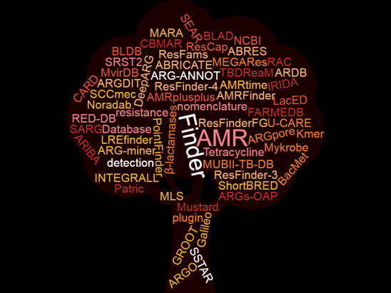

Outline of the exercise:
In this exercise, you will detect antimicrobial resistance (AMR) determinants in four bacterial isolates (Enterococcus faecium, Escherichia coli, Klebsiella pneumoniae, Staphylococcus aureus) based on whole genome sequence (WGS) data. As there are many bioinformatics tools available for this purpose, and due to the lack of a gold standard, you will have to familiarize yourself with as many tools as possible and understand which one(s) you can or cannot use based on your expertise. You will also have to assess if results differ when using different tools, and you should try to understand and explain the underlying reasons. Finally, you will have to predict a phenotype for the isolates under investigation based on the results of the WGS analysis and, for a subset of isolates, compare it with the phenotype obtained in the laboratory, and troubleshoot in case of discordances.

Learning outcomes:
After stage 1 of this exercise, you should be able to:
- Describe usability of different tools for WGS-based detection of AMR;
After stage 2 of this exercise, you should be able to:
- Use at least two different bioinformatics tools for WGS-based detection of AMR;
- Critically evaluate the results of bioinformatics tools for WGS-based detection of AMR;
- Troubleshoot in case of discordance between the results of different bioinformatics tools;
- Troubleshoot in case of discordance between AMR genotype and phenotype.
Instructions – STAGE 2
In this part of the exercise, you should follow the instructions provided below to analyze the FASTA files obtained by whole-genome sequencing (WGS) of four bacterial strains
You can find the FASTA files in the folder “Stage 2 – WGS data”.

The FASTA files are named using the following abbreviations:
- Ef for Enterococcus faecium
- Ec for Escherichia coli
- Kp for Klebsiella pneumoniae
- Sa for Staphylococcus aureus
and
- sr for short reads
- lr for short reads

Your tasks are explained below, along with suggestions for summarizing data. Please note that you do not need to report the results ahead of Session 2, but I recommend that you have an overview of results in front of you as you will be invited to participate actively by answering questions concerning your results.

- Enterococcus faecium data
Please examine the Ef file using at least two bioinformatics tools, and note differences in results when using different tools. Try to think about possible reasons for the observed differences. Additionally, you should use the obtained results to predict the phenotype.
The table below (Table 1) is a suggestion for summarizing data.
Table 1.
Findings | Tool A | Tool B | Predicted resistance phenotype
Gene A | yes | yes | Drug A
Gene B | yes | yes | Drug B
Mutation A | yes | no | ?
Etc.
In the column “Findings”, you should report the AMR genes and chromosomal mutations detected with the tool you used. Add or delete rows according to needs. You can also add columns with findings from additional tools. In the column “Predicted resistance phenotypes”, you should report the antimicrobials towards which the isolate is resistant, based on the genome analysis. In case of discrepant results between tools, you should decide which result you consider reliable.

- Escherichia coli data
Please examine the Ec file using at least two bioinformatics tools, and note differences in results when using different tools. Try to think about possible reasons for the observed differences. Additionally, you should use the obtained results to predict the phenotype.

The table below (Table 2) is a suggestion for summarizing data.
Table 2.
Findings | Tool A | Tool B | Predicted resistance phenotype
Gene A | yes | yes | Drug A
Gene B | yes | yes | Drug B
Mutation A | yes | no | ?
Etc.
In the column “Findings”, you should report the AMR genes and chromosomal mutations detected with the tool you used. Add or delete rows according to needs. You can also add columns with findings from additional tools. In the column “Predicted resistance phenotypes”, you should report the antimicrobials towards which the isolate is resistant, based on the genome analysis. In case of discrepant results between tools, you should decide which result you consider reliable.

- Klebsiella pneumoniae data
Please examine both Kp_sr and Kp_lr files by using one bioinformatics tool of your choice and note differences in results for _sr and _lr. Try to think about possible reasons for the observed differences.
The table below (Table 3) is a suggestion for summarizing data.
Table 3.
Tool chosen:
Findings | Sequence file
 | Kp_sr | Kp_lr
Gene A
Gene B
Mutation A
Etc.
In the column “Findings”, you should report the AMR genes and chromosomal mutations detected with the tool you used. Add or delete rows according to needs.

If you like and/or have the time, you can repeat the analysis using another tool to determine if i) you observe the same differences between _sr and _lr files also with another tool, and ii) if you observe differences between the AMR genes and chromosomal mutations detected by the different tools.

- Staphylococcus aureus data
In the table below (Table 4), you find broth microdilution results for a S. aureus strain. The values reported represent the Minimum Inhibitory Concentration (MIC), expressed in μg/mL, for each antimicrobial. Start by determining if the strain is a wild-type (WT) or non-wild-type (non-WT) for the various antimicrobials, using the EUCAST ECOFFs (remember, MIC ≤ ECOFF is WT, and MIC > ECOFF is non-WT).

Afterwards, run the Sa file using a tool of your choice, and determine if there is a correlation between the phenotypic results obtained by broth microdilution and the AMR genes/mutations detected in the WGS data. If you like and have the time, you can use a second tool and observe if the phenotype-genotype correlation is the same as that obtained using the first tool, or if there are differences.

Table 4.
Staphylococcus aureus | Antimicrobial
 | VAN | Q-D | LZD | MUP | CLN | CHL | CIP | ERY | FOX | GEN | SMX | TET | TIA | TMP | RIF | PEN | KAN | FUS | STR
MIC (μg/mL) | <=1 | <=0.5 | <=1 | <=0.5 | <=0.12 | <=4 | 1 | <=0.25 | 8 | >16 | 512 | >16 | <=0.5 | <=2 | >0.5 | >2 | >64 | <=0.5 | >32
WT or non-WT
AMR genes/mutations (tool A)
AMR genes/mutations (tool B)
Concordance phenotype-genotype
VAN, vancomycin; Q-D, quinupristin-dalfopristin; LZD, linezolid; MUP, mupirocin; CLN, clindamycin; CHL, chloramphenicol; CIP, ciprofloxacin; ERY, erythromycin; FOX, cefoxitin; GEN, gentamicin; SMX, sulphamethoxazole; TET, tetracycline; TIA, tiamulin; TMP, trimethoprim; RIF, rifampicin; PEN, penicillin; KAN, kanamycin; FUS, fusidic acid; STR, streptomycin.

IMPORTANT! For these exercises, I chose specific examples to trigger reflections and discussions. While these examples represent real-life cases, it is important to emphasize that WGS-based detection of AMR is not always problematic.

