Exercise: Exploring tools for WGS-based detection of AMR

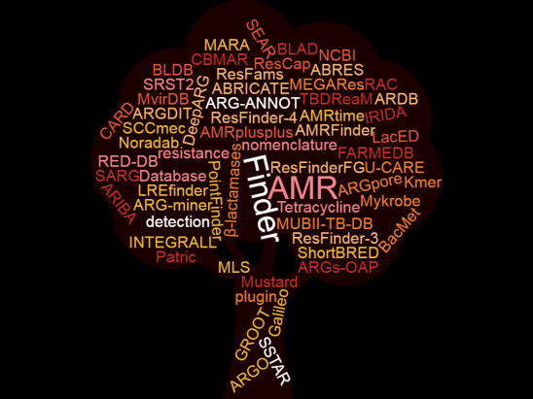

Outline of the exercise:
In this exercise, you will detect antimicrobial resistance (AMR) determinants in four bacterial isolates (Enterococcus faecium, Escherichia coli, Klebsiella pneumoniae, Staphylococcus aureus) based on whole genome sequence (WGS) data. As there are many bioinformatics tools available for this purpose, and due to the lack of a gold standard, you will have to familiarize yourself with as many tools as possible and understand which one(s) you can or cannot use based on your expertise. You will also have to assess if results differ when using different tools, and you should try to understand and explain the underlying reasons. Finally, you will have to predict a phenotype for the isolates under investigation based on the results of the WGS analysis and, for a subset of isolates, compare it with the phenotype obtained in the laboratory, and troubleshoot in case of discordances.

Learning outcomes:
After this exercise, you should be able to:
- Describe usability of different tools for WGS-based detection of AMR;
- Use at least two different bioinformatics tools for WGS-based detection of AMR;
- Critically evaluate the results of bioinformatics tools for WGS-based detection of AMR;
- Troubleshoot in case of discordance between the results of different bioinformatics tools;
- Troubleshoot in case of discordance between AMR genotype and phenotype.

Instructions - STAGE 1
In the first part of the exercise, you should explore as many tools for WGS-based detection of AMR as possible. The following table provides a list of suggested tools. Bear in mind that other tools exist but their primary use may be for example for metagenomic.
Tool | Link
Abricate | https://github.com/tseemann/abricate
AMRFinderPlus | https://www.ncbi.nlm.nih.gov/pathogens/antimicrobial-resistance/AMRFinder/
ARIBA | https://github.com/sanger-pathogens/ariba
LREFinder | https://cge.food.dtu.dk/services/LRE-finder/
Pathogenwatch | https://pathogen.watch/
PATRIC | https://www.bv-brc.org/
ResFinder/PointFinder v4.1 | https://cge.food.dtu.dk/services/ResFinder/
ResFinder/PointFinder v4.3.3 | http://genepi.food.dtu.dk/resfinder
RGI/CARD | https://card.mcmaster.ca/
SRST2 | https://github.com/katholt/srst2
SSTAR | https://github.com/chrisgulvik/c-SSTAR

Exploring a tool means familiarizing yourself with its technical specifications and usability, for example by focusing on the following:
- Which skills do the user need to operate the tool?
- Is the tool regularly maintained (e.g. updates in software and/or database)?
- In which format can WGS data be uploaded?
- Which parameters can the user modify?
- Which algorithm(s) (e.g. BLAST, K-mers, HMM) does the tool use?
- Which database does the tool use (e.g. own database, modified from other databases, generalized, species-specific, etc.)
- Are the inclusion criteria for the genes/mutations database clearly explained?
- Is it possible to download the database?
- Is it clearly explained how the tool selects the genes/AMR mutations to report, among those present in the database?
- Does use of this tool align with your institution policies (e.g. in case you had to upload WGS data produced by you, in the future)?

Afterwards, you are kindly asked to answer some questions so we learn a bit more about you and the methods that you find useful for WGS-based detection of AMR.
Submission of answers is open from 4 September 15:30 to 5 September 23:00 (CEST) under “Share your experience”
Q1. Which tools did you explore?
- Abricate
- AMRFinderPlus
- ARIBA
- LREFinder
- Pathogenwatch
- PATRIC
- ResFinder/PointFinder v4.1
- ResFinder/PointFinder v4.3.3
- RGI/CARD
- SRST2
- SSTAR
- Other (please specify)
- None (please explain)
Q2. Which tool(s) are you planning to use for analysis of Escherichia coli WGS data?
- Abricate
- AMRFinderPlus
- ARIBA
- LREFinder
- Pathogenwatch
- PATRIC
- ResFinder/PointFinder v4.1
- ResFinder/PointFinder v4.3.3
- RGI/CARD
- SRST2
- SSTAR
- Other (please specify)
- None (please explain)
Q3. Which tool(s) are you planning to use for analysis of Klebsiella pneumoniae WGS data?
- Abricate
- AMRFinderPlus
- ARIBA
- LREFinder
- Pathogenwatch
- PATRIC
- ResFinder/PointFinder v4.1
- ResFinder/PointFinder v4.3.3
- RGI/CARD
- SRST2
- SSTAR
- Other (please specify)
- None (please explain)
Q4. Which tool(s) are you planning to use for analysis of Enterococcus faecium WGS data?
- Abricate
- AMRFinderPlus
- ARIBA
- LREFinder
- Pathogenwatch
- PATRIC
- ResFinder/PointFinder v4.1
- ResFinder/PointFinder v4.3.3
- RGI/CARD
- SRST2
- SSTAR
- Other (please specify)
- None (please explain)
Q5. Which tool(s) are you planning to use for analysis of Staphylococcus aureus WGS data?
- Abricate
- AMRFinderPlus
- ARIBA
- LREFinder
- Pathogenwatch
- PATRIC
- ResFinder/PointFinder v4.1
- ResFinder/PointFinder v4.3.3
- RGI/CARD
- SRST2
- SSTAR
- Other (please specify)
- None (please explain)
Q6. What are the determining factors in your choice of tool(s) to use?
- Prior experience with the tool(s)
- Recommendation by other colleagues
- Availability of web-interface since I cannot operate the command line
- Species-specific approach of the tool(s)
- Generalized approach of the tool(s), which allows for high sensitivity
- Other (please specify)

