

Case study
Developing intersectoral collaboration to assess human risk from zoonotic disease
Participant handout

Purpose
The aim of this case study is to demonstrate the application of One Health principles to the development of a vector-borne disease operational research project.
This case study is based on real activities conducted in Poland. It has been adapted for teaching purposes, to ensure anonymity, parts of the story have been fictionalised.
Intended Learning Outcomes
By the end of this case study, participants should be able to:
- Understand the importance of an interdisciplinary approach to investigate human risk from a vector-borne disease.
- Define the prerequisites for a sustainable One Health collaboration.
- Recognise the complexity of microbiological methods in intersectoral investigations.
- Define the study designs and methodological choices for an intersectoral epidemiological investigation.
- Recognise the barriers for intersectoral investigations.
- Propose the Public Health messages that are tailored to different audiences.

How to use this case study?
This case study is designed as stand-alone.
The participants will receive a handout with the scenario and questions they need work on.
Participants should go through the case study, question by question. Each question is followed by a paragraph summarising the answer to the previous questions and introducing the next ones.
Participants should refrain from reading the following pages until all previous questions have been answered.
To ensure the smooth running of the case study, it is advised to discuss some rules with the group.
Below are some suggestions on how to run the case study:
- Distribution: It is proposed to distribute one section at a time or to advise learners not to look at the following pages before they have answered all previous questions.
- Reading Aloud: Participants can take turns to read it aloud paragraph by paragraph.
Note: Reading all paragraphs aloud and in turn has two advantages:
      - Everyone can quickly participate and go beyond the inhibition of having their voice heard in a large room.
      - Time is given to the whole group to understand the issue and think about the answers.
- Answering Questions: The participant reading the question may try to answer it first. Then, the question is discussed as a group.
The next participant then reads the next question and so on until the end of the section.
- Reviewing Objectives: Once the epilogue has been read, it is proposed to go back to the purpose and intended learning outcomes again. This re-iterates the acquisitions and provides an additional opportunity to clarify what may have been misunderstood or not fully acquired.
Estimated duration of the case study: 2 hours

Part 1: Overview of the Public Health problem
Expected duration: 40 minutes
In early summer 2012, you work as an epidemiologist at the Polish National Institute of Public Health. You would like to investigate the risk of tick-borne encephalitis (TBE) in Poland. You have noticed that cases are notified only in few limited regions. Most regions have either no cases reported at all or sporadic cases once every few years.
Figure 1: TBE reported rates by NUTS-4 administrative units, Poland, 1999–2011.
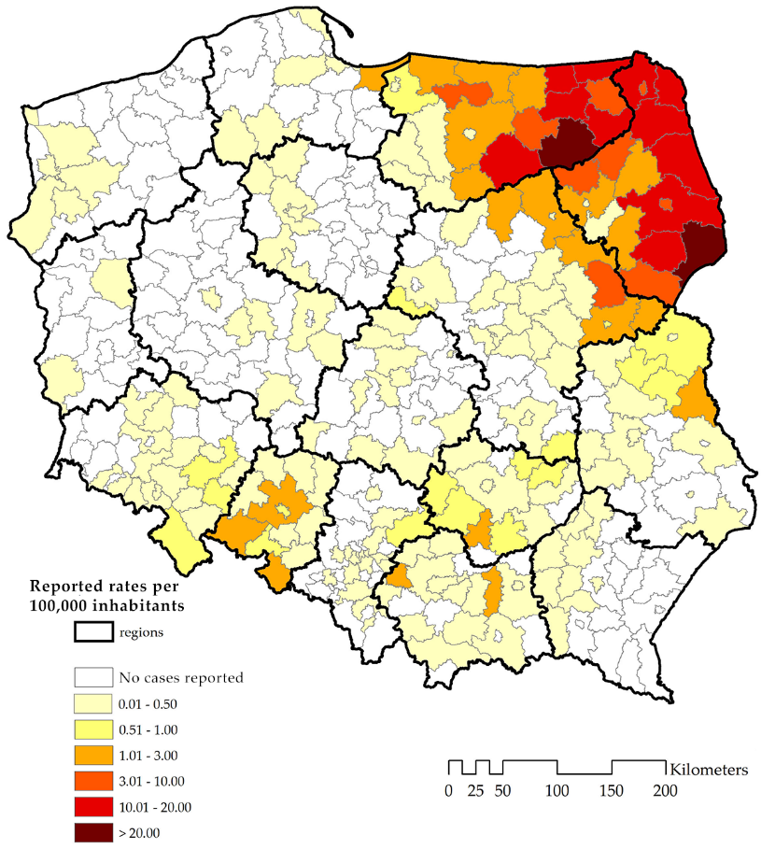

When talking with microbiologists and entomologists on conferences, you understood that human cases are not the most suitable indicator of TBE risk. The virus persists in nature in limited so-called “natural foci”, which are usually the size of a football field, where ticks infected by TBE Virus (TBEV) can find enough small rodents to feed on and ecological conditions are optimal. Although the virus is transmitted from infected female ticks to their offsprings through eggs, and later through consecutive developmental stages (larvae, nymphs, adults), rodents serve as natural reservoir for the virus. The virus does not cause symptoms in rodents and amplifies in their bodies, enabling the spread of the infection to other ticks that feed on the same rodent. Large forest animals, like deer or wild boars, also play a role in maintaining TBE foci since they are the main source of feeding for the adult ticks. Large animals and birds can also move longer distances with attached ticks, potentially spreading the disease to new foci. Humans and livestock animals are so-called “accidental hosts” or “dead-end hosts”, i.e. they can become infected but do not play a role in the life cycle of the TBE virus.
You find a summary of the known facts about TBE in the following fact sheet. You make additional notes.

Tick-Borne Encephalitis (TBE)
- TBE is an infection of the central nervous system caused by Tick-Borne Encephalitis Virus (TBEV), a member of the Flaviviridae family.
- Transmission cycle (depicted on infographic below) involves ticks and small rodents such as voles and mice as a reservoir. Infected ticks transmit the virus, and small mammals are the natural hosts. Humans are incidental and dead-end hosts and can become infected through tick bites or, less commonly, by consuming unpasteurised dairy products from infected animals. Rarely, the virus can be transmitted through blood transfusion, organ transplantation, and breastfeeding.
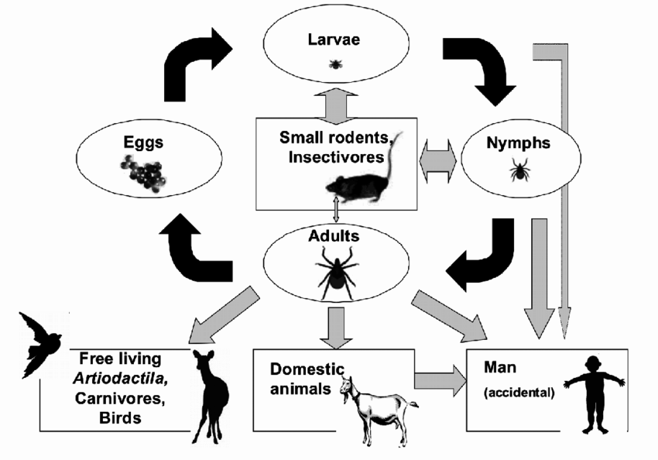
Donoso Mantke, Oliver & Karan, Luidmila & Ruzek, Daniel. (2011). Tick-Borne Encephalitis Virus: A General Overview. 10.5772/21912.
Pathogen
TBEV has three subtypes, of which the European and Siberian subtypes can be found in Europe. The number of human cases of TBE in all endemic regions of Europe has increased by almost 400% in the last 30 years; the risk areas have spread, and new foci have been discovered.

Clinical picture
After an infectious bite of tick, there is an incubation period of about seven days before symptoms appear. This period can sometimes extend up to 28 days. The incubation after foodborne infection, is around four days. Normally, 70-80% of human TBE virus infections are non-symptomatic. Symptoms could occur in two phases:
- First phase (15-30% patients): lasts approximately five days and is characterized by non-specific symptoms, such as fever, fatigue, headache, muscular pain, nausea.
- Second phase (up to 10% patients): lasting approximately seven days and characterized by neurological symptoms such as meningitis (inflammation of the membranes surrounding the brain and spinal cord) and/or encephalitis (inflammation of the brain). Severe cases can result in long-term neurological symptoms or death.
The European subtype is associated with milder disease, with case-fatality of 0.5-2%.
NOTE: There is no antiviral treatment for tick-borne encephalitis (TBE), only supportive treatment.

Laboratory diagnosis
- Laboratory criteria for case confirmation (At least one of the following five):
  - TBE specific IgM AND IgG antibodies in blood,
  - TBE specific IgM antibodies in cerebrospinal fluid,
  - Seroconversion or four-fold increase of TBE-specific antibodies in paired serum samples,
The ECDC case definitions include “detection of TBE viral nucleic acid in a clinical specimen” and “Isolation of TBE virus from clinical specimen” for case confirmation, but they are never used for routine diagnosis.
NOTE: Routinely used anti-TBEV serologic tests can give cross-reactions with other flavivirus infections and vaccination against flaviviruses

Prevention measures
- Personal protection: use insect repellents, wear protective clothing to prevent tick bites.
- Vaccination: available in some disease endemic areas.
- Avoidance: refrain from consuming unpasteurised dairy products in endemic regions.
NOTE: In Poland, the vaccine is recommended to residents of endemic areas and to people professionally exposed (i.e., foresters)

To recommend the vaccine to residents and visitors of endemic areas, you need to know where the risk for humans persists, i.e. which areas are TBE-endemic. You think that just relying on passive surveillance of human cases may not be sufficient.
Question 1: How can you reliably monitor a disease such as TBE where humans are accidental hosts?

During further discussions and literature searches, you learn that there are several challenges with using human cases to map endemic areas:
- An estimated 70-95% of infections with European TBE subtype are asymptomatic and 2/3 of symptomatic cases have mild symptoms like fever, typically not referred to testing.
- Diagnostic detection bias leading to increased testing in known endemic areas and lack of testing in areas considered non-endemic.
- In large urban centres, due to frequent travelling and travel immunisation, incidence will not be a good indicator of TBE risk.
- In districts with a large proportion of residents vaccinated against TBE, there may be only few diagnosed and reported cases but still a high risk for visitors.
With your team, you discuss other ways to document the TBE risk. You consider various options and start to think who to contact in other institutions in the country.
Question 2: Which actors (disciplines, professions or institutions) can be involved in collecting data from animals and vectors?

You discuss with your team which data on animals or vectors could be a good indicator of TBE risk in humans. In principle, ticks and rodents should be the perfect indicator of TBE local risk, since they are the natural reservoir of the virus. Such investigations enable isolation of the virus and studying the genetic changes in the virus on a given territory. However, you would have to tests thousands of ticks and/or hundreds of rodents collected in many locations, which would be extremely costly.
You briefly discuss and consider testing carcasses of hunted game that could be done in collaboration with hunters and district veterinarians. However, you could not assure a standardised approach due to many stakeholders involved. Finally, you choose as best option to screen livestock animals for anti-TBEV antibodies as indicators of local TBE transmission. Livestock animals, especially bred in larger food producing plants, undergo regular health checks and live in proximity of human dwellings. Therefore, livestock animals could be good “sentinels” of human exposure to tick-borne pathogens that collect ticks from the vegetation surrounding the farms.
You think you could use left-over funding from an ongoing project in which you were involved in the past three years. You receive approval to use 15K EUR for intersectoral risk assessment project. While the emotions don’t let you sleep at night, you realise that there are not enough qualified experts in your Institute to plan such a study or carry out the fieldwork. You decide to contact other institutions to propose collaboration.
Question 3: What should be considered when proposing collaboration on scientific investigations with other sectors?

Part 2: Planning a collaborative project
Expected duration: 40 minutes
You first approach the Ministry of Agriculture and the General Veterinary Inspectorate. You think that due to their legal mandate, these institutions could help you organise the fieldwork efficiently and understand the Public Health rationale of your approach. Already at this stage, you think about a long-term sustainable solution. A governmental institution could be a reliable partner for a future integrated surveillance if the results of your pilot study would lead to such recommendation. However, after several attempts to identify officials that would talk to you, you understand that any collaboration with the animal health sector requires an official agreement at the ministry level. Some ministry contacts even suggest that starting an intersectoral collaboration would need changing the legal acts guiding the work of both institutions.
Following this, you decide to focus on a pilot study that could provide evidence for a potential systematic approach in the future. You contact research institutions, looking for affiliations of authors of relevant publications. You find some researchers who studied the prevalence of pathogens in ticks. However, there are no published studies on TBE in animals that were carried out in Poland. Also, there were only sparse studies from other countries. When approaching researchers, you offer funding for the field work and co-authorship in resulting publications. Many research groups refuse because this type of study is not in line with their workplan or area of interest. However, some contacted researchers from universities, consider your request.
Question 4: What are the advantages and disadvantages of developing intersectoral collaboration with university-based research teams?

Following the review of the literature and discussions with animal health experts and entomologists, you decide to screen livestock animals for anti-TBEV antibodies. The best “sentinels” of human TBE risk would be animals living close to humans, but who can roam freely around their farms. You decide to focus on goats, which are bred all around the country. You identify a veterinary team based in a polish university, specialised in goat health. They confirmed their interest in the proposed research. The team consists of an adjunct professor graduated from veterinary university in 1990, two research assistants and one PhD student, the three of them graduated in 2006-2008.
There is however one more issue flagged by the arbovirus expert from your Institute. She explained that TBEV is usually not detected in blood or cerebrospinal fluid in any stage of disease. Therefore, direct detection methods (PCR-based) are not useful in either routine diagnostics or detecting past infections. Therefore, you can only confirm TBE indirectly by detecting anti-TBEV antibodies. The Institute laboratory uses routinely the enzyme-linked immunosorbent assay {ELISA} designed for testing human specimens (serum and cerebrospinal fluid).
The Institute laboratory currently does not offer tests that would allow reliable confirmation of TBEV in animals. Also, veterinary institutions in Poland did not have established methods. There are two types of tests that allow detections of anti-TBEV antibodies in both humans and animals, haemagglutination inhibition {HI} and plaque reduction neutralisation test {PRNT}. Since both tests require working with a live virus, they can be done only in an approved biosafety level 3 (BSL-3) laboratory.
Question 5: Considering that other flaviviruses can be present in Poland, how can you address the problem of confirming TBE infection in goats?

You learn that laboratories in several European countries offer HI and/or PRNT testing. However, the cost of shipment and testing of samples to foreign laboratories would be prohibitively high. You decide to validate the human commercial ELISA for testing goat specimens. The arbovirus expert prepares the protocol for such a validation procedure. She explains that the validation is important, because some proteins present in goat blood can interfere with the immunologic reaction. Therefore, her laboratory needs to set a new cut-off against validated “positive and negative controls”. To obtain such valid controls, the Polish laboratory will need positive and negative goat serum specimens tested with a species-independent test considered as “gold standard” for TBE.
She also explains that TBEV belongs to the family of flaviviruses, which are structurally very similar, and are responsible for millions of infections in animals and humans worldwide every year. Antibodies against one flavivirus or following vaccination against a flavivirus, can give positive reaction in the ELISA test for another flavivirus (cross-reaction). Therefore, if more than one flavivirus is present on a given territory, positive ELISA tests should be ideally confirmed by a HI or PRNT test.
You decide to take action to help your virologist in getting required material support. You review your list of contacts of virologists you met on various conferences and network meetings. After few weeks of correspondence, the Institute of Virology of Slovakia agrees to send goat sera confirmed positive and negative with HI test. At the same time, a virologist from Hungary that you met on an ECDC fellowship module and befriended, agreed to help by retesting the goat specimens that were positive or negative in the validation study, using their in-house HI test.
Question 6: Which study design would be most suitable to ascertain the proportion of goats positive for anti-TBEV antibodies as “sentinels” for human TBE risk?
You discuss with a statistician and decide to carry out a cross-sectional survey of goat farms, located in all sixteen provinces and collect serum and milk samples from goats bred at each farm. The statistician also advises you to apply stratified sampling, by selecting a separate sample of farms in known TBE endemic regions, and a separate – in non-endemic regions. To achieve geographic representativeness, you apply to the Ministry of Agriculture for a complete list of milk-producing goat farms registered at the Ministry. However, the Ministry unfortunately cannot share confidential information (i.e., contact information) with researchers, since it does not have a legal basis for such an action. The Ministry at least provides a map in JPEG format of all registered goat farms.
Figure 2. Geographical location of goat milk-producing farms registered at the Agency for Restructuring and Modernization of Agriculture, Poland, 2011.
One dot represents 5 goats (477 farms, breeding 13,387 goats)
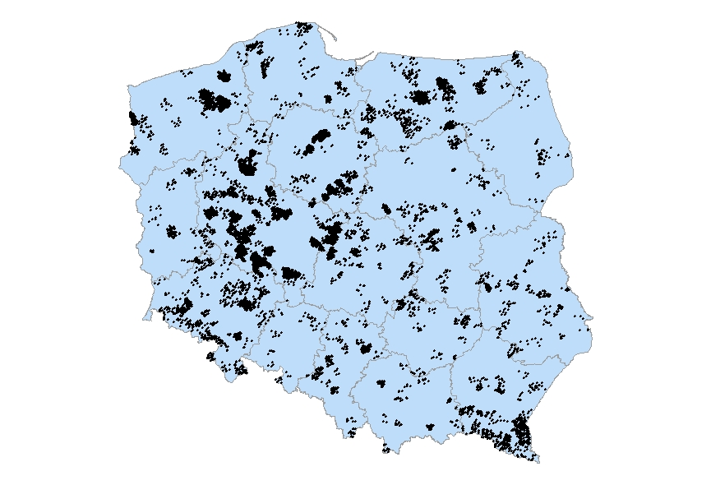

The veterinary team from a large university which you contacted earlier, informs you that they are periodically visiting milk-producing farms for regular health checks. They have more than 120 large farms on their list, located in 12 provinces. They inform you that four provinces do not have registered large farms, only small farms breeding only a few goats for hobby or for self-sufficient farming. The veterinary team offers to select the farms from their list, if you provide the selection criteria.
Question 7: Is it a problem that the distribution of farms is not uniform across the country?

You discuss again with your statistician the selection of goat milk-producing farms. Your primary aim is to assess the usefulness of goats bred around the country as “sentinels” for spatially referenced human TBE infections. In the proposed approach, you would like to “translate” the TBE seroprevalence in livestock animals living in various regions into an intuitive TBE risk map. Therefore, your sample of milk-producing farms does not have to represent all the milk producing farms but rather should be geographically representative, i.e., represent all administrative areas.
Therefore, you would like to carry out the study in many geographical locations spread out in the entire country. One approach would be to first select a sample of administrative areas spread out in the country and then screen goats bred in these areas. This way, your sampling frame would be the list of administrative areas. Another approach would be to select goat milk-producing farms spread throughout the country. In this case the sampling frame will be the list of milk-producing farms. You discuss about a practical and feasible sampling strategy.

Question 8: Propose a sampling strategy to select the farms for your pilot study

With your statistician you revise the map of registered goat milk-producing farms (Figure 2). You see that the milk-producing farms are not evenly distributed, i.e., there are areas without any single farm and many areas with only few small farms. You agree that your primary sampling unit should be a farm. To assure good geographic representation, you propose a multi-stage sampling. First, you will select provinces stratified by known TBE endemic and non-endemic regions. You decide to limit the study to 9 out of 16 provinces, to address logistical constrains of the veterinary team related to travelling to distant locations. Second, you will select an equal number of farms in each province, each farm located in a different district, and test 15 goats randomly selected from each farm.
This approach, equivalent to cluster sampling (where farms are clusters), will enable selecting a fair representation of farms located in “pilot” provinces and address your shortcomings:
- You do not have a list of registered farms. Therefore, you will not have a sampling frame that would allow you drawing a representative sample.
- Your budget does not allow having too many farms located far away from each other. This would increase the cost of travel of the field workers and create challenges with transporting the specimens.
The advantage of having goats and not humans as subjects, is that on each farm, you will be able to draw specimens from randomly selected goats, without asking them for permission. Nevertheless, you still need to consider ethical issues related to investigating animals. The best would be to consult relevant online resources and consult a specialised ethical committee.
Question 9: Why do you want to screen animals in both endemic and non-endemic regions?

Your statistician asks why you cannot just select farms in regions not reporting human TBE cases. You explain that in your pilot study the main hypothesis is that goats roaming freely in a few kilometres radius around the farm and collecting lots of ticks, may serve a sentinel of TBE virus presence and potential risk for humans during outdoor activities. To check such a hypothesis, one needs to both confirm that goats are positive in the known endemic areas and negative in the areas where the virus is absent. You just need to make sure to include in your protocol a strict requirement to exclude goats that were moved between regions during their lifetime, i.e., who were not born on investigated farms.
You cannot forget about the minimum sample size estimation. You use the OpenEpi online calculator (https://www.openepi.com/Menu/OE_Menu.htm), and agree on the following assumptions:
- In endemic regions, you anticipate 7.5% seropositive goats, confidence limits +/-3%, design effect of 1.5. You obtain a minimum sample of 420 goats (=28 farms);
- In non-endemic regions, you anticipate 2.5% seropositive goats, confidence limits +/-1.75%, design effect of 2. You obtain a minimum sample of 594 goats (=40 farms).

Part 3: Implementation of the intersectoral project
Expected duration: 30 minutes
According to your sample size estimation, to achieve required precision, you need to test at least 420 goat sera in four TBE endemic provinces and 594 goat sera in five non-endemic provinces. This means that you would aim to include at least 68 farms and collect 15 specimens at each farm. Therefore, considering that at least 10% of farms may refuse participation, you decide to visit at least 76 farms, eight to nine farms in each of the nine provinces. This approach required compromising lower precision of your estimates in the non-endemic provinces and higher precision of your estimates in the endemic provinces, as you probably noticed during the sample size estimation.
You meet with the veterinary team and present your protocol. After considering logistical aspects, they agree with most procedures but would like to select the farms from their own list to minimise travelling time and costs. Together, you develop the list of materials needed for the field trip (sample collection tubes, syringes, printed questionnaires to collect milk-production and milk-consumption practices at the farms, basic information on goat specimens).
The veterinary team proposes that they will apply for the ethical clearance of their university ethical committee. While waiting for ethical clearance, you organise additional meetings, where you review the quality assurance procedures, go through the inclusion and exclusion criteria. Finally, the ethical committee approves your study, and the veterinary team swiftly organises the field trip.
Question 10: How could you plan quality assurance in a subcontracted field work?

The veterinary team is indeed extremely efficient. After a week, they bring large bags with collected and frozen sera with the documentation. Your team at the Institute proceeds with the validation of human serologic assay to test biological specimens from goats. Following successful validation of these tests, all the specimens are being tested.
When you review the results, however, you notice that the veterinary team only visited 47 farms and collected 764 specimens. You call them and you learn that they visited farms that were scheduled previously for a routine health survey, and they just visited 8 farms per region in six regions according to the protocol. They never planned to visit the remaining three regions, since they were visited during the past two years. They offer to provide materials from the three remaining regions by randomly selecting sera from their archived serum bank. You agree on this solution, because it will allow you to assess the risk based on the location of the farms. Soon you receive a smaller bag with 358 frozen goat sera collected in 2010-2011 in 35 farms located in the three missing regions.
You summarise the results of the survey. Of 1,112 collected sera, 52 were positive for anti-TBEV antibodies, for an overall seroprevalence of 4.6% (95% CI 2.7-6.5). Seroprevalence in endemic regions was 27/339 (8.0%, 95% CI 3.5-12.5), and was higher compared to non-endemic regions – 25/783 (3.2%, 95% CI 1.4 – 5.0).

Goats age | Samples tested | TBEV IgG-positive | Sero-prevalence (%) | Sero-prevalence (95% CI)
1 year | 385 | 18 | 4.7 | 1.5 – 7.8
2 years | 135 | 7 | 5.2 | 0.0 – 10.4
3 years | 175 | 6 | 3.4 | 0.6 – 6.2
4 years | 124 | 4 | 3.2 | 0.3 – 6.2
5 years | 86 | 5 | 5.8 | 0.0 – 12.5
6 or more years | 149 | 9 | 6.0 | 0.0 – 12.9
All tested | 1,122 | 52 | 4.6 | 2.7 - 6.5

When you continue to analyse the provided dataset, you notice that the information on the geographical location of the farm (region, district, municipality, address) is missing in all the collected forms. When you ask the veterinary team to complete this information, they refuse, explaining that they need to protect the milk-producing business and wellbeing of the farmers, who are their customers. They were happy to contribute to the survey, since it was aligned with their routine health checks of goat milk-producing farms. But now, they feel that the study can harm the farmers by publicizing the risk related to consumption of goat dairy products. Therefore, they do not want the National Institute of Public Health to use these data for precise risk assessments. Despite many interventions, including meetings between the Director of the Public Health institute and the Dean of the university, the veterinary team does not share the necessary information.
Question 11: Why is it a problem that the veterinary team did not follow some study protocol procedures?

Following the heated argument, you realise that although you received biological materials from milk-producing farms, you cannot really use them.
First, you are not sure whether the veterinary team followed the agreed protocol. Since they skipped three provinces without consulting you and collected different number of goat sera from each farm, you cannot be sure if they followed other procedures. It can also have ethical implications, because you are not sure if they disclosed to the farmers the purpose of the survey, collected their consent to collect the information on the farm, etc.
Second, without the geographic coordinates of the farm, you cannot assess the risk for humans. The purpose of your investigation was to use livestock animals as sentinels for the spatially referenced TBE risk, a form of “validation” of TBE endemic areas.
Question 12: If you could start all over again, how would you foster trust and mutual understanding with the veterinary sector in future investigations?

You discuss with your management how you could avoid such conflicts in the future. Some colleagues believe that you could avoid such situation by signing a formal contract with the veterinary team to enforce quality assurance, assure collecting of complete data and supervise their fieldwork. They would get paid only when dutifully completing their tasks. However, deep inside, you feel that treating the veterinary team as subcontractors would not help in building trust and a long-term partnership.
You brainstorm with your team about the argument with the veterinary team. During the argument, you were too emotional to really understand their logic. But now, after calming down, you try to put on an “animal health expert hat” and understand their arguments. Their main task is to teach students about infectious and chronic diseases of goats. In addition, they are expected to do research and publish their work in peer-reviewed journals. For more than a decade, they have developed a relationship of trust with an increasing network of milk-producing farmers. They visited them regularly and offered health checks, screening for important pathogens, advising on prophylaxis and milk production. It took them time to build this kind of trust, and they can quickly lose it. When an enthusiastic well-published researcher came to them offering funding to do a survey that they could align with their routine work, they thought why not have another publication with a minimal effort. But they would prefer not to breach the confidentiality of their customers and maybe did not fully understood the communication on the public health rationale of the project. You conclude that on one hand, the veterinary team did not follow the protocol and ethical principles. But on the other hand, they probably gave priority to protecting their core business. From their perspective, TBE is not important for goat health. Aside from the unclear ethical aspects, you can even understand their reasoning.
You propose to your Institute director calling up a working group between institutions working with public health, animal health, forestry and wildlife protection, working at the national level. This cooperation would likely need intersectoral memorandum of understanding between three ministries that supervise these institutions: Ministry of Health, Ministry of Agriculture and Ministry of Environmental Protection. The working group could meet regularly and discuss how to better collaborate in the food safety area, to make sure that the human health is protected on one hand, and the interests of farmers are also considered.
Question 13: Formulate a message for veterinary experts that could improve their collaboration in future intersectoral TBE risk assessment

Part 4: Epilogue
Expected duration: 10 minutes
Unfortunately, because of the conflict situation, missing variables and unclarities related to the ethical compliance, you could not publish the results of the investigation in a peer-reviewed journal. You were extremely disappointed, but you also learned a lot.
You decided to engage in the newly formed intersectoral working group. You thought that discussing with the other sector experts every month will allow a better understanding of their perspective, context in which they are working, and mission of their respective institutions. Knowing each other will also help in building mutual trust and plan new intersectoral investigations without hurry.
You also reflect about what went wrong in your investigation. Aside from misunderstandings regarding the scientific contents, you probably did not communicate clearly the Public Health rationale that the veterinarians and farmers could identify with. You discuss with your team which type of messages for farmers could potentially help in setting up a similar screening programme, that could include testing of milk and assessing farm-level TBE foodborne transmission risk:
- Goat milk is a very healthy food. However, unpasteurized milk and dairy products could carry pathogens which can harm consumers and your family. Since it’s not possible to test dairy products for all possible pathogens, it is safer to cook or pasteurise all milk products.
- Although your livestock animals are not affected by the TBEV, testing them can help us understand if there are infected ticks in your neighbourhood that can feed on humans during outdoor activities. Knowing that the disease is there will help us better protect your community and your family.
- Your participation in this screening programme will be a guarantee for your clients that you are a reliable producer, and your product is safe from the TBEV.
Question 14: How would you see the collaboration with other sectors in 20 years?

References
- Ruzek D, Avšič Županc T, Borde J, Chrdle A, Eyer L, Karganova G, Kholodilov I, Knap N, Kozlovskaya L, Matveev A, Miller AD, Osolodkin DI, Överby AK, Tikunova N, Tkachev S, Zajkowska J. Tick-borne encephalitis in Europe and Russia: Review of pathogenesis, clinical features, therapy, and vaccines. Antiviral Res. 2019 Apr;164:23-51. doi: 10.1016/j.antiviral.2019.01.014. Epub 2019 Jan 31. PMID: 30710567.
- Brêchet A, Kohler P, Dörr T, Grässli F, Vock M, Salát J, Růžek D, Friedl A, Vuichard-Gysin D, Croxatto A, Lienhard R, Ackermann-Gäumann R. Tick-borne encephalitis virus seroprevalence and infection incidence in Switzerland, 2020-2021. Sci Rep. 2025 Mar 11;15(1):8346. doi: 10.1038/s41598-025-92560-1. PMID: 40069290; PMCID: PMC11897124.
- Topp AK, Springer A, Mischke R, Rieder J, Feige K, Ganter M, Nagel-Kohl U, Nordhoff M, Boelke M, Becker S, Pachnicke S, Schunack B, Dobler G, Strube C. Seroprevalence of tick-borne encephalitis virus in wild and domestic animals in northern Germany. Ticks Tick Borne Dis. 2023 Nov;14(6):102220. doi: 10.1016/j.ttbdis.2023.102220. Epub 2023 Jun 23. PMID: 37356181.
- Stefanoff P, Pfeffer M, Hellenbrand W, Rogalska J, Rühe F, Makówka A, Michalik J, Wodecka B, Rymaszewska A, Kiewra D, Baumann-Popczyk A, Dobler G. Virus detection in questing ticks is not a sensitive indicator for risk assessment of tick-borne encephalitis in humans. Zoonoses Public Health. 2013 May;60(3):215-26. doi: 10.1111/j.1863-2378.2012.01517.x. Epub 2012 Jul 6. PMID: 22765504.
- Stefanoff P, Zielicka-Hardy A, Hlebowicz M, Konior R, Lipowski D, Szenborn L, Siennicka J, Orlikova H; TBE enhanced surveillance working group. New endemic foci of tick-borne encephalitis (TBE) identified in districts where testing for TBE was not available before 2009 in Poland. Parasit Vectors. 2013 Jun 18;6:180. doi: 10.1186/1756-3305-6-180. PMID: 23777675; PMCID: PMC3689627.

Credits
This case study was initially produced for the One Health ECDC fellowship module in May 2025.
It was developed by Pawel Stefanoff and critically reviewed by Anna Machowska, Timothee Dub, Ambrogio Cerri, Gaetano Marrone (ECDC, Stockholm); Kim Blom (Folkhälsomyndigheten, Stockholm); Teresa Nygren (Robert Koch Institute, Berlin); Piotr Polanski (National Institute of Public Health – National Institute of Hygiene, Warsaw)

Copyright and License
This training material is published under a Creative Commons (CC BY) licence. You must give appropriate credit, provide a link to the licence, and indicate if changes were made.
You may do so in any reasonable manner, but not in any way that suggests ECDC endorses you or your use. For more information, please check http://creativecommons.org/licenses/by/4.0/.
For more information, visit ECDC Learning Portal: User policy information and code of conduct.

