Exercise: Basic analysis of three NGS SARS-CoV-2 amplicon data sets

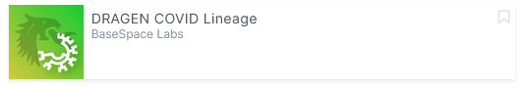

Outline of the exercise:
In this exercise, you will use the DRAGEN COVID Lineage app on the Illumina Basespace cloud to analyze three different NGS data sets of SARS-CoV-2. You will create a project, upload the NGS data and start the analysis with the appropriate settings. You will evaluate the results for their quality, detect the SARS-CoV-2 variant and mutations in the S-gene.

Steps to follow:
- If you do not have a Basespace account you need to create one: https://platform.login.illumina.com/platform-services-manager/?rURL=https://basespace.login.illumina.com/platform-home/&redirectMethod=GET&clientId=ps-home#/register
- Download the three NGS data sets from EVA. Each sample consists of 8 fastq.gz files.
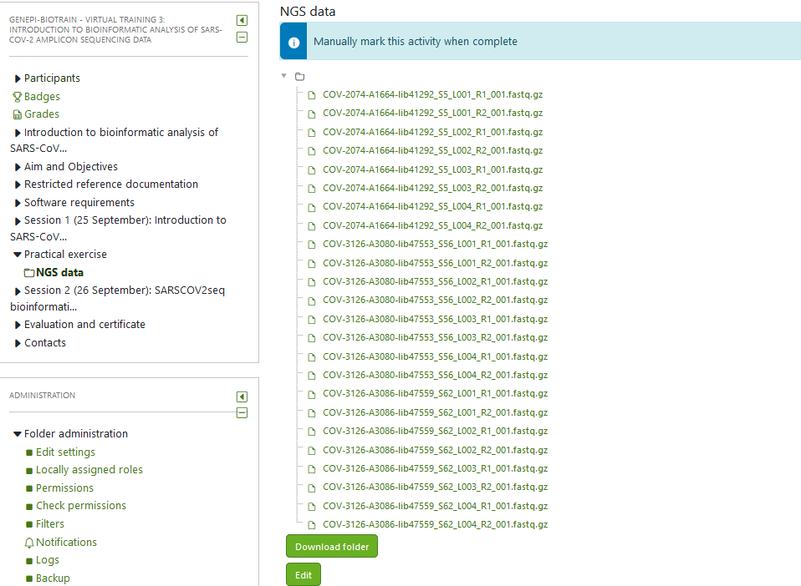
blue: artic v3; orange: artic v4.1
- Create a new project on Basespace
- Upload NGS datasets to the created project
- Launch the DRAGEN COVID Lineage App
- Select the samples to be analyzed and select the correct amplicon panel version!
- NOTE! You need to start the analysis at least two times to use different amplicon panel versions. Only include in the analysis the corresponding datasets and not each time all three.
- Get an overview about the summary report and critically evaluate the results of the app.
  - Have a look on coverage and amplicon coverage. Do you observe any peculiarities?
  - Which SARS-CoV-2 variants are identified?
  - Which mutations in the S-gene are identified?
  - Would you continue with all datasets if you would like to analyze S-gene mutations?
- Also have a look at covariants.org and cov-lineages.org webpages for variant and mutation information

