MODULE 3: COMMUNITY
INJECT 1.0


DATE: 4 August
FROM: Anytown Hospital
SUBJECT: Patients with Legionnaires’ disease

Notification of 8 patients with Legionnaires’ disease from Anytown hospital
Please find below the details of 8 patients with confirmed or suspected Legionnaires’ disease, among inpatients at Anytown Hospital, all of whom are residents of Anytown. Diagnoses between 31 July and 3 August.
ID | Sex | Age | Symptom onset | Admission | Clinical status | Microbiology results | Date of test
1 | M | 45 | 23/07 | 31/07 | Suspected pneumonia, chest pain, cough | UAT* pos for Lp sg 1** | 31/07 (primary health doctor)
2 | F | 72 | 26/07 | 29/07 | Pneumonia, nausea, vomiting, and diarrhoea; high fever, cough | UAT pos for Lp sg 1 | 03/08
3 | M | 54 | 27/07 | 30/07 | Pneumonia, fever, cough | UAT pos for Lp sg 1 | 03/08
4 | M | 55 | 27/07 | 30/07 | Pneumonia, fever, cough, difficulty breathing | UAT pos for Lp sg 1 | 03/08
5 | M | 62 | 30/07 | 31/07 | Suspected pneumonia, high fever, cough, difficulty breathing | UAT pos for Lp sg 1 | 03/08
6 | F | 89 | 30/07 | 31/07 | Disorientation, confusion, gastrointestinal discomfort | UAT pos for Lp sg 1 | 03/08
7 | F | 78 | 30/07 | 01/08 | Suspected pneumonia, fever, cough | UAT pos for Lp sg 1 | 03/08
8 | M | 66 | 30/07 | 01/08 | Pneumonia, high fever, breathlessness; deteriorating. Immunocompromised due to cancer, chemotherapy. | UAT pos for Lp sg 1 | 03/08
* Urinary Antigen Test
**Legionella pneumophila serogroup 1

Note: A mean of 19.4 cases per year (range 16–26) were recorded in Anytown over the past five years. Until 1 August, 6 cases of Legionnaires’ disease have been reported in Anytown this year.

MODULE 3: COMMUNITY
INJECT 1.0

SESSION 1: QUESTIONS

- What is your initial assessment?
  - Is this an outbreak? Why or why not?
  - Discuss use of case definitions.

- What immediate actions would you take at this point?
What are your next steps in the investigation of, and response to, this situation?

- Who are you communicating with about this situation?
By which methods and to what timeline? What information do you need?

- What are the co-ordination arrangements you should consider in this situation?

INJECT 2.0
MODULE 3: COMMUNITY

DATE: 7 August
FROM: Anytown Hospital
SUBJECT: Additional cases of Legionnaires’ disease

Notification of 12 additional cases of Legionnaires’ disease from Anytown hospital
Please note the following additional 12 patients now diagnosed with Legionnaires’ disease since our previous report on 4 August.
ID | Sex | Age | Symptom onset | Admission | Clinical status | Microbiology results | Date of test
9 | M | 55 | 31/07 | 04/08 | Pneumonia, fever, cough | UAT pos for Lp sg 1 | 04/08
10 | M | 76 | 31/07 | 05/08 | Pneumonia, fever, cough | UAT pos for Lp sg 1 | 05/08
11 | M | 46 | 01/08 | 05/08 | Pneumonia, fever, cough, difficulty breathing | UAT pos for Lp sg1 | 05/08
12 | F | 79 | 01/08 | 05/08 | Pneumonia, fever, cough | UAT pos for Lp sg 1 | 06/08
13 | M | 88 | 01/08 | 06/08 | Pneumonia, nausea, vomiting, and diarrhoea; high fever | UAT pos for Lp sg 1 | 06/08
14 | F | 92 | 02/08 | 06/08 | Pneumonia, disorientation, confusion, gastrointestinal discomfort | UAT pos for Lp sg 1 | 06/08
15 | F | 56 | 02/08 | 06/08 | Pneumonia, fever, cough | UAT pos for Lp sg 1 | 06/08
16 | M | 63 | 02/08 | 07/08 | Pneumonia, high fever, cough;  Immunocompromised due to cancer, chemotherapy. | UAT pos for Lp sg 1 | 07/08
17 | M | 63 | 03/08 | 07/08 | Pneumonia, fever, cough | UAT pos for Lp sg 1 | 07/08
18 | M | 78 | 03/08 | 07/08 | Pneumonia, chest pain, cough | UAT pos for Lp sg 1 | 07/08
19 | M | 47 | 03/08 | 07/08 | Pneumonia, high fever, cough;  Immunocompromised due to cancer, chemotherapy. | UAT pos for Lp sg 1 | 07/08
20 | M | 49 | 03/08 | 07/08 | Pneumonia, chest pain, cough | UAT pos for Lp sg 1 | 07/08
Please also note that five of the eight original patients reported on 4 August have now been admitted to the Intensive Care Unit. All eight also have a diagnosis of clinical pneumonia.

INJECT 2.1
MODULE 3: COMMUNITY

DATE: 7 August
FROM: Public Health Officer
SUBJECT: Case finding

Results from case finding and review of previous Legionnaires’ disease notifications in the Anytown area
A review of previous notifications of patients with Legionellosis from 1 May, as well as active case finding in Anytown and the areas neighbouring Anytown, allowed the identification of 33 Legionnaires’ disease cases in total so far. In addition to the cases notified by Anytown Hospital on 4 and 7 August, the review lists the following cases (all having clinical diagnosis of pneumonia), not all of which are necessarily linked to the current outbreak:

ID | Sex | Age | Symptom onset | Microbiology results | Date of test | Notes
21 | F | 78 | 24/06 | UAT pos for Lp sg 1 | 29/06 | Potential sporadic case, no particular risk sources identified
22 | M | 67 | 27/06 | UAT pos for Lp sg 1 | 03/07 | Potential nosocomial case, due to incubation time spent in medical rehabilitation facility
23 | M | 65 | 03/07 | UAT pos for Lp sg 1 | 10/07 | Potential travel-associated to Country B, due to travel abroad for two weeks before falling ill
24 | M | 65 | 11/07 | UAT pos for Lp sg 1 | 19/07 | Diagnosed by primary health doctor, recovered
25 | F | 72 | 11/07 | UAT pos for Lp sg 1 | 19/07 | Diagnosed by primary health doctor, recovered
26 | F | 48 | 15/07 | UAT pos for Lp sg 1 | 20/07 | Diagnosed by primary health doctor, recovered
27 | M | 95 | 18/07 | UAT pos for Lp sg 1 | 24/07 | Diagnosed by primary health doctor, deceased
28 | F | 77 | 21/07 | UAT pos for Lp sg 1 | 27/07 | Diagnosed in Neighbourtown Hospital, recovered and discharged
29 | M | 69 | 21/07 | UAT pos for Lp sg 1 | 27/07 | Diagnosed in Neighbourtown Hospital, recovered and discharged
30 | M | 77 | 22/07 | UAT pos for Lp sg 1 | 31/07 | Patient hospitalised in Neighbourtown
31 | M | 59 | 22/07 | UAT pos for Lp sg 1 | 31/07 | Patient hospitalised in Neighbourtown
32 | M | 82 | 23/07 | UAT pos for Lp sg 1 | 31/07 | Patient hospitalised in Neighbourtown
33 | F | 81 | 24/07 | UAT pos for Lp sg 1 | 31/07 | Patient hospitalised in Neighbourtown
Continued on second page.

DATE: 7 August
FROM: Public Health Officer
SUBJECT: Case finding
Results from case finding and review of previous Legionnaires’ disease notifications in the Anytown area
Please see below a chart plotting all 33 cases by date of symptom onset:

Please note that all cases are Anytown residents. Case interviews are currently taking place.

INJECT 2.1 continued
MODULE 3: COMMUNITY
INJECT 2.2
MODULE 3: COMMUNITY

DATE: 8 August
FROM: National Meteorological Service
SUBJECT: Meteorological data Anytown, 1 June to 31 July

Evaluation of local weather conditions for Anytown, 1 June to 31 July
Good morning,
The evaluation of the meteorological conditions from Anytown showed that the mean temperatures were on average 3.2 and 1.2°C above the climatological mean (1981–2020) during June and July, respectively, in association with stormy conditions in late June and early July.
A heat wave was recorded in the Anytown area from 6 to 13 July, with the third highest mean temperature recorded since 1864.
A gusty, northerly wind coincided with the days of the heat wave; a rare weather phenomenon for Anytown, where the usual wind direction is from the southwest.
Please let us know if you have any further questions.

Hannah Lange
Administrative Officer
National Meteorological Service

INJECT 2.3
MODULE 3: COMMUNITY

DATE: 8 August
FROM: Public Health Officer
SUBJECT: Case geographical mapping

Geographical mapping of confirmed Legionnaires’ disease cases across Anytown
Case interviews identified overlapping visit, work or residential locations, including local movements, pointing to the Anytown Harbour area for 25/33 cases, comprising 13 residents, 2 workers and 10 visitors (people visiting cafés, restaurants, shops or having regular activities in the area for more than two hours per day)
Mapping of confirmed cases of Legionnaires’ disease in Anytown by place of residence provides the following picture. Blue dots indicate 25 confirmed cases with a connection to the Anytown Harbour area. Red dots indicate 8 confirmed cases with no such connection.

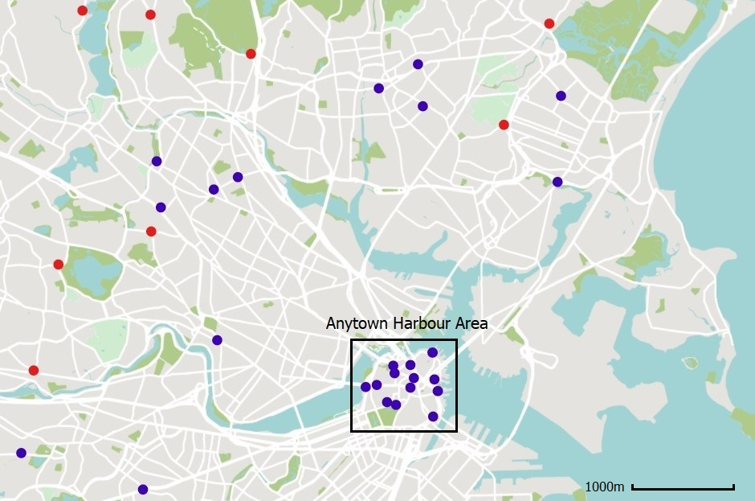

MODULE 3: COMMUNITY
INJECT 2.4

DATE: 8 August
FROM: Anytown City Council
SUBJECT: Register of cooling tower systems in Anytown

Register of at-risk cooling tower systems in Anytown
Good afternoon,
Anytown City Council holds a voluntary register of cooling tower systems at risk of Legionella. There are four sites with 6 wet cooling towers in the central Anytown area noted in this register which concern residential large tower blocks and two manufacturing industries.
Please note that the register has not been actively updated for the last four years as the city’s resources for public health have been cut following the last council elections.
I hope this is helpful to your investigations.
Kind regards,

Thomas Jenner
Senior Executive Officer
Anytown City Council

MODULE 3: COMMUNITY
INJECT 2.5

DATE: 9 August
FROM: Public Health Officer
SUBJECT: Aerosol dispersion model

Aerosol dispersion model with potential sources' plumes
Modelling of aerosol dispersion for the cooling towers identified by Anytown City Council for the period of 1 June to 7 August provides the following map.
The four triangles reflect the four cooling tower sites in the area (A, B, C, D). Aerosol dispersion is indicated as high, medium and low, according to the intensity of colour used.
Note that the model reflects the varying wind conditions during the observation period (blowing from the north between 5-11 July, and from south-west for the remaining days between 1 June to 7 August).

A
B
C
D

INJECTS 2.0-2.5
MODULE 3: COMMUNITY

SESSION 2: QUESTIONS

- What does your risk assessment look like?

- What can you learn from the epidemic curve?
  - What is the minimum, median maximum incubation time? Plot the minimum incubation time on the first case, the median on the peak and the maximum on the case with latest onset.
  - What is the most likely time of transmission? Does it look like a point source or is transmission still ongoing?

- What are your next steps in the outbreak investigation and response?
What measures are you taking?

- Are you communicating with the public and the media?
What key messages and formats are being considered?

MODULE 3: COMMUNITY
INJECT 3.0

DATE: 16 August
FROM: Anytown Laboratory
SUBJECT: Results of environmental samples

DATE & TIME: 06 July, 10:00
FROM: Environmental Agency - Anytown
SUBJECT: Environmental investigation results – Clear River
Inn Hotel

Results of samples taken from cooling towers in central Anytown area
Please find below the test results of environmental samples taken from cooling towers in the central Anytown area:
Site | Legionella detected | Highest sample cfu/l | Type
A | No |  | n/a
B | Yes | 1.5×10⁶ | L. pneumophila serogroup 1 ST23, mAb France-Allentown
C | No |  | n/a
D | Yes | 3×10³ | L. pneumophila serogroup 1 ST23 mAb France-Allentown;  ST1 OLDA/Oxford

- Environmental samples were taken in 6 cooling towers at four sites in the Anytown area (A, B, C, D). The sampled cultures of two cooling towers revealed concentrations of L. pneumophila above the recommended national threshold for which resampling, maintenance and disinfection procedures should occur.
- Monoclonal antibodies and sequence-based typing of several colonies isolated from these positive environmental samples revealed the presence of L. pneumophila serogroup 1 ST23 mAb France-Allentown in site B, and of L. pneumophila serogroup 1 ST23 mAb France-Allentown and ST1 mAb OLDA/Oxford in site D.
- No Legionella was identified in sites A and C.

MODULE 3: COMMUNITY
INJECT 3.1


DATE: 16 August
FROM: Anytown Hospital Laboratory
SUBJECT: Sequence results of clinical samples

Results of clinical samples taken from patients at Anytown Hospital

Monoclonal antibodies and sequence-based typing analyses were performed on 14 clinical samples. These analyses allowed the complete subtype identification for 10 samples:
- L. pneumophila serogroup 1 ST62 mAb Knoxville: 6 samples
- L. pneumophila serogroup 1 ST23 mAB France-Allentown: 3 samples
- L. pneumophila serogroup 1 ST1 mAb OLDA/Oxford: 1 sample
All patients infected with L. pneumophila serogroup 1 ST62 had an exposure to Anytown Harbour area. Two patients infected with L. pneumophila serogroup 1 ST23 also had an exposure to Anytown Harbour area.
ST1
A
B
C
D
ST23
ST62
ST62
ST23

ST62
ST62
ST23
ST62
ST62

INJECT 3.2
MODULE 3: COMMUNITY


DATE: 16 August
FROM: Anytown Gazette
SUBJECT: Media enquiry

Urgent! Request for information on Anytown Legionella Outbreak
Good morning,
Please could you provide information on the following questions in relation to an alleged outbreak of Legionnaire’s disease in Anytown:
- How many cases have you identified so far?
- How many people have died? We have heard that at least two patients at Anytown Hospital have died as a result of the infection.
- Can you confirm whether the Anytown Harbour area presents a risk to locals?
- What advice can you give local residents on how to protect themselves?
You can see below that Anytown residents are already reporting their concerns on social media:

Please provide a response by 14:00 today: health@anytowngazette.com
Torben Clark
Journalist, Anytown Gazette

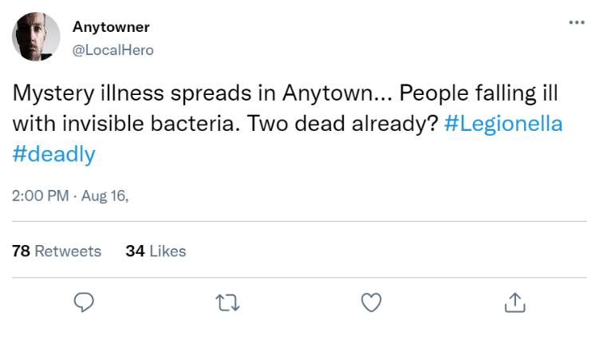
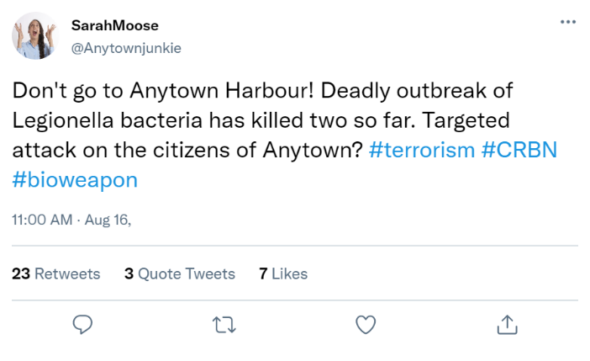

MODULE 3: COMMUNITY
INJECT 3.3

DATE: 16 August
FROM: Occupational Health – Port of Anytown
SUBJECT: Public health advice

Enquiry from Occupational Health Department at Port of Anytown
Good afternoon,
I work as a nurse at Port of Anytown’s Occupational Health Department. I am contacting you to find out more information about the source of the Legionella outbreak in Anytown, and the associated dangers for port workers.
Two of our staff members have so far been hospitalised with Legionnaires’ disease, and several other port workers are now starting to exhibit flu-like symptoms.
I am also concerned about rising absenteeism, as our staff members are increasingly worried about catching an infectious disease.
Could you please provide me with your expert advice on what to tell our workers about the outbreak and associated risks. Please also advise how to manage those staff falling ill.
Thank you,

Steve Jones
Occupational Health Nurse
Port of Anytown

MODULE 3: COMMUNITY
INJECT 3.4

DATE: 16 August
FROM: Environmental Health – Anytown City Council
SUBJECT: New information on possible outbreak sources

New information on possible outbreak sources
Good afternoon,
Further to our previous correspondence, we have discovered some new information about a possible source of the current Legionnaires’ disease outbreak.
It seems that due to the recent redevelopment of existing buildings in the harbour area to accommodate luxury apartments, a cooling tower which had been out of use in the recent year has been reactivated recently (late June) to service some of these new apartments.
Testing of water samples from the cooling tower basins is ongoing but dispersal plume mapping would suggest a plausible source based on exposure area (site E).
I hope this helps with your outbreak investigation.

A
B
C
D

E

INJECTS 3.0-3.4
MODULE 3: COMMUNITY

SESSION 3: QUESTIONS

- What are your next steps in the outbreak investigation and response?

- How do you interpret the environmental and clinical sample results?
What factors may explain the inconclusive results?

- What are your priorities for communication?
What information are you giving to the media, national partners and the public?

- What long-term prevention actions are being considered in view of lessons learned from this event?

